Appendix 1a. Female presentation cards for the Cognitive Mediation Task (Dagnan et al., 2009)

1.
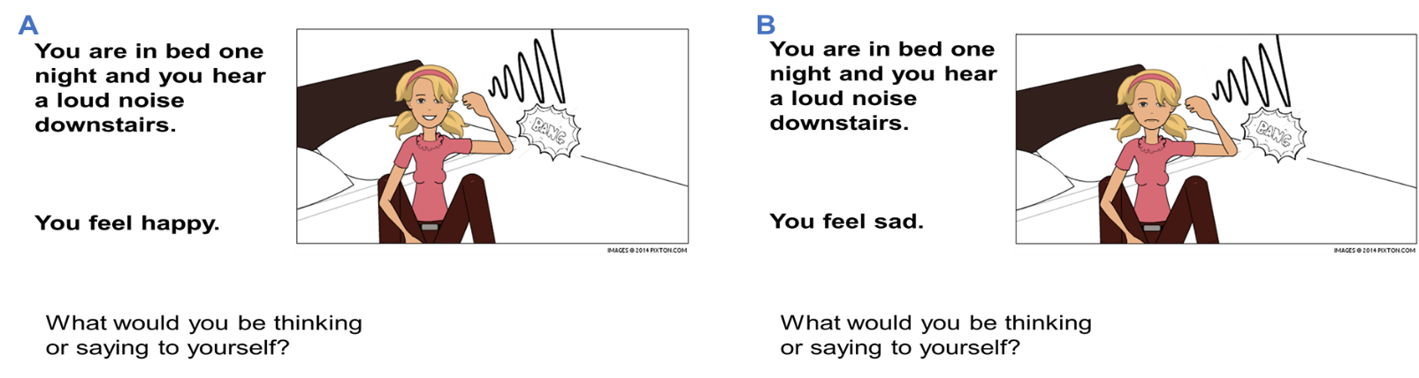

2.
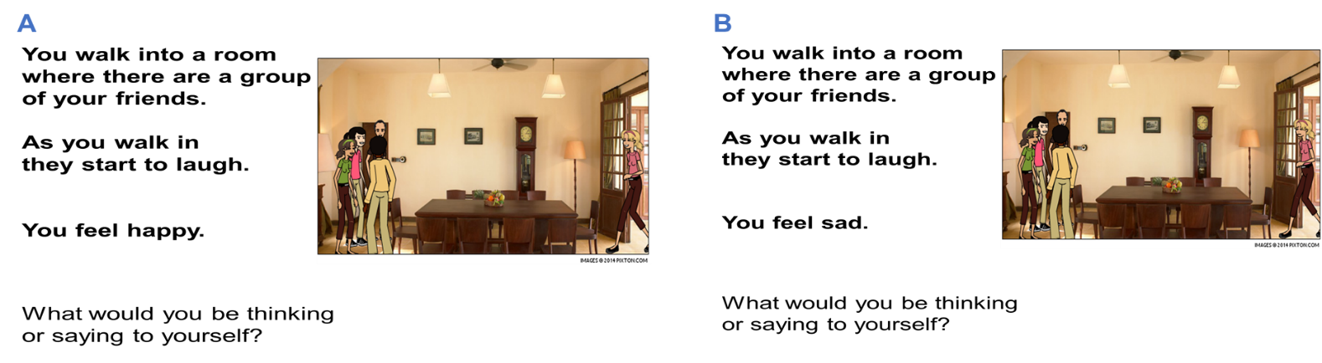

3.
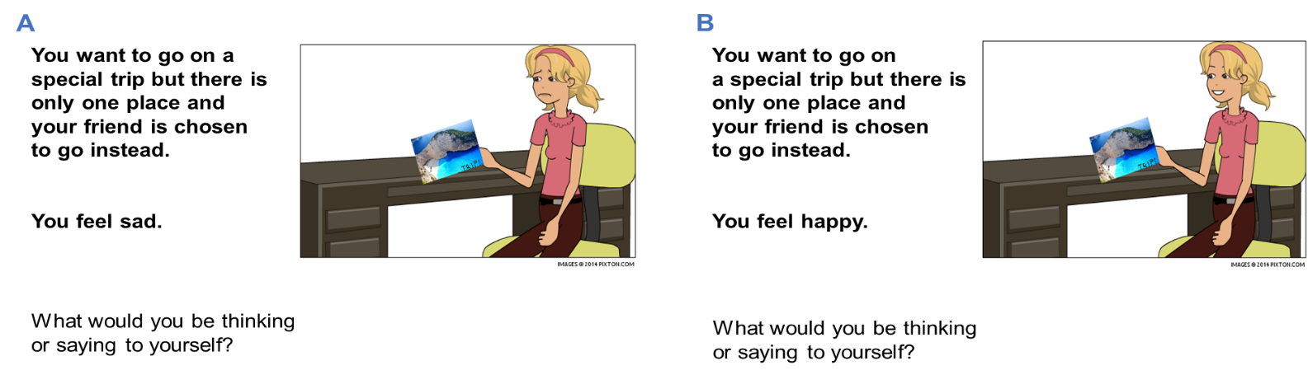

4.
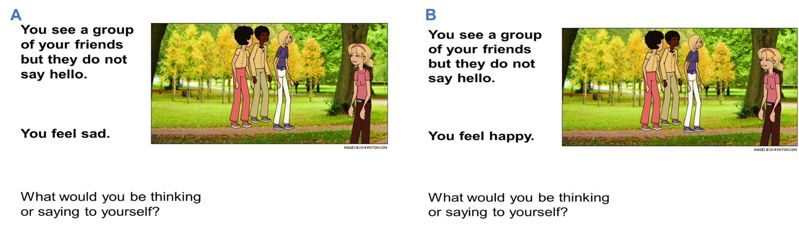

5.
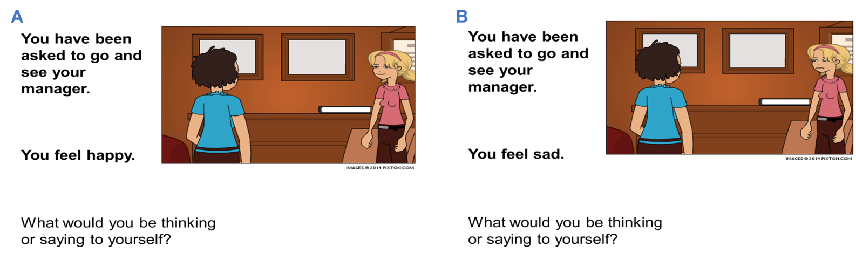

6.
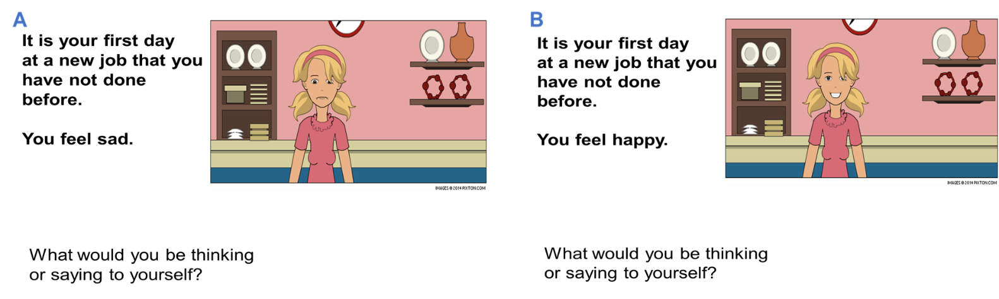

Appendix 1b. Male presentation cards for the Cognitive Mediation Task (Dagnan et al., 2009)

1.
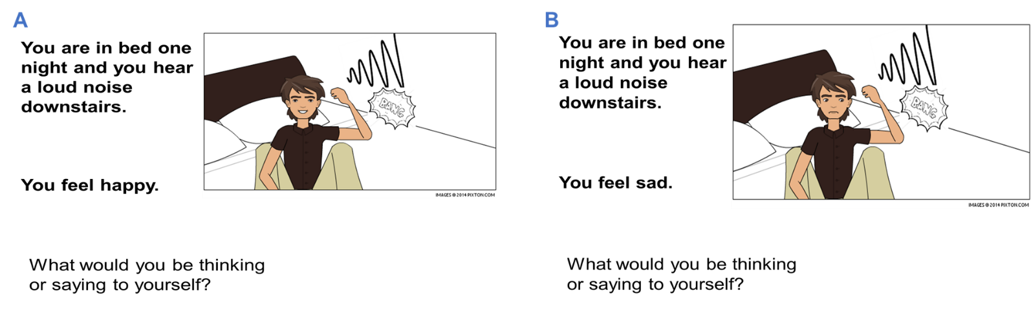

2.
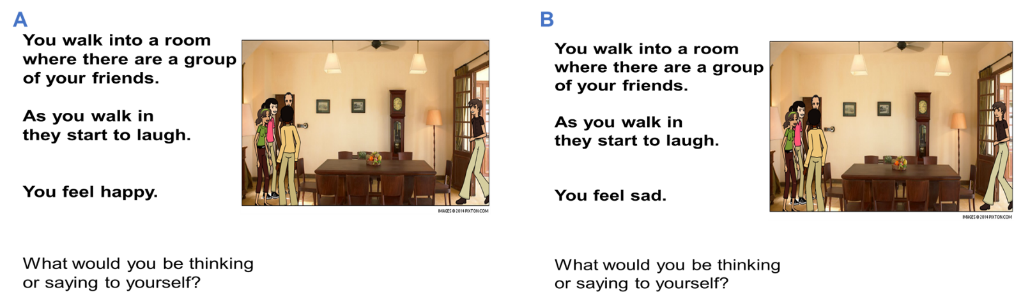

3.
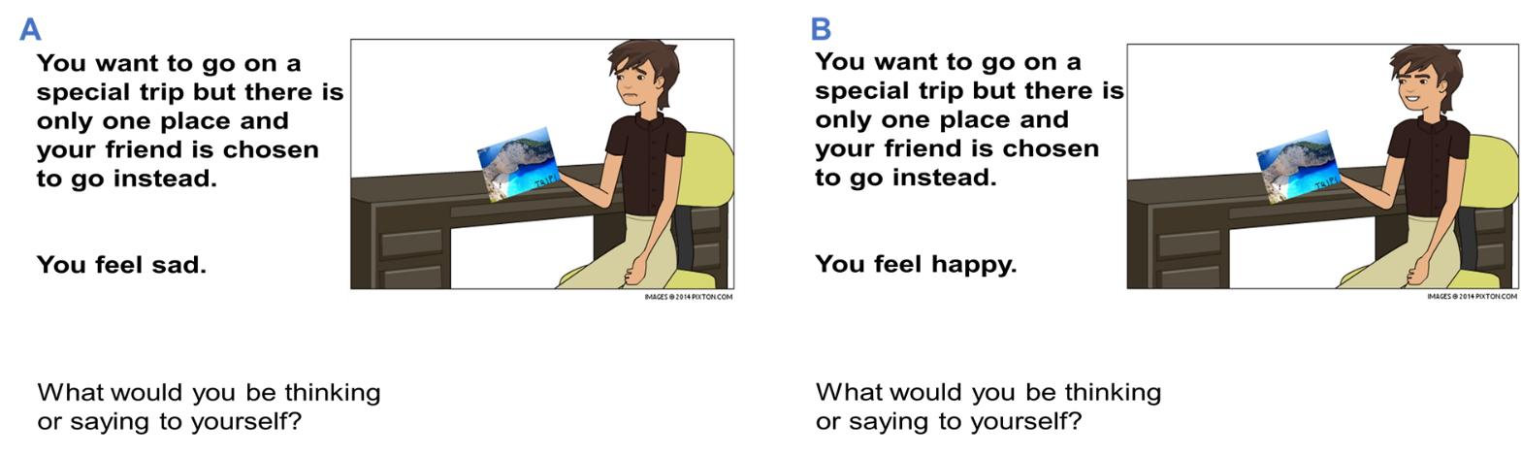

4.
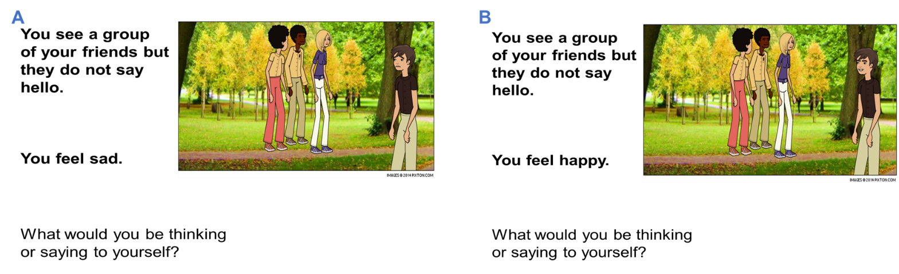

5.
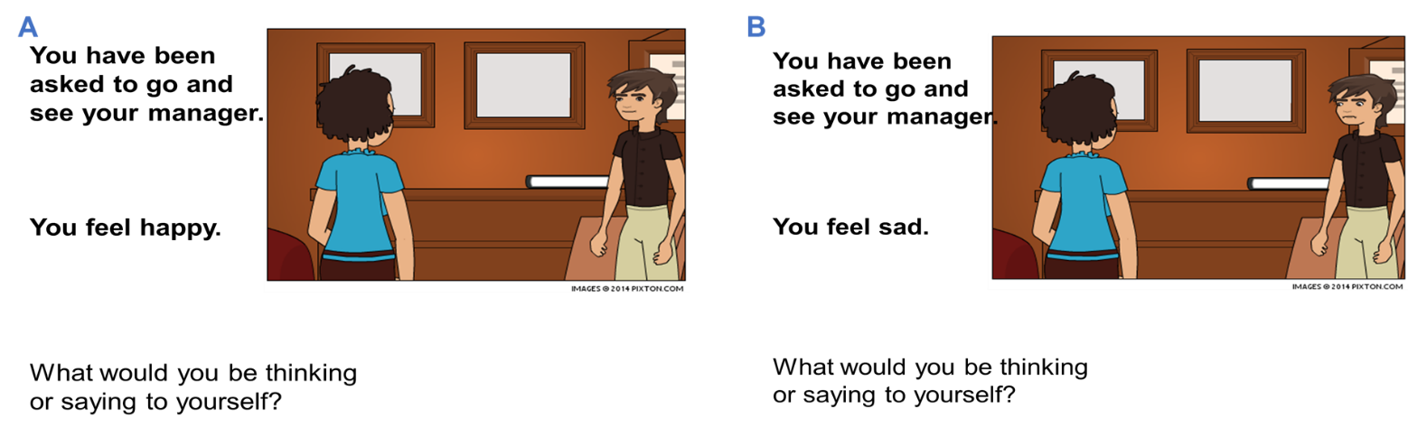

6.
