The effect of supplementing pony diets with yeast on 2. The faecal microbiome
A. Garber, P. M. Hastie, V. Farci, D. Mcguinness, L. Bulmer, O. Alzahal and J.M.D. Murray
animal journal
Supplementary material
Supplementary Figure S1 Significant taxa in the equine faeces for each diet identified by linear discriminant analysis effect size (LEfSe). Each bar of the graph represents the effect size (LDA) for particular taxa (genus level or higher) in a certain group. The length of the bar represents a log10 transformed linear discriminant analysis (LDA) score. Any taxa coloured according to a variable (HF, HFY, HS and HSY diets) can be interpreted as that taxa relative abundance (RA) was significantly higher compared to the other groups (LDA score > 2). HF: high fibre without yeast, HFY: high fibre with yeast, HS: high starch without yeast, HSY: high starch with yeast; c_: class, o_: order, f_: family, g_: genus.
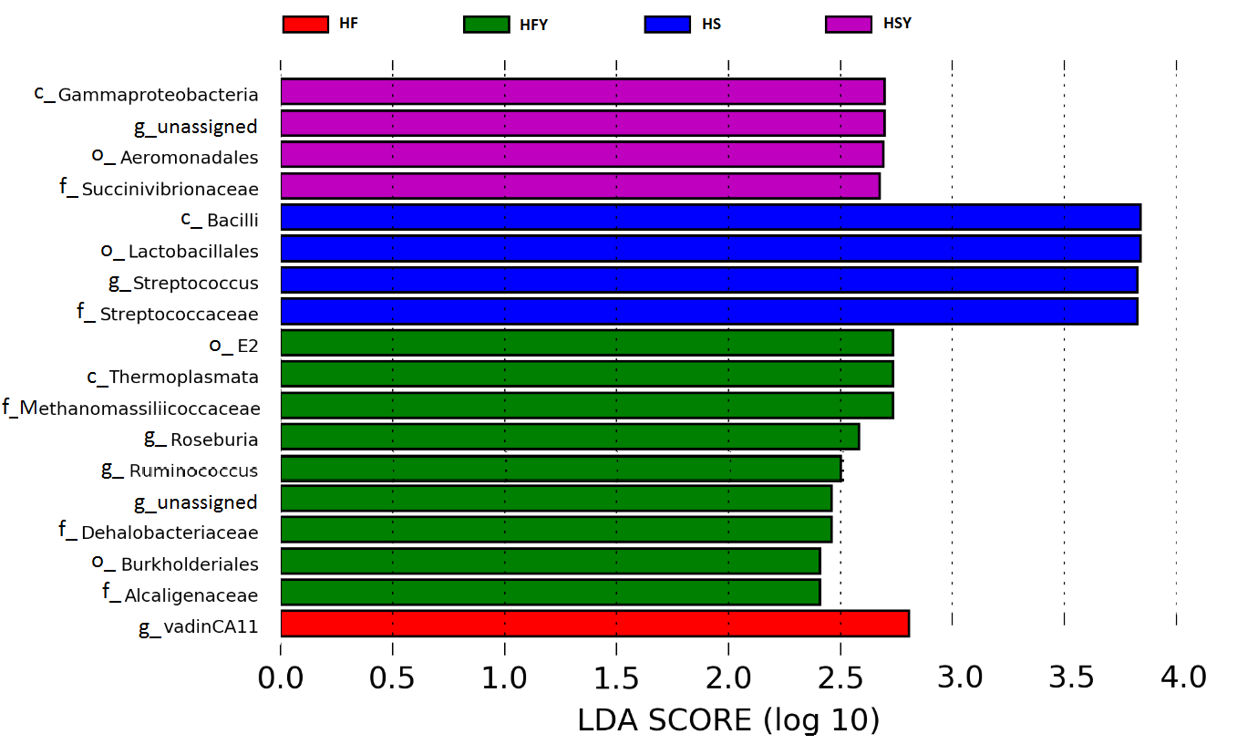
Supplementary Figure S2 Distribution of sequences by phyla.
Bacterial and Archaeal phyla relative abundance of sequences detected in equine faeces at level of 0.1 % or greater. HF: high fibre without yeast, HFY: high fibre with yeast, HS: high starch without yeast, HSY: high starch with yeast.

