The effect of willow fodder feeding on immune cells populations in the blood and milk of late-lactating dairy goats

H. Muklada ^{1,2}, H. Voet², T. Deutch¹, M. Zachut³, G. Kra³, S.E. Blum⁴, O. Krifuks⁴, T.A. Glasser⁵, J.D. Klein¹, R. Davidovich-Rikanati⁶, E. Lewinsohn⁶, S.Y. Landau^{1,*}

¹ Department of Natural Resources, Institute of Plant Sciences, Agricultural Research Organization, Volcani Center, 68 Hamakabim Rd, Rishon Le Ziyyon, 7505101, Israel
² Robert H. Smith Faculty of Agriculture, Food and Environment. The Hebrew University of Jerusalem, Rehovot, 76200 Israel.
³ Department of Ruminant Science, Institute of Animal Science, Agricultural Research Organization, 68 Hamakabim Rd, Rishon Le Ziyyon, 7505101, Israel

⁴ National Mastitis Center, Division of Bacteriology, Kimron Veterinary Institute, P.O.Box 12, Bet Dagan 50250, Israel

⁵ The Ramat Hanadiv Nature Park, P.O. Box 325, Zikhron Ya'akov, 3095202, Israel

⁶ Institute of Plant Sciences, Newe Ya’ar Research Center, Agricultural Research Organization, Ramat Yishay, 30095, Israel

* Corresponding author: S.Y. Landau. E-mail: vclandau@agri.gov.il
Table S1: Gating strategy for goat blood leucocytes with Phycoerythrin (PE) and allophycocyanine (APC) as antibody-staining agents.
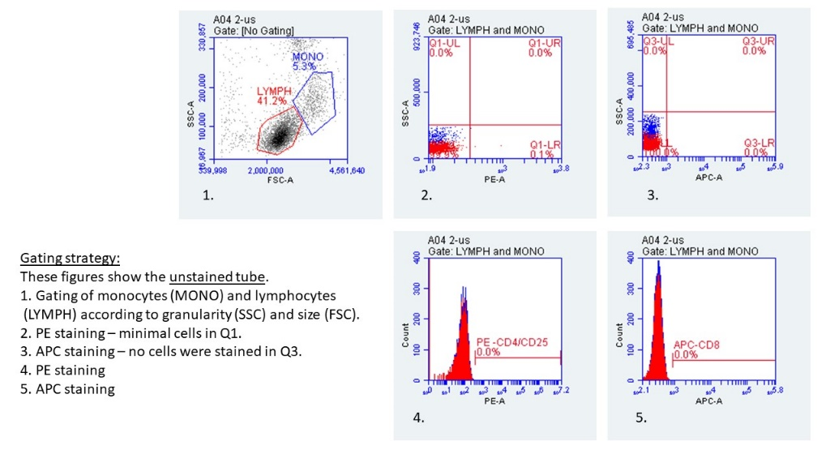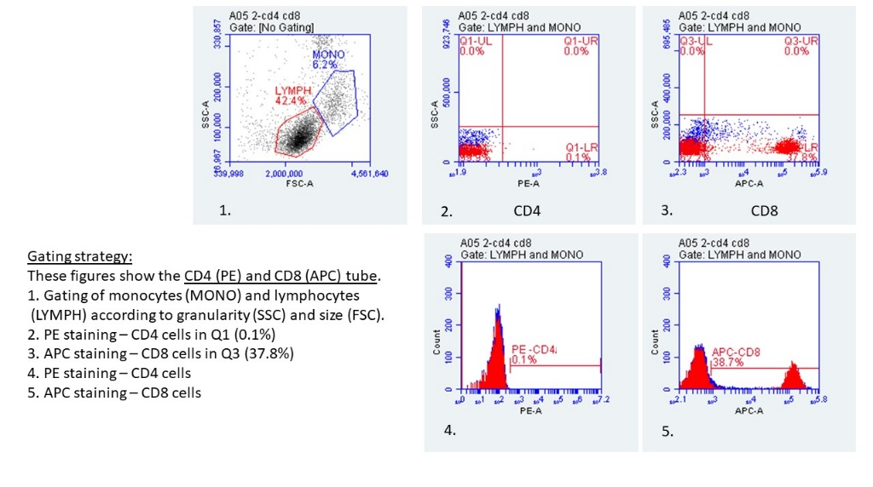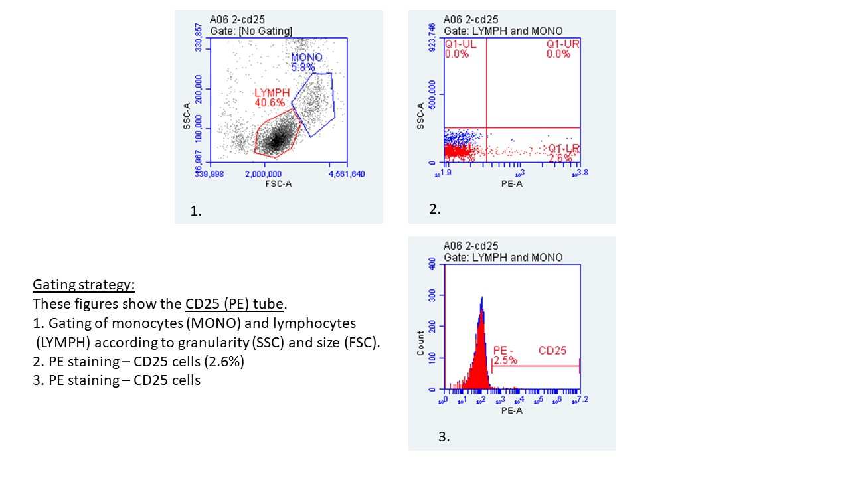

Table S2: Plant secondary compounds in willow fodder offered to goats as determined by calculation of areas under the liquid chromatography / time-of-flight / mass spectrometry peaks (artificial units based on peak area of exact mass counts detected by time-of-flight / mass spectrometry): means ± SE of 3 last days of experiment.
 | Compound | Method | Concentration (ug/gr DM)
salicortin_5.4 | salicylate glucoside | RT, EMM | 33 848 097 ± 6 680 127
Tremulacin | salicylate glucoside | RT, EMM | 7 465 088 ± 3 075 609
HCH salicortin | salicylate glucoside | RT, EMM | 835 093 ± 224 149
Lasiandrin | salicylate glucoside | EMM | 211 813 ± 80 093
Salicyloyl tremuloidin | salicylate glucoside | RT, EMM | 152 183 ± 49 768
Salicylic acid glucoside | salicylate glucoside | RT, EMM | 131 653 ± 33 800
Salicortin-6.5 | salicylate glucoside | RT, EMM | 76 751 ± 30 465
Populoside C | salicylate glucoside | EMM | 61 132 ± 9 636
Chaenomeloidin | Phenolic glucoside | EMM | 1 004 573 ± 336 334
Syringin | phenolic acids_glucoside | EMM | 233 415 ± 9 264
Coumaric acid_Glucoside | phenolic acids_glucoside | EMM | 108 963 ± 10 413
3-p-coumaroylquinic acid derivative | Phenolic acids | RT, EMM | 2 180 392 ± 907 119
Chlorogenic acid derivative | Phenolic acids | RT, EMM | 712 380 ± 234 835
Rosmarinic acid | Phenolic acids | RT, EMM | 150 001 ± 53 587
Gallocatechin | Phenolic acids | RT, EMM | 143 383 ± 10 209
Fumaric acid | Organic acid | RT, EMM | 508 716 ± 71 103
Fragilin_5 | Glycoside | RT, EMM | 452 311 ± 97 945
Fragilin_5.2 | Glycoside | RT, EMM | 283 216 ± 36 522
Trichocarposide | Glucoside coumaryl | RT, EMM | 1 684 446 ± 350 822
Deltoidin | Glucopyranoside | EMM | 40 498 ± 16 165
Kaempferol_Glucoside | flavonol glucoside | RT, EMM | 2 294 674 ± 298 811
Rutin | flavonol | RT, EMM | 185 859 ± 48 928
Epicatechin | flavonoids | RT, EMM | 1 688 097 ± 212 687
* Identification Method (RT = retention time; EMM: exact molecular mass)

