Title: Domestication is associated with differential expression of pikeperch egg proteins involved in metabolism, immune response and protein folding
Authors: J. Nynca, D. Żarski, J. Bobe and A. Ciereszko
Journal: Animal

Supplementary Material S1 - Detailed methods
Two-dimensional differential in-gel electrophoresis(2D DIGE) and image analysis
Protein labelling with CyDye DIGE fluor and 2D electrophoresis slices were performed under the same conditions as described by Nynca et al., 2015. Briefly, an aliquot of 50 μg of protein from each sample of (i) domesticated pikeperch fish (DF) eggs extract (n=6) and (ii) wild pikeperch fish (WF) eggs extract (n=6) was labelled with CyDye DIGE Fluor minimal dyes (GE Healthcare, Uppsala, Sweden) at a concentration of 400 pmol dye/50 μg of protein. Cy2 was used to label the internal standard, which was created by mixing equal amounts of protein from DF and WF eggs, and Cy3 and Cy5 to label individual egg extracts of DF and WF. A dye swap (Cy3/Cy5) was performed between DF and WF egg extract samples to exclude dye bias. An internal standard was created by mixing equal amounts of protein from the egg of domesticated (DF) and wild pikeperch fish (WF). Differentially labeled samples were mixed together as follows:
Gel no. | Cy2 (50µg) | Cy3 (50µg) | Cy5 (50µg)
1 | Pooled Standard | egg extract of DF 1 | egg extract of WF 1
2 | Pooled Standard | egg extract of DF 2 | egg extract of WF 2
3 | Pooled Standard | egg extract of DF 3 | egg extract of WF 3
4 | Pooled Standard | egg extract of WF 4 | egg extract of DF 4
5 | Pooled Standard | egg extract of WF 5 | egg extract of DF 5
6 | Pooled Standard | egg extract of WF 6 | egg extract of DF 6

In each gel therefore egg extract from DF (Cy3 or Cy5) and WF fish (Cy5 or Cy3) and internal standard (Cy2) were separated. The samples were loaded onto immobiline DryStrip gels strips (24 cm, pH 3 to 10 non-linear; GE, Healthcare).
Isoelectric focusing was performed with an IPGphor isoelectric focusing unit (GE Healthcare), and SDS-PAGE was run using the ETTAN Dalt six electrophoresis unit (GE Healthcare) as described by Nynca et al., 2015. The CyDye-labelled gels were analysed by post-run fluorescence imaging using the Typhoon FLA 9500 (GE Healthcare) with parameters recommended for 2D DIGE experiments by the manufacturer. The Cy2-, Cy3-, and Cy5-labeled images were at excitation and emission values of 488/520, 532/580, and 633/670 nm, respectively. Intragel spot detection and quantification and intergel matching and quantification were achieved using the differential in-gel analysis (DIA) and biological variation analysis (BVA) modules of DeCyder software (version 5.0; GE Healthcare). Differences in the abundance levels of proteins between DF and WF egg extracts were considered to be relevant if 1) the corresponding spots were detected in all gels, 2) a Student’s t-test was significant at the P ≤ 0.05 level (including a false discovery rate correction), and 3) the intensity ratio of spots showed at least a 1.3-fold increase or decrease in their relative abundance. After DIGE analysis, gels were stained with Coomassie Brilliant Blue R-250 (Bio-Rad, Hercules, CA, USA).
Matrix-assisted laser desorption/ionization time-of-flight/time-of-flight mass spectrometry (MALDI TOF/TOF) protein identification
Spots of interest were cut from the gel and prepared for identification as previously described by Nynca et al. (2015). Differentially abundant protein spots of interest were manually excised from the gels and in-gel digested with trypsin. Briefly, gel plugs were destained with 30% acetonitrile in 100mM ammonium bicarbonate for 30 min and vacuum dried. Then, digestion solution (20 ng/μl trypsin, Promega, Madison, WI, USA) in 20mM ammonium bicarbonate was added, and the samples were digested at 37 °C overnight. After digestion, peptides were extracted with 0.1% trifluoroacetic acid (TFA) and then concentrated and desalted using Zip-Tip C18 pipette tips (Millipore, Billerica, MA, USA)). Equal volumes of sample and α-cyano-4-hydroxycinnamic acid matrix (5 mg/mL) were mixed and spotted on the plate (MTP384 GrandSteel). Matrix-assisted laser desorption/ionization time-of-flight/time-of-flight (MALDI-TOF/TOF) mass spectrometry (MS) analysis was accomplished using a MALDI-TOF/TOF mass spectrometer (Autoflex Speed; Bruker Daltonics, Bremen, Germany). Collected MS and tandem mass spectrometry LIFT spectra of selected ions were externally calibrated using monoisotopic protonated ion peptide calibration standards (Bruker Daltonics) and imported to Bio-Tools (Bruker Daltonics).MS peptide mass fingerprint and fragment spectra from each individual spot were combined and used to search against the NCBI database using Mascot (version 2.4; Matrix Science Ltd, London, UK) with the following criteria: enzyme, trypsin; fixed modification, carbamidomethylation (C); and variable modifications, oxidation (M) peptide mass tolerance of 100 ppm, fragment mass tolerance of 0.9 Da, and 1 missed cleavage allowed. The search results were filtered with a significant threshold of p < 0.05 and a Mascot ion score cut-off of ≥30 for at least two peptides.
LIFT - is not an abbreviation; it is a proprietary trademarked term of Bruker Daltonics used with their TOF/TOF mass spectrometer to describe the process of elevating the potential of the collision cell above that of the ion source
Statistical analysis
All of the results of egg quality parameters (survival rate, hatching rate) are presented as the means ± SD. For statistical procedures, percentage data of the survival rate and hatching were transformed by arcsine square-root transformation. Then data were subjected to a Student’s t-test for unpaired samples. All analyses were performed at a significance level of 0.05 using GraphPad Prism software (GraphPad Software Inc. San Diego, CA, USA).

Supplementary Material S2 – Quality parameters of eggs obtained from domesticated and wild caught pikeperch - raw data

Eggs | Survival rate (72 h post fertilization; %) | Hatching Rate (%)
Domesticated fish | 85 | 67
 | 90 | 67
 | 91 | 74
 | 89 | 77
 | 96 | 86
 | 91 | 87
 | 89 | 64
 | 91 | 66
Average | 90.2 | 73.5
Standard deviation | 2.9 | 9.2
Wild fish | 91 | 79
 | 92 | 68
 | 89 | 85
 | 95 | 89
 | 97 | 87
 | 87 | 83
 | 89 | 79
Average | 91.4 | 81.4
Standard deviation | 3.6 | 7.0

Supplementary Table S1 Functional enrichement Biological process (species Homo sapiens; https://string-db.org/)
More in wild
#term ID | term description | matching proteins in your network (labels)
GO:0002224 | toll-like receptor signaling pathway | COLEC12,HSP90B1,HSPD1
GO:0006457 | protein folding | HSP90B1,HSPA5,HSPA9,HSPD1,
GO:0006810 | transport | ALDOC,ATP5A1,COLEC12,HSP90B1,HSPA5,HSP, HSPD1,NME2,RPS21,SERPINB1A9,
GO:0006986 | response to unfolded protein | HSP90B1,HSPA5,HSPD1
GO:0009152 | purine ribonucleotide biosynthetic process | ALDOC,ATP5A1,NME2
GO:0009206 | purine ribonucleoside triphosphate biosynthetic process | ALDOC,ATP5A1,NME2
GO:0017144 | drug metabolic process | ALDOC,ATP5A1,IL4I1,NCAN,NQO1
GO:0034975 | protein folding in endoplasmic reticulum | HSP90B1,HSPA5
GO:0036500 | ATF6-mediated unfolded protein response | HSP90B1,HSPA5
GO:0043066 | negative regulation of apoptotic process | HSP90B1,HSPA5,HSPA9,HSPD1,NME2,NQO1
GO:0009205 | purine ribonucleoside triphosphate metabolic process | ALDOC,ATP5A1,NME2
GO:1901575 | organic substance catabolic process | ALDOC,HSP90B1,HSPA5,IL4I1,NCAN,RPS21
GO:0002366 | leukocyte activation involved in immune response | ALDOC,HSPD1,NME2,SERPINB1
GO:0002376 | immune system process | ALDOC,COLEC12,HSP90B1,HSPA9,HSPD1,NME2,SERPINB1
GO:0002443 | leukocyte mediated immunity | ALDOC,HSPD1,NME2,SERPINB1
GO:0006165 | nucleoside diphosphate phosphorylation | ALDOC,NME2
GO:0030433 | ubiquitin-dependent ERAD pathway | HSP90B1,HSPA5
GO:0044248 | cellular catabolic process | ALDOC,HSP90B1,HSPA5,IL4I1,NCAN,RPS21
GO:0048519 | negative regulation of biological process | ATP5A1,HSP90B1,HSPA5,HSPA9,HSPD1,NME2,NQO1,RPS21,SERPINB1,STMN1
GO:1901137 | carbohydrate derivative biosynthetic process | ALDOC,ATP5A1,NCAN,NME2
GO:0006754 | ATP biosynthetic process | ALDOC,ATP5A1
GO:0035690 | cellular response to drug | HSP90B1,HSPA5,NQO1
GO:1990542 | mitochondrial transmembrane transport | ATP5A1,HSPD1
GO:0048523 | negative regulation of cellular process | ATP5A1,HSP90B1,HSPA5,HSPA9,HSPD1,NME2,NQO1,SERPINB1,STMN1
GO:0009168 | purine ribonucleoside monophosphate biosynthetic process | ALDOC,ATP5A1
GO:0032091 | negative regulation of protein binding | HSPA5,STMN1
GO:0034613 | cellular protein localization | HSP90B1,HSPA5,HSPA9,HSPD1,RPS21
GO:0046907 | intracellular transport | ATP5A1,HSP90B1,HSPA9,HSPD1,RPS21
GO:1901566 | organonitrogen compound biosynthetic process | ALDOC,ATP5A1,NCAN,NME2,RPS21
GO:0006886 | intracellular protein transport | HSP90B1,HSPA9,HSPD1,RPS21
GO:0071236 | cellular response to antibiotic | HSPA5,NQO1
more in domesticated

#term ID | term description | matching proteins in your network (labels)
GO:0009124 | nucleoside monophosphate biosynthetic process | ATIC,ATP5B,ENO3,GAPDH,GAPDHS,PGK1,SHMT1
GO:0017144 | drug metabolic process | ALDH2,ATP5B,BHMT,CKB,ENO3,GAPDH,GAPDHS,IL4I1,MDH1,PGK1,SHMT1
GO:0046364 | monosaccharide biosynthetic process | ENO3,GAPDH,GAPDHS,MDH1,PGK1,TKT
GO:0006734 | NADH metabolic process | ENO3,GAPDH,GAPDHS,MDH1,PGK1
GO:0006094 | gluconeogenesis | ENO3,GAPDH,GAPDHS,MDH1,PGK1
GO:0006458 | 'de novo' protein folding | CCT2,CCT3,CCT6A,CCT7,HSPD1
GO:0006732 | coenzyme metabolic process | ATIC,ENO3,GAPDH,GAPDHS,MDH1,PGK1,SHMT1,TKT
GO:0009168 | purine ribonucleoside monophosphate biosynthetic process | ATIC,ATP5B,ENO3,GAPDH,GAPDHS,PGK1
GO:0019752 | carboxylic acid metabolic process | ALDH6A1,ATIC,BHMT,CKB,ENO3,GAPDH,GAPDHS,IL4I1,MDH1,PGK1,SHMT1
GO:0044281 | small molecule metabolic process | ALDH2,ALDH6A1,ATIC,ATP5B,BHMT,CKB,ENO3,GAPDH,GAPDHS,IL4I1,MDH1,PGK1, SHMT1,TKT
GO:0046496 | nicotinamide nucleotide metabolic process | ENO3,GAPDH,GAPDHS,MDH1,PGK1,TKT
GO:0055086 | nucleobase-containing small molecule metabolic process | ALDH6A1,ATIC,ATP5B,ENO3,GAPDH,GAPDHS,MDH1,PGK1,SHMT1,TKT
GO:0072522 | purine-containing compound biosynthetic process | ATIC,ATP5B,ENO3,GAPDH,GAPDHS,PGK1,SHMT1
GO:1904851 | positive regulation of establishment of protein localization to telomere | CCT2,CCT3,CCT6A,CCT7
GO:0044282 | small molecule catabolic process | ALDH2,ALDH6A1,ENO3,GAPDH,GAPDHS,IL4I1,PGK1,SHMT1
GO:0044283 | small molecule biosynthetic process | ATIC,BHMT,ENO3,GAPDH,GAPDHS,MDH1,PGK1,SHMT1,TKT
GO:0009117 | nucleotide metabolic process | ATIC,ATP5B,ENO3,GAPDH,GAPDHS,MDH1,PGK1,SHMT1,TKT
GO:0061077 | chaperone-mediated protein folding | CCT2,CCT3,CCT6A,CCT7,HSPD1
GO:0009123 | nucleoside monophosphate metabolic process | ATIC,ATP5B,ENO3,GAPDH,GAPDHS,PGK1,SHMT1
GO:0006735 | NADH regeneration | ENO3,GAPDH,GAPDHS,PGK1
GO:0006754 | ATP biosynthetic process | ATP5B,ENO3,GAPDH,GAPDHS,PGK1
GO:0061621 | canonical glycolysis | ENO3,GAPDH,GAPDHS,PGK1
GO:0061718 | glucose catabolic process to pyruvate | ENO3,GAPDH,GAPDHS,PGK1
GO:0009165 | nucleotide biosynthetic process | ATIC,ATP5B,ENO3,GAPDH,GAPDHS,PGK1,SHMT1
GO:0050821 | protein stabilization | CCT2,CCT3,CCT6A,CCT7,GAPDH,HSPD1
GO:0046394 | carboxylic acid biosynthetic process | ATIC,BHMT,ENO3,GAPDH,GAPDHS,PGK1,SHMT1
GO:0009152 | purine ribonucleotide biosynthetic process | ATIC,ATP5B,ENO3,GAPDH,GAPDHS,PGK1
GO:0032212 | positive regulation of telomere maintenance via telomerase | CCT2,CCT3,CCT6A,CCT7
GO:0005996 | monosaccharide metabolic process | ENO3,GAPDH,GAPDHS,MDH1,PGK1,TKT
GO:0006757 | ATP generation from ADP | ENO3,GAPDH,GAPDHS,PGK1
GO:0042866 | pyruvate biosynthetic process | ENO3,GAPDH,GAPDHS,PGK1
GO:0006006 | glucose metabolic process | ENO3,GAPDH,GAPDHS,MDH1,PGK1
GO:0090407 | organophosphate biosynthetic process | ATIC,ATP5B,ENO3,GAPDH,GAPDHS,PGK1,SHMT1,TKT
GO:0006091 | generation of precursor metabolites and energy | ALDH2,ATP5B,ENO3,GAPDH,GAPDHS,MDH1,PGK1
GO:0009167 | purine ribonucleoside monophosphate metabolic process | ATIC,ATP5B,ENO3,GAPDH,GAPDHS,PGK1
GO:1901137 | carbohydrate derivative biosynthetic process | ATIC,ATP5B,ENO3,GAPDH,GAPDHS,PGK1,SHMT1,TKT
GO:0009435 | NAD biosynthetic process | ENO3,GAPDH,GAPDHS,PGK1
GO:0019693 | ribose phosphate metabolic process | ATIC,ATP5B,ENO3,GAPDH,GAPDHS,PGK1,TKT
GO:0005975 | carbohydrate metabolic process | ALDH2,ENO3,GAPDH,GAPDHS,MDH1,PGK1,TKT
GO:0072521 | purine-containing compound metabolic process | ATIC,ATP5B,ENO3,GAPDH,GAPDHS,PGK1,SHMT1
GO:0006090 | pyruvate metabolic process | ENO3,GAPDH,GAPDHS,PGK1
GO:0009108 | coenzyme biosynthetic process | ATIC,ENO3,GAPDH,GAPDHS,PGK1
GO:0046034 | ATP metabolic process | ATP5B,ENO3,GAPDH,GAPDHS,PGK1
GO:1901605 | alpha-amino acid metabolic process | ALDH6A1,BHMT,CKB,IL4I1,SHMT1
GO:0009166 | nucleotide catabolic process | ENO3,GAPDH,GAPDHS,PGK1
GO:0055114 | oxidation-reduction process | ALDH2,ALDH6A1,ENO3,GAPDH,GAPDHS,IL4I1,MDH1,PGK1
GO:0009150 | purine ribonucleotide metabolic process | ATIC,ATP5B,ENO3,GAPDH,GAPDHS,PGK1
GO:0007339 | binding of sperm to zona pellucida | CCT2,CCT3,CCT7
GO:0044270 | cellular nitrogen compound catabolic process | ALDH6A1,BHMT,ENO3,GAPDH,GAPDHS,PGK1
GO:1901998 | toxin transport | CCT2,CCT3,CCT7
GO:1901361 | organic cyclic compound catabolic process | ALDH6A1,ENO3,GAPDH,GAPDHS,IL4I1,PGK1
GO:0008037 | cell recognition | CCT2,CCT3,CCT7,COLEC12
GO:1901575 | organic substance catabolic process | ALDH2,ALDH6A1,BHMT,ENO3,GAPDH,GAPDHS,IL4I1,PGK1,SHMT1
GO:0006575 | cellular modified amino acid metabolic process | ATIC,BHMT,CKB,SHMT1
GO:0006796 | phosphate-containing compound metabolic process | ATIC,ATP5B,CKB,ENO3,GAPDH,GAPDHS,MDH1,PGK1,SHMT1,TKT
GO:0044248 | cellular catabolic process | ALDH2,ALDH6A1,BHMT,ENO3,GAPDH,GAPDHS,IL4I1,PGK1,SHMT1
GO:1904951 | positive regulation of establishment of protein localization | CCT2,CCT3,CCT6A,CCT7,GAPDH
GO:0051702 | interaction with symbiont | GAPDH,HSPD1,PTX3
GO:1901566 | organonitrogen compound biosynthetic process | ATIC,ATP5B,BHMT,ENO3,GAPDH,GAPDHS,PGK1,SHMT1
GO:0046700 | heterocycle catabolic process | ALDH6A1,ENO3,GAPDH,GAPDHS,PGK1
GO:0019439 | aromatic compound catabolic process | ENO3,GAPDH,GAPDHS,IL4I1,PGK1
GO:0051131 | chaperone-mediated protein complex assembly | CCT2,HSPD1
GO:1903827 | regulation of cellular protein localization | ACTB,CCT2,CCT3,CCT6A,CCT7
GO:0006577 | amino-acid betaine metabolic process | BHMT,SHMT1
GO:0043648 | dicarboxylic acid metabolic process | ATIC,MDH1,SHMT1
GO:1901606 | alpha-amino acid catabolic process | ALDH6A1,IL4I1,SHMT1
GO:0046653 | tetrahydrofolate metabolic process | ATIC,SHMT1
GO:1901564 | organonitrogen compound metabolic process | ACTB,ALDH6A1,ATIC,ATP5B,BHMT,CKB,ENO3,GAPDH,GAPDHS,HSPD1,IL4I1,MDH1,PGK1,SHMT1,TKT
GO:0009063 | cellular amino acid catabolic process | ALDH6A1,IL4I1,SHMT1
GO:0032880 | regulation of protein localization | ACTB,CCT2,CCT3,CCT6A,CCT7,GAPDH
GO:0009112 | nucleobase metabolic process | ALDH6A1,SHMT1
GO:0042398 | cellular modified amino acid biosynthetic process | ATIC,SHMT1
GO:0006909 | phagocytosis | ACTB,COLEC12,PTX3
GO:0065008 | regulation of biological quality | ATP5B,BHMT,CCT2,CCT3,CCT6A,CCT7,CKB,GAPDH,HSPD1,PTX3,SHMT1
GO:1901607 | alpha-amino acid biosynthetic process | BHMT,SHMT1
GO:0009620 | response to fungus | GAPDH,PTX3
GO:0016310 | phosphorylation | ATP5B,CKB,ENO3,GAPDH,GAPDHS,PGK1
GO:0051851 | modification by host of symbiont morphology or physiology | GAPDH,PTX3
GO:0008652 | cellular amino acid biosynthetic process | BHMT,SHMT1
GO:0002252 | immune effector process | ACTB,CCT2,HSPD1,PTX3,TUBB4B
GO:1990542 | mitochondrial transmembrane transport | ATP5B,HSPD1
GO:0002224 | toll-like receptor signaling pathway | COLEC12,HSPD1
GO:0042133 | neurotransmitter metabolic process | BHMT,SHMT1
GO:0001505 | regulation of neurotransmitter levels | BHMT,PTX3,SHMT1
GO:0006725 | cellular aromatic compound metabolic process | ALDH6A1,ATIC,ATP5B,ENO3,GAPDH,GAPDHS,HSPD1,IL4I1,MDH1,PGK1,SHMT1,TKT
GO:0072527 | pyrimidine-containing compound metabolic process | ALDH6A1,SHMT1
GO:0002366 | leukocyte activation involved in immune response | CCT2,HSPD1,PTX3,TUBB4B
GO:0021549 | cerebellum development | ATIC,CKB
GO:0002443 | leukocyte mediated immunity | CCT2,HSPD1,PTX3,TUBB4B
GO:0002757 | immune response-activating signal transduction | ACTB,COLEC12,HSPD1
GO:1901360 | organic cyclic compound metabolic process | ALDH6A1,ATIC,ATP5B,ENO3,GAPDH,GAPDHS,HSPD1,IL4I1,MDH1,PGK1,SHMT1,TKT
GO:0032879 | regulation of localization | ACTB,ATP5B,CCT2,CCT3,CCT6A,CCT7,GAPDH,PTX3
GO:0042737 | drug catabolic process | ALDH2,IL4I1
GO:0009987 | cellular process | ACTB,ALDH2,ALDH6A1,ATIC,ATP5B,BHMT,CCT2,CCT3,CCT6A,CCT7,CKB,COLEC12,ENO3,GAPDH,GAPDHS,HSPD1,IL4I1,MDH1,PGK1,PTX3,SHMT1,TKT,TUBB4B
GO:0045087 | innate immune response | COLEC12,GAPDH,PTX3,TUBB4B
ATF 6 - Activating transcription factor 6
ERAD - endoplasmic reticulum-associated
NADH - Nicotinamide adenine dinucleotide

1 2 3 4 5 6 1 2 3 4 5 6
Domesticated Wild
sample

Supplementary Figure S1 Hierarchical clustering heatmap of differentially expressed proteins in eggs of domesticated females (a) compared with wild-caught (b), as indicated under each column of clusters. Levels of protein expression are indicated on the color scale to the left down with numbers indicating the fold difference from the grand mean for all fish shown in black and indicated by the zero value). Red: increased expression levels; Green: decreased expression levels. The clustering of individual proteins with respect to their similarity in changes of expression between individual fish is represented by the dendrogram to the left. The dendrogram at the top shows similarities in protein expression patterns between individual fish regardless of group.

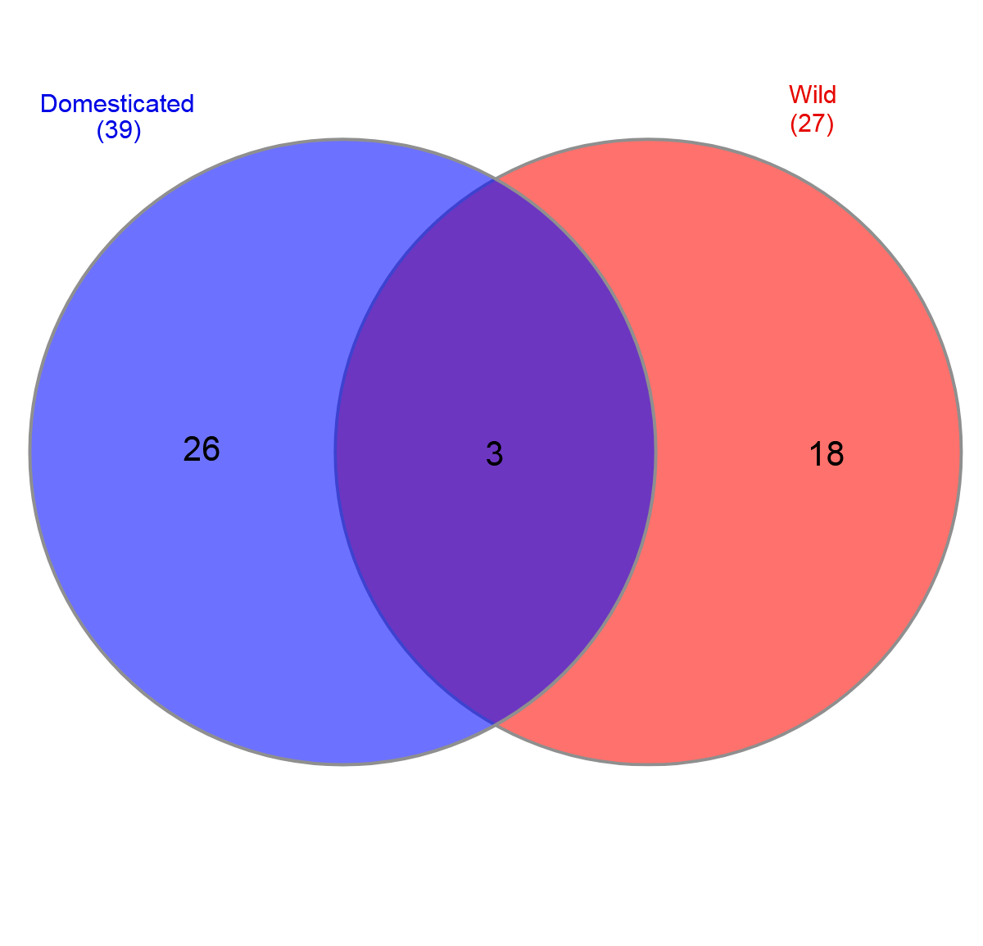

Supplementary Figure S2 Venn diagram displaying the protein overlap between eggs form domesticated (blue) and wild pikeperch females (red).

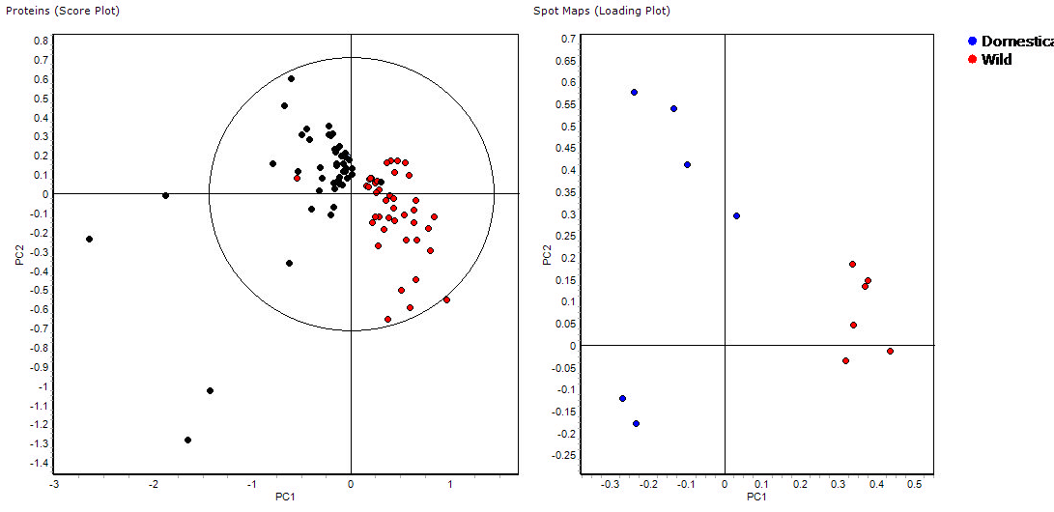
B
A
Domesticated
Wild
14.2%
14.2%

62.3%
62.3%
Supplementary Figure S3 A principal component analysis (PCA) score plot obtained for protein of wild-caught and domesticated pikeperch eggs showing alterations in protein abundance. Replicates (n=6 in each group) of different egg samples are represented as: black circles, eggs of domesticated pikeperch eggs; red circles, eggs of wild-caught pikeperch eggs. Spatial distribution of protein spots (A) and gel samples (B).

