Weight gain responses of laying-type pullets to methionine plus cystine intake

E.P. Silva^{1,a}, M.B. Lima¹, N.K. Sakomura¹, L.E.F.D. Moraes², N.J. Peruzzi¹

Animal Journal

Supplementary material S1

Description of mathematical functions
Broken line. This function was obtained from Robbins et al. (2006) and describes the relationship between weight gain (WG) and consumption of methionine+cystine (CMet+Cys) (X) by three parameters:

$\text{WG = }{\text{WG}}_{\text{max}}\text{+ U × }\left(\text{R}-\text{X}\right)$ Eq. [1]

Where WG_{max} is the plateau of the response; U is the slope to the break point and R is the requirement to express the WG_{max} or the break point. The model is considered under the conditions: X < R and when X$≥$R, WG=WG_{max}. Solving Eq. [1] for X, we obtain:

$\text{X = }\frac{\left(-\text{WG+}{\text{WG}}_{\text{max}}\text{ + U × R}\right)}{\text{U}}$ Eq. [2]

The X for which WG is zero was obtained by the equation 3.
${\left.\text{X}\right|}_{\text{WG=0}}\text{ =}\frac{\text{(}{\text{WG}}_{\text{max}}\text{+U. R)}}{\text{U}}$ Eq. [3]

Broken line with curvilinear ascendancy (BLQ). The function was obtained from Robbins et al. (2006) and describes the relationship between WG and CMet+Cys (X) with three parameters that have a similar biological interpretation as in Eq. [1] but the slope describe a quadratic ascent where WG_{max} is the plateau of the response; U is the slope to the break point and R is the requirement to express the or breaking point WG_{max}, according to the equation 4:

$\text{WG = }{\text{WG}}_{\text{max}}\text{+ U × }{\left(R-X\right)}^{2}$ Eq. [4]

This model is considered under the conditions: X < R and when X$≥$R, WG=WG_{max}. By inverting the Eq. [4], it is possible to obtain the CMet+Cys (X, mg/day) for a desired gain:

$\text{X =}\frac{\text{U × R+}\sqrt{\left(\text{U × WG }-\text{U ×}{\text{ WG}}_{\text{max}}\right)}}{\text{U}}$ Eq. [5]

Eq. [5] presents two square roots (+ and ‒); the positive one was used in our derivation. The X when the WG is zero was obtained by the equation 6:
${\left.\text{X}\right|}_{\text{WG=0}}\text{ = }\frac{\text{U × R+}{\left( -\text{U ×}{\text{ WG}}_{\text{max}}\right)}^{\frac{\text{1}}{\text{2}}}}{\text{U}}$ Eq. [6]

Michaelis-Menten (M&M). This function describes a response function using two parameters, the maximum response, (WG_{max}) and a constant (km) determining the methionine+cystine (Met+Cys) supply to obtain the half of the maximum response (WG_{max}/2). The function was obtained from Michaelis and Menten (1913):
$\text{WG = }\frac{{\text{ WG}}_{\text{max}}\text{ × X}}{\text{Km + X}}$ Eq. [7]

By inverting Eq. [7], it is possible to obtain the CMet+Cys (X, mg/day) according to a desired gain:

$\text{X = }-\frac{\text{WG × Km}}{\text{WG }-{\text{ WG}}_{\text{max}}}$ Eq. [8]
It is important to note that replacing WG = 0 in Eq. [8], the equation becomes null.

Saturation kinetics (SK). The function was obtained from Morgan et al. (1975) and describes the response with four parameters: WG_{max} is the maximum response or asymptotic; b is the intercept on the axis y; km is the intake required to achieve half maximum response (WG_{max}/2) and n is the apparent kinetic order:

$\text{WG = }\frac{\text{b × }{\text{km}}^{\text{n}}\text{ +}{\text{ WG}}_{\text{max}}\text{ × }{\text{X}}^{\text{n}}}{{\text{km}}^{\text{n}}\text{+}{\text{ X}}^{\text{n}}}$ Eq. [9]

By inverting Eq. [9], it is possible to obtain the CMet+Cys (X, mg/day) according to a desired gain:
${\text{X =}\left(\frac{-\text{ WG + b}}{\text{WG }-{\text{ WG}}_{\text{max}}}\right)}^{\frac{\text{1}}{\text{n}}}\text{× km}$ Eq. [10]

This function allows the estimation of the CMet+Cys for WG = 0:
${{\left.\text{X}\right|}_{\text{WG=0}} \text{ =}\left(-\frac{\text{b}}{{\text{ WG}}_{\text{max}}}\right)}^{\frac{\text{1}}{\text{n}}}\text{× km}$ Eq. [11]

Sigmoidal (Sig). This function has two parameters that describe asymptotes: lower (WG_{min}) and upper (WG_{max)}. The WG_{max} is obtained by adding WG_{min} + Range; the parameters r and s are related to the shape of the curve, r is related to the intercept on the y-axis for the minimum CMet+Cys; the parameter s is related to the direction of the curve. In the present relationship between WG and Met+Cys, its value is negative, i.e., the function grows to the right. This function is described as in Robbins et al. (1979):
$\text{WG = }{\text{WG}}_{\text{min}}\text{+}\frac{\text{Range}}{\text{1+}{\text{e}}^{ \left(\text{ r + s × X}\right)}}$ Eq. [12]

By inverting the Eq. [12], it is possible to obtain the CMet+Cys (X, mg/day) according to a desired gain:

$\text{X = }\frac{-\text{ r + ln}\left(- \frac{\text{WG -}{\text{ WG}}_{\text{min}} -\text{ Range}}{\text{WG }-{\text{ WG}}_{\text{min}}}\right)}{\text{s}}$ Eq. [13]

The X for which WG = 0 is given by:

${\left.\text{X}\right|}_{\text{WG=0}}\text{ = }\frac{-\text{ r + ln}\left( \frac{- {\text{ WG}}_{\text{min}} -\text{ Range}}{{\text{ WG}}_{\text{min}}}\right)}{\text{s}}$ Eq. [14]

Logistic (LOGI). This function was obtained from Ware et al. (1980) and describes the response with four parameters and two are asymptotes with a biological meaning similar to the Sigmoidal model:

$\text{WG = }\frac{{\text{ WG}}_{\text{max}}\text{+}{\text{ WG}}_{\text{min}}\text{ × c × }{\text{d}}^{\text{X}}}{\text{1 + c × }{\text{d}}^{\text{X}}}$ Eq. [15]

Where WG_{max} means the maximum asymptotic response, WG_{min} means the lower asymptote, i.e., the theoretical limit of WG when the intake of Met+Cys tends to – infinite, $\lim_{x→-∞}\left(fx\right)$. The parameter c reports the minimum intake of Met+Cys to intercept the coordinates (y) $≠0$.
By inverting Eq. [15], the intake of Met+Cys (X, mg/day) according to a desired gain is obtained with:

$\text{X =}\frac{\text{ln}\left(- \frac{\text{WG }-{\text{ WG}}_{\text{max}}}{\text{c × }\left(\text{WG }-{\text{ WG}}_{\text{min}}\right)}\right)}{\text{ln}\left(\text{d}\right)}$ Eq. [16]
The X for WG = 0 is given by:
${\left.\text{X}\right|}_{\text{WG=0}}\text{ = }\frac{\text{ln}\left(- \frac{{\text{ WG}}_{\text{max}}}{\text{c × }{\text{ WG}}_{\text{min}}}\right)}{\text{ln}\left(\text{d}\right)}$ Eq. [17]

Logistic II (LOGII). A second parameterization of the logistic functional form was obtained by the re-parameterization of LOGI as presented by Gahl et al. (1991):

$\text{WG = }{\text{ WG}}_{\text{max}}\text{+ }\frac{\left(\text{ b × }\left(\text{1 + c}\right) -{\text{ WG}}_{\text{max}}\right)\text{ × }{\text{e}}^{\text{( }-\text{ k × X)}}}{\text{1+c ×}{\text{e}}^{\left(-\text{ k × X}\right)}}$ Eq. [18]

Where WG_{max} is the maximum asymptotic response, the parameter $c$ describes the minimum intake of Met+Cys to intercept the coordinate axis (y) $≠0$. According to Finke et al. (1987), the change of WG_{min} to b allows inferring the responses on the y-axis, in x = 0, with $\left.\text{b =}\frac{{\text{ WG}}_{\text{min}}\text{+}{\text{ WG}}_{\text{max}} \text{× c}}{\text{1+c}}\right.$. Solving this equation, the value of b is obtained for the equation [18]. The parameter d is related to the nutrient quality and determines the growth rate of the function. The parameter k was obtained by the simplification of d from Eq. [15]. That is, ${\text{d}}^{\text{X}}\text{=}{\text{ e}}^{\text{X ×}\text{ ln}{\text{d}}}\text{, with }-\text{ k =}\text{ln}{\text{d}}\text{ →}{\text{d}}^{\text{X}}\text{=}{\text{ e}}^{-\text{ k × X}}$. Thus, k has a unit reciprocal of X. By inverting Eq. [18], it is possible to obtain the intake of Met+Cys (mg/day) according to the desired gain:
$\text{X = }-\frac{\text{ln}\left( \frac{\text{WG }-{\text{ WG}}_{\text{max}}}{-\text{ WG × c +}{\text{ WG}}_{\text{max}}\text{ × c + b + b × c }-{\text{ WG}}_{\text{max}}}\right)}{\text{k}}$ Eq. [19]
The intake of Met+Cys for WG = 0 is obtained through:
${\left.\text{X}\right|}_{\text{WG=0}} \text{ = }-\frac{\text{ln}\left(- \frac{{\text{ WG}}_{\text{max}}}{{\text{ WG}}_{\text{max}}\text{ × c + b + b × c }-{\text{ WG}}_{\text{max}}}\right)}{\text{k}}$ Eq. [20]

Mitscherlich (MITS). This function was described by Mitscherlich (1909) and describes the relationship between WG and intake of Met+Cys (X) with two parameters: maximum response WG_{max} and rate of growth (b).

$\text{WG = }{\text{ WG}}_{\text{max}}\text{ × }\left(\text{1 }- {\text{e}}^{\text{( }-\text{ b × X)}}\right)$ Eq. [21]

Solving Eq. 21 for X, it is possible to estimate the intake of Met+Cys for gains lower than WG_{max}:

$\text{X = }- \frac{\text{ln}\left(- \frac{\text{ WG -}{\text{ WG}}_{\text{max}}}{{\text{ WG}}_{\text{max}}}\right)}{\text{b}}$ Eq. [22]

It is important to note that the solution of Eq. [21] to estimate Met+Cys when WG = 0 has no practical significance. That is, the solution for WG = 0 results in the expression: $-\frac{ln\left(1\right)}{b}→\frac{0}{b}$, i.e., 0.

Monomolecular I and II (MONOI and MONOII). These functions were obtained by re-parameterization of Eq. [21]. These re-parameterizations sought to approach the mathematical description of the biological phenomenon. The monomolecular I (Eq. 23) was obtained from Kaps and Lamberson (2004) and the monomolecular II (Eq. 24) was obtained from Kebreab et al. (2008):

$\text{WG = }{\text{ WG}}_{\text{max}} - \left({\text{ WG}}_{\text{max}} -{\text{ WG}}_{\text{min}}\right)\text{ × }{\text{e}}^{\left(-\text{ k × }\left(\text{X }-\text{ Yb}\right)\right)}$ Eq. [23]
$\text{WG = }{\text{ WG}}_{\text{max}}\text{ × (1}- {\text{e}}^{\text{( }-\text{k × (X }-\text{ Xm))}}\text{)}$ Eq. [24]

The function MONOI is described by four parameters: WG_{max} and WG_{min} are asymptotic values for weight gain; k is the growth rate of the function; Yb is the value predicted on the y-axis corresponding to the basal diet. The function MONOII is described by three parameters, being WG_{max} and k analogous to the above description, the third parameter X_{m} is the Met+Cys intake for zero gain. By inverting Eq. [23] and Eq. [24] are obtained the Eq. [25] and Eq. [26], respectively. Applying Eq. [25] and Eq. [26] it is possible to estimate Met+Cys intake for production levels (WG) less than WG_{max}:

$\text{X = }-\frac{-\text{ k × Yb + ln}\left(- \frac{\text{WG }-{\text{ WG}}_{\text{max}}}{{\text{ WG}}_{\text{max}} -{\text{ WG}}_{\text{min}}}\right)}{\text{k}}$ Eq. [25]
$\text{X = }-\frac{-\text{ k × Xm + ln}\left(- \frac{\text{WG }-{\text{ WG}}_{\text{max}}}{{\text{ WG}}_{\text{max}}}\right)}{\text{k}}$ Eq. [26]

The intake of Met+Cys (X) when the weight gain is zero can be obtained by:
${\left.\text{X}\right|}_{\text{WG=0}}\text{ = ‒}\frac{\text{‒ k × }\text{Yb}\text{ + ln}\left(\frac{{\text{ WG}}_{\text{max}}}{{\text{ WG}}_{\text{max}}\text{ ‒}{\text{ WG}}_{\text{min}}}\right)}{\text{k}}$ Eq. [27]
${\left.\text{X}\right|}_{\text{WG=0}}\text{ = ‒}\frac{\text{‒ k × }\text{Xm}\text{ + ln}\left(\text{1}\right)}{\text{k}} \text{∴}\text{ X = }\text{Xm}$ Eq. [28]

It is important to note that, differently than the solution of Eq 22, for WG = 0, Eqs. 27 and 28 have solutions that are biologically relevant.

Partitioning Methionine+Cystine intake between growth and maintenance

The Met+Cys requirements were estimated considering a 99% asymptotic response of the models (a₁). The coefficient a₂ was obtained for WG in the limiting region, the end of the response phase (a₂, mg/day to obtain 10.8 g/day of WG). However, the composition of the gain is affected by several factors and is, therefore, not constant. One alternative to this variable composition is the direct modeling of the requirement. In this context, coefficients representing the Met+Cys requirement (mg) for 1 g of WG (a₃, mg/g) and to maintain 1 kg of body weight (m₁, mg/kg BW) and metabolic weight (m₂, mg/kg BW^{0,75}) are estimated as follows:
$\text{Met+Cys}\text{ = }\text{a.WG}\text{ + m. }{\text{BW}}^{\text{0.75}}$ Eq. [29]

Through the inverse function g(y) = 0, the minimum requirement was determined for each function of gain = 0. The calculated values in the unit mg/day were converted into mg/kg BW and mg/kg BW^{0.75}.

Supplementary Figure S1. Responses observed (O) and predicted for the weight gain (WG) and consumption of methionine+cystine (CMet+Cys) of pullets from the phase of 2 - 6 weeks old, using the Sigmoidal (Sig) and Broken line (BL) models.

Supplementary Figure S2. Responses observed (O) and predicted for the weight gain (WG) and consumption of methionine+cystine (CMet+Cys) of pullets from the phase of 8 - 12 weeks old, using the Saturation Kinetics (SK) and Sigmoidal (Sig) models.

Supplementary Figure S3. Responses observed (O) and predicted for the weight gain (WG) and consumption of methionine+cystine (CMet+Cys) of pullets from the phase of 14 – 18 weeks old, using the Broken line with curvilinear ascendancy (BLQ) and Sigmoidal (Sig) models.

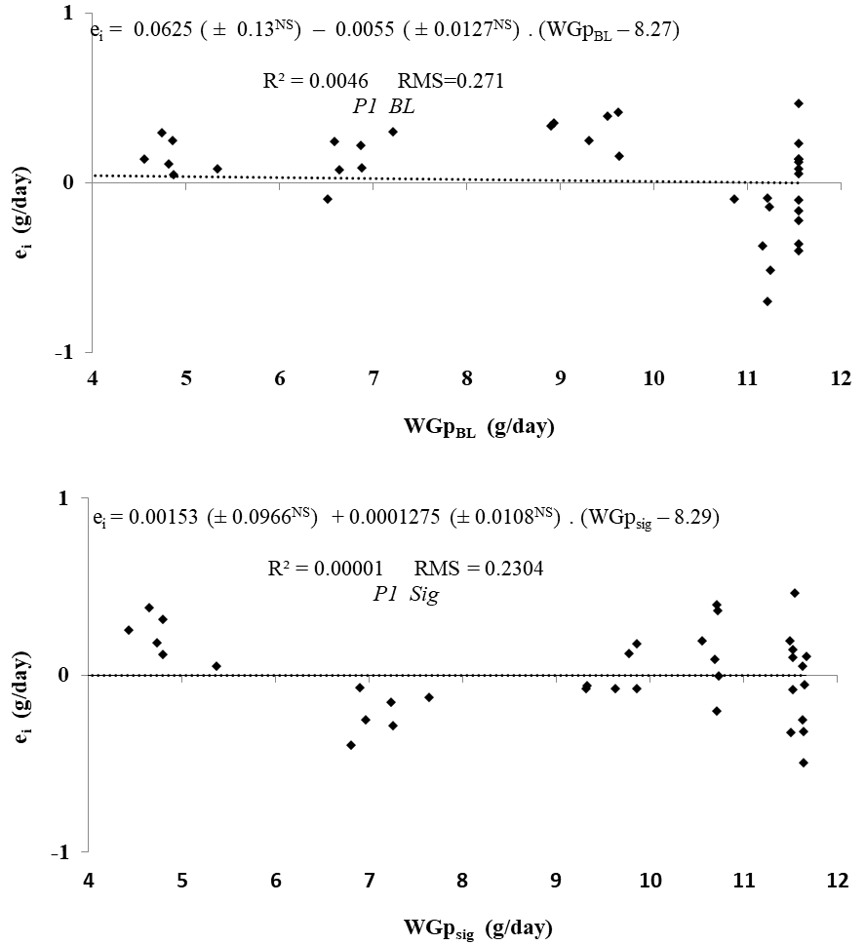
Supplementary Figure S4. Relationship between residuals (e_{i}) and predicted values for weight gain (WGp) of pullets by different models of the Phase 1 (2-6 weeks). BL, broken line; Sig, sigmoidal; ^{NS} P>0.05.

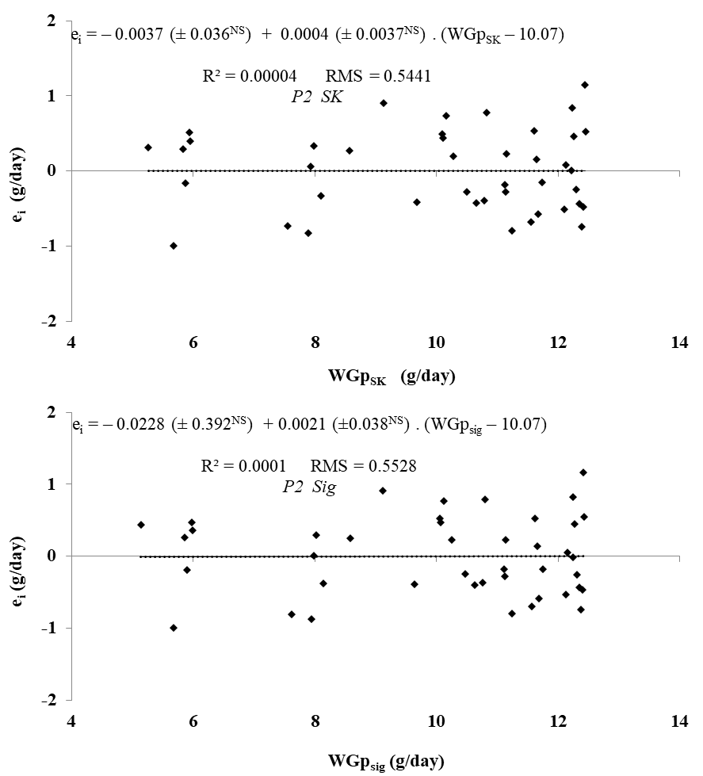
Supplementary Figure S5. Relationship between residuals (e_{i}) and predicted values for weight gain (WGp) of pullets by different models of the Phase 2 (8-12 weeks). Sig, sigmoidal; SK, saturation kinetics; ^{NS} P>0.05.

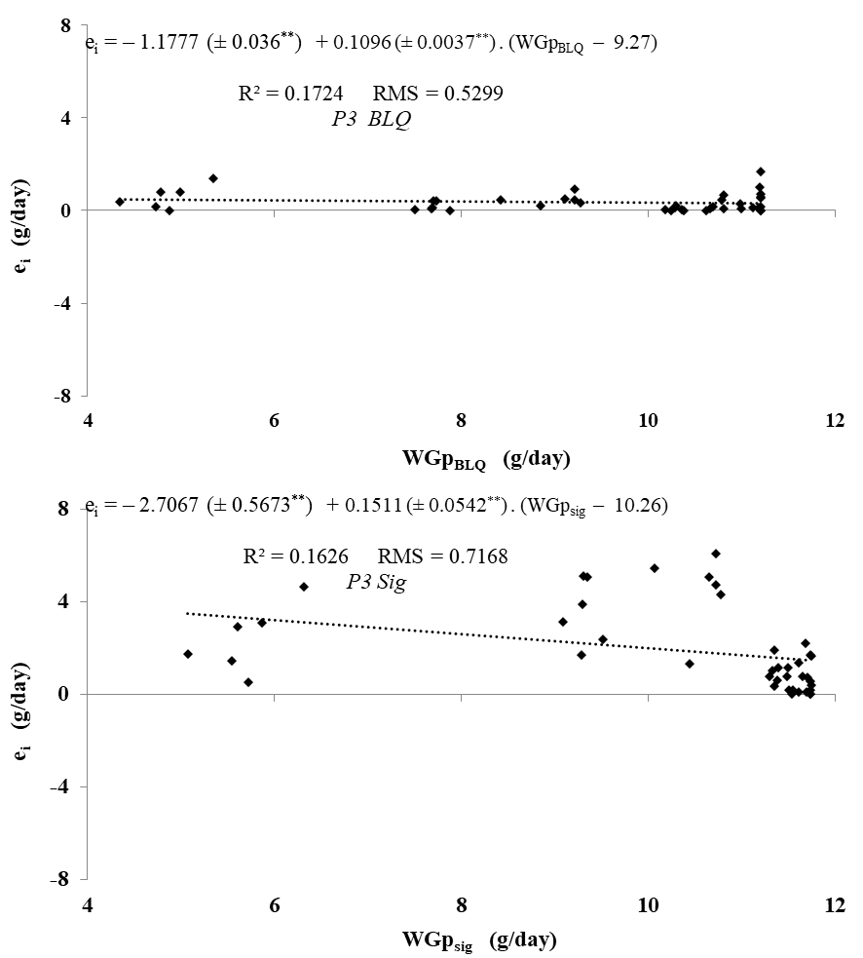
Supplementary Figure S6. Relationship between residuals (e_{i}) and predicted values for weight gain (WGp) of pullets by different models of the P3 (14-18 weeks). Sig, sigmoidal; BLQ, broken line with curvilinear ascendancy; ^{NS} P>0.05; **P<0.01.

