animal journal

Supplementary material
A longitudinal study of pre- and post-weaning tail damage in non-docked pigs
F. Hakanssonª,*, H. P. Lahrmann^{b} and B. Forkmanª

ªDepartment of Veterinary and Animal Sciences, University of Copenhagen, Groenegaards-vej 8, 1870, Frederiksberg, Copenhagen, Denmark
^{b}SEGES, Danish Pig Research Centre, Agro Food Park 15, 8200 Aarhus N

Corresponding author: Franziska Hakansson. E-mail: fh@sund.ku.dk
Supplementary Table S1: Picture examples for the classification scheme for tail damage in piglets prior to weaning (see Table 1 in manuscript).
 | 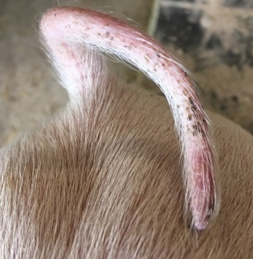
Tail-wound score: 0  Tail-length score: 0 | Tail-wound score: 1  Tail-length score: 0 | Tail-wound score: 2  Tail-length score: 0
Tail-wound score: 3  Tail-length score: 0 | Tail-wound score: 3  Tail-length score: 1 | Tail-wound score: 2  Tail-length score: 2

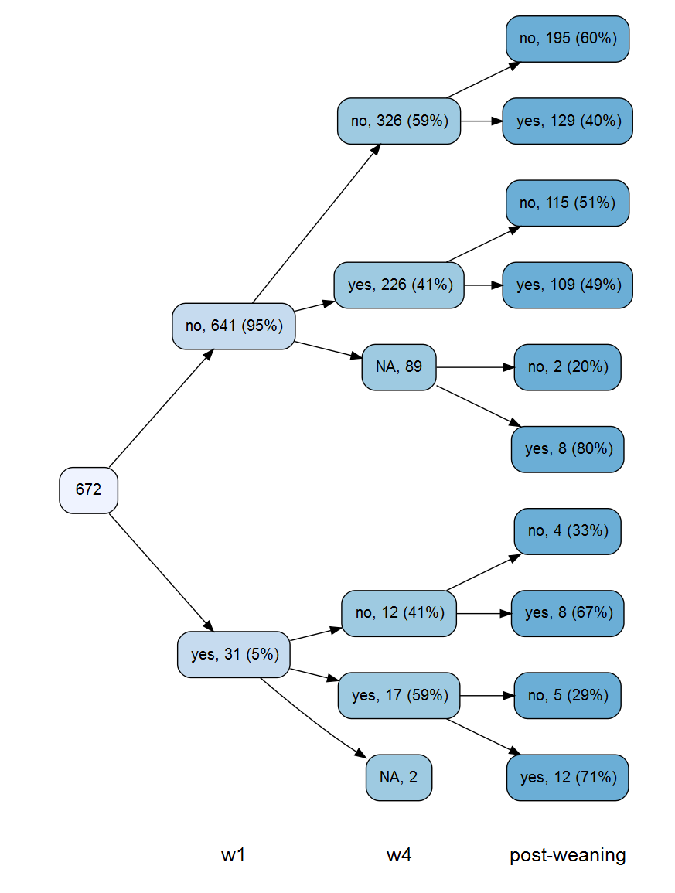
Supplementary Figure S1: Number and percentage of pigs identified with/without tail damage pre- and post-weaning (w= week of age, NA= missing/dead at assessment). Tail damage was summarized as the number of individuals with any tail lesion.

