High biosecurity and welfare standards in fattening pig farms are associated with reduced antimicrobial use

A.H. Stygar^{1,2}, I. Chantziaras⁴, I. Toppari⁵ , D. Maes ⁴, J.K. Niemi^{1,3}

¹ Natural Resources Institute Finland (Luke), Bioeconomy and Environment Unit
² Latokartanonkaari 9, 00790 Helsinki, FINLAND
³ Kampusranta 9, 60320 Seinäjoki, FINLAND
⁴ Ghent University, Faculty of Veterinary Medicine, Unit of Porcine Health Management, Salisburylaan 133, 9820, Merelbeke, BELGIUM
⁵ Animal Health ETT, 60100 Seinäjoki, FINLAND

animal journal

Supplementary material S1
Material and methods
Data used in the study
The data used in this study covered the period when an obligation to register treatments into a database was introduced. Consequently, farmer who had failed to record treatments would have received an official warning. To account for farms which failed to record treatments, only farms which had recorded at least one treatment for a particular disease in the three years-period were used for model building.
Data on biosecurity and resource-based indicators for animal welfare assessment collected from 2011 to 2013 covered 406 farms for musculoskeletal diseases, 377 for tail biting and 169 for respiratory diseases. Pen cleanliness and enrichment were the most often evaluated as poor or average in studied farms. Stocking density was most often evaluated as good (Supplementary Table 1).

Supplementary Table 1. Number of pig fattening farms which received at least one (in 3-year time) poor or average evaluation from biosecurity and resource-based indicators for animal welfare assessment
Reason for antimicrobial treatment |  | Musculoskeletal diseases | Tail biting | Respiratory diseases
Number of farms with poor or average evaluation¹ | Drinking equipment | 90 | 87 | 32
 | Air quality | 147 | 144 | 59
 | Pen cleanliness | 239 | 228 | 92
 | Condition of pen structures | 97 | 89 | 28
 | Stocking density | 71 | 66 | 25
 | Enrichment material | 184 | 179 | 66

¹ farms which do not comply with animal welfare regulations and farms which comply with regulations but have some room for improvement

Model building
Assessing the fitted model was performed using graphical and numerical summaries as advised by Pinheiro and Bates, (2000). Different error distributions were tested: a zero-inflated Poisson model with a single zero-inflation parameter applying to all observations (nbinom2), quasi-Poisson zero-inflated negative binomial (nbinom1), hurdle model (combination of truncated Poisson and negative binomial families) and Poisson. A model assuming a standard zero-inflated negative binomial distribution was the best-suited option for modelling the number of antimicrobial treatments (Supplementary Table 2).
Supplementary Table 2. Summary of Akaike’s information criterion for models describing the number of antimicrobial treatments in fattening pigs. Results presented as a difference in Akaike’s information criterion between the baseline model (assuming a standard zero-inflated negative binomial distribution) and models assuming different error distribution.

Tested distributions¹ | Musculoskeletal disease | Tail biting | Respiratory disease
nbinom2 | 0 | 0 | 0
nbinom1 | LC | 1 638 | 287
Poisson | 19 614 | 63 341 | LC
hurdle | 1 101 | LC | LC

¹ nbinom2 – baseline model with standard zero-inflated negative binomial, nbinom1- quasi-Poisson zero-inflated negative binomial, LC - Lack of Convergence.
An example on model visual diagnostic is presented on Supplementary Figure 1.

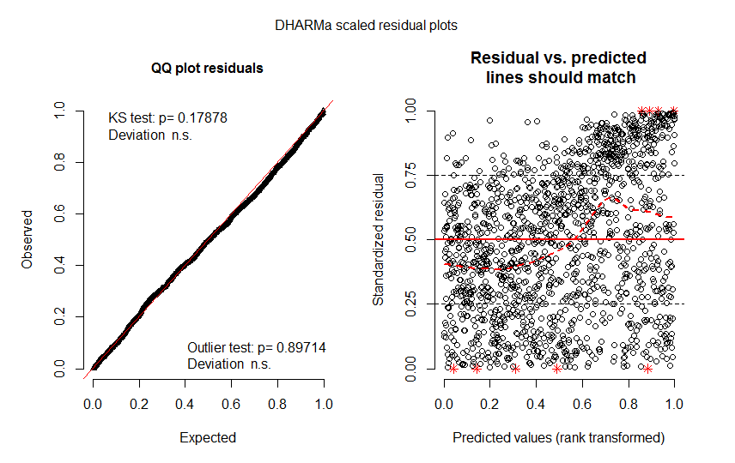
Supplementary Figure 1. An example of visual diagnostic for models describing antimicrobial use in fattening pigs: QQ-plot residuals to detect overall deviations from the expected distribution (with added tests for uniformity and outliers), the plot of residuals vs. predicted values was used to detect any systematic increase in variance.
Presented plots were obtained using DHARMa package (Hartig, 2019). This package allows plotting residuals versus predicted values (standardized to values between 0 and 1). However, because the glmmTMB package used for model building is not allowing creating unconditional predictions, plots of residuals for models with strong random effects could have diagonal patterns from bottom left to the top right. For that reason, model visual diagnostic was based mostly on examination of QQ-plot.
Regarding numerical summaries, confidence intervals for all model parameters were obtained and are presented in the Supplementary Table 3.

Supplementary Table 3. Approximate 95% Wald-type confidence intervals for the final parameters of the models. For the parameter definition of the models describing antimicrobial use in fattening pigs, see Materials and methods section of the article.
Parameter | Musculoskeletal diseases | Tail biting | Respiratory diseases
Intercept | [-3.93, -3.62] | [-4.49, -4.12] | [-6.09, -4.56]
Drinking equipment_2 | [ 0.10, 0.65] | - | -
Air quality_2 | [-0.29, 0.05] | - | [-2.20, 0.13]
Pen cleanliness_2 | [-0.05, 0.11] | [-0.24, -0.02] | [-1.60, -0.43]
Condition_2 | [-0.31, 0.01] | - | [-2.96, -0.19]
Stocking density_2 | [-0.31, 0.05] | [-0.00, 0.80] | [-0.78, 2.89]
Enrichment material_2 | [ 0.03, 0.25] | [-0.37, 0.07] | [-0.80, 0.57]
Lung lesions | [ 0.01, 0.03] | - | [ 0.04, 0.14]
Joint lesions | [-0.01, 0.02] | [-0.03, 0.02] | [ 0.03, 0.24]
Liver lesions | [-0.01, -0.00] | [-0.02, -0.00] | -
Abscess | - | - | [-0.25, -0.00]
Pleurisy | - | - | [ 0.00, 0.04]
Lung lesions * Joint lesions | [-0.01, -0.02] | - | -
Stocking density_2* Joint lesions | - | [-0.24, -0.01] | -
Stocking density_2* Abscess | - | - | [-0.96, -0.13]
Enrichment material_2* Joint lesions | - | [ 0.02, 0.12] | -
Enrichment material_2* Liver lesions | [-0.02, -0.00] | - | -
Enrichment material_2* Lung lesions | [-0.06, -0.01] | - | [-0.46, -0.15]
Drinking equipment_2* Lung lesions | - | - | -
Air quality_2* Joint lesions | - | - | -
Air quality_2* Lung lesions | - | - | [-0.33, -0.03]
Air quality_2* Abscess | [ 0.01, 0.10] | - | [ 0.28, 0.83]
Pen cleanliness_2* Lung lesions | - | - | [ 0.05, 0.35]
Drinking equipment_2* Pen cleanliness_2 | [-0.65, -0.08] | - | -
Condition_2* Stocking density_2 | [ 0.04, 0.71] | - | -
Pen cleanliness_2*Condition_2 | - | - | [ 1.31, 4.74]
Quarter_2 | [-0.18, -0.04] | [-0.26, -0.05] | [-1.17, -0.33]
Quarter_3 | [-0.21, -0.06] | [-0.34, -0.13] | [-1.25, 0.37]
Quarter_4 | [-0.11, 0.04] | [ -0.20, 0.00] | [-0.59, 0.23]
Year_2012 | - | - | [-0.12, 0.59]
Year_2013 | - | - | [-0.70, 0.13]
Variance between farms | [ 1.16, 1.36] | [ 1.26, 1.49] | [2.10, 2.73]

Results

Interactions
In each estimated model, different statistically significant interactions between traits were found (Table 2). In order to facilitate understanding of dependencies (interactions), the constructed models were used to predict the number of antimicrobial treatments per pig for a given prevalence of slaughter lesions, welfare and biosecurity indicators (Supplementary Fig. 2, 3 and 4). In all analyzed situations, the number of treatments per pig increased with farm size (Supplementary Fig 2, 3 and 4). The number of treatments per pig was predicted for a farm with average, low and high prevalence of lesions. Supplementary figures 2A, 3A, 4A represent a farm with average prevalence of lesions, where 3.2% of carcasses had joint lesions, 4.1% had abscesses, 2% lung lesions, 14.7% pleurisy and 5.3% liver lesions, similar to the average prevalence of lesions in the Finnish farm population presented in Figure 2. For a farm with a low prevalence of lesions (Supplementary Fig 2B, 3B, 4B), average meat inspection scores were decreased by 50%. Finally, for a farm with high prevalence of lesions (Supplementary Fig 2C, 3C, 4C) average meat inspection scores were increased by 50%. According to the results, farms with good conditions (biosecurity and welfare indicators evaluated as good) but low prevalence of lesions had a higher number of antimicrobial treatments per pig due to musculoskeletal diseases and tail biting (green line on Supplementary Fig. 2B and Fig. 3B) when compared to farms with the same biosecurity and welfare indicators scores but a high prevalence of lesions (green line in Supplementary Fig. 2C and Fig. 3C). Regarding respiratory disease, an opposite pattern was observed (green line in Supplementary Fig. 4B and Fig. 4C). Predicted number of antimicrobial treatments will depend both on biosecurity and welfare indicators and health status of a farm. For example, at farms with high prevalence of lesions and average or poor air quality (Supplementary Fig. 4C), the number of predicted antimicrobial treatments due to respiratory diseases will be substantially higher compared to farms which had all biosecurity and welfare indicators evaluated as good.
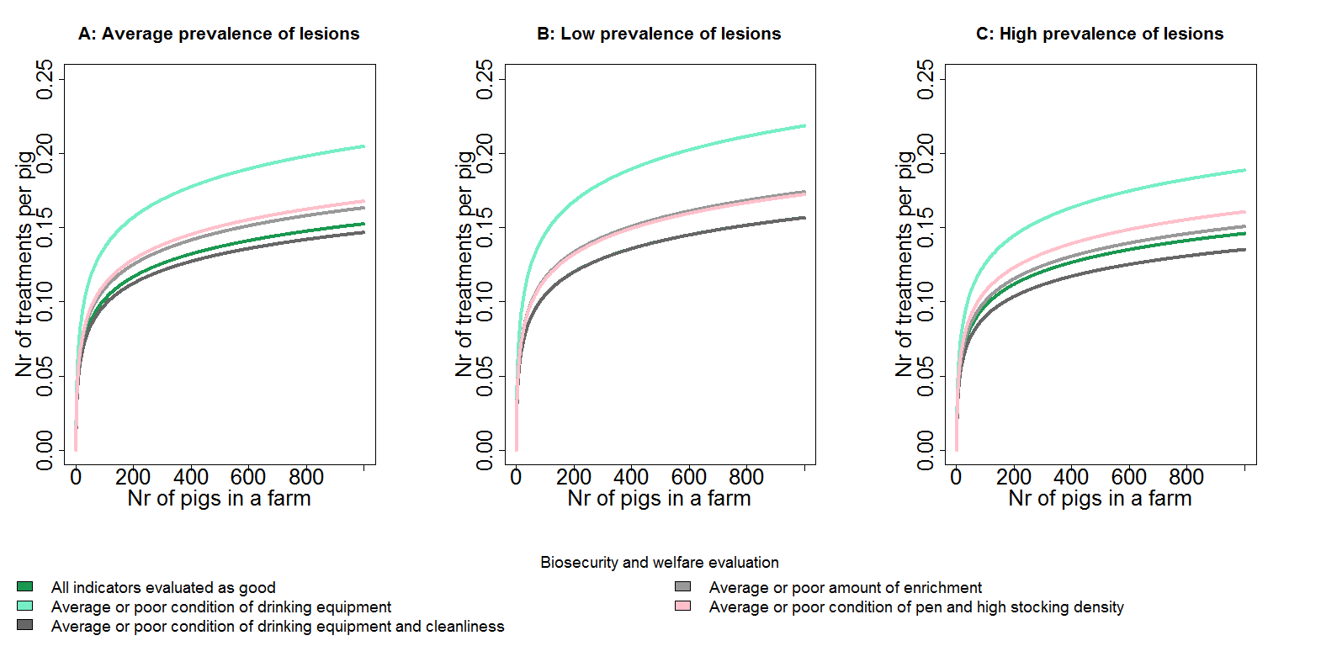
Supplementary Figure 2. Predicted number of antimicrobial treatments per pig due to musculoskeletal diseases assuming different prevalence of lesions A) average result for Finnish farms (joint lesions 3.2%, abscess 4.1%, lung lesions 2%, pleurisy 14.7%, liver lesions 5.3%), B) low prevalence – average meat inspection scores decreased by 50%, C) high prevalence – average meat inspection scores increased by 50%. Plots drawn for selected biosecurity and welfare indicators. “All indicators evaluated as good” represents a farm with no failures during biosecurity and welfare evaluation. “Average or poor condition of drinking equipment” represents a farm with failures concerning quality of drinking equipment, other indicators evaluated as good.
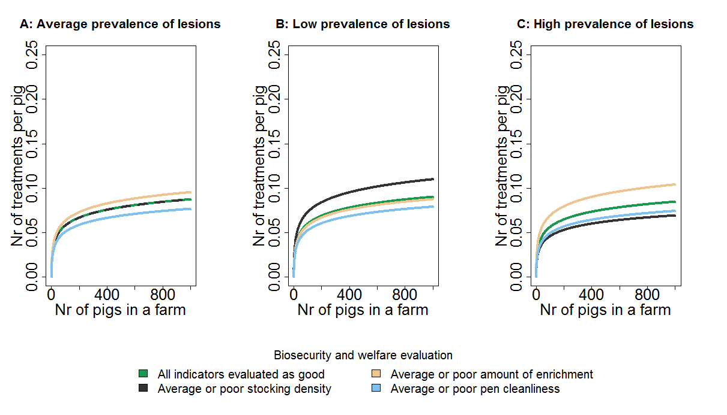
Supplementary Figure 3. Predicted number of antimicrobial treatments per pig due to tail biting assuming different meat inspection results A) average prevalence, B) low prevalence, C) high prevalence, as defined for supplementary Figure 2. Plots drawn for selected biosecurity and welfare indicators. “All indicators evaluated as good” represents a farm with no failures during biosecurity and welfare evaluation. “Average or poor amount of enrichment” represents a farm with failures concerning quantity of enrichment, other indicators evaluated as good.
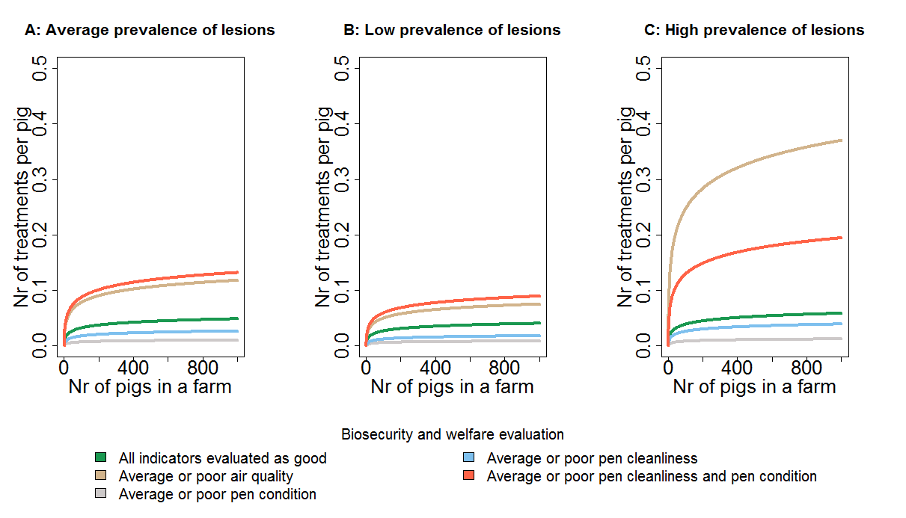
Supplementary Figure 4. Predicted number of antimicrobial treatments per pig due to respiratory diseases assuming different meat inspection results A) average prevalence, B) low prevalence, C) high prevalence, as defined for supplementary Figure 2. Plots drawn for selected biosecurity and welfare indicators. “All indicators evaluated as good” represents a farm with no failures during biosecurity and welfare evaluation. “Average or poor air quality” represents a farm with failures concerning air quality, other indicators evaluated as good.

Time effect
The significance of collective variability among years and quarters was asses using Wald chi-square tests. Season effect (quarter of a year) was significant for all reasons of antimicrobial use (P<0.001 for musculoskeletal diseases, tail biting and respiratory diseases). Numerically, the highest antimicrobial consumption was predicted for colder months (Q1 and Q4, between October and March), while the lowest for warmer season (Q2 and Q3 between April and September).
Year effect was significant predictor only for respiratory diseases (P=0.04).

Discussion
Improving goodness of fit

In this study, we have tested different distributions (Poisson or negative binomial) to model count data on antimicrobial use. Poisson model assumes that the mean and variance of the errors are equal. The negative binomial distribution is an over-disperse alternative to the Poisson model, where an additional parameter is included to estimate how much larger the variance is than the mean. We have tested for a scenario where variance increases linearly with the mean (nbinom 1) and variance increases quadratically with the mean (nbinom2).
In order to further improve the fit of the models, less known distributions (e.g., the Conway-Maxwell-Poisson) could be tested. The Conway-Maxwell-Poisson distribution is flexible enough to fit both over- and under-disperse data (Brooks et al., 2017). A natural fit for count variables that follow the Poisson or negative binomial distribution is the log link. However, other links (identity and power) could also be examined.

Variance between farms

Data set used in this study contained repeated observations of antimicrobial use at a farm level. By adding a farm random effect, we have included an additional error term to account for correlation among observations within the same group (farm). When specifying the model without farm as random effect, the variability between the farms would be unaccounted for and just considered as residual unexplained noise.
Therefore, adding farm as random effect has reduced the unexplained variability.
By inspecting model parameters, we could already get an initial idea about the contribution of farm effect to the variability. Let us consider an example of model describing the number of antimicrobial treatments due to tail biting. Modelling results indicated that standard deviation between farms was 1.37, while the largest effect (fixed effect parameter) was only 0.4. This implies that farms are varying a lot relative to magnitude of the “treatments effects”.
In order to further discuss importance of farm random effect in the final models we have specified null model (with only farm random effect) and compare how much the variances will be reduced between null and the full model. On average, adding fixed effects to the null model resulted in only very slight reduction in the variance in random farm effect (by 1.5%). However, here it must be noted that the total variance in the full model is composed not only by variance related to fixed effect and random effect, but also by distribution specific variance and variance for the additive overdispersion term. According to our calculations, for example adding fixed terms to tail biting model, reduced total variance by 30%.
The high variability in antimicrobial use could be explained for instance by different criteria used to initiate antimicrobial treatments (veterinarians could apply different medication strategies). Therefore, in order to further improve population-level inferences, slaughterhouse and veterinarian random effect should be included to the model estimation. This information has a high potential to increase the validity and precision of the models.

References
Brooks ME, Kristensen K, van Benthem KJ, Magnusson A, Berg C, Nielsen A, Skaug H, Mächler M and Bolker B 2017. glmmTMB balances speed and flexibility among packages for Zero-inflated Generalized Linear Mixed Modeling. The R Journal 9, 378–400.
Hartig F 2019. DHARMa: Residual Diagnostics for Hierarchical (Multi-Level / Mixed) Regression Models. R package version 0.2.4. Retrieved on 2 February 2019 from https://CRAN.R-project.org/package=DHARMa.
Pinheiro JC and Bates DM 2000. Mixed-Effects Models in S and S-PLUS, pp.19. Springer-Verlag, New York, NY, USA.

