Genotype by environment interaction in response to cold stress in a composite beef cattle breed
Sajjad Toghiani*^{1a}, El Hamidi Hay¹, Breno Fragomeni², Romdhane Rekaya^{3,4,5} and Andy Roberts¹
¹USDA Agricultural Research Service, Fort Keogh Livestock and Range Research Laboratory, Miles City, MT, USA
² Department of Animal Science, University of Connecticut, Storrs, CT, USA
³ Department of Animal and Dairy Science, University of Georgia, Athens, GA, USA
⁴ Department of Statistics, University of Georgia, Athens, GA, USA
⁵ Institute of Bioinformatics, University of Georgia, Athens, GA, USA

a Present address: USDA-ARS-PA-Livestock & Range Res. Lab (LARRL), 243 Fort Keogh Road, Miles City, MT, 59301, USA.

Corresponding author: Sajjad Toghiani. Email: Sajjad.toghiani@usda.gov

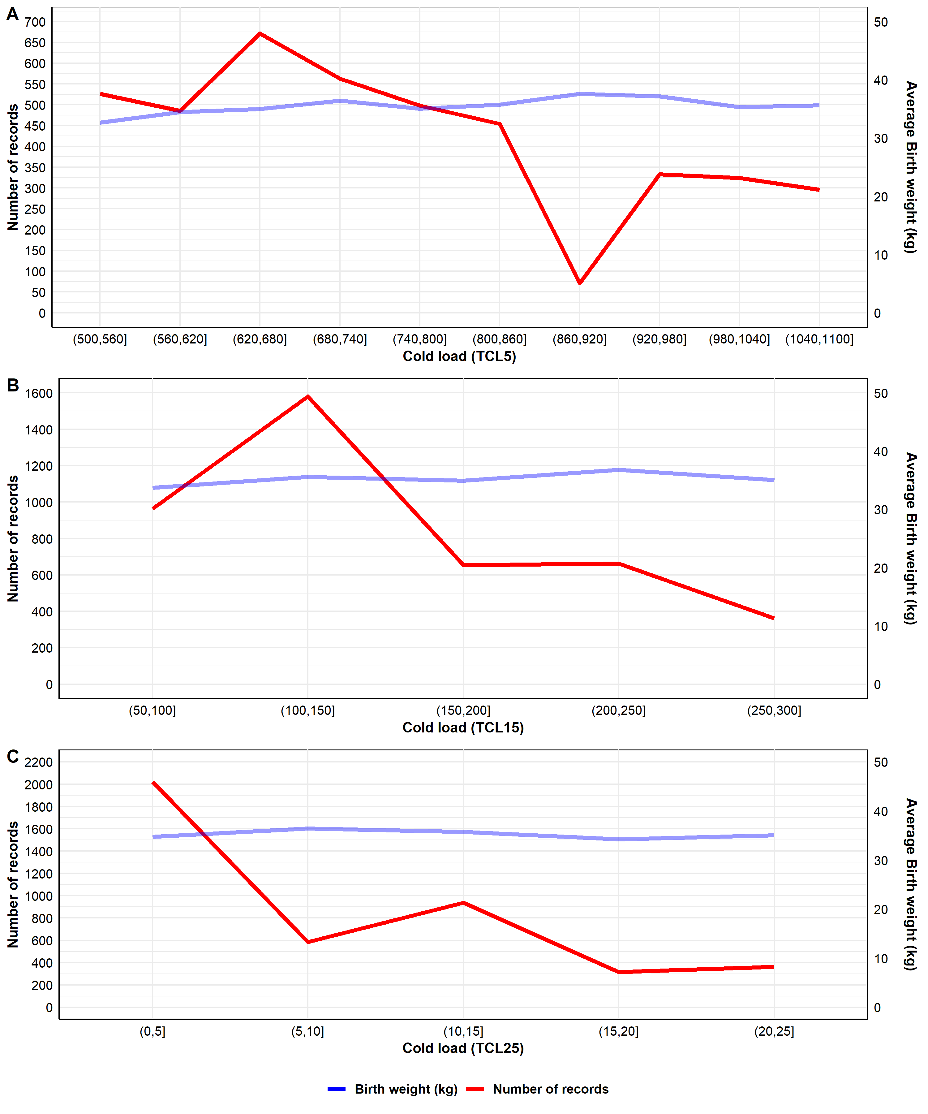
Supplementary Figure S1 Number of birth weight (BW) records (red solid line) and average BW (blue solid line) distribution of the composite beef cattle population across different classes of the total cold load using thresholds of less than -5 °C (TCL5) (A), -15 °C (TCL15) (B) and -25 °C (TCL25) (C).

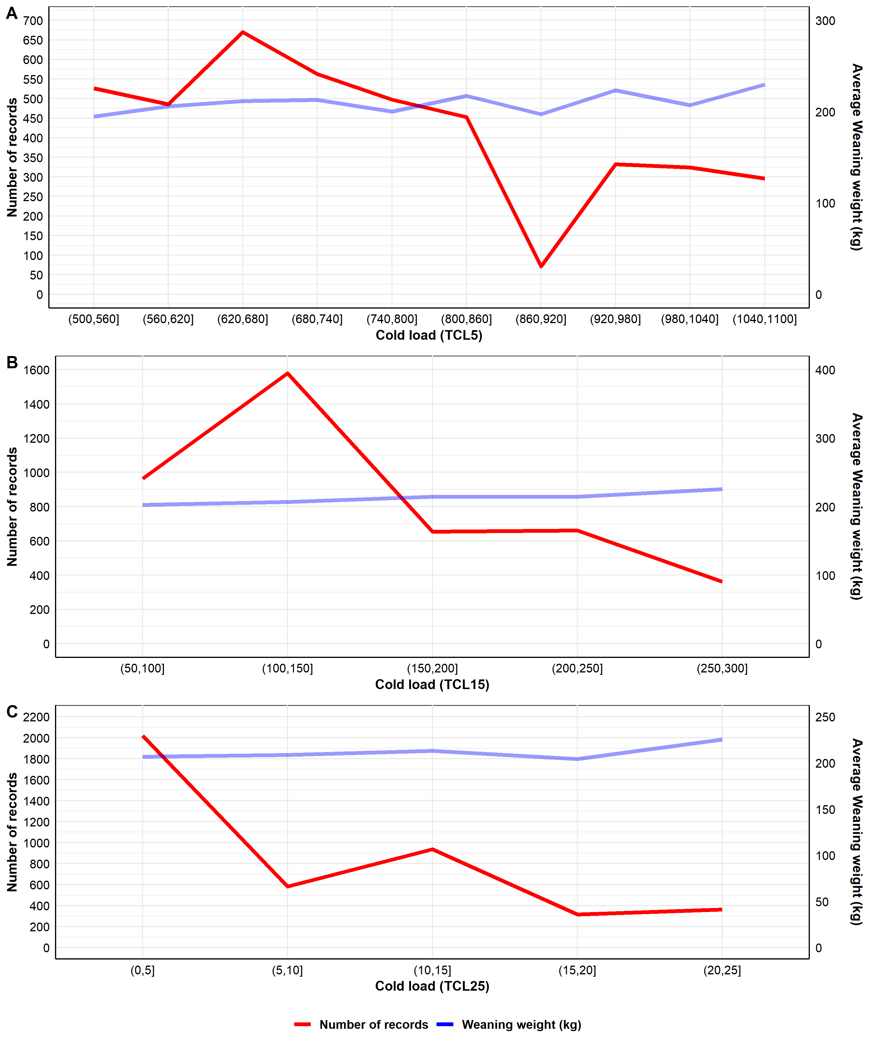
Supplementary Figure S2 Number of weaning weight (WW) records (red solid line) and average WW (blue solid line) distribution of the composite beef cattle population across different classes of the total cold load using thresholds of less than -5 °C (TCL5) (A), -15 °C (TCL15) (B) and -25 °C (TCL25) (C).

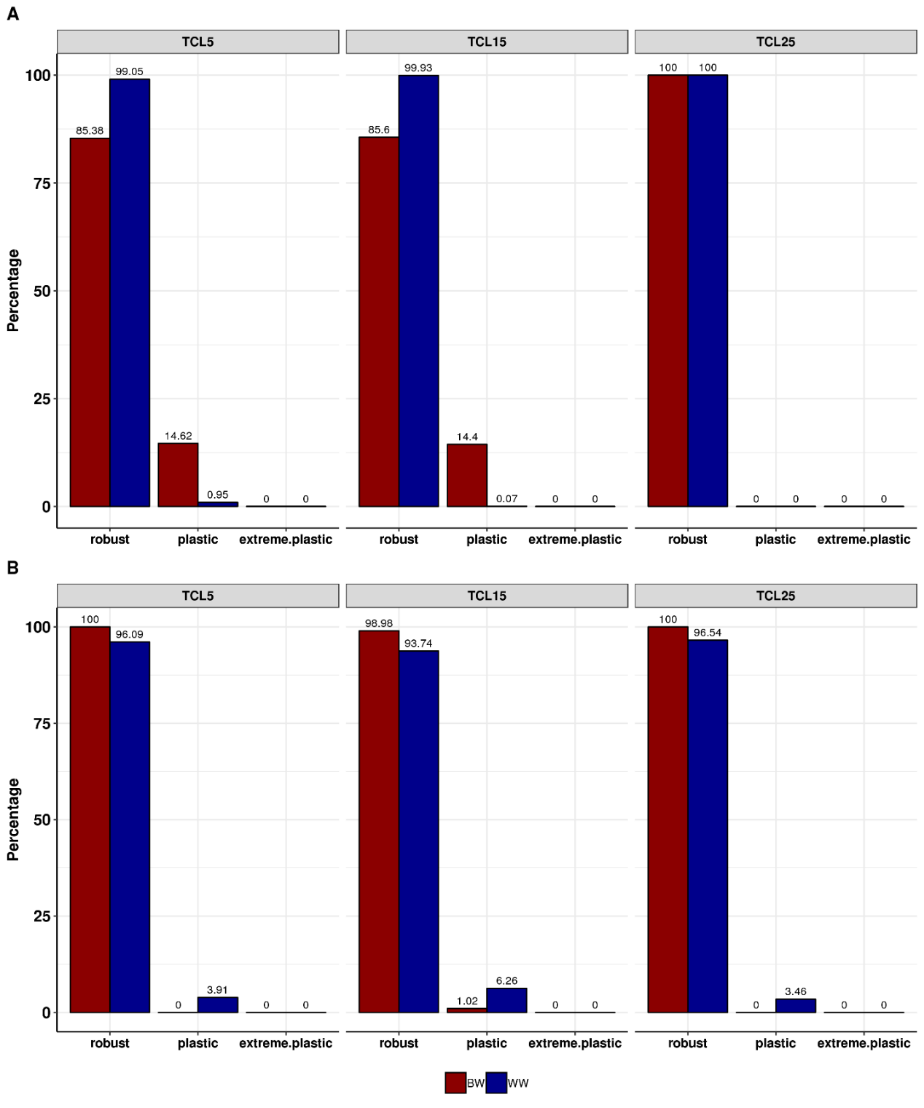
Supplementary Figure S3 Percentage of robust, plastic and extremely plastic animals in the composite beef cattle population based on their direct (A) and maternal (B) slope analyzed by reaction norm for birth weight (BW) and weaning weight (WW) within different classes of the total cold load using thresholds of less than -5 °C (TCL5), -15 °C (TCL15) and -25 °C (TCL25).

