Effects of interactions between feeding practices, animal health and farm infrastructure on technical, economic and environmental performances of a pig fattening unit
A. Cadero^{1,2}, A. Aubry¹, J. Y. Dourmad², Y. Salaün¹ and F. Garcia-Launay²

1 IFIP – Institut du porc, 35651 Le Rheu, France
2 PEGASE, Agrocampus Ouest, INRA, 35590 Saint-Gilles, France

animal Journal.

Table S1 Influence of interactions between parameters on least-square means of technical, economic and environmental variables of the pig-fattening unit for the 96 simulations of the virtual experiment. The table contains only interactions that have a significant effect on at least one variable. See Table 1 for definitions of variable abbreviations.
 | FCR | Lean | SW | SA | Nexc | Pexc | %ASW | %LSW | FC | Rev | GM | CC | AC | EU | CED | LO
BI x Health¹
7d - Healthy | 2.73^{b} | 59.9ª | 119.4^{d} | 174.4^{c} | 3.23^{b} | 0.61^{c} | 99.3^{c} | 0.7ª | 81.8^{c} | 132.9^{d} | 10.8^{c} | 2.26^{b} | 56.8^{b} | 16.5^{b} | 15.5ª | 3.50^{b}
7d - Imp health | 2.87^{d} | 59.7ª | 114.5^{b} | 183.2^{d} | 3.38^{b} | 0.63^{d} | 94.4^{b} | 5.6^{b} | 82.9^{c} | 126.0^{b} | 2.2^{b} | 2.42^{d} | 61.7^{d} | 17.9^{d} | 16.5^{c} | 3.73^{d}
35d - Healthy | 2.67ª | 60.5^{b} | 117.2^{c} | 169.5ª | 3.04ª | 0.57^{b} | 95.6^{b} | 2.9^{ab} | 79.2^{b} | 131.0^{c} | 11.6^{c} | 2.21ª | 55.1ª | 16.0ª | 15.2ª | 3.42ª
35d - Imp health | 2.76^{c} | 60.5^{b} | 108.5ª | 172.1^{b} | 3.00ª | 0.55ª | 76.4ª | 23.1^{c} | 77.0ª | 118.5ª | 0.8ª | 2.34^{c} | 59.1^{c} | 17.2^{c} | 16.1^{b} | 3.60^{c}
P-value | 0.001 | NS | <0.001 | <0.001 | 0.04 | <0.001 | <0.001 | <0.001 | <0.001 | <0.001 | 0.004 | NS | NS | NS | NS | 0.007
% variance exp | 1.8 | 1.1 | 5.1 | 8.9 | 3.2 | 7.9 | 13.4 | 15.6 | 6.7 | 6.1 | 1.2 | 0.5 | 0.6 | 0.5 | 0.3 | 1.0
FRP x Health²
Adl - Healthy | 2.72^{b} | 59.7ª | 118.6^{b} | 171.0ª | 3.19ª | 0.60ª | 96.6^{b} | 2.2ª | 81.0ª | 130.6^{b} | 9.4^{c} | 2.25ª | 56.6ª | 16.4ª | 15.4ª | 3.48ª
Adl - Imp health | 2.83^{c} | 59.9ª | 111.9ª | 177.4^{b} | 3.23ª | 0.60ª | 85.6ª | 14.1^{b} | 80.4ª | 121.9ª | 0.7ª | 2.39^{b} | 60.8^{b} | 17.6^{b} | 16.3^{b} | 3.68^{b}
Res - Healthy | 2.68ª | 60.7^{b} | 118.0^{b} | 172.8ª | 3.07ª | 0.58ª | 98.3^{b} | 1.4ª | 79.9ª | 133.2^{c} | 13.0^{d} | 2.22ª | 55.4ª | 16.1ª | 15.3ª | 3.43ª
Res - Imp health | 2.81^{c} | 60.4^{b} | 111.1ª | 177.8^{b} | 3.15ª | 0.59ª | 85.2ª | 14.6^{b} | 79.5ª | 122.5ª | 2.3^{b} | 2.37^{b} | 60.1^{b} | 17.4^{b} | 16.2^{b} | 3.65^{b}
P-value | NS | NS | NS | NS | NS | NS | NS | NS | NS | NS | 0.001 | NS | NS | NS | NS | NS
% variance exp | 0.2 | 2.3 | 0.0 | 0.4 | 0.1 | 0.1 | 0.3 | 0.1 | 0.0 | 0.7 | 0.9 | 0.1 | 0.2 | 0.2 | 0.1 | 0.1
BR x Health
Yes - Healthy | 2.70ª | 60.2ª | 118.5^{b} | 172.2ª | 3.14ª | 0.60ª | 99.1^{c} | 0.4ª | 80.6ª | 132.2^{b} | 11.4^{b} | 2.24ª | 56.0ª | 16.3ª | 15.4ª | 3.46ª
Yes - Imp health | 2.83^{b} | 60.1ª | 111.9ª | 178.5^{b} | 3.21ª | 0.60ª | 90.3^{b} | 9.5^{b} | 80.4ª | 122.9ª | 1.7ª | 2.39^{b} | 60.6^{b} | 17.6^{b} | 16.3^{b} | 3.67^{b}
No - Healthy | 2.70ª | 60.2ª | 118.1^{b} | 171.7ª | 3.12ª | 0.59ª | 95.8^{c} | 3.2ª | 80.3ª | 131.6^{b} | 11.0^{b} | 2.23ª | 55.9ª | 16.2ª | 15.3ª | 3.46ª
No - Imp health | 2.81^{b} | 60.2ª | 111.1ª | 176.8^{b} | 3.16ª | 0.59ª | 80.5ª | 19.2^{c} | 79.5ª | 121.6ª | 1.3ª | 2.37^{b} | 60.2^{b} | 17.5^{b} | 16.2^{b} | 3.65^{b}
P-value | NS | NS | NS | NS | NS | NS | 0.02 | 0.01 | NS | NS | NS | NS | NS | NS | NS | NS
% variance exp | 0.1 | 0.0 | 0.1 | 0.3 | 0.1 | 0.2 | 2.7 | 3.1 | 0.2 | 0.1 | 0.0 | 0.0 | 0.0 | 0.0 | 0.0 | 0.1
FRP x scale
Adl - Room | 2.77ª | 59.8ª | 115.2ª | 174.1ª | 3.22ª | 0.60ª | 91.1ª | 8.2ª | 80.8ª | 126.3ª | 4.9ª | 2.32ª | 58.8ª | 17.1ª | 15.9ª | 3.58ª
Adl - Pen | 2.77ª | 59.8ª | 115.3ª | 174.2ª | 3.22ª | 0.60ª | 91.0ª | 8.1ª | 80.9ª | 126.4ª | 5.1ª | 2.32ª | 58.8ª | 17.1ª | 15.9ª | 3.58ª
Adl - Ind | 2.78ª | 59.8ª | 115.2ª | 174.3ª | 3.19ª | 0.60ª | 91.1ª | 8.1ª | 80.5ª | 126.2ª | 5.3ª | 2.31ª | 58.5ª | 17.0ª | 15.8ª | 3.58ª
Res - Room | 2.76ª | 60.1^{ab} | 115.1ª | 174.9ª | 3.18ª | 0.60ª | 92.1ª | 7.5ª | 80.5ª | 127.6ª | 6.6ª | 2.31ª | 58.3ª | 16.9ª | 15.8ª | 3.57ª
Res - Pen | 2.75ª | 60.4^{b} | 114.8ª | 175.2ª | 3.14ª | 0.59ª | 92.4ª | 7.4ª | 80.1ª | 128.0ª | 7.3ª | 2.30ª | 58.0ª | 16.8ª | 15.8ª | 3.55ª
Res - Ind | 2.72ª | 61.1^{c} | 113.7ª | 175.9ª | 3.00ª | 0.57ª | 90.8ª | 9.0ª | 78.5ª | 128.1ª | 8.9ª | 2.27ª | 56.8ª | 16.5ª | 15.6ª | 3.51ª
P-value | NS | <0.001 | NS | NS | NS | NS | NS | NS | NS | NS | NS | NS | NS | NS | NS | NS
% variance exp | 1.3 | 10.4 | 0.5 | 0.1 | 1.4 | 2.2 | 0.1 | 0.2 | 1.3 | 0.0 | 0.7 | 0.5 | 0.8 | 0.7 | 0.3 | 0.7
^{a–d} Means followed by the same letter do not differ (P > 0.05) according to Fischer’s test
¹ NS, not significant; BI, batch interval; Health, health status; Imp, impaired; 7d, 7-day batch interval; 35d, 35-day batch interval; exp, explained; FRP, feed rationing plan; Adl, ad libitum; Res, restriction to 2.5 kg/d; BR, use of a buffer room; scale, scale at which feeding plan is applied; Ind, individual scale; FCR, feed conversion ratio; Lean, lean meat content of carcass; SW, pig weight at slaughter; SA, pig age at slaughter; Nexc, nitrogen excreted per pig; Pexc, phosphorus excreted per pig; %ASW, percentage of pigs at adequate slaughter weight on the payment grid; %LSW, percentage of pigs with light slaughter weight on the payment grid; FC, feed cost; Rev, Revenue; GM, gross margin; CC, climate change; AC, acidification; EU, eutrophication; CED, cumulative energy demand; LO, land occupation

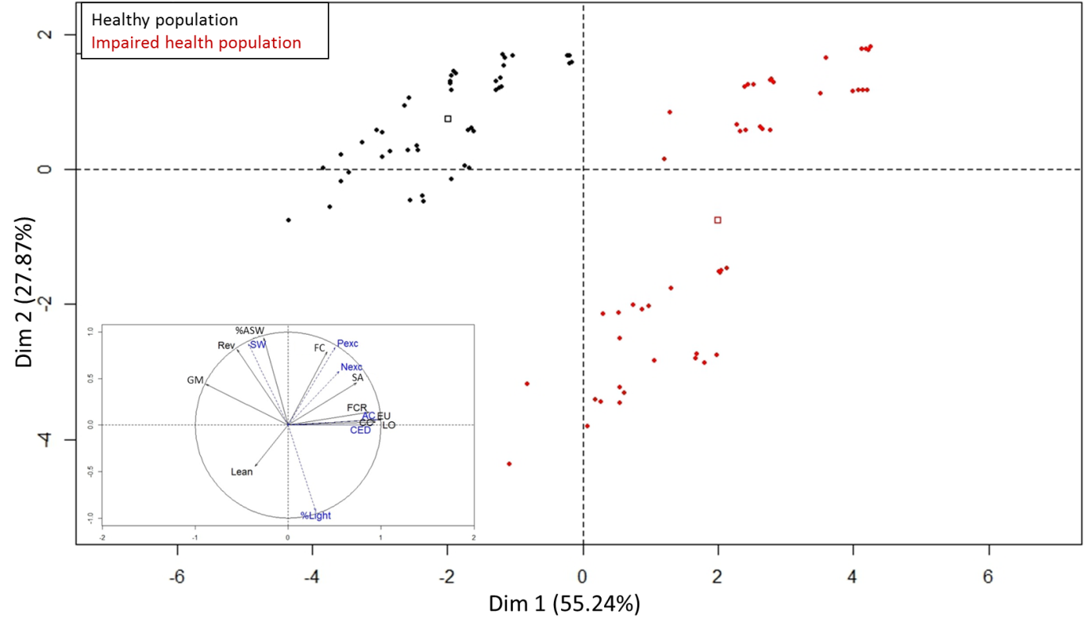
Figure S1 Distribution of the 96 scenarios in the first and second dimension biplot of the first Principal Component Analysis (PCA). On the correlation circle, active variables are in black and illustrative variables are in blue. (FCR, feed conversion ratio; Lean, lean meat content of carcass; SW, pig weight at slaughter; SA, pig age at slaughter; Nexc, nitrogen excreted per pig; Pexc, phosphorus excreted per pig; %ASW, percentage of pigs at adequate slaughter weight; %LSW, percentage of pigs with light slaughter weight; FC, feed cost; Rev, Revenue; GM, gross margin; CC, climate change; AC, acidification; EU, eutrophication; CED, cumulative energy demand; LO, land occupation)

Principal component analysis results
Principal component analysis (PCA) results for the healthy population scenarios explained 72.1% of the data variation in the first and second dimensions, and 22.7% in the third dimension (Supplementary Figure S2). The first dimension was related mainly (r > 0.9) to land occupation (LO), acidification (AC), phosphorus excreted (Pexc) and slaughter weight (SW). The second dimension was related to revenue (Rev) (r = 0.94), and the third to FCR (r = -0.76). The first, second and third dimensions were related mainly to batch interval, feed rationing plan and feed sequence plan, respectively.

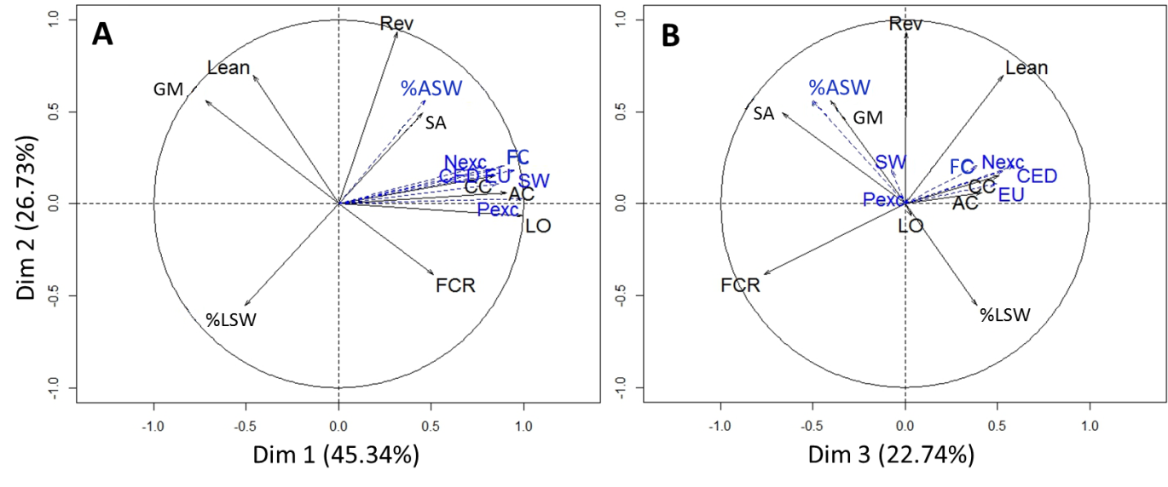
Figure S2 Correlation circles in the (A) first and second dimensions and (B) second and third dimensions of the Principal Component Analysis (PCA) performed on the healthy population simulations (n=48). (FCR, feed conversion ratio; Lean, lean meat content of carcass; SW, pig weight at slaughter; SA, pig age at slaughter; Nexc, nitrogen excreted per pig; Pexc, phosphorus excreted per pig; %ASW, percentage of pigs at adequate slaughter weight; %LSW, percentage of pigs with light slaughter weight; FC, feed cost; Rev, Revenue; GM, gross margin; CC, climate change; AC, acidification; EU, eutrophication; CED, cumulative energy demand; LO, land occupation)

PCA results for the impaired health population scenarios explained 88.7% of the data variation in the first and second dimensions, and 10.0% in the third dimension (Supplementary Figure S3). The first dimension was related (correlation > 0.9) to LO, Rev, SA, %LSW, Pexc, SW, FC, and %ASW. The second dimension was related mainly to GM (r = 0.95), and the third to Lean (r = 0.72). The first and second dimensions were related to batch interval and feed sequence plan, respectively.

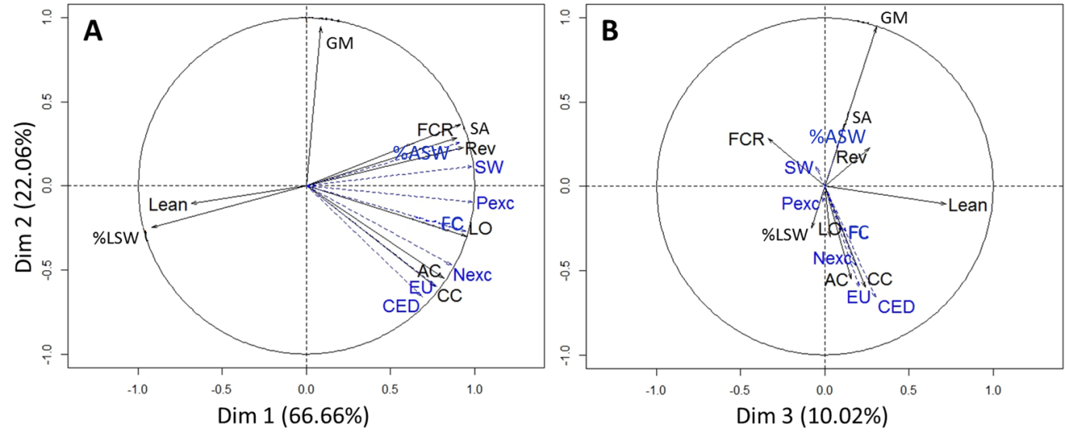
Figure S3 Correlation circles in the (A) first and second dimensions and (B) second and third dimensions of the Principal Component Analysis (PCA) performed on the impaired health population simulations (n=48). (FCR, feed conversion ratio; Lean, lean meat content of carcass; SW, pig weight at slaughter; SA, pig age at slaughter; Nexc, nitrogen excreted per pig; Pexc, phosphorus excreted per pig; %ASW, percentage of pigs at adequate slaughter weight; %LSW, percentage of pigs with light slaughter weight; FC, feed cost; Rev, Revenue; GM, gross margin; CC, climate change; AC, acidification; EU, eutrophication; CED, cumulative energy demand; LO, land occupation)

