Effects of glucocorticoids on the gene expression of nutrient transporters in different rabbit intestinal segments
Hongli Liu^{1,a}, Lei Liu^{1,a}, Fuchang Li^{1*}
Animal: an International Journal in Animal Biosciences
Supplementary Material S1
Expression of genes in tissues was quantified using quantitative real-time PCR (RT-PCR) with SYBR Green I labeling. Total RNA was isolated by the guanidinium isothiocyanate method with Trizol Reagent (Invitrogen, San Diego, CA, USA). The quality of RNA after DNase treatment was tested by electrophoresis on an agarose gel and the quantity of RNA was determined using a biophotometer (Eppendorf, Germany). RT-PCR reactions (10 μL) consisted of 500 ng total RNA, 5 mmol/L MgCl2, 1 μL RT buffer, 1 mmol/L dNTP, 2.5 U AMV, 0.7 nmol/L oligo d(T) and 10 U Ribonuclease inhibitor (TaKaRa Biotechnology, Co.,Ltd. Dalian, P. R. China). Real-time PCR analysis was conducted using the Applied Biosystems 7500 Real-time PCR System (Applied Biosystems, Foster, CA, USA). Each RT-reaction served as a template in a 20 μL PCR reaction containing 0.2 μmol/L of each primer and SYBR green master mix (Takara Biotechnology, Co., Ltd. Dalian, P. R. China). Primer-set sequences are described in Table 1. Real-time PCR reactions were performed at 95 °C for 10s, followed by 40 cycles at 95 °C for 5 s and 60 °C for 40 s. SYBR green fluorescence was detected at the end of each cycle to monitor the amount of PCR product. A standard curve was plotted to calculate the efficiency of the real-time PCR primers. The PCR data were analyzed with the 2 ^{−ΔΔCT} method. The mRNA levels of the target genes were normalized to those of glyceraldehyde 3-phosphate dehydrogenase (GAPDH) and β-actin (ΔCT). Based on the cycle threshold (CT) values, GAPDH and β-actin mRNA expression was stable across treatments in this study (P>0.1). The ΔCT was calibrated against an average of the control rabbits. The linear amount of target molecules relative to the calibrator was calculated by 2^{−ΔΔCT} . Therefore, all gene transcription results are reported as the n-fold difference relative to the calibrator. Specificity of the amplification product was verifified.
Supplementary Figure S1 Reference genes in different rabbit intestinal segments (Experiment 1)

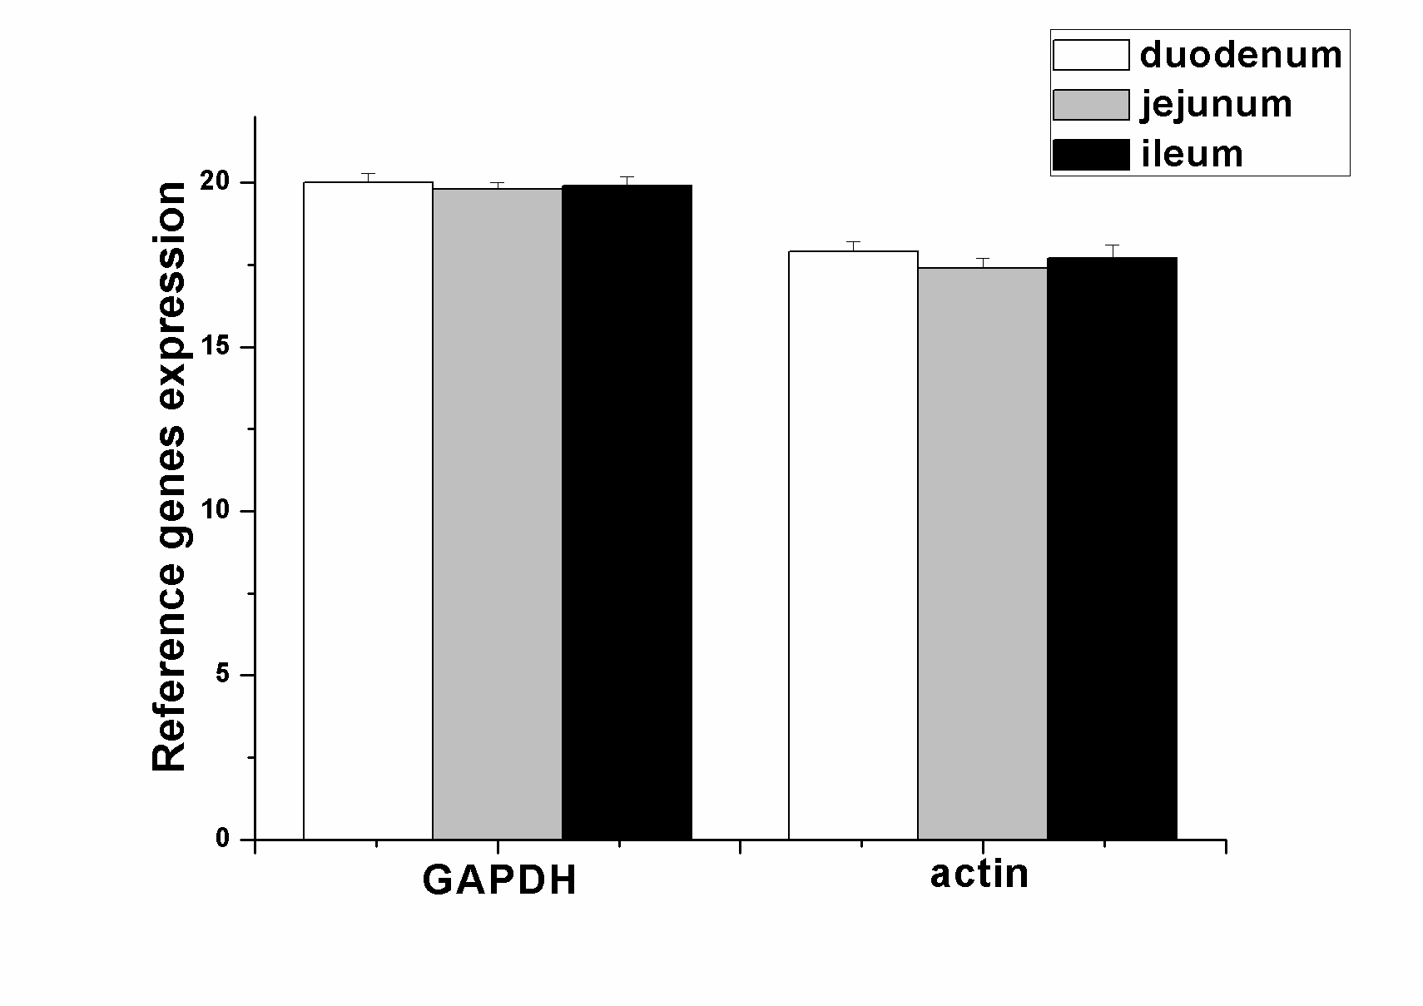
GAPDH, glyceraldehyde 3-phosphate dehydrogenase

Supplementary Figure S2 Reference genes ((A) GAPDH,(B) actin) in different rabbit intestinal segments after dexamethasone (DEX) treatment (Experiment 2)
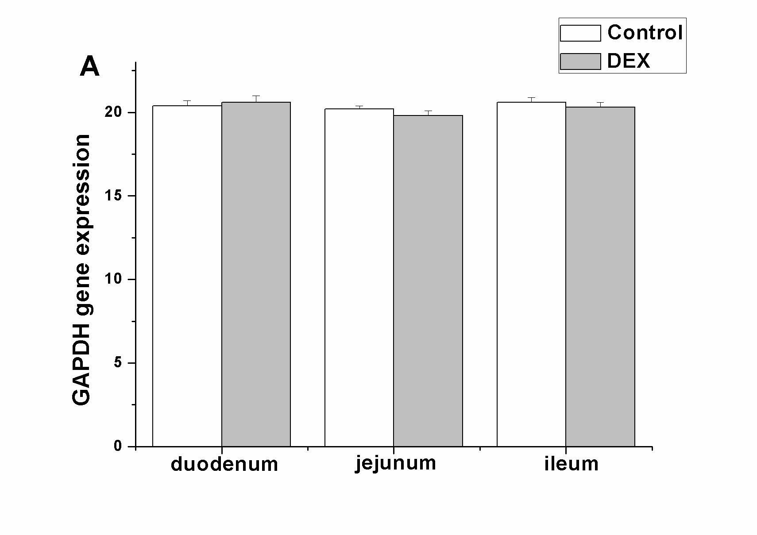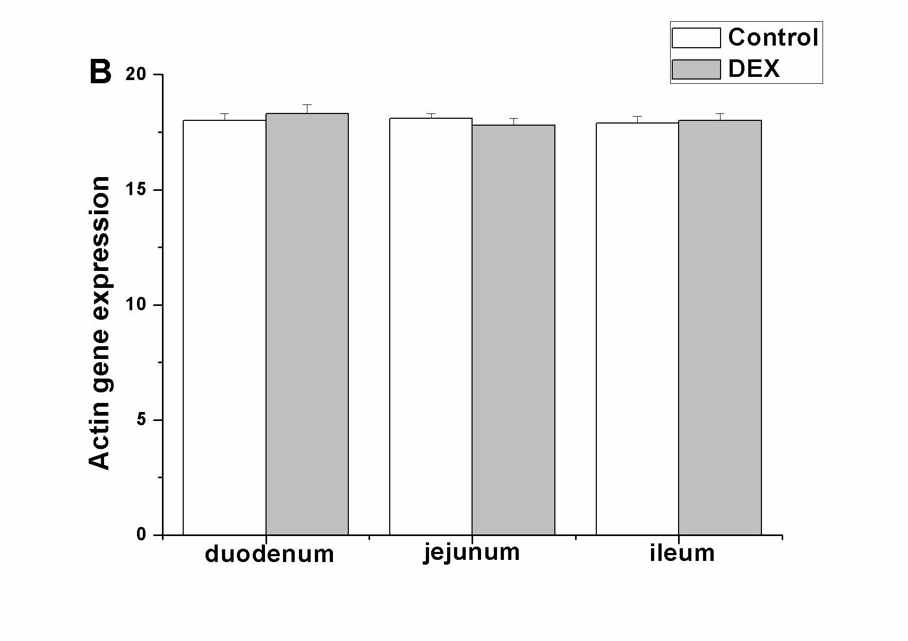
GAPDH, glyceraldehyde 3-phosphate dehydrogenase

Supplementary Figure S3 Reference genes ((A) GAPDH,(B) actin) in different rabbit intestinal segments after dexamethasone (DEX) treatment (Experiment 3)

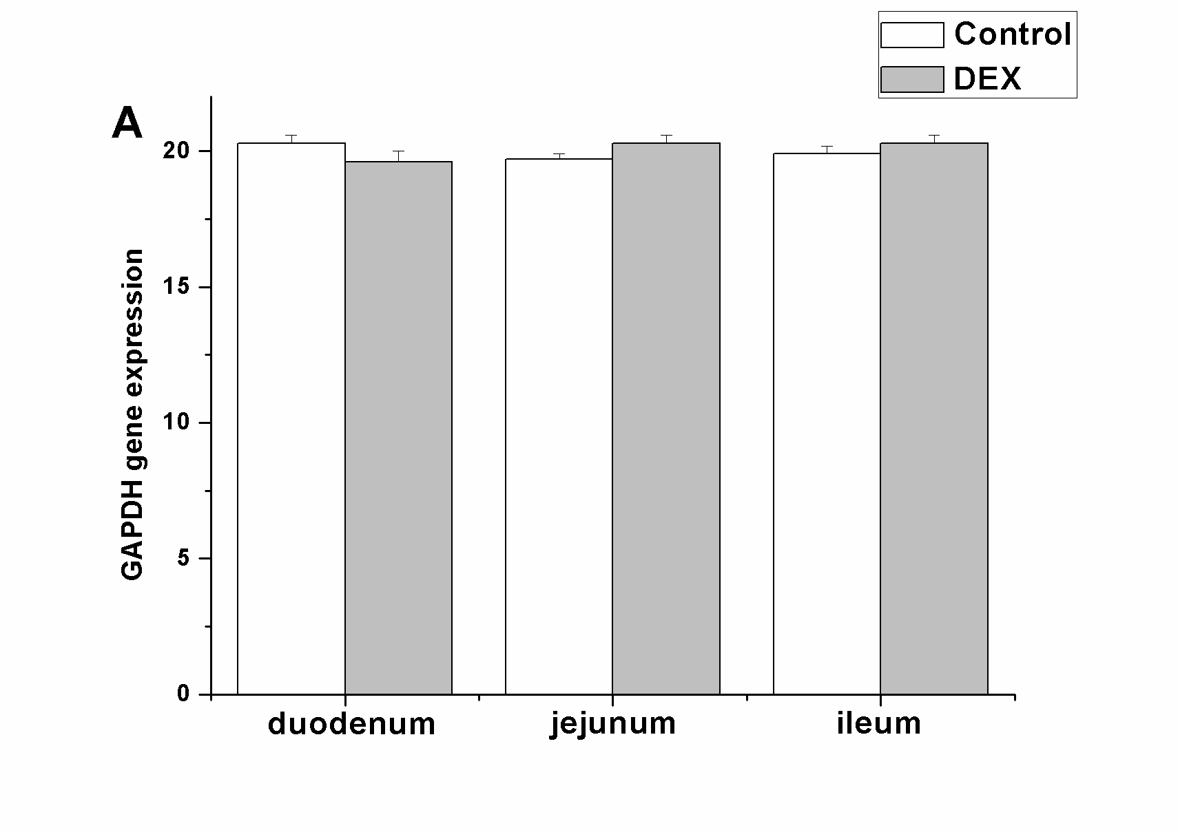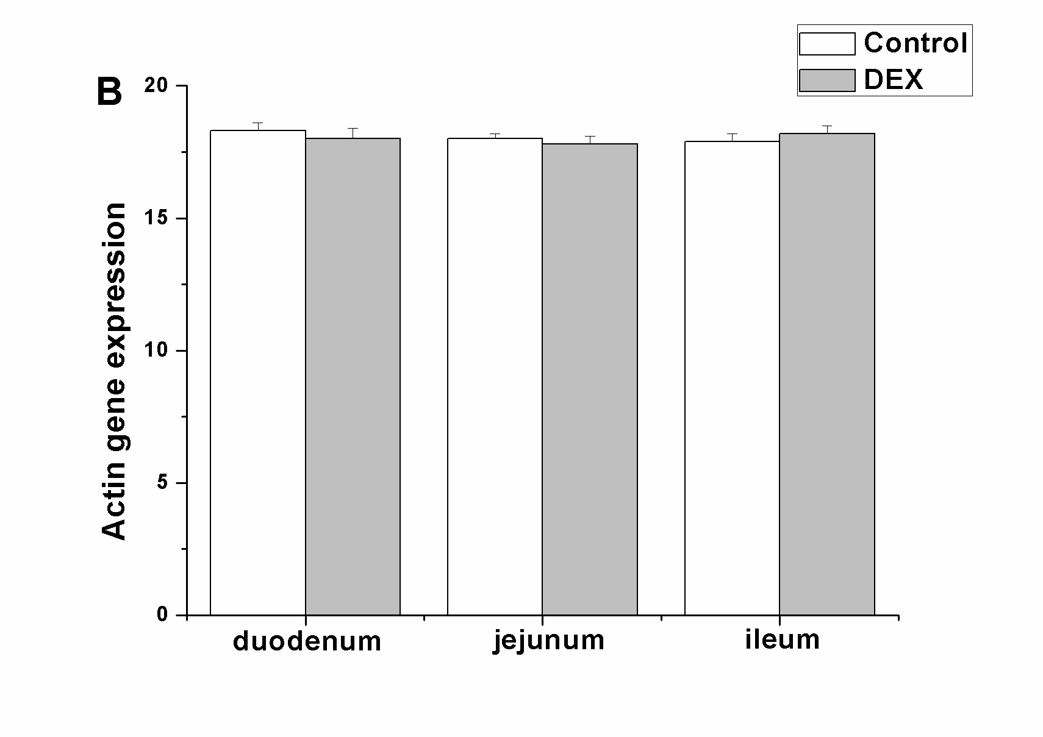
GAPDH, glyceraldehyde 3-phosphate dehydrogenase

