animal - The International Journal of Animal Biosciences

Effects of alternative feed additives to medicinal zinc oxide on productivity, diarrhea incidence and gut development in weaned piglets
G.D. Satessa, N.J. Kjeldsen, M. Mansouryar, H.H. Hansen, J.K. Bache, and M.O.Nielsen

Supplementary materials

Supplementary Table S1 Ingredients and chemical composition of basal diets fed to weaning piglets during the three phases of experimental feeding.
Items | Phase 1¹ |  |  |  |  |  | Phase 2¹ |  |  |  |  |  | Phase 3¹
 | NC | PC | RDZ | OFS² | Miya-Gold³ | GærPlus⁴ | NC | PC | DRZ | OFS² | Miya-Gold³ | GærPlus⁴ | NC | PC | DRZ | OFS² | Miya-Gold³ | GærPlus⁴
Ingredients in basal diet (g/kg)
Wheat | 517 | 511 | 513 | 512 | 523 | 517 | 489 | 489 | 489 | 485 | 491 | 489 | 461 | 461 | 461 | 457 | 463 | 461
Barley | 210 | 210 | 210 | 210 | 210 | 210 | 210 | 210 | 210 | 210 | 210 | 210 | 210 | 210 | 210 | 210 | 210 | 210
Vilosoy^{®5} | 121 | 122 | 122 | 119 | 122 | 121 | 166 | 166 | 166 | 164 | 166 | 166 | 210 | 210 | 210 | 208 | 211 | 210
Protastar^{®6} | 45.5 | 45.5 | 45.5 | 45.5 | 45.5 | 45.5 | 37.5 | 37.5 | 37.5 | 37.5 | 37.5 | 37.5 | 29.5 | 29.5 | 29.5 | 29.5 | 29.5 | 29.5
Fishmeal | 35.4 | 35.4 | 35.4 | 35.9 | 33.3 | 35.4 | 33.5 | 33.5 | 33.5 | 34.0 | 32.9 | 33.5 | 31.5 | 31.5 | 31.5 | 32.1 | 31.0 | 31.5
PFAD | 23.8 | 25.6 | 24.9 | 23.8 | 23.8 | 23.8 | 14.4 | 14.4 | 14.4 | 14.4 | 14.4 | 14.4 | 5 | 5 | 5 | 5 | 5 | 5
Sugar beet molasses | 7.56 | 7.56 | 7.56 | 6.3 | 7.6 | 7.56 | 12.8 | 12.8 | 12.8 | 11.6 | 12.9 | 12.8 | 18.1 | 18.1 | 18.1 | 16.9 | 18.1 | 18.1
Calcium carbonate | 6.08 | 5.52 | 5.73 | 6.08 | 6.08 | 6.08 | 3.04 | 3.04 | 3.04 | 3.04 | 3.04 | 3.04
Monocalcium phosphate | 11.2 | 12.4 | 12.0 | 10.5 | 10.4 | 11.2 | 10.8 | 10.8 | 10.8 | 10.8 | 10.6 | 10.8 | 10.4 | 10.4 | 10.4 | 9.66 | 10.2 | 10.4
Sodium chloride | 2.46 | 2.46 | 2.46 | 1.84 | 2.44 | 2.46 | 2.9 | 2.9 | 2.9 | 2.28 | 2.90 | 2.9 | 3.34 | 3.34 | 3.34 | 2.72 | 3.335 | 3.34
Sodium bicarbonate | 1.04 | 1.04 | 1.04 | 0.8 | 1.22 | 1.04 | 0.92 | 0.92 | 0.92 | 0.68 | 0.97 | 0.92 | 0.8 | 0.8 | 0.8 | 0.56 | 0.845 | 0.8
Lys sulphate 70% | 5.96 | 5.96 | 5.96 | 8 | 5.88 | 5.96 | 5.92 | 5.92 | 5.92 | 7.96 | 5.9 | 5.92 | 5.88 | 5.88 | 5.88 | 7.92 | 5.86 | 5.88
Met DL 98% | 0.8 | 0.8 | 0.8 | 0.8 | 0.8 | 0.8 | 1 | 1 | 1 | 1 | 1 | 1 | 1.2 | 1.2 | 1.2 | 1.2 | 1.2 | 1.2
Thr 98% | 1.1 | 1.1 | 1.1 | 1.04 | 1.1 | 1.1 | 1.22 | 1.22 | 1.22 | 1.16 | 1.22 | 1.22 | 1.34 | 1.34 | 1.34 | 1.28 | 1.34 | 1.34
Trp 99% | 0.4 | 0.4 | 0.4 | 0.4 | 0.4 | 0.4 | 0.32 | 0.32 | 0.32 | 0.32 | 0.32 | 0.32 | 0.24 | 0.24 | 0.24 | 0.24 | 0.24 | 0.24
Val L 96.5% | 0.24 | 0.24 | 0.24 | 0.24 | 0.24 | 0.24 | 0.36 | 0.36 | 0.36 | 0.36 | 0.36 | 0.36 | 0.48 | 0.48 | 0.48 | 0.48 | 0.48 | 0.48
MVP | 4 | 4 | 4 | 4 | 4 | 4 | 4 | 4 | 4 | 4 | 4 | 4 | 4 | 4 | 4 | 4 | 4 | 4
RHP-GT⁷ | 0.3 | 0.3 | 0.3 | 0.3 | 0.3 | 0.3 | 0.3 | 0.3 | 0.3 | 0.3 | 0.3 | 0.3 | 0.3 | 0.3 | 0.3 | 0.3 | 0.3 | 0.3
ZiCare^{8*} |  | 2.88 | 1.8
OFS^{9*} |  |  |  | 15 |  |  |  |  |  | 15 |  |  |  |  |  | 15
MG* |  |  |  |  | 2 |  |  |  |  |  | 1 |  |  |  |  |  | 0.5
GP^{10*} |  |  |  |  |  | 5 |  |  |  |  |  | 5 |  |  |  |  |  | 2.5
ZooLac^{®811} |  |  |  |  |  | 2 |  |  |  |  |  | 2 |  |  |  |  |  | 1
Analysed composition of basal diet (g/kg, unless stated)
Crude protein | 193 | 187 | 189 | 190 | 191 | 191 | 195 | 195 | 195 | 193 | 194 | 193 | 197 | 197 | 197 | 195 | 197 | 196
Fat (%) | 5.04 | 5.2 | 5.14 | 5.34 | 5.12 | 5.34 | 5.04 | 5.04 | 5.04 | 5.34 | 5.08 | 5.34 | 5.04 | 5.04 | 5.04 | 5.34 | 5.06 | 5.19
Ash (%) | 4.62 | 5.02 | 4.87 | 4.98 | 4.62 | 4.72 | 5.02 | 5.02 | 5.02 | 5.38 | 5.02 | 5.12 | 5.42 | 5.42 | 5.42 | 5.78 | 5.42 | 5.47
Water (%) | 11.5 | 11.1 | 11.3 | 11.5 | 11.5 | 11.5 | 11.7 | 11.7 | 11.7 | 11.6 | 11.7 | 11.6 | 11.8 | 11.8 | 11.8 | 11.8 | 11.8 | 11.8
Phosphorus | 6.04 | 6.44 | 6.29 | 5.96 | 6 | 6.04 | 6 | 6 | 6 | 5.92 | 5.98 | 6 | 5.96 | 5.96 | 5.96 | 5.88 | 5.95 | 5.96
Calcium | 7.56 | 7.88 | 7.76 | 7.48 | 7.42 | 7.56 | 8.72 | 8.72 | 8.72 | 8.64 | 8.65 | 8.72 | 9.88 | 9.88 | 9.88 | 9.8 | 9.845 | 9.88
Copper (mg/kg) | 137 | 138 | 138 | 136 | 135 | 136 | 137 | 137 | 137 | 137 | 136 | 136 | 137 | 137 | 137 | 137 | 137 | 137
Zinc (mg/kg) | 137 | 2118 | 1375 | 144 | 138 | 149 | 142 | 142 | 142 | 149 | 143 | 154 | 148 | 148 | 148 | 155 | 148.35 | 154
Phytase activity (FTU/kg⁾ | 1399 | 1272 | 1320 | 1353 | 1396 | 1420 | 1444 | 1444 | 1444 | 1398 | 1442 | 1464 | 1488 | 1488 | 1488 | 1442 | 1487 | 1499
Lysine | 13.0 | 13.1 | 13.1 | 12.8 | 12.9 | 12.9 | 13.2 | 13.2 | 13.2 | 13.1 | 13.2 | 13.2 | 13.5 | 13.5 | 13.5 | 13.4 | 13.5 | 13.5
Methionine | 3.88 | 4.12 | 4.03 | 3.84 | 3.86 | 3.84 | 4 | 4 | 4 | 3.96 | 3.99 | 3.96 | 4.12 | 4.12 | 4.12 | 4.08 | 4.115 | 4.1
Threonine | 8.2 | 8.84 | 8.6 | 8.1 | 7.34 | 7.32 | 6.16 | 6.16 | 6.16 | 6.06 | 5.73 | 5.28 | 4.12 | 4.12 | 4.12 | 4.02 | 3.905 | 3.68

ZnO = zinc oxide; NC = negative control (basal feed without any additive); PC = positive control (basal feed with 2500 ppm ZnO); RDZ =reduced dose of ZnO (basal feed with 1500 ppm ZnO); OFS = basal feed with OceanFeedTM Swine; PFAD = palm fatty acid destillate; RHP-GT = RONOZYME® HiPhos GT⁴; MVP = micromineral/vitamin premixes; Lys = Lysine; Met = Methionine; Thr = Threonine; Trp =Tryptophan; Val = Valine:
¹Feeding phase when piglets were: 7 – 9 kg or days 1 – 11 post-weaning (PW) = Phase 1; 9 – 15 kg or days 12 -27 PW = Phase 2; 15 – 33 kg or day 28 - 52 PW = Phase 3
²Composed of blend of green, brown and red macroalgae
³Composed of a combination of yeast extracts with the probiotics Bacillus licheniformis and subtilis
⁴Composed of spore of Clostridium butricum
⁵Vilosoy® (Danish Agro, Sjølund, Denmark) = Soya protein
⁶Protastar® (Veendam, Netherlands) is a high purity potato protein product

⁷RONOZYME® HiPhos GT (DSM Nutritional Products AG, Mszczonow, Poland) is a granulated form of phytase added into pelleted feed for piglets at 4000 phytase units (FTU or FYT)/kg of feed
⁸ZiCare Premix (Vilofarm A/S, Hobro, Denmark) is a zinc oxide preparation with strength of 1000 mg/g
⁹OFS contains such bioactive compounds as laminarin (8.7%), fucoidan (3.7%), alginin or alginate (14%), mannitol (9.7%), fucoxanthin (0.3%) and rhaminose sulfphate (13.7%) as analyzed by JHG Analytical Services (Waterford, Ireland)
¹⁰GP was included 10 fold higher than the intended level by mistake
¹¹Zoolac® (ChemVet A/S, Silkeborg, Denmark) is preparation of feed grade (1.00%) product containing Lactobacillus acidophilus and its fermentation products
*The weights of ZnO, OFS, MG and GP are expressed as g/kg in the table but as part per million (ppm) in the text where 1g/kg = 1000 ppm. Thus, the respective values in the text were obtained by multiplying the value in the table by 1000.

Supplementary Table S2 Diarrhea treatments and piglet mortality during the experiment
Group | NC | PC | RDZ | OFS¹ | Miya-Gold² | GærPlus³
Individual pig treatment⁴ (% )
Phase 1 | 2.7^{b} | 0.2ª | 0.6ª | 3.5^{b} | 2.2^{b} | 2.4^{b}
Phase 2 | 5.5^{b} | 2.9ª | 3.4ª | 7.0^{b} | 6.1^{b} | 5.1ª
Phase 3 | 4.6 | 4.5 | 3.3 | 4.4 | 3.8 | 4.6
Total period | 4.8^{b} | 2.9ª | 2.7ª | 5.1^{b} | 4.2^{b} | 4.2^{b}
Pen treatment⁵ (%)
Phase 1 | 16.1^{b} | 0.0ª | 1.7ª | 12.9^{b} | 12.1ª | 9.8ª
Phase 2 | 38.7^{b} | 13.4ª | 26.7ª | 50.0^{b} | 50.0^{b} | 34.4^{b}
Phase 3 | 46.7 | 48.6 | 31.0 | 43.8 | 42.7 | 49.0
Entire period | 68.0ª | 54.0ª | 51.7ª | 84.4^{b} | 69.2ª | 72.4^{b}
Culled or dead piglets
Mortality (%) | 0.5 | 0.4 | 0.4 | 0.1 | 0.5 | 0.4
Piglets removed from pen⁶ (%) | 3.9 | 2.8 | 2.8 | 2.0 | 3.3 | 3.6
^{a,b}Different letters in the same row indicate significant differences at P < 0.05. NC = negative control (basal feed without any additive); PC = positive control (basal feed with 2500 ppm ZnO); RDZ =reduced dose of ZnO (basal feed with 1500 ppm ZnO); OFS = basal feed with OceanFeedTM Swine; ZnO = zinc oxide
Phase 1, Phase 2, Phase 3 and Entire Period refer the phases when the piglets weighed between 7 -9 kg (appr. d 0 to 11), 9-15 kg (appr. d 12 to 27), 15-30 kg (d 0 to 52) and 7-30 kg (d 0 to 52), respectively.
¹Composed of blend of green, brown and red macroalgae
²Composed of a combination of yeast extracts with the probiotics Bacillus licheniformis and subtilis
³Composed of spore of Clostridium butricum
⁴When one or two piglets in a pen showed diarrhea then the piglet/s was/were treated individually and the number of days of individual pig treatments was then expressed as the percentage of feeding days (until and excluding days of group treatment, if any).
⁵When three or more piglets, including previous incidents, developed diarrhea then the whole piglets in a pen were treated as group
⁶Exclusion due to death or culling.

Supplementary Table S3 Effect of feed additives on the various body and gastrointestinal parameters of piglets sacrificed 11 days after weaning
Parameters |  | NC | PC | OFS¹ | Miya-Gold² | GærPlus³ | SEM
Live BW, kg |  | 8.37 | 8.92 | 8.36 | 8.55 | 7.94 | 0.29
Dressed BW, kg |  | 6.79 | 6.96 | 6.81 | 6.68 | 6.23 | 0.26
Girt circumference, cm |  | 45.7^{ab} | 46.2ª | 45.6^{ab} | 46.1^{a1} | 44.2^{b1} | 0.60
Crown-rump length, cm |  | 51.0 | 50.3 | 50.5 | 50.2 | 48.2 | 0.90
Head length, cm |  | 16.0 | 16.2 | 16.2 | 16.1 | 15.9 | 0.20
Head width, cm |  | 8.61 | 8.69 | 8.74 | 8.69 | 8.63 | 0.14
SI length, m |  | 11.3 | 11.3 | 11.0 | 11.2 | 11.2 | 0.43
Stomach, g
 | Tissue | 62.2 | 67.1 | 62.1 | 67.2 | 63.1 | 3.82
 | Content | 181 | 219 | 182 | 197 | 197 | 29.3
Proximal SI, g
 | Tissue | 197 | 215 | 190 | 211 | 191 | 14.0
 | Content | 57.8 | 61.8 | 54.7 | 79.7 | 56.0 | 9.29
Distal SI, g
 | Tissue | 221 | 238 | 208 | 236 | 203 | 11.6
 | Content | 122 | 128 | 142 | 150 | 113 | 15.2
Hindgut, g
 | Tissue | 164^{ab} | 173^{a*1} | 140^{b*1} | 164^{ab} | 149^{ab} | 10.2
 | Content | 192^{ab} | 226ª | 147^{b} | 168^{ab} | 186^{ab} | 18.3
^{a,b}Different superscripts letters in the same row indicate significant differences at P < 0.05 and ¹tendency for significance at P < 0.1. NC = negative control (basal feed without any additive); PC = positive control (basal feed with 2500 ppm ZnO)OFS = basal feed with OceanFeedTM Swine; ZnO = zinc oxide; ; SI = Small intestine.
¹blend of green, brown and red macroalgae
²composed of yeast extracts with the probiotics Bacillus licheniformis and subtilis
³Composed of spore of Clostridium butricum;

Supplementary Table S4 Effects of various feed additives on the hematological parameters of weaning piglets sacrificed 11 days after weaning
Parameters | NC | PC | OFS | Miya-Gold² | GærPlus³ | SEM | P-value
Erythrocyte indices
RBC (x10¹²/L) | 6.22 | 5.86 | 5.99 | 6.40 | 5.90 | 0.21 | 0.32
Haemoglobin (mmol/L) | 7.26 | 7.01 | 6.79 | 7.37 | 6.87 | 0.31 | 0.57
Haematocrit (%)⁴ | 42.6 | 39.6 | 23.7 | 41.7 | 37.4 | 1.27 | 0.36
MCV (fL) | 68.7 | 67.2 | 62.7 | 64.3 | 64.6 | 1.47 | 0.07¹
MCHC (mmol/L) | 2.87 | 2.88 | 2.90 | 3.45 | 2.87 | 0.22 | 0.28
Platelet indices
Thrombocytes (x10⁹/L) | 266 | 191 | 135 | 214 | 231 | 48.3 | 0.38
MPV ( fL) | 2.54 | 2.55 | 2.59 | 2.47 | 2.44 | 0.07 | 0.44
MPC ( g/L) | 195 | 203 | 214 | 210 | 202 | 7.64 | 0.35
Total and differential WBC counts (x10⁹/L)
Total WBC | 19.1 | 12.4 | 11.1 | 13.9 | 14.0 | 2.16 | 0.14
Neutrophiles | 9.43 | 5.87 | 5.66 | 7.75 | 7.53 | 1.36 | 0.26
Lymphocytes | 8.49 | 5.61 | 5.26 | 5.48 | 6.00 | 1.11 | 0.27
Monocytes | 0.44 | 0.34 | 0.14 | 0.14 | 0.31 | 0.09 | 0.07¹
Eosinophiles | 0.29 | 0.28 | 0.25 | 0.45 | 0.17 | 0.07 | 0.46
Basophiles | 0.18 | 0.12 | 0.08 | 0.11 | 0.09 | 0.03 | 0.06¹
LUC | 0.16 | 0.08 | 0.08 | 0.09 | 0.09 | 0.03 | 0.27
Difference was considered significant at P < 0.05 and ¹tendency for significance at P < 0.1. NC = negative control (basal feed without any additive); PC = positive control (basal feed with 2500 ppm ZnO); OFS = basal feed with OceanFeedTM Swine; ZnO = zinc oxide; LUC = large unstained cells, RBC = red blood cells, PCV = packed cell volume; MCV = mean corpuscular volume; MCHC = mean corpuscular hemoglobin concentration; MPV=mean platelet volume; MPC = mean platelet component; WBC = white blood cells
¹blend of green, brown and red macroalgae; ²composed of yeast extracts with the probiotics Bacillus licheniformis and subtilis); ³basal feed with Miya-Gold (Spore of Clostridium butricum); ⁴log transformed

Supplementary Material S1 Statistical model for the performance, slaughter and in vitro fermentation data
Performance: Data from 362 pens across 62 batches were analyzed with linear mixed model using SAS version 7.1 (SAS Institute Inc., Cary, NC). The following model was used to examine the effect of feeding treatment on average daily gain (ADG), average daily feed intake (ADFI), and feed conversion ratio (FCR):
$$Y_{ijk}= μ+ α_{i}+ γ*x_{ij}+A_{k}+ ε_{ijk}$$
, where $Y_{ijk}$ is the response variable, $μ$ is the intercept, $α_{i}$ is the fixed effect of dietary treatments (i = NC = Negative control, PC = positive control, RDZ = reduced dose of ZnO, OFS = OceanFeedTM Swine, Miya-Gold, GærPlus), $γ$ is the regression coefficient, $x_{j}$ is the covariate of pen weight at start of feeding period, $Α_{k}$ is the random effect of batch k = (1, …, 62]), and $ε_{ijk}$ is the residual error. The pen was considered as the experimental unit. The four alternative treatments (RDZ, OFS, Miya-Gold, GærPlus) were compared with the NC and PC treatments.
Slaughter piglets:
$$Y_{ijk} =μ+ α_{i}+ P_{j}(R_{K})+ε_{ijk}$$
, where $Y_{ijk}$ is the response variable, $μ$ is the overall mean, $α_{i}$ is the fixed effect dietary treatments (i = NC, PC, OFS, Miya-Gold or GærPlus), $A_{j}$ is the random effect of pig (j =75) nested in experimental replicates (j=15) and $ε_{ijk}$ is the residual error.
In vitro gas production:

The statistical model used for in vitro gas production analysis was as follow:
$Y_{ij} =μ+ α_{i}+ A_{j}+ε_{ij}$, Where $Y_{ij}$ is the volume of cumulative gas production, $μ$ overall mean, $α_{i}$ is the fixed effect of feed treatments (i =Maize silage, OFS or Maize silage+OFS), $A_{j}$ the dates of in vitro trials (j=day 1 or day 2) and ε_{ij} is the residual error.

Supplementary Material S 2. R codes and commands for hematology, gut histology, body parameters, gut weights and in vitro gas production

R codes and commands for hematology data analysis

# Install appropriate R packages
library(nlme)
library(lsmeans)
library(MASS)
library(multcomp)
library(car)

# Import the data
> setwd("Desktop/ Data file")
> SEGES_bld <- read.csv("Pig_Bld.csv", header=T, sep=",")

> str(SEGES_bld)
'data.frame': 75 obs. of 29 variables:
$ SN : Factor w/ 75 levels "1","2","3","4",..: 1 2 3 4 5 6 7 8 9
$ Sdate : Factor w/ 5 levels "2016-1107","2016-1114",..: 1 1 1 1 1 1
$ Barn : Factor w/ 3 levels "K13","K14","K15": 1 1 1 1 1 1 1 1 1 1 .
$ Pen : Factor w/ 50 levels "67","69","70",.: 12 13 11 10 9 8 7 6 5
$ Repetition : Factor w/ 15 levels "34","35","36",..: 3 3 3 2 2 2 2 2 1 1
$ Treatment : Factor w/ 5 levels "TG1","TG3","TG4",..: 4 1 5 3 4 1 5 2 3
$ Random : Factor w/ 11 levels "1","2","3","4",..: 9 3 4 11 6 1 1 7 1
$ CBC : num NA NA NA NA NA NA NA NA NA NA ...
$ Erythrocytes : num NA NA NA NA NA NA NA NA NA NA ...
$ Hemoglobin : num NA NA NA NA NA NA NA NA NA NA ...
$ Haematocrit : num NA NA NA NA NA NA NA NA NA NA ...
$ MCV : num NA NA NA NA NA NA NA NA NA NA ...
$ MCHC : num NA NA NA NA NA NA NA NA NA NA ...
$ Thrombocytes : num NA NA NA NA NA NA NA NA NA NA ...
$ MPV : num NA NA NA NA NA NA NA NA NA NA ...
$ MPC : int NA NA NA NA NA NA NA NA NA NA ...
$ Neut.pct : num NA NA NA NA NA NA NA NA NA NA ...
$ Lymph.pct : num NA NA NA NA NA NA NA NA NA NA ...
$ Mono.pct : num NA NA NA NA NA NA NA NA NA NA ...
$ EOS.pct : num NA NA NA NA NA NA NA NA NA NA ...
$ Baso.pct : num 1 1 1 1 1 1 1 1 1 1 ...
$ LUC.pct : num NA NA NA NA NA NA NA NA NA NA ...
$ Neutrophiles : num NA NA NA NA NA NA NA NA NA NA ...
$ Lymphocytes : num NA NA NA NA NA NA NA NA NA NA ...
$ Monocytes : num NA NA NA NA NA NA NA NA NA NA ...
$ Eosinophiles : num NA NA NA NA NA NA NA NA NA NA ...
$ Basophiles : num NA NA NA NA NA NA NA NA NA NA ...
$ LUC : num NA NA NA NA NA NA NA NA NA NA ...

> lme_blood<- lme (blood ~ Treatment, random=~1|Repetition/SN, data=SEGES_bld, na.action = na.omit, method="ML")
#check the data for normality: data were checked for normality using Shapiro test and QQ residual plots. Non normal data were log transformed.
> shapiro.test(residuals(lme_blood))
> qqnorm(residuals( lme_blood))(
> qqline(residuals(lme_blood))
> dev.off()
# anova and least square means
> anova_blood <- anova(lme_blood)
> lsmean_blood <- lsmeans(lme_blood, pairwise~Treatment, adjust="tukey")
#Each hematological parameters including red blood cells (RBC), hemoglobin, mean corpuscular volume (MCV), mean corpuscular hemoglobin concentration (MCHC), thrombocytes, total white blood cells (WBC), neutrophils, eosinophils, basophiles, lymphocytes, monocytes, mean platelet volume (MPV); mean platelet component (MPC) and large unstained cells (LUC) were analysed using the above model by replacing “blood” with one of these hematological parameters.

R codes and commands for gut histology data analysis
Install appropriate R packages
> library(nlme)
> library(lsmeans)
> library(MASS)
> library(multcomp)
> library(car)
> require(emmeans)
> library(ggplot2)

# convert to SN and Repitition into factor terms

> Hist$SN <- factor(Hist$SN)
> Hist$Repetition <- factor(Hist$Repetition)

> str(Hist)

'data.frame' : 6896 obs. of 6 variables:
$ SN : Factor w/ 6896 levels "1","2","3","4",..: 1 2 3 4 5 6 7...
$ TG : Factor w/ 5 levels "TG1","TG3","TG4",..: 1 1 1 1 1 1 1 1 ...
$ Repetition: Factor w/ 14 levels "34","35","36",..: 14 14 14 14 14 14 14...
$ JVH : num 0.361 0.275 0.366 0.227 0.339 ...
$ JCD : num 0.167 0.172 0.197 0.205 0.21 ...
$ EH : num 0.0983 0.0881 0.083 0.0825 0.084 ...

#visualization of data using ggplot and inspection of data for outliers

> ggplot(Hist, aes(x=TG, y=VH, colour=Sex)) + geom_point(aes(x=TG,y=VH))

> ggplot(Hist, aes(x=TG, y=CD, colour=Sex)) + geom_point(aes(x=TG,y=CD))

> ggplot(Hist, aes(x=TG, y=VCR, colour=Sex)) + geom_point(aes(x=TG,y=VCR))

> ggplot(Hist, aes(x=TG, y=EH, colour=Sex)) + geom_point(aes(x=TG,y=EH))

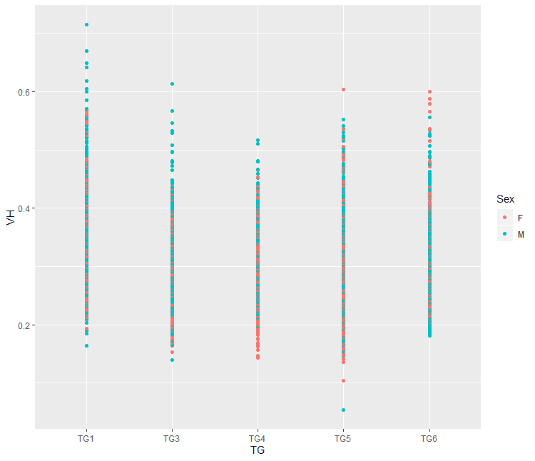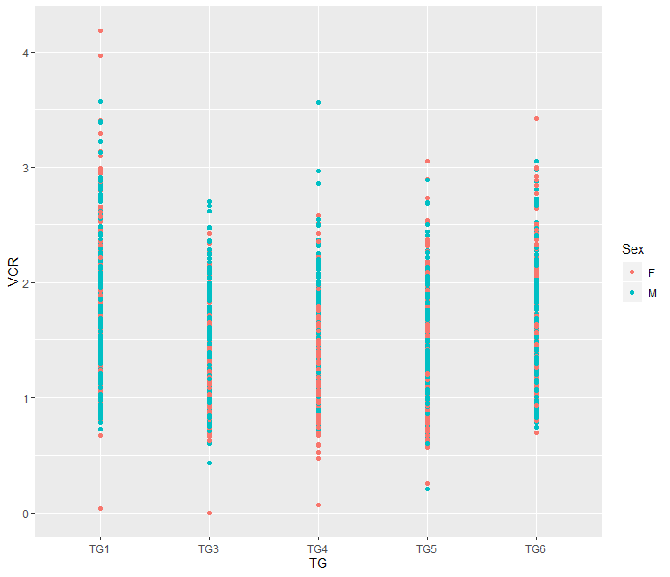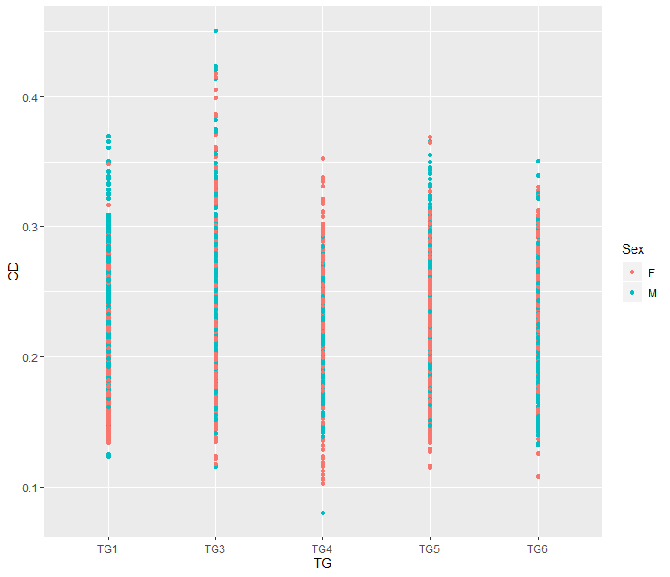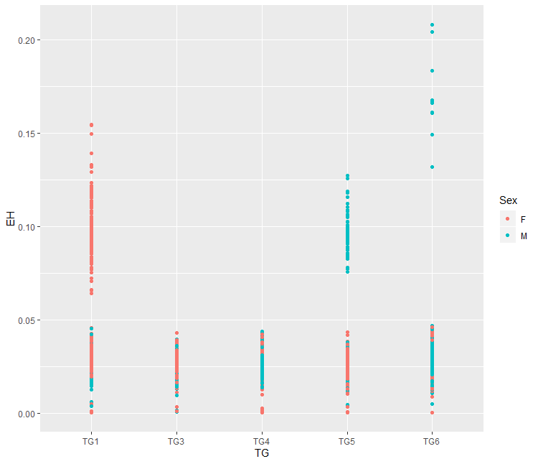
#linear mixed model commands for data analysis
Model selection:
> lme_VH1 <- lme(VH~TG, random=~1|Repetition/Pig/NM, na.action = na.omit, data=Hist, method="ML")
> lme_VH2 <- lme(VH~TG+Sex, random=~1|Repetition/Pig/NM, na.action = na.omit, data=Hist, method="ML")
> lme_VH3 <- lme(VH~TG*Sex, random=~1|Repetition/Pig/NM, na.action = na.omit, data=Hist, method="ML")
> anova (lme_VH1, lme_VH2, lme_VH3)
Model df AIC BIC logLik Test L.Ratio p-value
lme_VH1 1 9 -8931.548 -8876.940 4474.774
lme_VH2 2 10 -8931.714 -8871.039 4475.857 1 vs 2 2.1662171 0.1411
lme_VH3 3 14 -8924.517 -8839.573 4476.259 2 vs 3 0.8034356 0.9380

The model with the lowest Akaiki information criteria (AIC) value were selected but since there was no significant difference between the three models and the sex showed no significant effect and there was no interaction between treatment and sex we selected the first model which drops the sex in the model.

# Selected model for villi height (VH), crypt depth (CD), villi to crypt depth ratio (VCR) and enterocyte height (EH)

> lme_VH <- lme(VH~TG, random=~1|Repetition/Pig/NM, na.action = na.omit, data=Hist, method="ML")
> lme_CD <- lme(CD~TG, random=~1|Repetition/Pig/NM, na.action = na.omit, data=Hist, method="ML")
> lme_VCR<- lme(VCR~TG, random=~1|Repetition/Pig/NM, na.action = na.omit, data=Hist, method="ML")
> lme_EH <- lme(EH~TG, random=~1|Repetition/Pig/NM, na.action = na.omit, data=Hist, method="ML")

#Check for normality using QQ plots

> qqnorm(residuals(lme_VH))
> qqline(residuals(lme_VH))

> qqnorm(residuals(lme_CD))
> qqline(residuals(lme_CD))

> qqnorm(residuals(lme_EH))
> qqline(residuals(lme_EH))

> qqnorm(residuals(lme_VCR))
> qqline(residuals(lme_VCR))

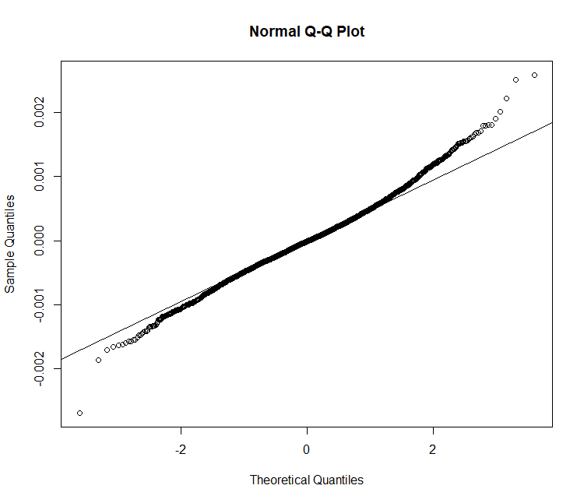  VH | 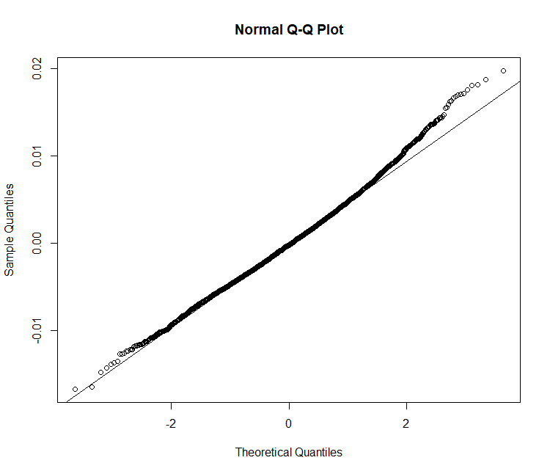  CD
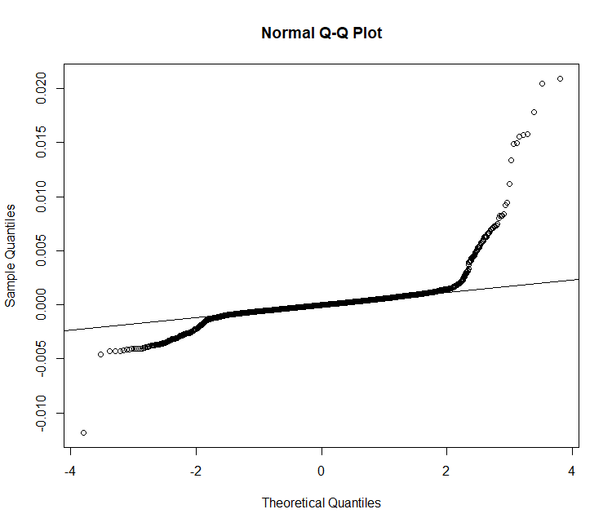  EH | 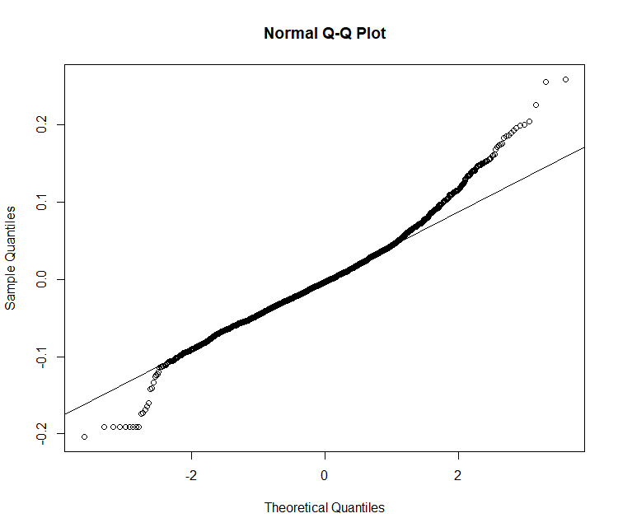  VCR

#anova and least square means (LSM)
> anova(lme_VH)
> anova(lme_CD)

> anova(lme_VCR)
> anova(lme_EH)

#Lsm and pairwise comparisons

#lsm

> glht_VH <- glht(lme_VH, lsm(~TG))
> summary(glht_VH)

> glht_CD <- glht(lme_CD, lsm(~TG))
> summary(glht_CD)

> glht_VCR <- glht(lme_VCR, lsm(~TG))
> summary(glht_VCR)

> glht_EH <- glht(lme_EH, lsm(~TG))
> summary(glht_EH)

#Pairwise comparison

> glht_VH <- glht(glht_VH, linfct=mcp(TG="Tukey"))
> summary(glht_VH)
> cld(glht_VH)

> glht_CD <- glht(lme_CD, linfct=mcp(TG="Tukey"))
> summary(glht_CD)
> cld(glht_CD)

> glht_VCR <- glht(glht_VCR, linfct=mcp(TG="Tukey"))
> summary(glht_VCR)
> cld(glht_VCR)

> glht_EH <- glht(glht_EH, linfct=mcp(TG="Tukey"))
> summary(glht_EH)
> cld(glht_EH)

#Linear or quadratic effect of BW at slaughter
Create a column with the square of body weight at slaughter (BW_2) in the data set file using the command:

> Hist$BW_2 <- Hist$BW^2

Add the linear (BW) and quadratic (BW_2) term of the body weight to the linear mixed model function as follows and assess using anova for each of the gut histomorphometric parameters (VH,CD,VCR and EH):

> lme_VHlq <- lme(VH~TG + BW+BW_2, random=~1|Repetition/Pig/NM, na.action = na.omit, data=Hist, method="ML")
> anova.lme(lme_VHlq)

numDF denDF F-value p-value
(Intercept) 1 3128 2521.7218 <.0001
TG 4 41 3.3590 0.0182
BW 1 41 10.6624 0.0022
BW_2 1 41 0.2565 0.6152

> lme_CDlq <- lme(CD~TG+BW+BW_2, random=~1|Repetition/Pig/NM, na.action = na.omit, data=Hist, method="ML")
> anova.lme(lme_CDlq)

numDF denDF F-value p-value
(Intercept) 1 3627 1439.6269 <.0001
TG 4 41 1.6834 0.1723
BW 1 41 4.5030 0.0399
BW_2 1 41 0.0229 0.8804

> lme_VCRlq <- lme(VCR~TG+BW+BW_2, random=~1|Repetition/Pig/NM, na.action = na.omit, data=Hist, method="ML")
> anova.lme(lme_VCRlq)
numDF denDF F-value p-value
(Intercept) 1 3117 1357.0066 <.0001
TG 4 41 5.0789 0.0020
BW 1 41 3.7542 0.0596
BW_2 1 41 0.0075 0.9315
> lme_EHlq <- lme(EH~TG+BW+BW_2, random=~1|Repetition/Pig/NM, na.action = na.omit, data=Hist, method="ML")
> anova.lme(lme_EHlq)

numDF denDF F-value p-value
(Intercept) 1 6817 431.4502 <.0001
TG 4 41 1.7397 0.1598
BW 1 41 0.0321 0.8587
BW_2 1 41 7.6422 0.0085

##Important to note that the inclusion of linear or quadratic BW affected the effect of the treatment on the gut morphometric parameters when pairwise comparison is made. Thus, the value presented in table 2 in the manuscript excluded the effect of the body weight at slaughter (linear or quadratic) but description is available in the text.

Body and digestive organs’ weight
# Install appropriate R packages
> library(nlme)
> library(lsmeans)
> library(MASS)
> library(multcomp)
> library(car)
> require(emmeans)
> library(ggplot2)

# upload the data

> setwd("C:/Users/hfk261/Desktop/SEGES_Data analysis/BW")
> pig_bw <- read.csv("Pig_BW.csv", header=T, sep=",")
> pig_bw[75,]
> pig_bw <- pig_bw[1:75,1:27]

# Convert SN and Repetition from integer to factor terms

> pig_bw$SN <- factor(pig_bw$SN)
> pig_bw$Repetition <- factor(pig_bw$Repetition)

> str(pig_bw)

'data.frame': 75 obs. of 19 variables:
$ SN : Factor w/ 75 levels "1","2","3","4",..: 1 2 3 4 5 6 7 8 9 10 ...
$ Repetition: Factor w/ 15 levels "34","35","36",..: 3 3 3 2 2 2 2 2 1 1 ...
$ TG : Factor w/ 5 levels "TG1","TG3","TG4",..: 4 1 5 3 4 1 5 2 3 1 ...
$ Sex : Factor w/ 2 levels "F","M": 2 1 2 1 1 1 1 1 2 2 ...
$ LBW : num 7.3 8.5 8.3 7.6 7.3 7.7 7.4 6.8 9.4 10 ...
$ DBW : num 5.41 6.28 6.27 5.41 5.8 6.47 4.89 5.72 7.3 8.21 ...
$ HW : num 9.4 9.7 9 9.6 9.1 8.7 9.1 8 10.1 9.5 ...
$ HL : num 16 17 16 16 16.5 16 16 15 17 17 ...
$ CRL : num 45 50 44 46 50 48 47 44 48 51 ...
$ GC : num 44 46 46 44 44.5 43.5 42 42.5 46.5 50 ...
$ SIL : num 7.9 7.9 10.8 10.3 9.2 11 11.3 11 10.8 9.2 ...
$ STC : num 235 323 NA 351 109 ...
$ PSIC : num 38.4 69.1 78.1 59.9 82.2 ...
$ DSIC : num 172 160 137 207 149 ...
$ HGC : num 95.4 208.5 301.8 112.6 133.2 ...
$ STT : num 62.6 75.5 56.6 58.5 44.6 ...
$ PSIT : num 215 161 216 212 165 ...
$ DSIT : num 255 237 265 269 197 ...
$ HGT : num 255 194 164 148 129 ...

SN=Serial number (pig number); TG= treatment group; LBW=live body weight; DBW= dressed body weight; HW=head width; HL=head length; CRL=crown-rump length; GC=girth circumference; SIL= small intestine length; STC= stomach content; PSIC= proximal small intestine content; DSIC = distal small intestine content; HGC = hind gut content; STT= stomach tissue; PSIT = proximal small intestine tissue; DSIT = distal small intestine tissue; HGT= hind gut tissue.

#visualization of data using ggplot and inspection of data for outliers

> ggplot(pigbw, aes(x=TG, y=LBW, colour=Sex))+
geom_point(aes(x=TG,y=LBW))

> ggplot(pigbw, aes(x=TG, y=DBW, colour=Sex))+
geom_point(aes(x=TG,y=DBW))

> ggplot(pigbw, aes(x=TG, y=HW, colour=Sex))+
geom_point(aes(x=TG,y=HW))

> ggplot(pigbw, aes(x=TG, y=HL, colour=Sex))+
geom_point(aes(x=TG,y=HL))

> ggplot(pigbw, aes(x=TG, y=CRL, colour=Sex))+
geom_point(aes(x=TG,y=CRL))

> ggplot(pigbw, aes(x=TG, y=GC, colour=Sex))+
geom_point(aes(x=TG,y=GC))

> ggplot(pigbw, aes(x=TG, y=SIL, colour=Sex))+
geom_point(aes(x=TG,y=SIL))

> ggplot(pigbw, aes(x=TG, y=STC, colour=Sex))+
geom_point(aes(x=TG,y=STC))

> ggplot(pigbw, aes(x=TG, y=PSIC, colour=Sex))+
geom_point(aes(x=TG,y=PSIC))

> ggplot(pigbw, aes(x=TG, y=DSIC, colour=Sex))+
geom_point(aes(x=TG,y=DSIC))

> ggplot(pigbw, aes(x=TG, y=HGC, colour=Sex))+
geom_point(aes(x=TG,y=HGC))

> ggplot(pigbw, aes(x=TG, y=STT, colour=Sex))+
geom_point(aes(x=TG,y=STT))

> ggplot(pigbw, aes(x=TG, y=PSIT, colour=Sex))+
geom_point(aes(x=TG,y=PSIT))

> ggplot(pigbw, aes(x=TG, y=DSIT, colour=Sex))+
geom_point(aes(x=TG,y=DSIT))

> ggplot(pigbw, aes(x=TG, y=HGT, colour=Sex))+
geom_point(aes(x=TG,y=HGT))

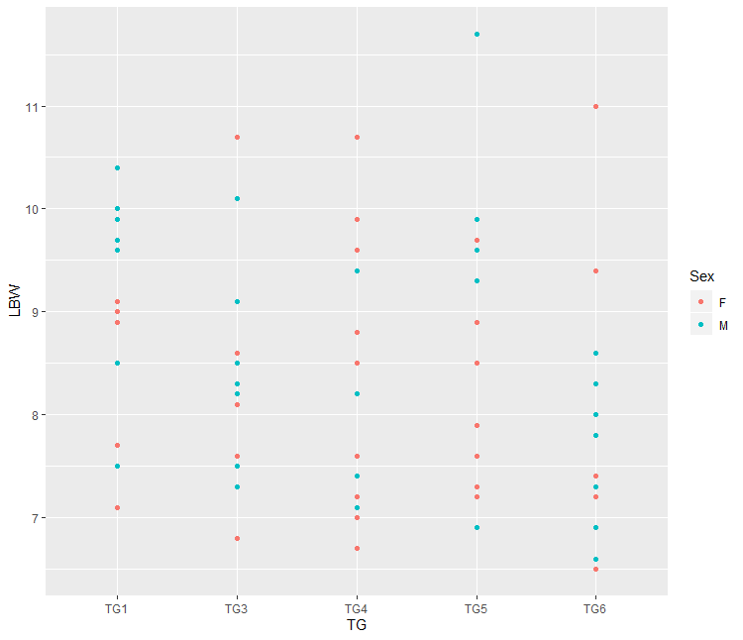 | 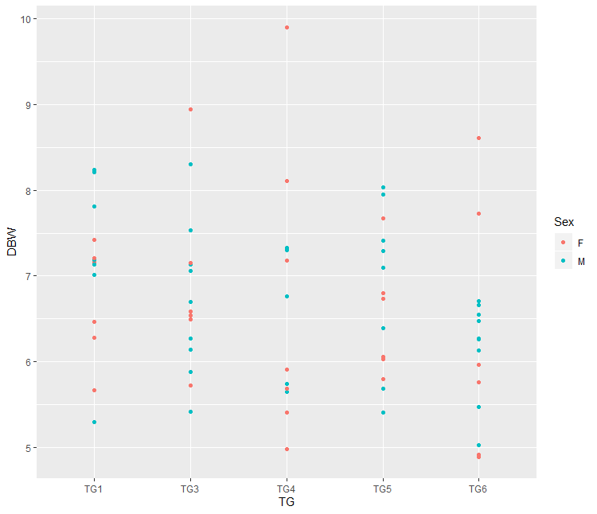 | 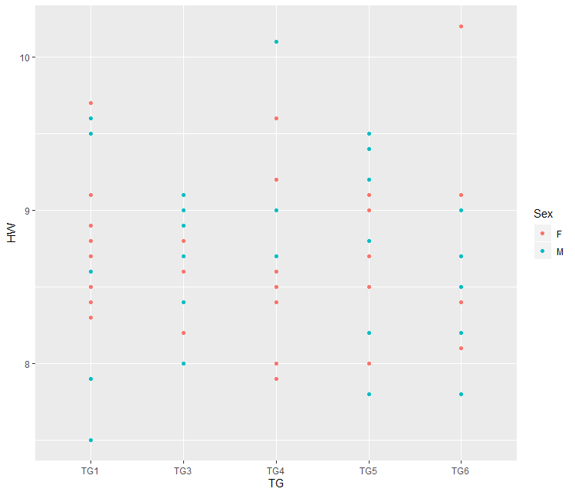
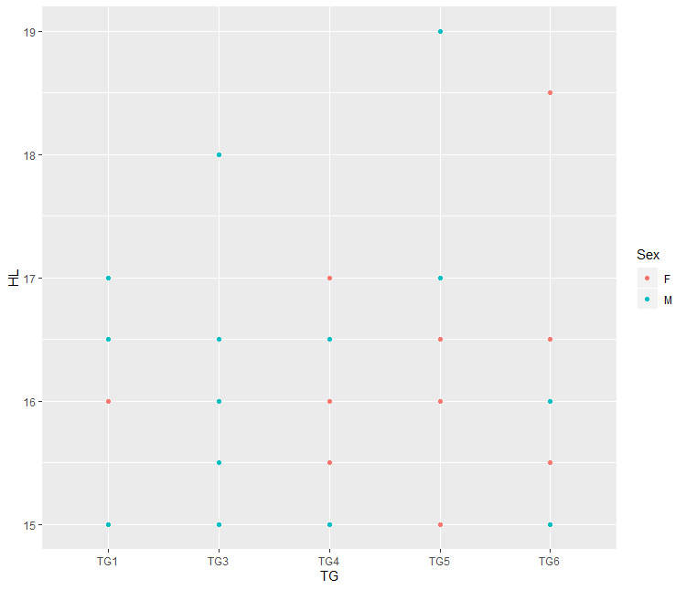 | 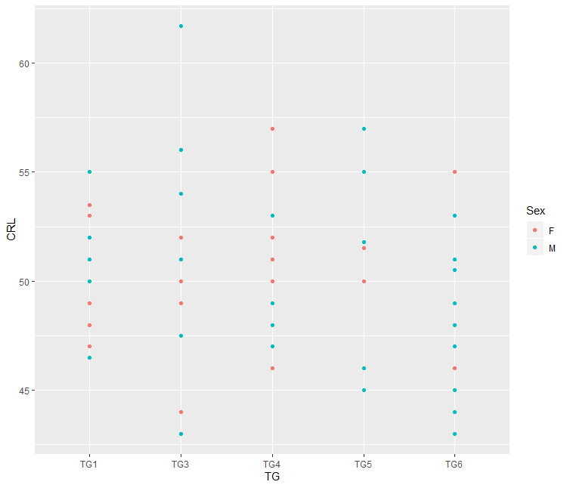 | 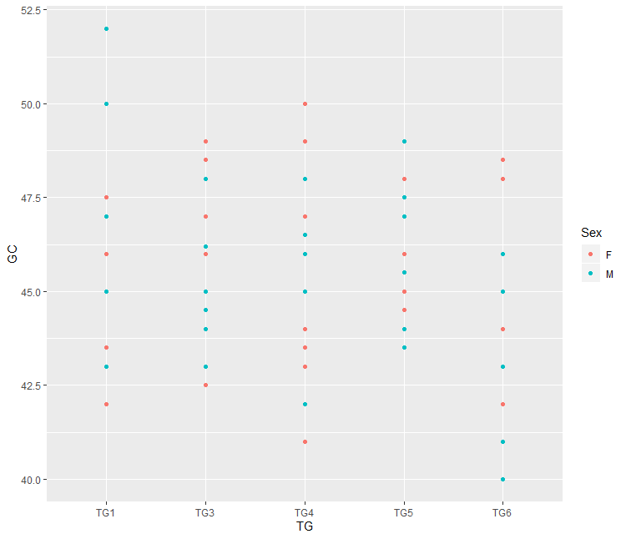
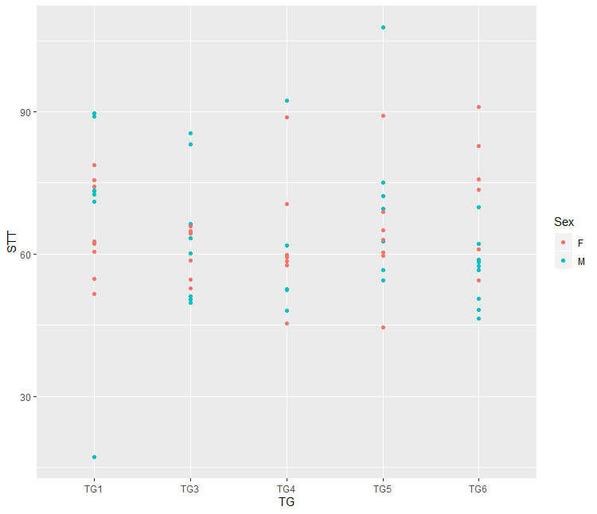 | 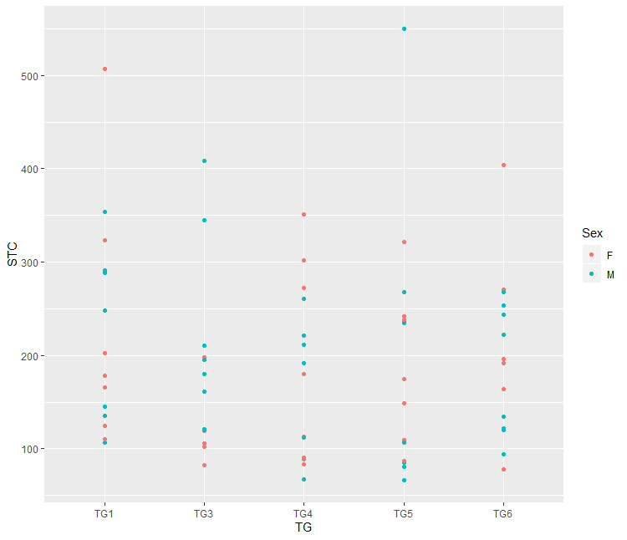 | 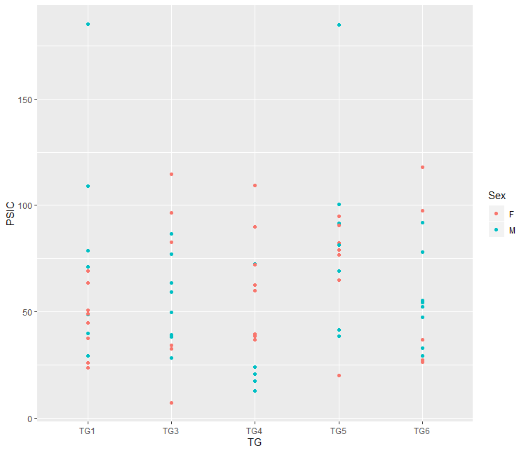
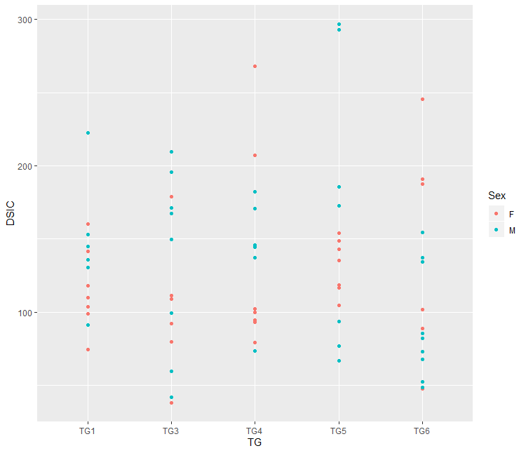 | 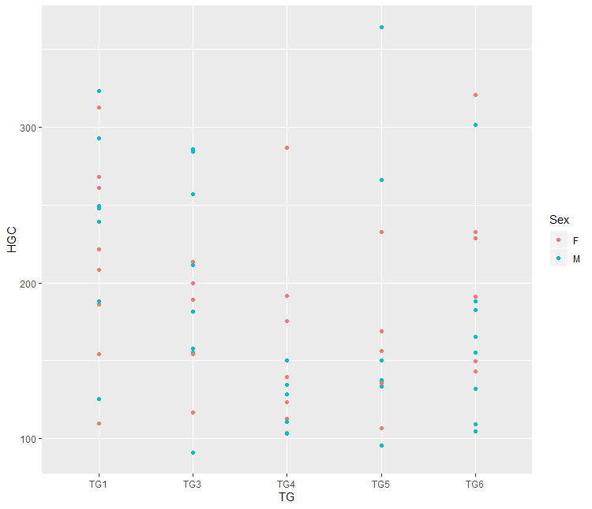
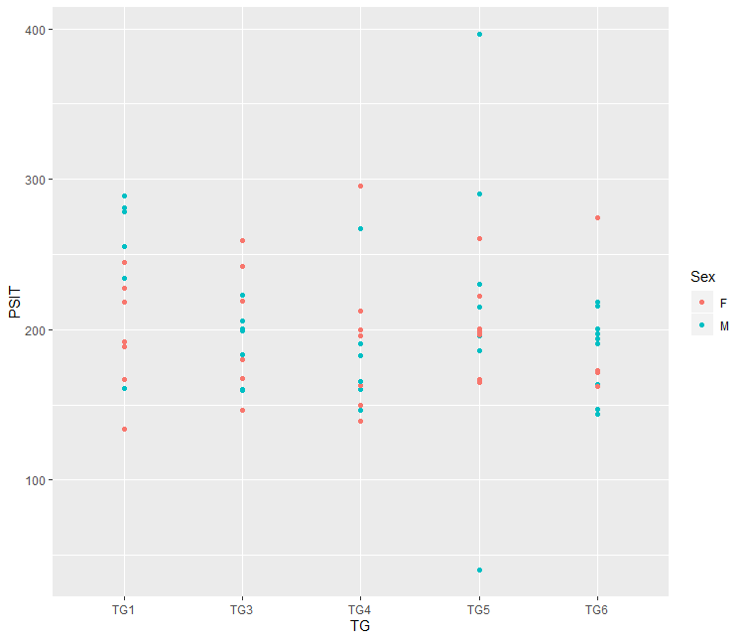 | 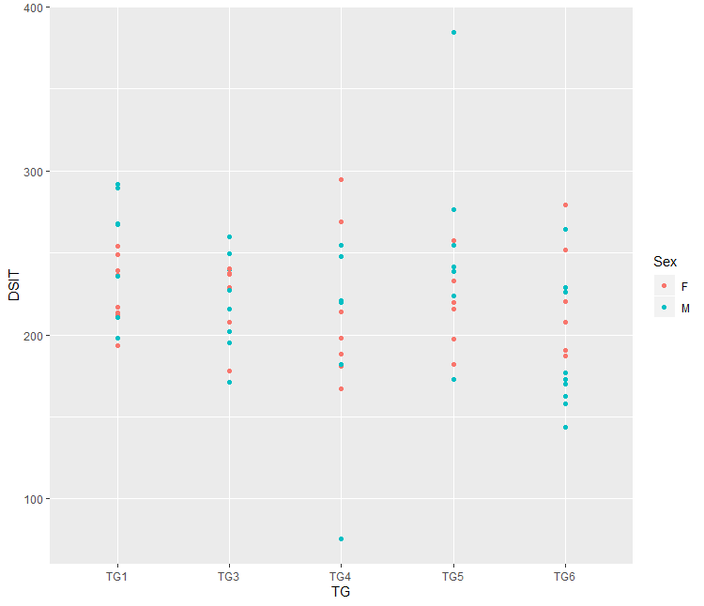 | 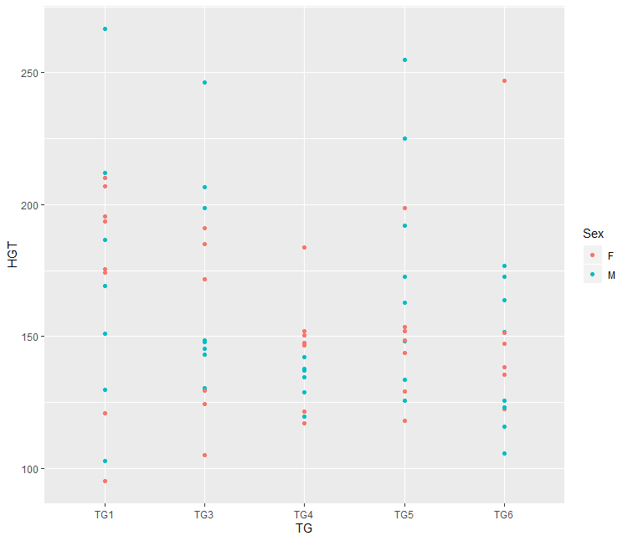

## Linear mixed model commands for data analysis

#Model selection:

> lme_DBW1<- lme(DBW ~ TG*Sex, random = ~1|Repetition/SN, na.action = na.omit, data=pigbw, method="ML")
> lme_DBW2<- lme(DBW ~ TG+Sex, random = ~1|Repetition/SN, na.action = na.omit, data=pigbw, method="ML")
> lme_DBW3<- lme(DBW ~ TG, random = ~1|Repetition/SN, na.action = na.omit, data=pigbw, method="ML")
> anova(lme_DBW1,lme_DBW2, lme_DBW3)

Model df AIC BIC logLik Test L.Ratio p-value
lme_DBW1 1 13 227.4843 257.6116 -100.7421
lme_DBW2 2 9 222.5823 243.4397 -102.2912 1 vs 2 3.0980772 0.5415
lme_DBW3 3 8 220.5846 239.1245 -102.2923 2 vs 3 0.0022258 0.9624

This model selection was done for all the other body lenght and gut parameters. Accordingly, the model with the lowest Akaiki information criteria (AIC) value were selected and hence we selected the third model which drops the sex from the model.

# Selected model for the body length and gut tissue and content weights:

# Selected model for the body length and gut tissue and content weights:

# LBW
> lme_LBW<- lme(LBW ~ TG, random = ~1|Repetition/SN, na.action = na.omit, data=pigbw, method="ML")

# DBW
> lme_DBW<- lme(DBW ~ TG, random = ~1|Repetition/SN, na.action = na.omit, data=pigbw, method="ML")

#HW
> lme_HW<- lme(HW ~ TG, random = ~1|Repetition/SN, na.action = na.omit, data=pigbw, method="ML")

#HL
> lme_HL<- lme(HL ~ TG, random = ~1|Repetition/SN, na.action = na.omit, data=pigbw, method="ML")

#CRL
> lme_CRL<- lme(CRL ~ TG, random = ~1|Repetition/SN, na.action = na.omit, data=pigbw, method="ML")

#GC
> lme_GC<- lme(GC ~ TG, random = ~1|Repetition/SN, na.action = na.omit, data=pigbw, method="ML")

#SIL
> lme_SIL<- lme(SIL ~ TG, random = ~1|Repetition/SN, na.action = na.omit, data=pigbw, method="ML")

#STC
> lme_STC<- lme(STC ~ TG, random = ~1|Repetition/SN, na.action = na.omit, data=pigbw, method="ML")

# PSIC
> lme_PSIC<- lme(PSIC ~ TG, random = ~1|Repetition/SN, na.action = na.omit, data=pigbw, method="ML")

#DSIC
> lme_DSIC<- lme(DSIC ~ TG, random = ~1|Repetition/SN, na.action = na.omit, data=pigbw, method="ML")

#HGC
> lme_HGC<- lme(HGC ~ TG, random = ~1|Repetition/SN, na.action = na.omit, data=pigbw, method="ML")

#STT
> lme_STT<- lme(STT ~ TG, random = ~1|Repetition/SN, na.action = na.omit, data=pigbw, method="ML")

#PSIT
> lme_PSIT<- lme(PSIT ~ TG, random = ~1|Repetition/SN, na.action = na.omit, data=pigbw, method="ML")

#DSIT
> lme_DSIT<- lme(DSIT ~ TG, random = ~1|Repetition/SN, na.action = na.omit, data=pigbw, method="ML")

#HGT
> lme_HGT<- lme(HGT ~ TG, random = ~1|Repetition/SN, na.action = na.omit, data=pigbw, method="ML")

## Normality was checked using QQ plot

#LBW
> qqnorm(residuals(lme_LBW))
> qqline(residuals(lme_LBW))

#DBW
> qqnorm(residuals(lme_DBW))
> qqline(residuals(lme_DBW))

# HW
> qqnorm(residuals(lme_HW))
> qqline(residuals(lme_HW))

# HL
> qqnorm(residuals(lme_HL))
> qqline(residuals(lme_HL))

#CRL
> qqnorm(residuals(lme_CRL))
> qqline(residuals(lme_CRL))

#GC
> qqnorm(residuals(lme_GC))
> qqline(residuals(lme_GC))

#SIL
> qqnorm(residuals(lme_SIL))
> qqline(residuals(lme_SIL))

#STC
> qqnorm(residuals(lme_STC))
> qqline(residuals(lme_STC))

#PSIC
> qqnorm(residuals(lme_PSIC))
> qqline(residuals(lme_PSIC))

#DSIC
> qqnorm(residuals(lme_DSIC))
> qqline(residuals(lme_DSIC))

#HGC
> qqnorm(residuals(lme_HGC))
> qqline(residuals(lme_HGC))

#STT
> qqnorm(residuals(lme_STT))
> qqline(residuals(lme_STT))

#PSIT
> qqnorm(residuals(lme_PSIT))
> qqline(residuals(lme_PSIT))

#DSIT
> qqnorm(residuals(lme_DSIT))
> qqline(residuals(lme_DSIT))

#HGT
> qqnorm(residuals(lme_HGT))
> qqline(residuals(lme_HGT))

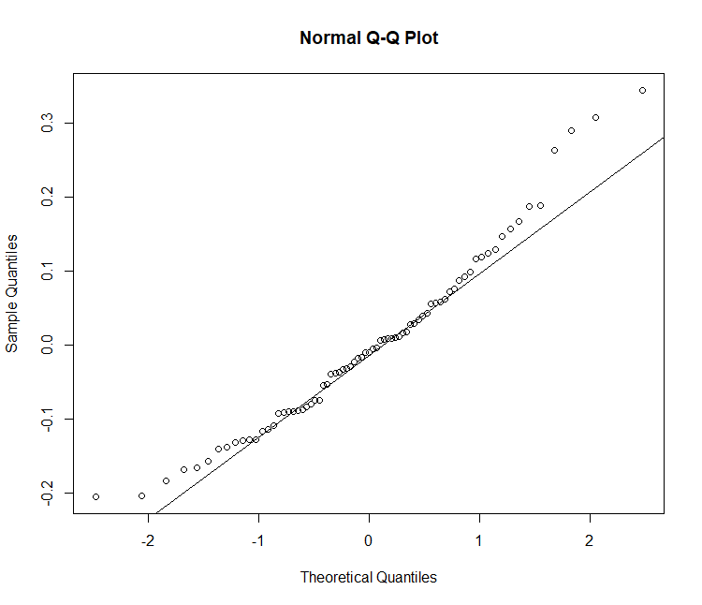  LBW | 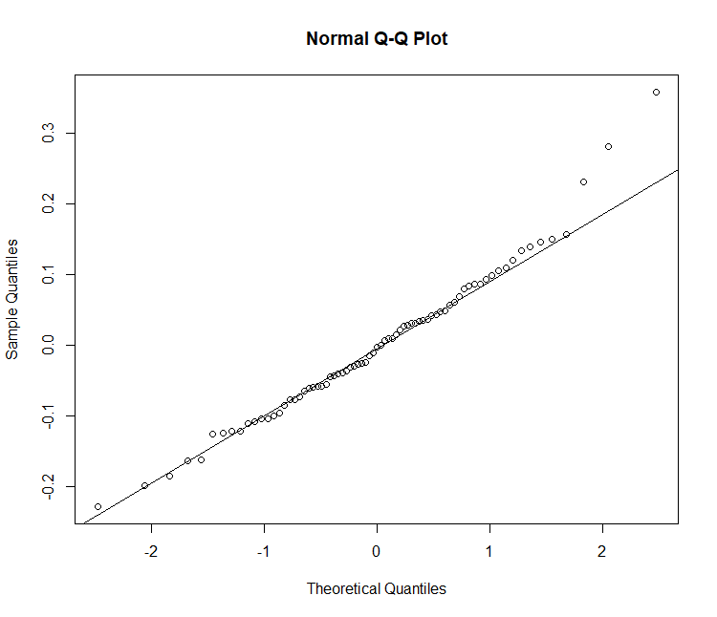  DBW | 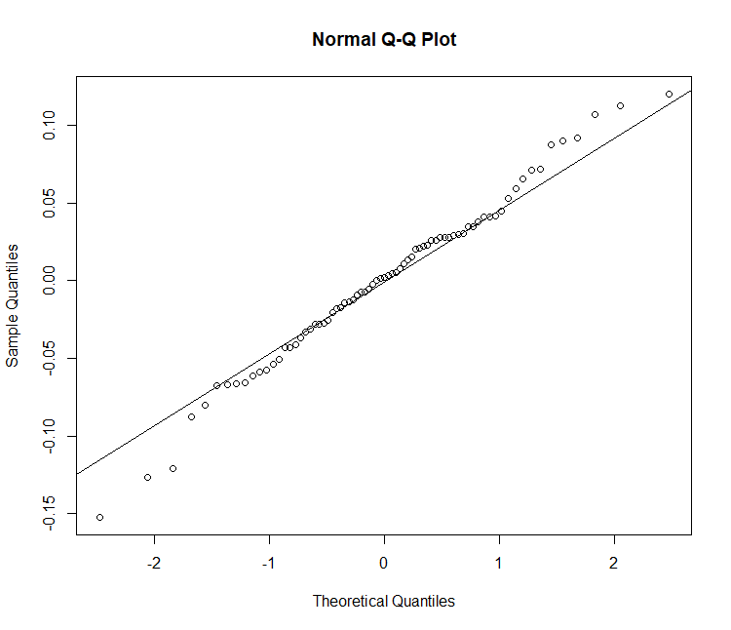  HW
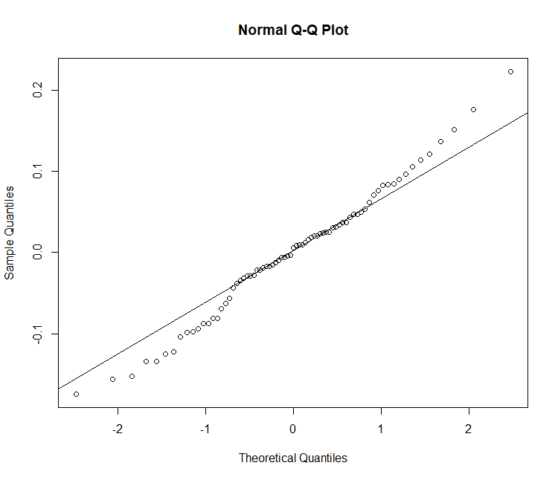  HL | 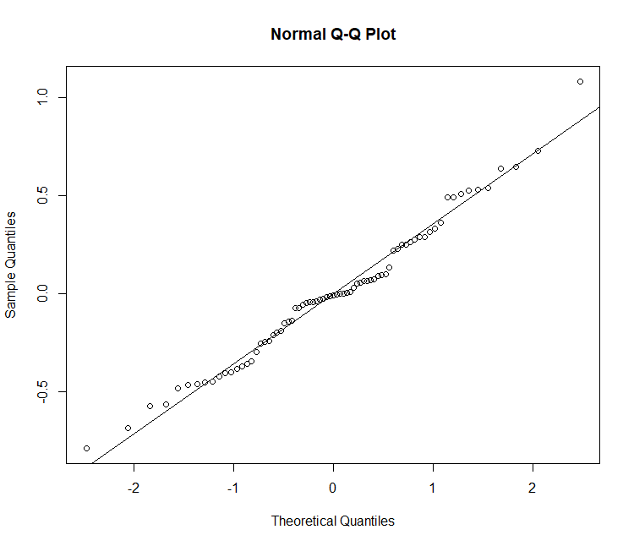  CRL | 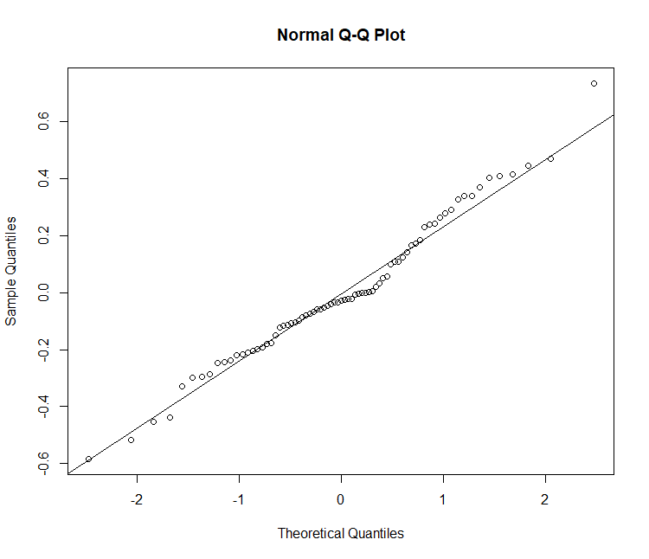  GC
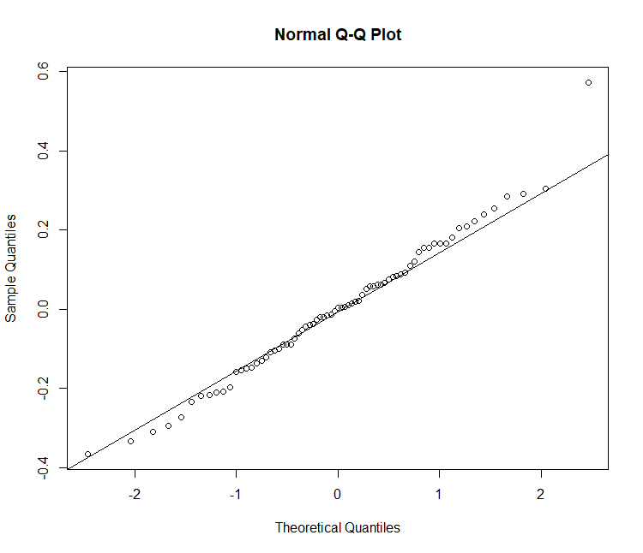  SIL | 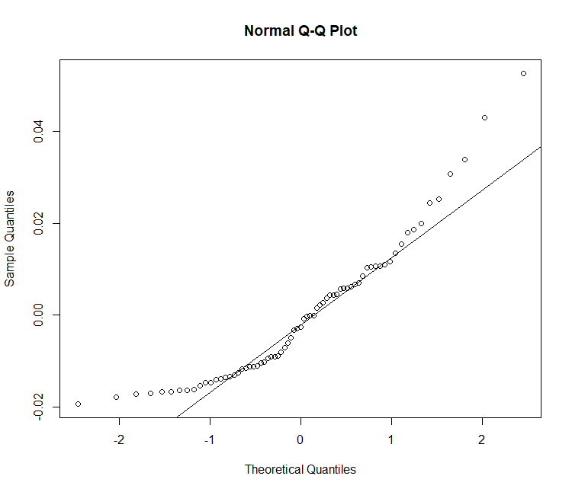  STC | 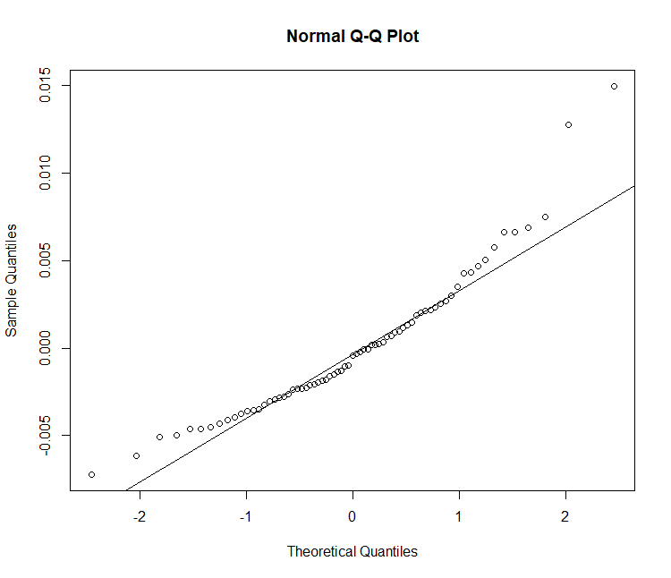  PSIC
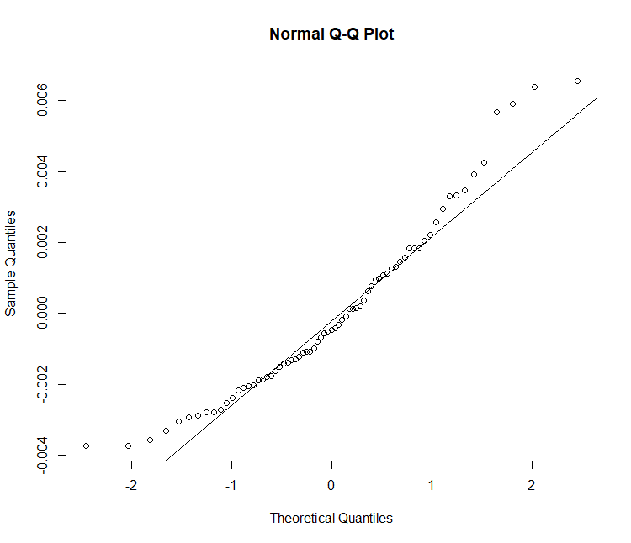  DSIC | 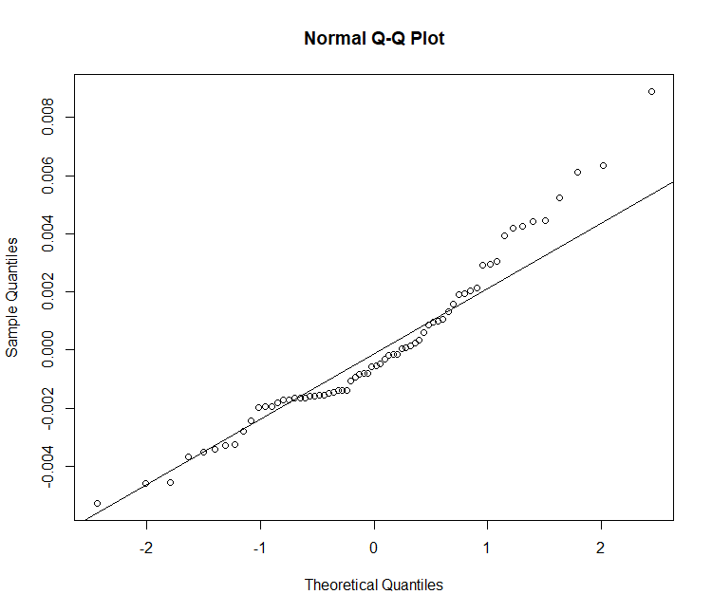  HGC | 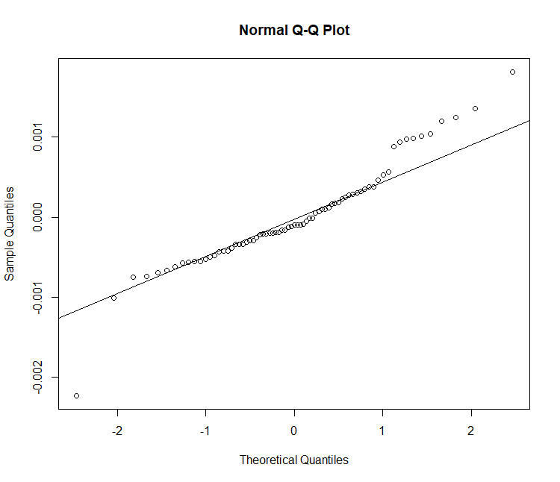  STT
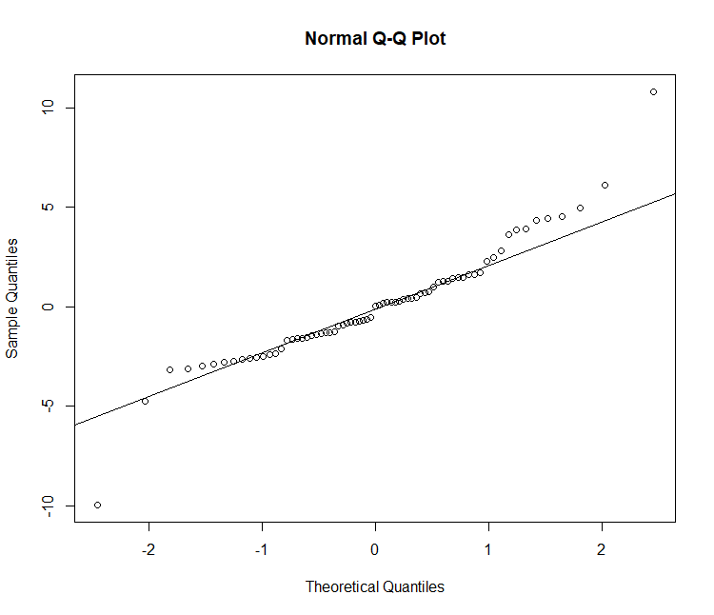  PSIT | 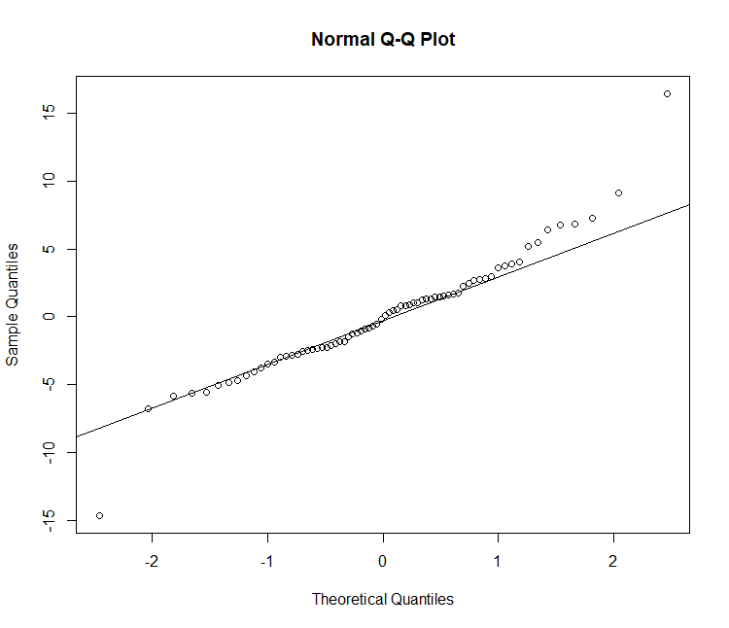  DSIT | 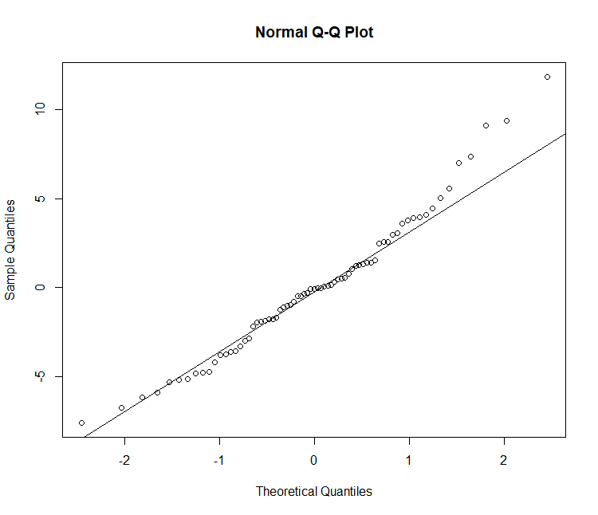  HGT

# anova, least square means (LSM) and pairwise comparison

# LBW
> anova(lme_LBW)
> glht_LBWlsm <- glht(lme_LBW, lsm(~TG))
> summary(glht_LBWlsm)
> glht_LBWpw <- glht(lme_LBW, linfct=mcp(TG="Tukey") )
> summary(glht_LBWpw)
> cld(glht_LBWpw)

# DBW
> anova(lme_DBW)
> glht_DBWlsm <- glht(lme_DBW, lsm(~TG))
> summary(glht_DBWlsm)
> glht_DBWpw <- glht(lme_DBW, linfct=mcp(TG="Tukey") )
> summary(glht_DBWpw)
> cld(glht_DBWpw)

# HW
> anova(lme_HW)
> glht_HWlsm <- glht(lme_HW, lsm(~TG))
> summary(glht_HWlsm)
> glht_HWpw <- glht(lme_HW, linfct=mcp(TG="Tukey") )
> summary(glht_HWpw)
> cld(glht_HWpw)

#HL
> anova(lme_HL)
> glht_HLlsm <- glht(lme_HL, lsm(~TG))
> summary(glht_HLlsm)
> glht_HLpw <- glht(lme_HL, linfct=mcp(TG="Tukey") )
> summary(glht_HLpw)
> cld(glht_HLpw)

# CRL
> anova(lme_CRL)
> glht_CRLlsm <- glht(lme_CRL, lsm(~TG))
> summary(glht_CRLlsm)
> glht_CRLpw <- glht(lme_CRL, linfct=mcp(TG="Tukey") )
> summary(glht_CRLpw)
> cld(glht_CRLpw)

#GC
> anova(lme_GC)
> glht_GClsm <- glht(lme_GC, lsm(~TG))
> summary(glht_GClsm)
> glht_GCpw <- glht(lme_GC, linfct=mcp(TG="Tukey") )
> summary(glht_GCpw)
> cld(glht_GCpw)

#SIL
> anova(lme_SIL)
> glht_SILlsm <- glht(lme_SIL, lsm(~TG))
> summary(glht_SILlsm)
> glht_SILpw <- glht(lme_SIL, linfct=mcp(TG="Tukey") )
> summary(glht_SILpw)
> cld(glht_SILpw)

#STC
> anova(lme_STC)
> glht_STClsm <- glht(lme_STC, lsm(~TG))
> summary(glht_STClsm)
> glht_STCpw <- glht(lme_STC, linfct=mcp(TG="Tukey") )
> summary(glht_STCpw)
> cld(glht_STCpw)

#PSIC
> anova(lme_PSIC)
> glht_PSIClsm <- glht(lme_PSIC, lsm(~TG))
> summary(glht_PSIClsm)
> glht_PSICpw <- glht(lme_PSIC, linfct=mcp(TG="Tukey") )
> summary(glht_PSICpw)
> cld(glht_PSICpw)

# DSIC
> anova(lme_DSIC)
> glht_DSIClsm <- glht(lme_DSIC, lsm(~TG))
> summary(glht_DSIClsm)
> glht_DSICpw <- glht(lme_DSIC, linfct=mcp(TG="Tukey") )
> summary(glht_DSICpw)
> cld(glht_DSICpw)

# HGC
> anova(lme_HGC)
> glht_HGClsm <- glht(lme_HGC, lsm(~TG))
> summary(glht_HGClsm)
> glht_HGCpw <- glht(lme_HGC, linfct=mcp(TG="Tukey") )
> summary(glht_HGCpw)
> cld(glht_HGCpw)

#STTT
> anova(lme_STT)
> glht_STTlsm <- glht(lme_STT, lsm(~TG))
> summary(glht_STTlsm)
> glht_STTpw <- glht(lme_STT, linfct=mcp(TG="Tukey") )
> summary(glht_STTpw)
> cld(glht_STTpw)

#PSIT
> anova(lme_PSIT)
> glht_PSITlsm <- glht(lme_PSIT, lsm(~TG))
> summary(glht_PSITlsm)
> glht_PSITpw <- glht(lme_PSIT, linfct=mcp(TG="Tukey") )
> summary(glht_PSITpw)
> cld(glht_PSITpw)

# DSIT
> anova(lme_DSIT)
> glht_DSITlsm <- glht(lme_DSIT, lsm(~TG))
> summary(glht_DSITlsm)
> glht_DSITpw <- glht(lme_DSIT, linfct=mcp(TG="Tukey") )
> summary(glht_DSITpw)
> cld(glht_DSITpw)

# HGT
> anova(lme_HGT)
> glht_HGTlsm <- glht(lme_HGT, lsm(~TG))
> summary(glht_HGTlsm)
> glht_HGTpw <- glht(lme_HGT, linfct=mcp(TG="Tukey") )
> summary(glht_HGTpw)
> cld(glht_HGTpw)

R codes and commands in vitro gas production data analysis

#Install required packages:
> library(nlme)
> library(lsmeans)
> library(MASS)
> library(multcomp)
> Import the dataset:

#Import the dataset
> setwd("Desktop/OFS_folder")
> ofs <- read.table("ofs634.txt", header=T, sep="\t")
> head(ofs)
> str(ofs)
> str(ofs)
'data.frame': 14 obs. of 11 variables:
$ run : Factor w/ 2 levels "F63","F64": 1 1 1 1 1 1 1 2 2 2 ...
$ Feed: Factor w/ 3 levels "MS","MS-OFS",..: 2 2 1 1 1 3 3 2 2 1 ...
$ T0 : int 0 0 0 0 0 0 0 0 0 0 ...
$ T3 : num 9.49 6.16 8.22 9.88 8.75 ...
$ T6 : num 17.7 13.5 16 17.6 14.3 ...
$ T9 : num 31.5 27.2 29.4 30.6 25.7 ...
$ T12 : num 77.7 73.6 78 75.4 66.9 ...
$ T18 : num 141 140 162 162 148 ...
$ T24 : num 161 158 186 184 166 ...
$ T36 : num 182 173 210 208 183 ...
$ T48 : num 188 177 221 217 185 ...
Convert the values at T0 from int (intiger) to num (numeric) by the following R command:
> ofs $T0 <- as.numeric(ofs $T0)

Linear mixed model functions and R commands:
T3, T6, T9, T12, T18, T24, T36 and T48: refer to 3, 6, 9, 12, 18, 24, 36 and 48 hours after the start of the in vitro fermentation. The “Feed” refers to the type of feed incubated which include “MS=maize silage”, “OFS = ”OceanFeed swine”, and “MS+OFS”. The model considered the effect of the “Feed” as fixed effect and that of the day of in vitro fermentation (“day 1” and “day 2”) as random effect.
#.................................................T3
lme_ofs3 <- lme(T3 ~ Feed, random = ~1|day, data = ofs, na.action = na.omit, method="ML")
## Normality was checked using Q-Q plot
> qqnorm(residuals(lme_ofs3))
> qqline(residuals(lme_ofs3))
> dev.off()
## anova and lsmeans
> anova(lme_ofs3)
> lsmean_T3 <- lsmeans(lme_ofs3, pairwise ~ Feed, adjust="tukey")

## Same R commands were used for the time point T6, T9, T12, T18, T24, T36 and T48 where number 3 in T3 and ofs3 were replaced by either 6, 9, 12, 18, 24, 36 or 48.
The LSM and anova values were presented as figure in the paper (Figure 3) using the LSM and SEM (the highest values were selected) obtained from the linear mixed model.

Supplementary Materials S3 Quality control methods and or methods for hematological and gut histomorphological parameters.
Hematology: The ADVIA® 2120i System with Autoslide is considered as the gold-standard for hematologic analysis. According to the company, the equipment gives a coefficient of variation (CV) of 2.7% for white blood cells (WBC), 1.2% for red blood cells (RBC), 0.93% for haemoglobin, 0.78% for mean corpascular volume (MCV) and 2.93% for platelet (PLT) count.
Gut histomorphology: As part of quality control measures for histological analyses, ALAB Weterynaria considered standardization of the procedures according to the ISO 9001:2015 (ISO 9001 certification for histopathological examination, and histochemical and immunohistochemically staining. The technical quality of the equipment was also ensured via annual inspection and servicing of the histological equipment such as microtome, tissue processors, microscopes, cameras, etc. The program for morphometric measurements were calibrated monthly for microscopic analysis. The results obtained were double verified through a supervisory control system involving at least two pathologists taking part in the acquisition and elaboration of the results.

