Animal journal
Identification of heat shock protein gene expression in hair follicles as a novel indicator of heat stress in beef calves
W. S. Kim1,2, J. Ghassemi Nejad1,2, D. Q. Peng1,2, U. S. Jung3, M. J. Kim13, Y. H. Jo1,2, J. H. Jo1,2, J. S. Lee1 and H. G. Lee1,2

Supplementary Table S1
Chemical composition of diets provided to the beef calves
 | Study 1 |  | Study 2
Chemical analysis | Concentrates | Roughage (Alfalfa) | Concentrates | Roughage (Timothy grass)
% of dry matter
Crude protein | 18.36 | 14.02 | 16.7 | 6.16
Ether extract | 3.14 | 1.54 | 3.13 | 1.17
Crude fibre | 5.86 | 31.32 | 8.84 | 36.57
Crude ash | 7.08 | 8.47 | 6.94 | 7.49
ADF | 8.45 | 36.77 | 10.08 | 38.69
NDF | 21.21 | 48.26 | 22.90 | 67.13
Calcium | 1.13 | 1.25 | 1.43 | 0.35
Phosphorus | 0.60 | 0.23 | 0.50 | 0.20
ADF = acid detergent fibre; NDF = neutral detergent fibre
Supplementary Infographic S1
Experimental design in study 2
The calves were randomly divided into four groups, namely, the threshold, mild, moderate, and severe groups, and each group consisted of four calves. Each chamber could house two animals at a time; we had a total of four chambers and used two chambers per treatment group. After the completion of two treatments, the other two treatments were performed different calves. Hence, we first subjected four calves to the threshold treatment and four other calves to the mild heat stress (HS) treatment (two calves per chamber). After finalizing these first two treatments, we conducted the other two treatments, namely, the moderate and severe HS treatments, using the same approach with different calves.
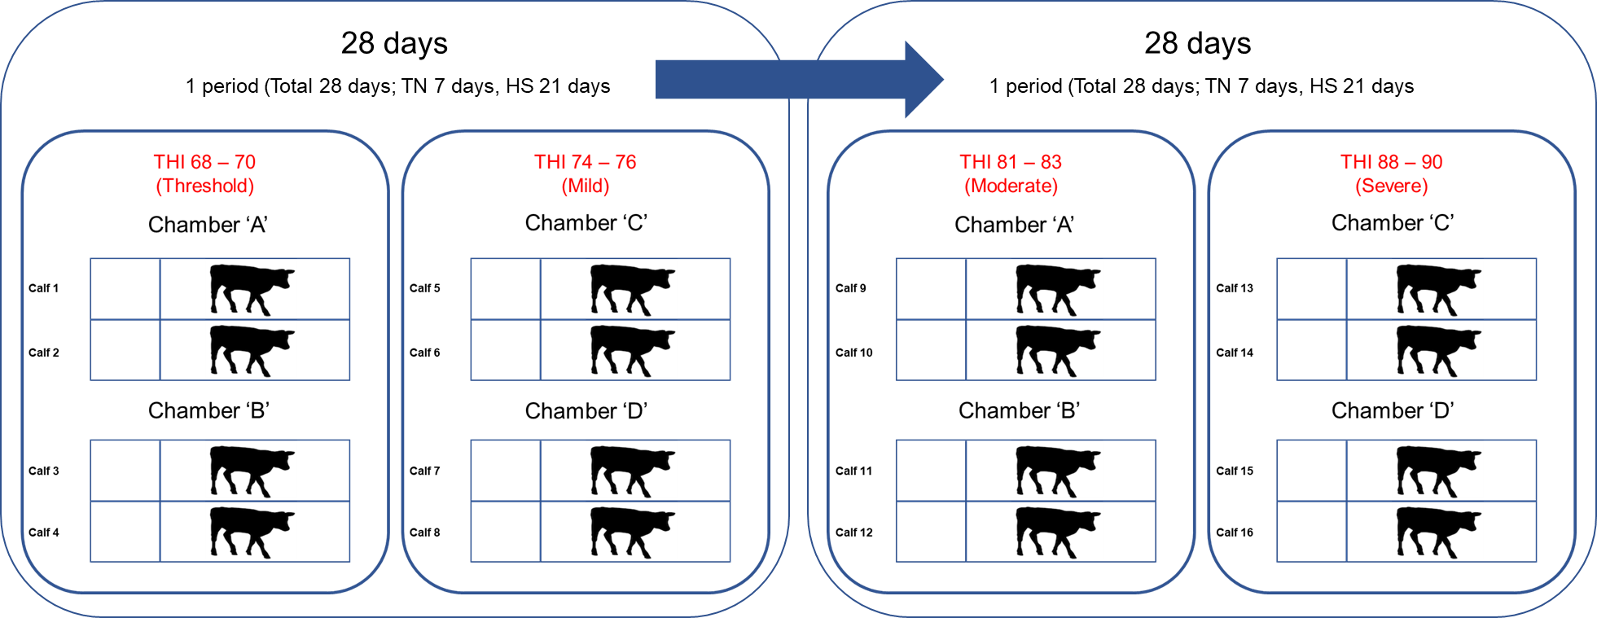
TN = thermoneutral; THI = temperature-humidity index
Supplementary Figure S1.
Hair follicle collection method from the calves.
1, 2. Tail hair (25 to 30 hairs) was pulled from the calves. Individual hairs were grasped as close to the scalp as possible and when then rapidly pulled out.
3. The hair follicles were washed using DEPC (dimethyl pyrocarbonate)-treated water.
4. After washing, hair follicles placed into a 5-ml specimen jar filled to the top with RNAlater™ (Ambion, Austin, TX).
5, 6. The hair follicles samples from each individual were removed from the RNAlater™. Then the bottom centimetre of each hair, containing the hair follicle, cut and placed directly into a 2-ml microcentrifuge tube that contained 1 ml of Trizol™.
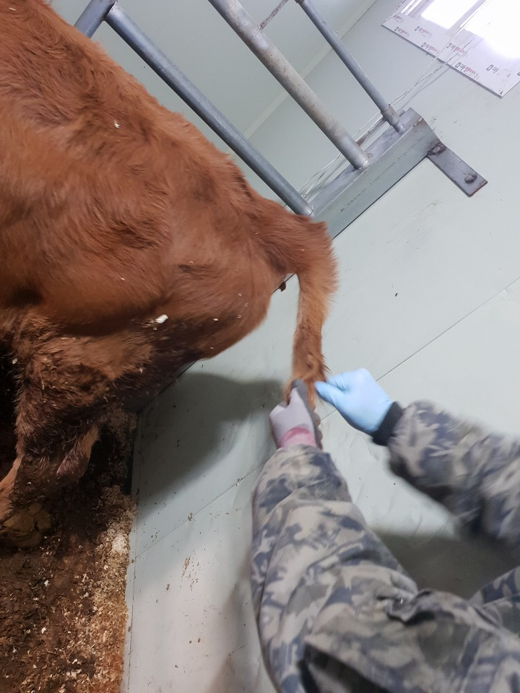  1 | 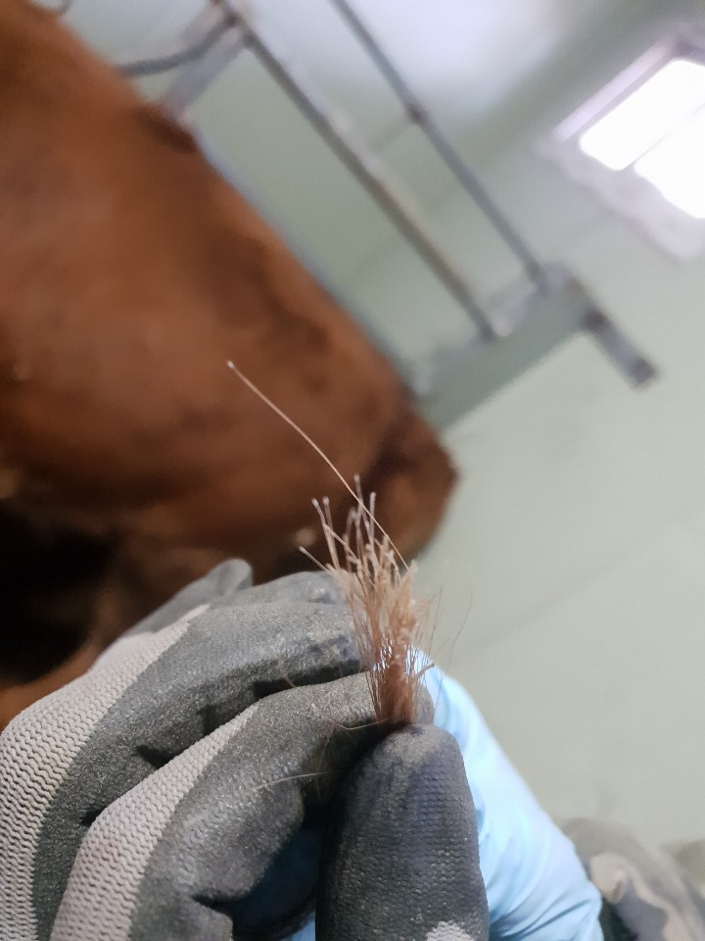  2
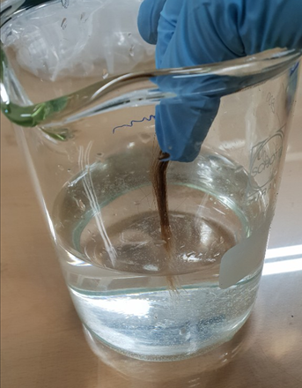  3 | 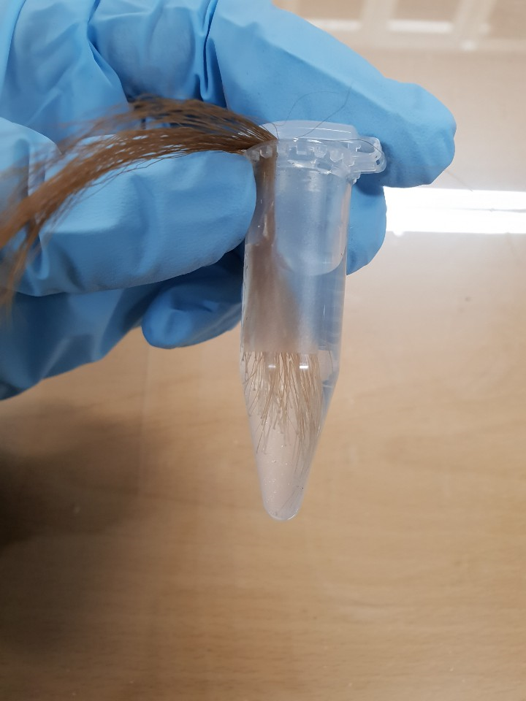  4
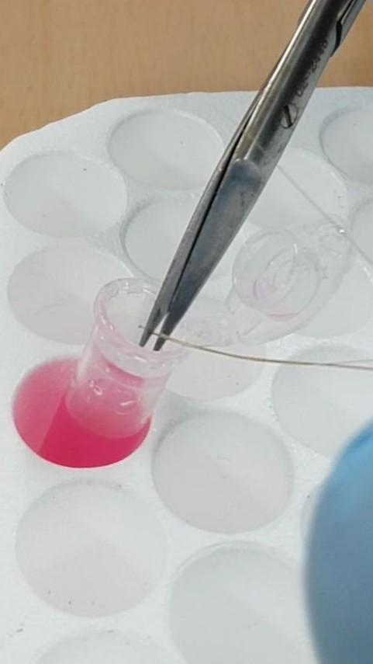  5 | 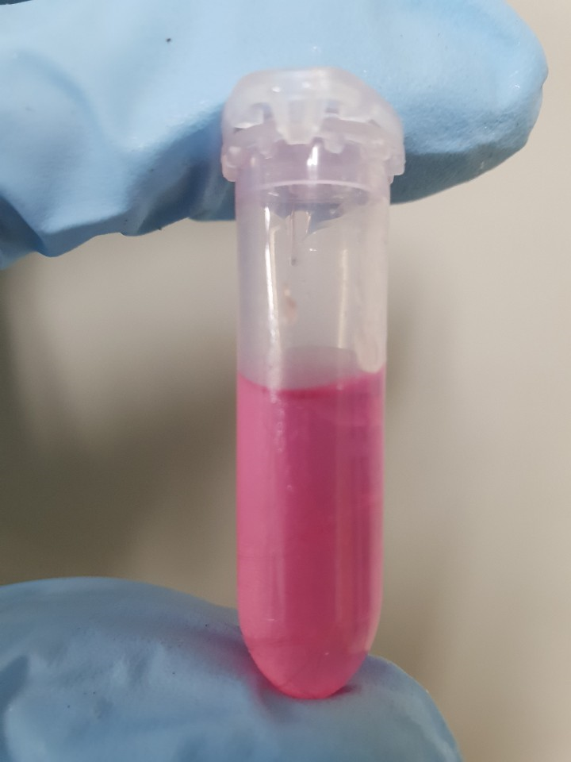  6

Supplementary Figure S2.
RNA quality test from hair follicles of the beef calves.
The RNA integrity number (RIN) was confirmed in a Bioanalyser 2100 (Agilent, Palo Alto, CA, USA) to check if the purified total RNA could be used in real-time PCR. The average RIN of hair follicles was 8.8 (8.1 to 9.4). The below figure is one of the sample measurement RIN (8.6) from hair follicle RNA sample.
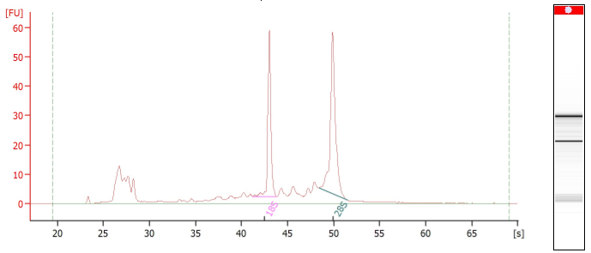
FU = Fluorescence; s = Time

