Animal – supplementary materials

Do farming conditions influence brominated flame retardant levels in pig and poultry products?

A. Huneau-Salaün¹*, R. Cariou², E. Royer^{3,a}, C. Jondreville⁴, L. Balaine¹, C. Souchet⁵, J. Coton¹, A. Vénisseau², R. Thomas¹, Y. Rousselière⁶, A. Charpiot ⁵, P. Marchand², G. Dervilly-Pinel², M. Marcon⁶, B. Le Bizec², A. Travel⁵, S. Le Bouquin¹

¹ ANSES- Ploufragan-Plouzané-Niort Laboratory - BP 53, 22440 Ploufragan, France.
² LABERCA, Oniris, INRA, 44307 Nantes, France.
³ IFIP-Institut du porc, 31500 Toulouse, France
⁴ AFPA, INRA, Université de Lorraine, 54500 Vandoeuvre-lès-Nancy, France.
⁵ ITAVI, Unité de Recherches Avicoles, Centre INRA de Tours, 37380 Nouzilly, France.
⁶ IFIP-Institut du porc, 35651 Le Rheu, France

ªPresent address: Institut de l’Elevage, 31321 Castanet-Tolosan, France

*Corresponding author: Adeline Huneau-Salaün. E-mail: adeline.huneau@anses.fr

Table S1 Mean and maximum concentrations of the sum of eight PBDE congeners (polybrominated diphenyl ethers) and of the sum of three HBCDD stereoisomers (hexabromocyclododecane) in eggs, and pig and broiler muscle reported in French surveillance surveys from 2012 to 2016. Results are expressed as upper bound concentrations in ng/g fat. (Results available at https://agriculture.gouv.fr/plans-de-surveillance-et-de-controle)
 |  |  | Eggs
Year | N |  | ∑₈ PBDEs |  |  |  |  |  |  |  | ∑₃ HBCDD
 |  |  | Mean |  |  |  | Max |  |  |  | Mean |  | Max
2016 | 18 |  | 2.98 |  |  |  | 46.4 |  |  |  | 0.14 |  | 1.27
2015 | 20 |  | 0.52 |  |  |  | 1.70 |  |  |  | 0.45 |  | 4.80
2014 | 20 |  | 0.35 |  |  |  | 1.03 |  |  |  | 0.10 |  | 0.60
2013 | 20 |  | 0.80 |  |  |  | 3.83 |  |  |  | 0.38 |  | 6.25
2012 | 20 |  | 0.75 |  |  |  | 2.44 |  |  |  | 0.34 |  | 2.53
 |  |  | Broiler muscle
Year | N |  | ∑₈ PBDE |  |  |  |  |  |  | ∑₃ HBCDD
 |  |  | Mean |  |  | Max |  |  |  | Mean |  |  |  | Max
2016 | 8 |  | 10.86 |  |  | 45.7 |  |  |  | 0.23 |  |  |  | 0.72
2015 | 10 |  | 2.99 |  |  | 21.7 |  |  |  | 0.19 |  |  |  | 0.48
2014 | 10 |  | 1.04 |  |  | 3.32 |  |  |  | 0.70 |  |  |  | 1.81
2013 | 10 |  | 1.73 |  |  | 7.70 |  |  |  | 1.57 |  |  |  | 13.3
2012 | 9 |  | 1.35 |  |  | 3.77 |  |  |  | 0.83 |  |  |  | 3.51
 |  |  | Pig muscle
Year | N |  | ∑₈ PBDE |  |  |  |  |  |  | ∑₃ HBCDD
 |  |  | Mean |  |  | Max |  |  |  | Mean |  |  |  | Max
2016 | 10 |  | 0.75 |  |  | 1.71 |  |  |  | 0.15 |  |  |  | 0.36
2015 | 10 |  | 1.70 |  |  | 5.59 |  |  |  | 0.22 |  |  |  | 0.69
2014 | 9 |  | 0.93 |  |  | 5.39 |  |  |  | 1.56 |  |  |  | 10.0
2013 | 10 |  | 0.28 |  |  | 0.82 |  |  |  | 0.13 |  |  |  | 0.49
2012 | 9 |  | 0.55 |  |  | 1.13 |  |  |  | 0.32 |  |  |  | 1.31

Table S2 Mean and maximum concentrations of brominated flame retardants in eggs, pig meat and broiler meat reported in scientific literature in Europe from 2012 to 2019. Results are expressed in ng/g fat. Publications with results in ng/g of whole product were excluded.
Country | Year | Product | RFB¹ | N | Mean | Max | Ref
NED² | 2009-2014 | Pork | Σ 17 PBDEs³ | 111 | 0.145 | 2.078 | Gebbink et al., 2019
 |  | Chicken |  | 97 | 0.060 | 0.334
 |  | Egg |  | 164 | 0.218 | 4.077
 |  | Pork | α-HBCDD⁴ | 14 | n.r.⁵ | 0.250
 |  | Chicken |  | 15 | n.r. | 0.090
 |  | Egg |  | 36 | n.r. | 42
POL² | n.r. | Egg: free-range | Σ 10 PBDEs | 31 | 1.08 | 12.0 | Parjurek et al., 2019
 |  | Egg: organic |  | 31 | 1.07 | 10.9
 |  | Egg: barn |  | 25 | 0.94 | 8.2
 |  | Egg: cage |  | 12 | 0.52 | 1.8
FRA² | 2014 | Pork: conventional | Σ 3 HBCDDs | 41 | 5.15 | 194.8 | Dervilly et al., 2017
 |  | Pork: organic |  | 43 | 0.52 | 4.76
 |  | Chicken: conventional |  | 31 | 0.63 | 3.02
 |  | Chicken: organic |  | 41 | 0.47 | 1.99
ITA² | 2011-2012 | Egg | Σ 8 PBDEs | 7 | 2.538 | 9.729 | Martellini et al., 2016
POL² | n.r. | Egg: free-range | Σ 13 PBDEs | 20 | 0.164 | 0.736 | Rosko et al., 2014
 |  | Egg: cage |  | 19 | 0.111 | 0.232
ESP² | 2009 | Pork | α- and γ-HBCDDs | 2 | 2.61 | n.r. | Eljarrat et al., 2014
 |  | Chicken |  | 3 | 6.56 | n.r.
¹Brominated flame retardants
² Country name abbreviations according to code ISO 3166-1 alpha-3
³ Polybrominated diphenyl ethers
⁴Hexabromocyclododecane
⁵Not reported

References
Eljarrat E, Gorga M, Gasser M, Diaz-Ferrero J and Barcelo D 2014. Dietary exposure assessment of Spanish citizens to Hexabromocyclododecane through the diet. Journal of Agricultural and Food Chemistry, 62, 2462-2468.
Dervilly-Pinel G, Guérin T, Minvielle B, Travel A, Normand J, Bourin M, Royer E, Dubreil E, Mompelat S, Hommet F, Nicolas M, Hort V, Inthavong C, Saint-Hilaire M, Chafey C, Parinet J, Cariou R, Marchand P, Le Bizec B, Verdon E and Engel E 2017. Micropollutants and chemical residues in organic and conventional meat. Food Chemistry, 232, 218-228.
Gebbink WA, van der Lee MK, Peters RJB, Traag WA, Dam GT, Hoogenboom RLAP and van Leeuwen SPJ 2019. Brominated flame retardants in animal derived foods in the Netherlands between 2009 and 2014. Chemosphere 234, 171-178.
Martellini T, Diletti G, Scortichini G, Lolini M, Lanciotti E, Katsoyiannis A and Cincinelli A 2016. Occurrence of polybrominated diphenyl ethers (PBDEs) in foodstuffs in Italy and implications for human exposure. Food and Chemical Toxicology, 89, 32-38.
Pajurek M, Pietron W, Maszewski S, Mikolajczyk S and Piskorska-Pliszczynska J 2019. Poultry eggs as a source of PCDD/Fs, PCBs, PBDEs and PBDD/Fs. Chemosphere 223, 651-658.
Roszko M, Szymczyk K and Jedrzejczak R 2014. Influence of hen breeding type on PCDD/F, PCB & PBDE levels in eggs. Science of the Total Environment, 487, 279-289.

A
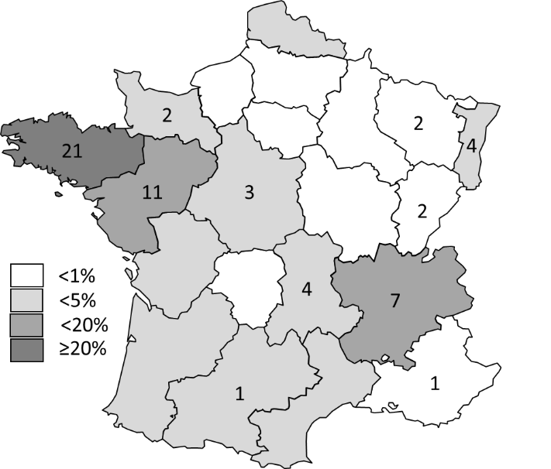
B
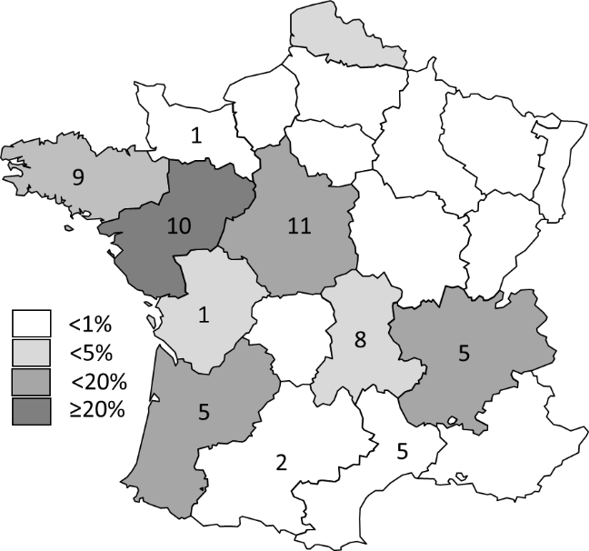
C
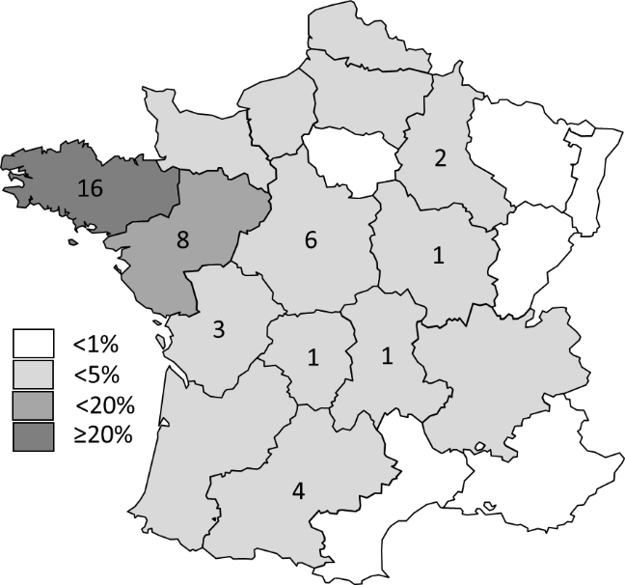

Supplementary Figure S1 Geographical repartition of the sampled farms for A/ egg farms, B/ broiler farms and C/ pig farms (N=159 farms) (France, 2013-2015). Shading is dependent to the share of the area production into the national production.

