Supplemental progesterone during early pregnancy exert divergent responses on embryonic characteristics in sows and gilts
B. B. D. Muro¹, R. F. Carnevale¹, D. F. Leal¹, M. A. Torres¹, M. V. Mendonça¹, D. H. Nakasone¹, C. H. G. Martinez¹, G. M. Ravagnani¹, M. S. Monteiro¹, A. P. Poor¹, S. M. M. K. Martins¹, P. Viau¹, C. A. Oliveira¹, L. H. Pulz², R. F. Strefezzi², G. W. Almond³, A. F. C. de Andrade¹

animal journal

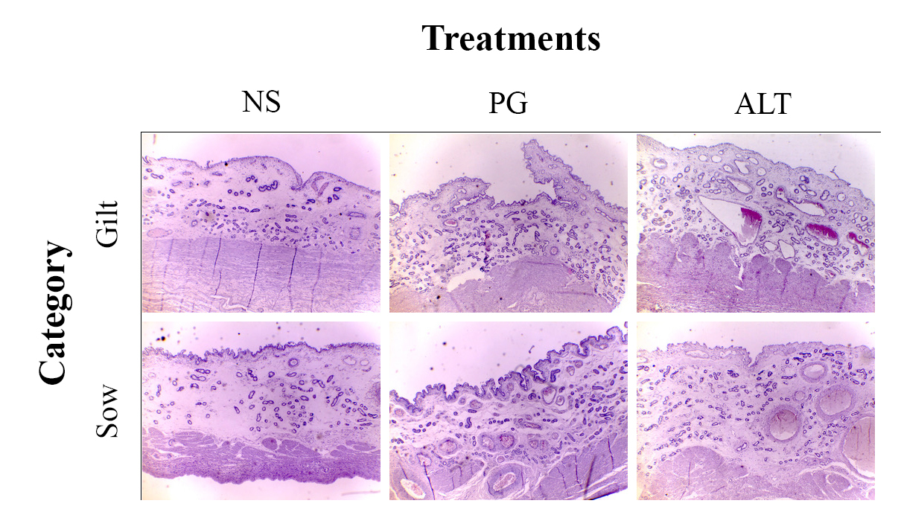
Supplementary figure S1 Effects of supplementation of female pigs with long-term progesterone (PG) or altrenogest (ALT) during early pregnancy on histology of pig uterine glandular epithelium. Representative photomicrographs (4X objective) of hematoxylin and eosin-stained uterine cross sections of gilts and sows from the three groups (NS, PG and ALT) on day 28 of pregnancy are shown. There was not a significant effect of treatment or category for glandular density (GD). Treatments affected total glandular area (GAI) differently in sows and gilts; gilts supplemented with PG or ALT had higher GAI than non-supplemented (NS) gilts. Otherwise, sows from NS had higher GAI than sows from ALT and similar GAI compared to PG-treated sows.

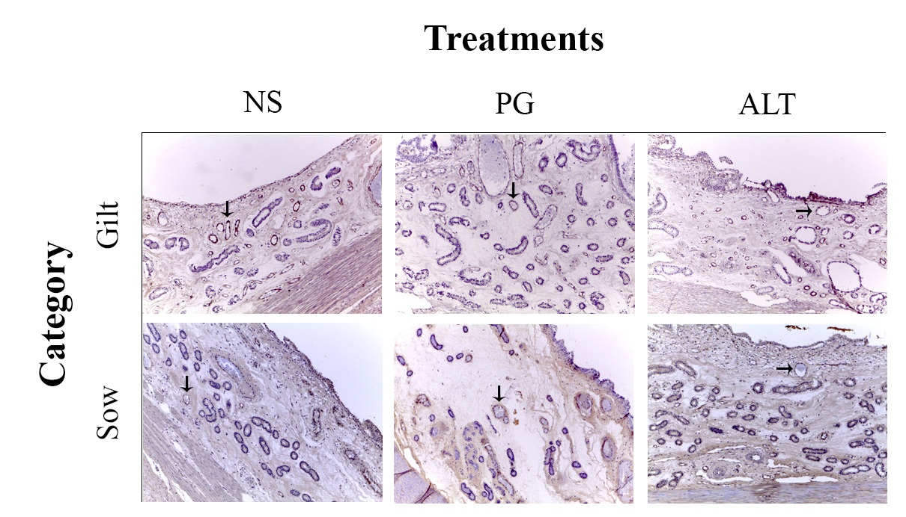
Supplementary figure S2 Effects of supplementation of female pigs with long-term progesterone (PG) or altrenogest (ALT) during early pregnancy on endometrial vasculature. Representative photomicrographs (10X objective) of immunohistochemistry staining for von Willebrand factor (vWF) in uterine cross section of gilts and sows from the three groups (NS, PG and ALT) on day 28 of pregnancy are shown. Arrows are pointing to vWF-stained vessels. Treatments did not affect endometrial vascular density. However, there was a significant difference of category. Gilts had higher endometrial vascular density than sow. NS = non-supplemented group.

