SUPPLEMENTARY INFORMATION
animal journal

Post mortem observations on rumen wall histology and gene expression and ruminal and caecal content of beef cattle fattened on barley-based rations
N.N. Jonsson ^{1,2}, H. Ferguson ^{1,a}, H.H.C. Koh-Tan ¹, C.A. McCartney ³, R.C. Cernat ³, E.M. Strachan ¹, W. Thomson ², T.J. Snelling ³, C.D. Harvey ², I. Andonovic ⁴, C. Michie ⁴, R.J. Wallace ³

¹ Institute of Biodiversity, Animal Health and Comparative Medicine, University of Glasgow, Glasgow G61 1QH, UK
² Harbro Ltd., Turriff, Aberdeenshire AB53 4PA, UK
³ Rowett Institute, University of Aberdeen, Aberdeen AB25 2ZD, UK
⁴ Department of Electrical and Electronic Engineering, Strathclyde University, Glasgow G1 1XW, UK

a Present address: SRUC Dairy Research and Innovation Centre, Hestan House, The Crichton, DG1 4TA, UK

Corresponding author: Nicholas N Jonsson. Email: nicholas.jonsson@glasgow.ac.uk

Short title: Post mortem ruminal findings in beef cattle

Table S1 Subjective, categorical scoring system for gross pathology in the ventral sac of the rumen of cattle at post mortem examination.
Feature | Score | Description
Papillae Colour
0 | A | Black/Brown
1 | B | Grey/Brown
2 | C | Grey/Brown small areas with pink tips
3 | D | Grey/Brown large areas with pink tips
4 | E | Pink
5 | F | Yellow
Papillae Shape
0 | A | Long + Thin
1 | B | Long + Oval
2 | C | Short + Thin
3 | D | Short + Oval
4 | E | Short + Brittle
Ventral Sac
0 | A | No evidence of any damage
1 | B | Small areas bare of papillae
2 | C | Large areas bare of papillae
3 | D | Small areas of excoriation/scarring
4 | E | Red/Bloody areas
5 | F | Parakeratosis

Table S2 List of all the Taqman Gene expression assays that were used in the study on cattle

Gene | Assay ID
ACTB* | Bt03279175_g1
CCL11 | Bt03244553_m1
GAPDH* | Bt03210913_g1
IFNγ | Bt03212723_m1
IL-10 | Bt03212724_m1
IL-1β | Bt03212745_m1
IL-2 | Bt03217368_m1
NHE3 | Bt04309751_m1
RPLP0* | Bt03218082_g1
TLR2 | Bt03223212_m1
TLR4 | Bt03251671_m1
*house-keeping genes

Table S3 Results of Shapiro-Wilk normality tests on continuous variables for the full dataset of 119 cattle, for which complete sets of observations were available.

Variable | W | p
Age | 0.94756 | 0.0004986 | ***
Cold Weight | 0.90969 | 3.424e-06 | ***
RF Histamine | 0.77318 | 3.004e-11 | ***
RF LPS | 0.80141 | 2.074e-10 | ***
RF Acetate | 0.97855 | 0.09577 | .
RF Propionate | 0.88139 | 1.664e-07 | ***
RF isoButyrate | 0.96141 | 0.004523 | **
RF Butyrate | 0.86582 | 3.772e-08 | ***
RF IsoValerate | 0.95326 | 0.0012 | **
RF Valerate | 0.92728 | 2.945e-05 | ***
RF Lactate | 0.95703 | 0.002192 | **
RF Succinate | 0.079727 | < 2.2e-16 | **
RF Prop:Pro | 0.89348 | 5.724e-07 | ***
RF Prop:Ace | 0.89565 | 7.204e-07 | ***
RF Prop:But | 0.87254 | 7.061e-08 | ***
RF Ace:Pro | 0.98896 | 0.5671 | NS
RF Total SCFA | 0.98016 | 0.1286 | NS
CF LPS | 0.80018 | 1.899e-10 | ***
CF Formate | 0.81117 | 4.218e-10 | ***
CF Acetate | 0.9845 | 0.2795 | NS
CF Propionate | 0.98591 | 0.3546 | NS
CF isobutyrate | 0.98044 | 0.1353 | NS
CF Butyrate | 0.70239 | 4.443e-13 | ***
CF isovalerate | 0.95884 | 0.002951 | **
CF Valerate | 0.98657 | 0.3953 | NS
CF Lactate | 0.92658 | 2.689e-05 | ***
CF Succinate | 0.23552 | < 2.2e-16 | ***
CF Ace:Pro | 0.90526 | 2.064e-06 | ***
CF Total SCFA | 0.98951 | 0.6111 | NS
TLR4 RE | 0.84794 | 7.773e-09 | ***
IL1B RE | 0.32455 | < 2.2e-16 | ***
CCL11 RE | 0.35602 | < 2.2e-16 | ***
NHE3 RE | 0.79918 | 1.769e-10 | ***
IL2 RE | 0.12574 | < 2.2e-16 | ***
IFNG RE | 0.19145 | < 2.2e-16 | ***
SC | 0.75313 | 8.384e-12 | ***
SG | 0.80126 | 2.051e-10 | ***
Vascular diameter | 0.69995 | 3.893e-13 | ***
CD3 | 0.96883 | 0.01634 | *
MHCII | 0.85897 | 2.03e-08 | ***
Key: NS p > 0.1, . p < 0.1; * p < 0.05, ** p < 0.01, *** p < 0.001; ace = acetate, but = butyrate, CD3 = cluster of distinction 3, CF = cecal fluid, LPS = lipopolysaccharide,MHCII = major histocompatibility 2, Pro = propionate, Prop = proportion of total, RE = relative expression, RF = rumen fluid, SC = stratum corneum, SCFA = short-chain fatty acids, SG = stratum granulosum.

Table S4 Count of cattle with post mortem papillae characterised by colour, grouped by farm of origin
 |  | Farm of origin
Description | Score | BH1 | BH6 | BH7 | BL2 | BL3 | BL7
Black/Brown | A | 3 | 5 | 10 | 14 | 1 | 16
Grey/Brown | B | 7 | 4 | 5 | 4 | 2 | 3
Grey/Brown small areas with pink tips | C | 5 | 6 | 2 | 0 | 6 | 0
Grey/Brown large areas with pink tips | D | 4 | 5 | 2 | 1 | 6 | 0
Pink | E | 1 | 0 | 0 | 1 | 5 | 0
Yellow | F | 0 | 0 | 0 | 0 | 0 | 0

Table S5 Count of cattle with post mortem papillae characterised by shape, grouped by farm of origin
 |  | Farm of origin
Description | Score | BH1 | BH6 | BH7 | BL2 | BL3 | BL7
Long + Thin | A | 10 | 12 | 9 | 8 | 12 | 17
Long + Oval | B | 9 | 6 | 8 | 11 | 6 | 2
Short + Thin | C | 0 | 2 | 0 | 0 | 0 | 0
Short + Oval | D | 0 | 0 | 2 | 1 | 1 | 0
Short + Brittle | E | 1 | 0 | 0 | 0 | 1 | 0

Table S6 Count of cattle with post mortem ruminal luminal wall characterised by presence of lesions, grouped by farm of origin

 |  | Farm of origin
Description | Score | BH1 | BH6 | BH7 | BL2 | BL3 | BL7
No evidence of any damage | A | 15 | 19 | 19 | 18 | 14 | 19
Small areas bare of papillae | B | 2 | 1 | 0 | 0 | 5 | 0
Large areas bare of papillae | C | 2 | 0 | 0 | 0 | 1 | 0
Small areas of excoriation/scarring | D | 1 | 0 | 0 | 0 | 0 | 0
Red/Bloody areas | E | 0 | 0 | 0 | 0 | 0 | 0
Parakeratosis | F | 0 | 0 | 0 | 2 | 0 | 0

Table S7 Correlation matrix of selected variables from 119 cattle.
 | Age | Cold  Wt | RF  SCFA | CF  SCFA | RF  Lact | RF  LPS | CF  LPS | IFNG | IL1B | NHE3 | TLR4 | CCL11 | RF  Hist | SC | SG | VASCD | CD3
ColdWt | 0.29
RF SCFA | -0.40 | -0.36
CF SCFA | 0.14 | -0.01 | -0.09
RF Lact | 0.09 | 0.50 | 0.03 | -0.20
RF LPS | 0.10 | 0.00 | -0.04 | 0.05 | -0.04
CF LPS | 0.19 | 0.03 | -0.02 | 0.06 | 0.09 | -0.16
IFNG | -0.01 | -0.27 | 0.08 | -0.05 | -0.14 | -0.24 | 0.15
IL1B | -0.08 | -0.16 | 0.25 | -0.16 | -0.10 | 0.23 | 0.01 | 0.33
NHE3 | -0.10 | 0.10 | 0.14 | -0.14 | 0.05 | 0.07 | -0.01 | 0.17 | 0.29
TLR4 | 0.08 | 0.21 | -0.11 | -0.16 | 0.18 | 0.03 | -0.11 | 0.36 | 0.28 | 0.44
CCL11 | -0.10 | -0.14 | 0.09 | 0.05 | -0.07 | -0.18 | 0.12 | 0.57 | 0.11 | -0.05 | 0.27
RF Hist | -0.25 | -0.08 | 0.30 | -0.27 | 0.02 | -0.09 | -0.28 | -0.03 | 0.13 | 0.30 | 0.13 | -0.07
SC | 0.15 | 0.36 | -0.40 | -0.11 | 0.07 | 0.28 | -0.32 | -0.13 | -0.11 | -0.03 | 0.11 | -0.19 | -0.02
SG | 0.10 | 0.21 | -0.28 | -0.15 | 0.07 | 0.33 | -0.38 | -0.15 | -0.07 | 0.01 | 0.17 | -0.20 | 0.07 | 0.81
VASCD | 0.12 | 0.17 | -0.26 | -0.16 | -0.05 | 0.17 | -0.21 | -0.13 | 0.11 | 0.21 | 0.24 | -0.24 | 0.21 | 0.53 | 0.63
CD3 | 0.09 | -0.13 | 0.08 | 0.16 | -0.14 | -0.24 | 0.29 | 0.19 | 0.06 | -0.16 | -0.17 | -0.03 | -0.10 | -0.20 | -0.29 | -0.13
MHCII | -0.06 | -0.30 | 0.18 | 0.19 | -0.12 | -0.11 | 0.24 | 0.30 | 0.02 | 0.00 | -0.07 | 0.17 | 0.10 | -0.31 | -0.35 | -0.21 | 0.31
CD3 = cluster of distinction 3, CF = caecal fluid, Cold Wt = cold weight of carcase after slaughter, Lact = lactate concentration, hist = histamine concentration, LPS = lipopolysaccharide, MHCII = major histocompatibility complex 2, Pro = propionate, Prop = proportion of total, RE = relative expression, RF = rumen fluid, SC = stratum corneum, SCFA = short-chain fatty acids, SG = stratum granulosum, VASCD = vascular diameter,

Table S8 Summary of linear regression models for each of the selected outcome variables against the dietary input variables (percentage dry matter of barley, silage, straw, crude protein and crude fibre, and percentage of fines in TMR). For each outcome variable (rows) the best predictor from among the dietary input variables is underlined and in bold.

Variable | Barley |  | Silage |  | Straw |  | TMR Fines % |  | Crude Protein |  | Crude Fibre
 | Adj R² | P-value | Adj R² | P-value | Adj R² | P-value | Adj R² | P-value | Adj R² | P-value | Adj R² | P-value
RF Histamine | 0.010 | 0.919 | 0.045 | 0.019 | 0.028 | 0.053 | 0.109 | <0.001 | 0.089 | 0.001 | 0.208 | <0.001
RF LPS | 0.016 | 0.112 | 0.012 | 0.142 | 0.009 | 0.793 | 0.050 | 0.008 | 0.181 | <0.001 | 0.070 | 0.002
CF LPS | 0.108 | 0.001 | 0.157 | <0.001 | 0.008 | 0.599 | 0.008 | 0.718 | 0.157 | <0.001 | 0.004 | 0.440
RF Lactate | 0.067 | 0.005 | 0.078 | 0.003 | 0.062 | 0.007 | 0.216 | <0.001 | 0.285 | <0.001 | 0.084 | 0.001
CF Lactate | 0.161 | <0.001 | 0.248 | <0.001 | 0.010 | 0.861 | 0.009 | 0.960 | 0.047 | 0.012 | 0.006 | 0.550
RF Total SCFA | 0.268 | <0.001 | 0.077 | 0.003 | 0.303 | <0.001 | 0.389 | <0.001 | 0.095 | <0.001 | 0.295 | <0.001
CF Total SCFA | 0.022 | 0.081 | 0.016 | 0.113 | 0.010 | 0.771 | 0.007 | 0.645 | 0.047 | 0.012 | 0.009 | 0.929
TLR4 RE | 0.054 | 0.011 | 0.033 | 0.038 | 0.047 | 0.018 | 0.088 | 0.001 | 0.165 | <0.001 | 0.037 | 0.020
IL1B RE | 0.054 | 0.012 | 0.011 | 0.148 | 0.071 | 0.004 | 0.111 | <0.001 | <0.001 | 0.310 | 0.065 | 0.003
CCL11 RE | 0.008 | 0.180 | 0.002 | 0.363 | 0.024 | 0.066 | 0.004 | 0.487 | 0.021 | 0.065 | 0.008 | 0.938
NHE3 RE | 0.018 | 0.097 | 0.011 | 0.155 | 0.010 | 0.859 | 0.004 | 0.488 | 0.088 | 0.001 | 0.009 | 0.979
IL2 RE | 0.023 | 0.073 | 0.004 | 0.439 | 0.015 | 0.115 | 0.008 | 0.778 | 0.082 | 0.001 | 0.009 | 0.926
IFNg | 0.064 | 0.007 | 0.072 | 0.004 | 0.039 | 0.028 | 0.079 | 0.001 | 0.180 | <0.001 | 0.009 | 0.150
SC | 0.271 | <0.001 | 0.114 | 0.001 | 0.261 | <0.001 | 0.314 | <0.001 | 0.380 | <0.001 | 0.208 | <0.001
SG | 0.208 | <0.001 | 0.076 | 0.004 | 0.187 | <0.001 | 0.202 | <0.001 | 0.331 | <0.001 | 0.166 | <0.001
VASCD | 0.136 | <0.001 | 0.040 | 0.030 | 0.161 | <0.001 | 0.094 | 0.001 | 0.192 | <0.001 | 0.062 | 0.005
CD3+ | 0.052 | 0.015 | 0.033 | 0.043 | 0.048 | 0.020 | 0.119 | <0.001 | 0.349 | <0.001 | 0.059 | 0.006
MHCII+ | 0.011 | 0.950 | 0.002 | 0.288 | 0.041 | 0.028 | 0.103 | <0.001 | 0.135 | <0.001 | 0.050 | 0.010
CD3 = cluster of distinction 3, CF = caecal fluid, LPS = lipopolysaccharide, MHCII = major histocompatibility complex2, Pro = propionate, Prop = proportion of total, RE = relative expression, RF = rumen fluid, SC = stratum corneum, SCFA = short-chain fatty acids, SG = stratum granulosum, TMR = total mixed ration, VASCD = vascular diameter,

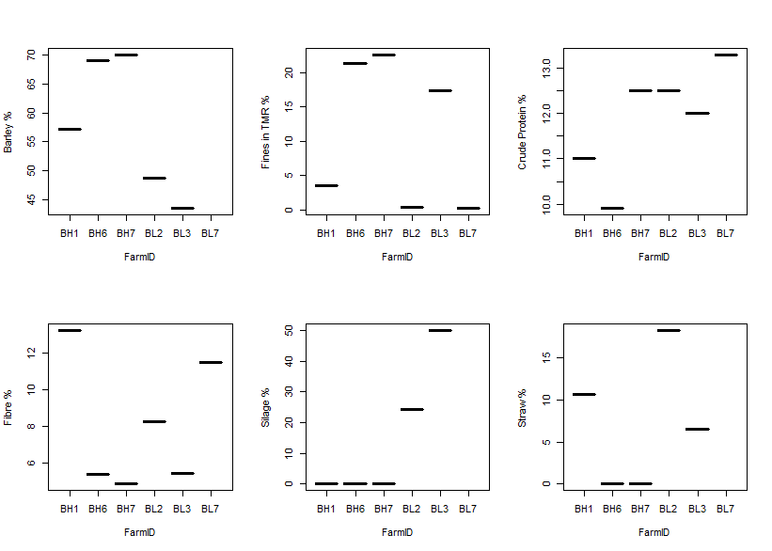
Figure S1 This panel summarises the distribution of the six variables in the diets of 119 cattle that were considered as possible predictors for variation in the dependent variables measured in the study. Farms labelled as BH1,BH6, BH7 were classed a priori as high-risk and those labelled BL2, BL3, BL7 were low-risk. It is clear that there is considerable potential for interaction among the variables, which is not amenable to statistical modelling. TMR = total mixed ration
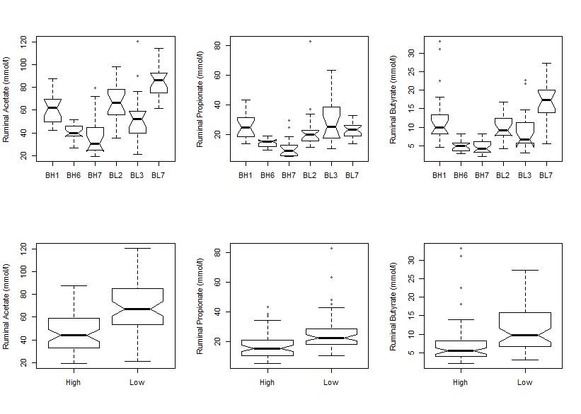
Figure S2 Concentrations of acetate, propionate and butyrate in the rumens of cattle, by farm of origin (above) and risk (below). Farms labelled as BH1,BH6, BH7 were classed a priori as high-risk and those labelled BL2, BL3, BL7 were low-risk.
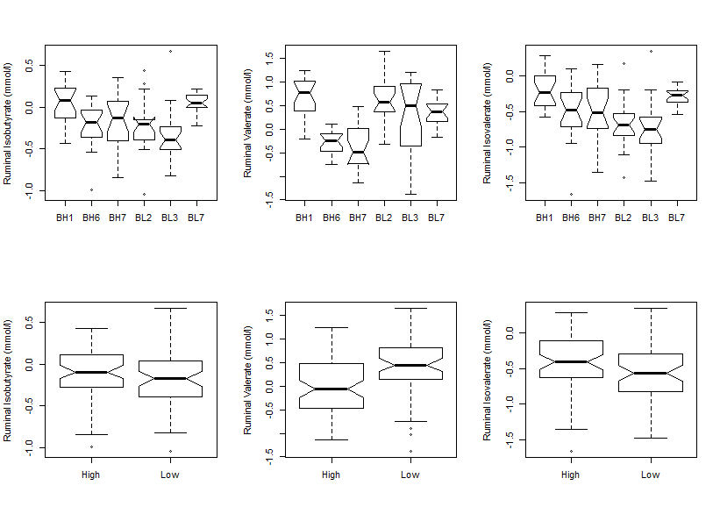
Figure S3 Concentrations of isobutyrate, valerate and isovalerate in the rumens of cattle from each farm (above) and by risk classification of the farm of origin (below). Farms labelled as BH1,BH6, BH7 were classed a priori as high-risk and those labelled BL2, BL3, BL7 were low-risk.
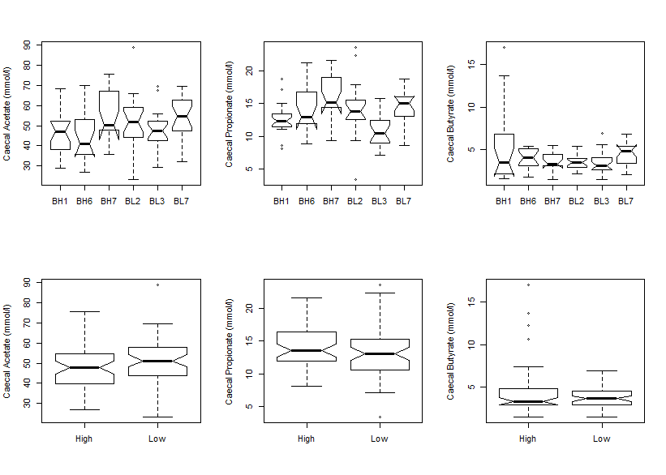
Figure S4 Box and whisker plots showing acetate, propionate, and butyrate concentration in caecal fluid of the cattle on six beef finishing units (above) and by risk category of farm of origin (below). Farms labelled as BH1,BH6, BH7 were classed a priori as high-risk and those labelled BL2, BL3, BL7 were low-risk.
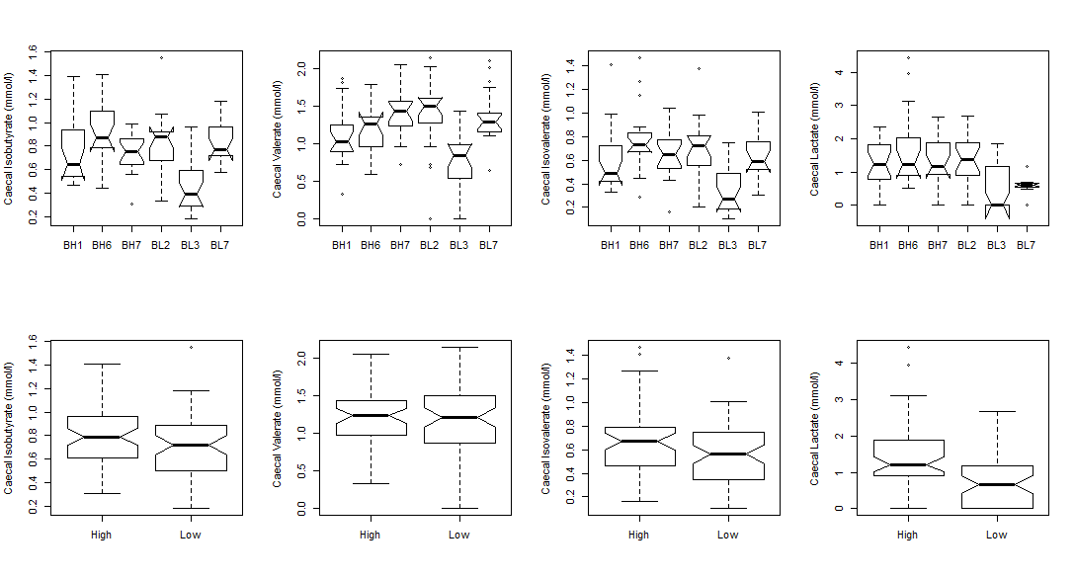

Figure S5 Box and whisker plots showing isobutyrate, valerate, isovalerate and lactate concentrations in caecal fluid of the cattle on six beef finishing units (above) and by risk category of farm of origin (below). Farms labelled as BH1,BH6, BH7 were classed a priori as high-risk and those labelled BL2, BL3, BL7 were low-risk.
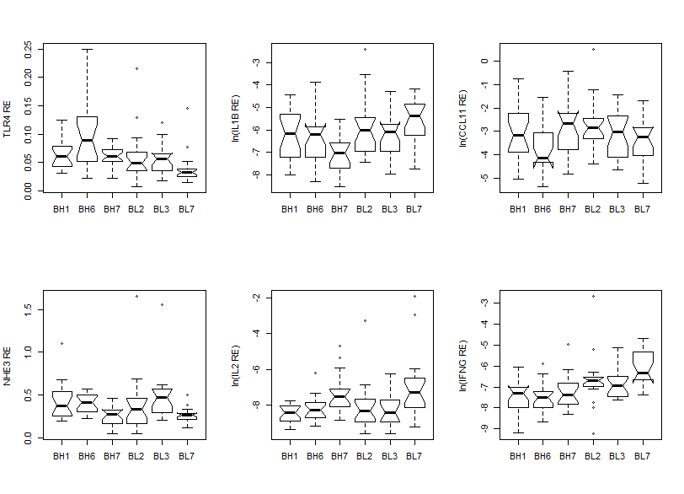
Figure S6 Box and whisker plots showing the relative gene expression of TLR4, IL1B, CCL11, NHE3, IL2 and IFNG in the ruminal wall of cattle from each of the farms. Farms labelled as BH1,BH6, BH7 were classed a priori as high-risk and those labelled BL2, BL3, BL7 were low-risk. Note that IL1B, CCL11, IL2 and IFNG relative expression values have been natural log transformed (ln) for ease of visualisation.
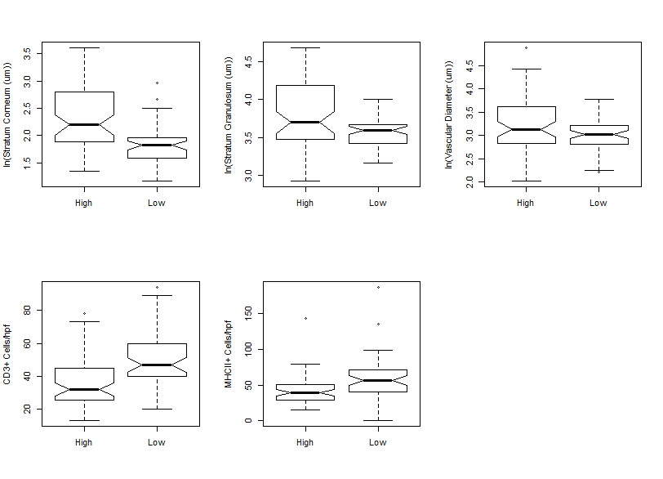
Figure S7 Box and whisker plots showing the main histological indicators in rumen of cattle, by a priori risk classification of farm of origin. Note that stratum corneum and granulosum thickness and vascular diameter are natural log-transformed (ln) for ease of visualisation.CD3 = cluster of distinction 3, hpf = high-power field, MHCII = major histocompatibility complex 2
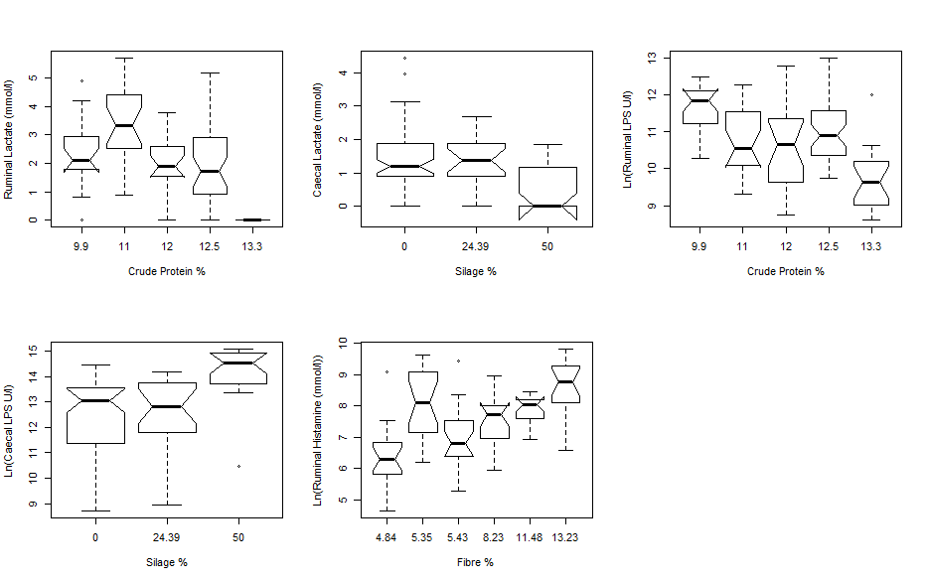
Figure S8 Box and whisker plots showing ruminal and caecal concentrations of lactate and lipopolysaccharide (LPS), and concentration of histamine in the rumen of cattle against the strongest potential predictor input variable for each.
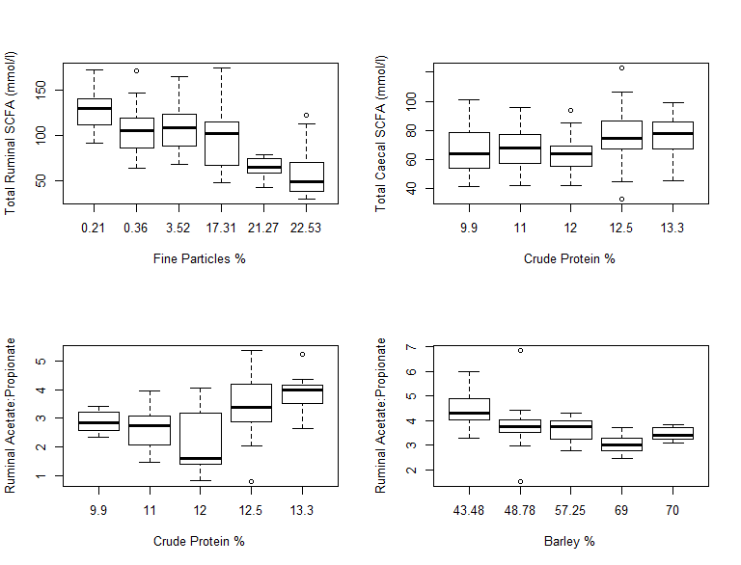
Figure S9 Box and whisker plots showing total short-chain fatty acids (SCFA) concentrations and the ratios of acetate to propionate in ruminal and caecal fluid of cattle against the strongest potential predictor input variable for each.
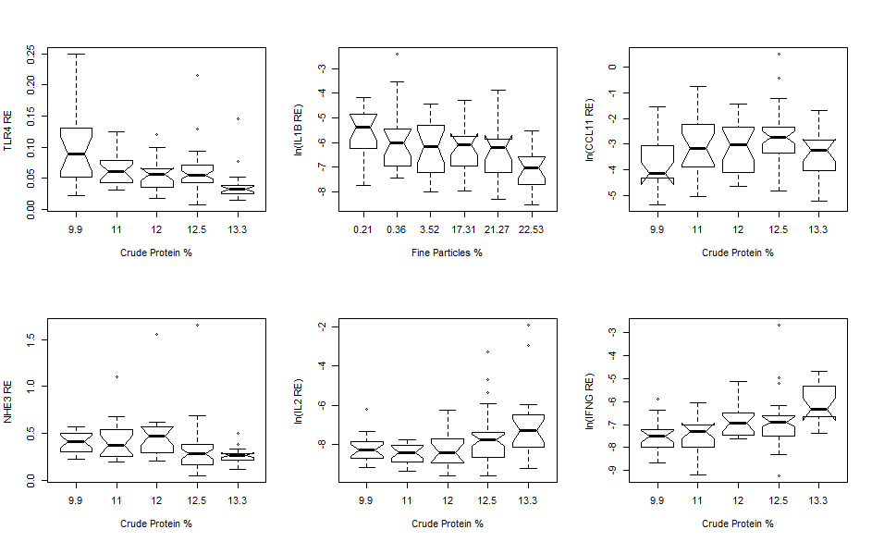
Figure S10 Box and whisker plots showing total relative expression of six genes (TLR4, IL1B, CCL11, NHE3, IL2 and IFNG) in ruminal wall against the strongest potential predictor input variable for each. Note that IL1B, CCL11, IL2 and IFNG have been natural log-transformed (ln) for ease of visualisation.
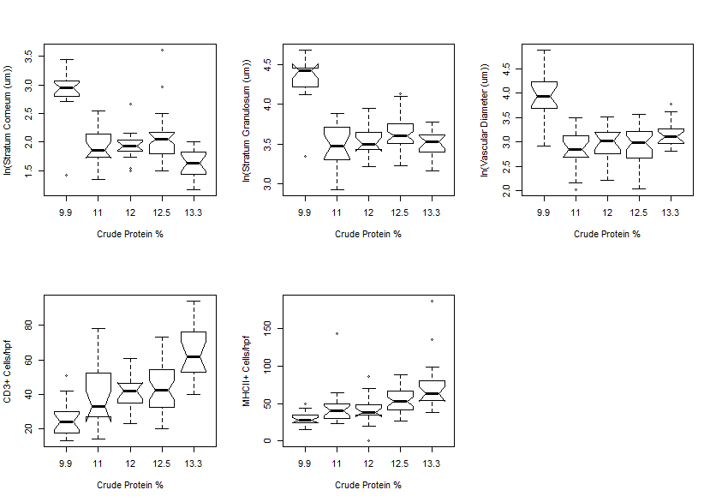
Figure S11 Box and whisker plots showing histological variables from ruminal wall tissue against the strongest potential predictor input variable for each (crude protein in all cases). CD3 = cluster of distinction 3, hpf = high-power field, MHCII = major histocompatibility complex 2.

