Animal Journal
Bacterial concentrations in bedding and their association with dairy cow hygiene and milk quality

1 Department of Animal Biosciences, University of Guelph, Ontario, N1G 2W1, Canada
2 Department of Population Medicine, University of Guelph, Guelph, N1G 2W1, Canada
3 Department of Production Animal Health, Faculty of Veterinary Medicine, University of Calgary, Calgary, AB, T2N 4N1, Canada
4 Atlantic Veterinary College, University of Prince Edward Island, Charlottetown, PEI, C1A 4P3, Canada
5 Faculté de médecine vétérinaire, Université de Montréal, St-Hyacinthe, QC, J2S 2M2, Canada
6 Animal Welfare Program, Faculty of Land and Food Systems, University of British Columbia, Vancouver, BC, V6T 1Z6, Canada

†Corresponding author: Trevor DeVries, Email: tdevries@uoguelph.ca

Supplementary Material S1: Predictor variables for univariable models
Predictor variables included in the univariable models for the outcome variables % dry matter (DM) and bacterial content (separate for Streptococcus spp., all Gram-negatives, Klebsiella spp.) in used bedding were: used bedding type (straw, sawdust, wood products, recycled manure solids [RMS]), housing (free-stall, tie-stall), weighed stocking density (# of cows/# of stalls, then average stocking density among all milking cows pens), lime used on bedding (yes/no), days since additional bedding was added to the stall, base of the stall (mattress, deep bedding), how often stalls were scraped (# per d), temperature, relative humidity of the environment, and visit.

Predictor variables included in the univariable models for the outcome variable hygiene - percentage of dirty cows per farm (body areas: lower legs, udder, upper legs and flanks) in free-stall barns were bedding type, DM% of used bedding type, temperature, relative humidity of the environment, weighed stocking density, milking system, neck rail distance from rear curb, how often stalls were scraped (# per d), days since additional bedding was added, lime used on bedding (yes/no),base of the stall, stall width, neck rail height (cm), number of times cows were milked (# per d), visit, frequency of alley cleaning per day, number of cows milking, days in milk (DIM), lactation, and milk yield (kg). Post dip (spray/dipper) was an additional predictor variable for the udder.

Predictor variables included in the univariable models for the outcome variable hygiene - percentage of dirty cows per farm (body areas: lower legs, udder, upper legs and flanks) in tie-stall barns were used bedding type, DM% of used bedding, temperature, relative humidity of the environment, weighed stocking density, milking system, neck rail distance from rear curb, how often stalls were scraped (# per d), days since additional bedding was added, base of the stall, stall width, neck rail height (cm), number of times cows were milked (# per d), visit, number of cows milking, DIM, lactation, milk yield (kg), herd access to pasture (yes/no) and lime added to bedding (yes/no). Post dip (spray/dipper) was an additional predictor variable for the udder.

Predictor variables included in the univariable models for the outcome variable farm weighted average somatic cell count (SCC) from the dairy herd improvement (DHI) organization, and bulk milk quality (bulk milk SCC and bulk milk bacteria count from the Dairy Farmers of Ontario [Mississauga, ON, Canada]) were DM% of used bedding type, temperature, gloves while milking (yes/no), relative humidity of the environment, housing, weighed stocking density, milking system, neck rail distance from rear curb, how often stalls were scraped (# per d), days since additional bedding was added, base of the stall, stall width, neck rail height (cm), lime, post dip, number of times cows were milked (# per d), visit (not included for the outcome variable farm weighted average SCC from DHI), number of cows milking, DIM, lactation, milk yield (kg), and bacterial content in used bedding (Streptococcus spp., all Gram-negatives, Klebsiella spp.)

Supplementary Material S2: Plots of model fit for one of each constructed model shown in Tables 3, 4, 5, and 6:

- Table 3: Udder hygiene in free stall barns
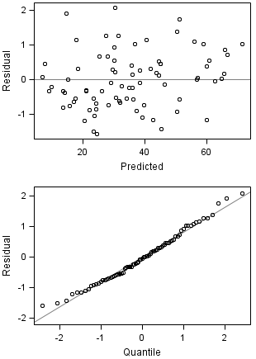
- Table 4: Lower leg hygiene in tie stall barns
Indications of outliers and variance heterogeneity should be considered when effect estimates and P-values are interpreted.

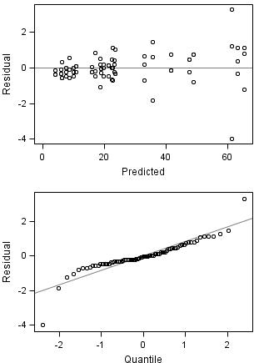

- Table 5: Bulk milk bacteria content
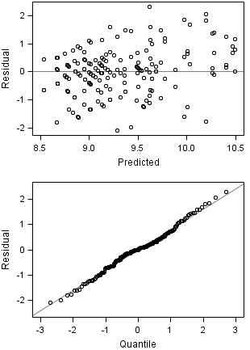

- Table 6: Dry matter percentage of unused bedding samples

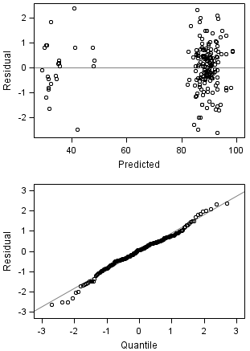

- Table 6: Dry matter percentage of used bedding samples
Indications of outliers and variance heterogeneity should be considered when effect estimates and P-values are interpreted.

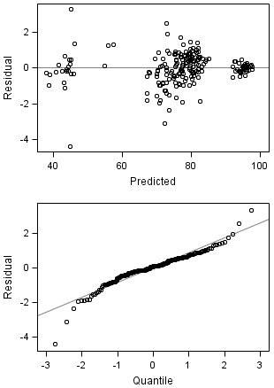

Supplementary Material S3: Example of SAS code for multivariable mixed model

ods graphics on;
proc mixed;
class Farm Bedding_subtype Visit ;
model Unused_DM = Bedding_subtype Tempavg Relhumavg Visit/ddfm=kr solution residual influence (iter=1000) ;
random Farm;
repeated Visit/ subject= farm type= cs;
lsmeans Bedding_subtype /pdiff adjust=tukey;
run;
ods graphics off;

Supplementary Figure S1: Association between stall width (cm) and back of the stall to neck rail length (cm) for dairy cows

