Use of milk electrical conductivity for the differentiation of mastitis causing pathogens
S. Paudyal¹, P. Melendez², D. Manriquez¹, A. Velasquez¹, G. Pena², I. N. Roman-Muniz¹, P. J. Pinedo^{1*}
¹Department of Animal Sciences, Colorado State University, Fort Collins, CO 80523, USA
²Department of Clinical Sciences, College of Veterinary Medicine, University of Missouri, Columbia, MO 65201, USA
³Zoetis, Parsippany, NJ 07054, USA
*Corresponding author: Pablo Pinedo. E-mail: pablo.pinedo@colostate.edu

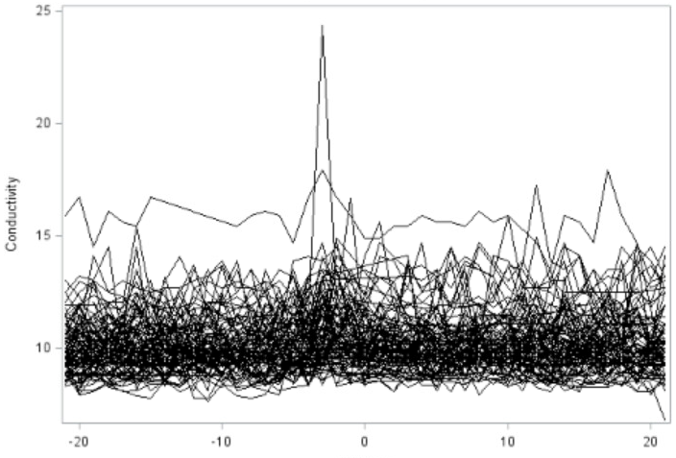
A
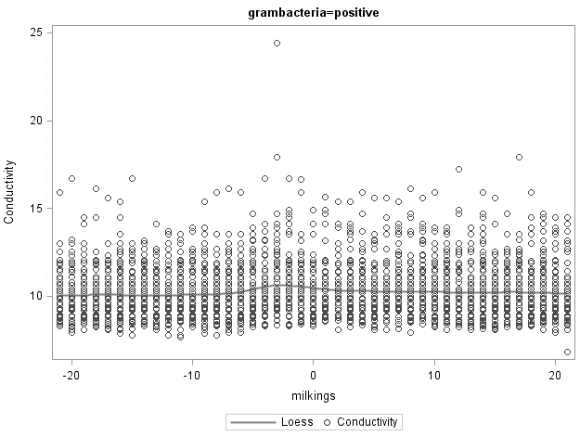
B
C

Milking event

Figure S1: Milk electrical conductivity by individual cow from -20 to 20 milking events relative to sampling in individuals identified with Gram positive bacteria in milk cultures. A) Cow-points connected by lines. B) Cow-points represented by circles with the average trend indicated by a solid line. C) Predicted linear regression for individual cows. Overall regression line indicated by a dashed line.
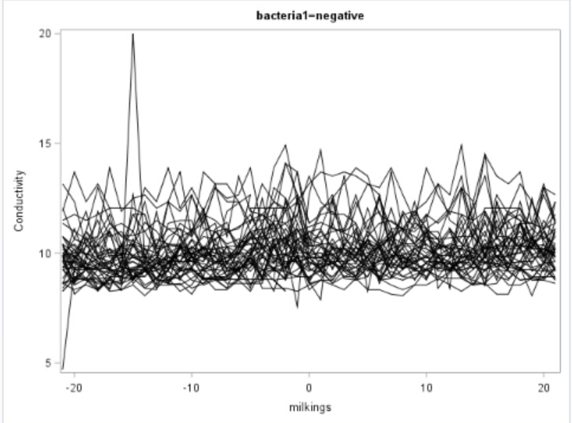
A

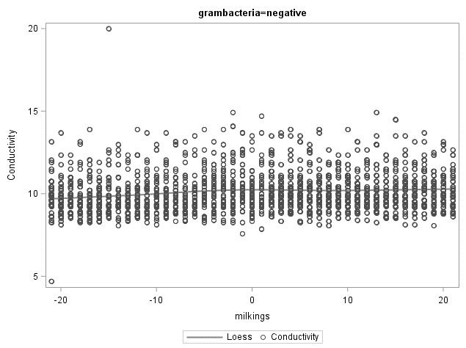
B
A
C
Milking event

Figure S2: Milk electrical conductivity by individual cow from -20 to 20 milking events relative to sampling in individuals identified with Gram negative bacteria in milk cultures. A) Cow-points connected by lines. B) Cow-points represented by circles with the average trend indicated by a solid line. C) Predicted linear regression for individual cows. Overall regression line indicated by a dashed line.

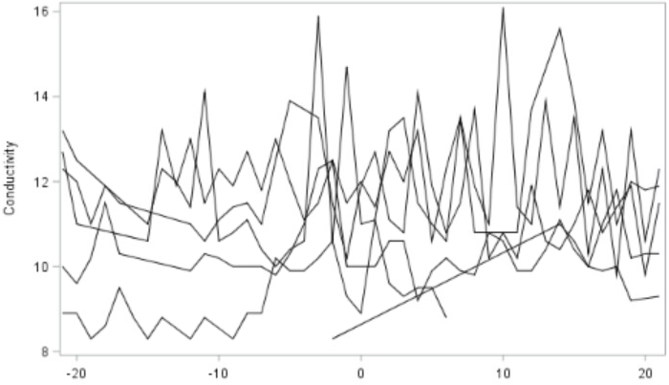
A
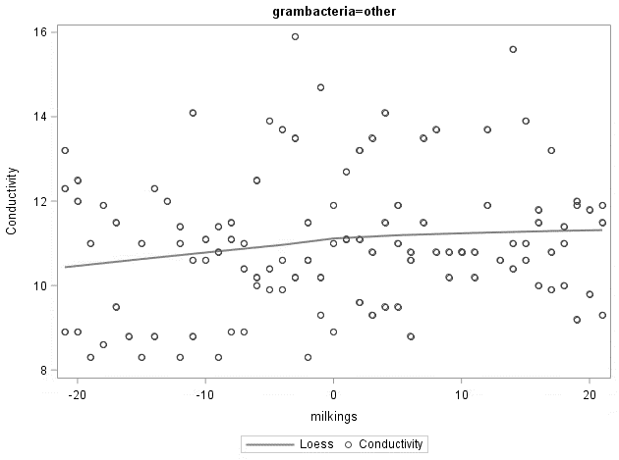
B
C
Milking event

Figure S3: Milk electrical conductivity by individual cow from -20 to 20 milking events relative to sampling in individuals identified with other pathogen in milk cultures. A) Cow-points connected by lines. B) Cow-points represented by circles with the average trend indicated by a solid line. C) Predicted linear regression for individual cows. Overall regression line indicated by a dashed line.

A
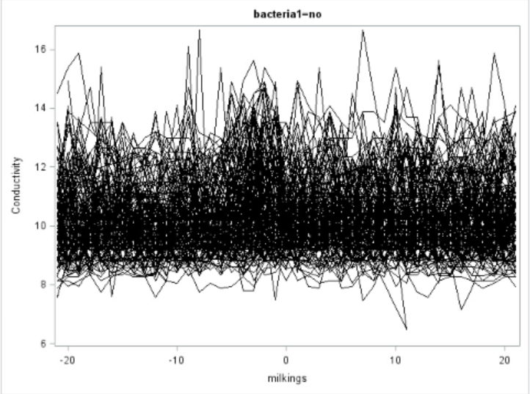
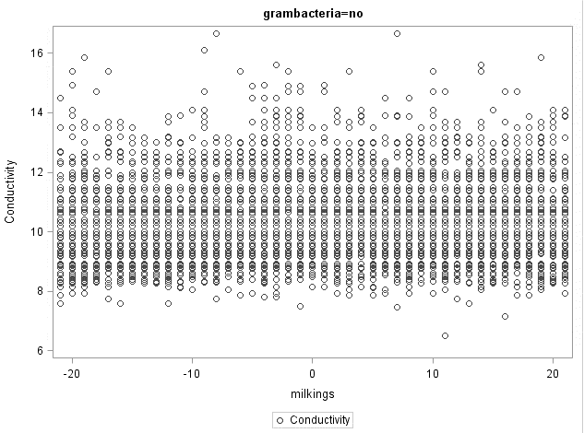
B
C

Milking event

Figure S4: Milk electrical conductivity by individual cow from -20 to 20 milking events relative to sampling in individuals identified with no bacterial growth in milk cultures. A) Cow-points connected by lines. B) Cow-points represented by circles with the average trend indicated by a solid line. C) Predicted linear regression for individual cows. Overall regression line indicated by a dashed line.

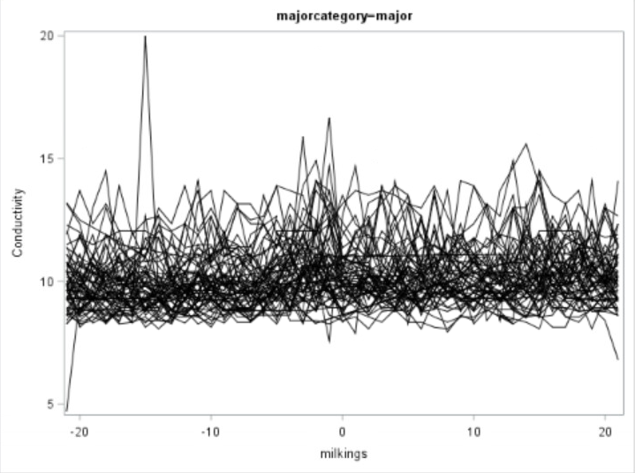
A

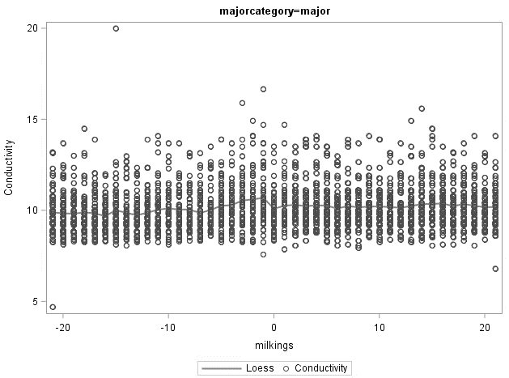
B
C
Milking event

Figure S5: Milk electrical conductivity by individual cow from -20 to 20 milking events relative to sampling in individuals identified with a major pathogen in milk cultures. A) Cow-points connected by lines. B) Cow-points represented by circles with the average trend indicated by a solid line. C) Predicted linear regression for individual cows. Overall regression line indicated by a dashed line.

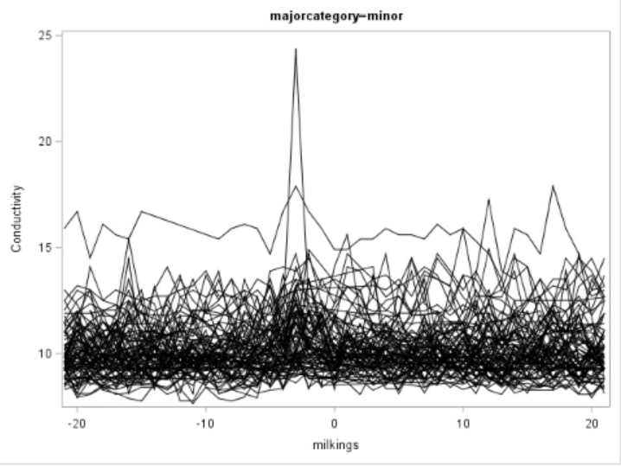
A
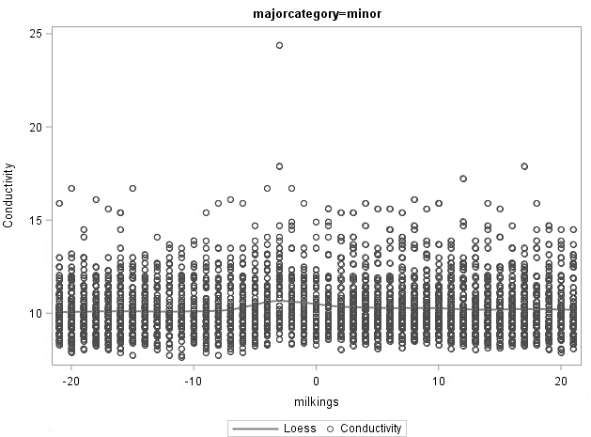
B
C
Milking event

Figure S6: Milk electrical conductivity by individual cow from -20 to 20 milking events relative to sampling in individuals identified with a minor pathogen in milk cultures. A) Cow-points connected by lines. B) Cow-points represented by circles with the average trend indicated by a solid line. C) Predicted linear regression for individual cows. Overall regression line indicated by a dashed line.

Figure S7: Average (SE) milk yield (d⁻¹; broken line) and conductivity (solid line) in latent mastitis cases from d -7 to d 7 relative to sampling.

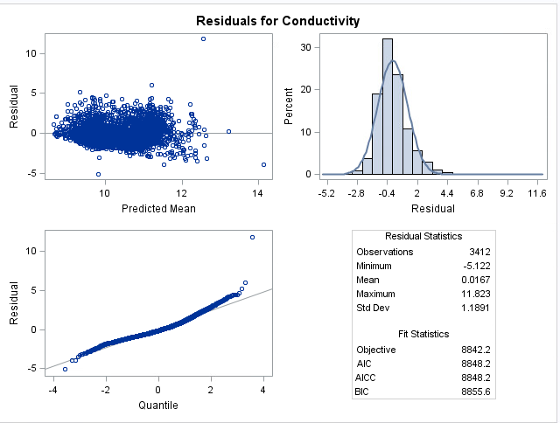

Figure S8: Residual influence diagnostics component of PROC MIXED (SAS) for milk electrical conductivity in the overall study population. AIC = Akaike's Information Criterion; AICC = Akaike's Information Criterion correction; BIC = Bayesian information criterion

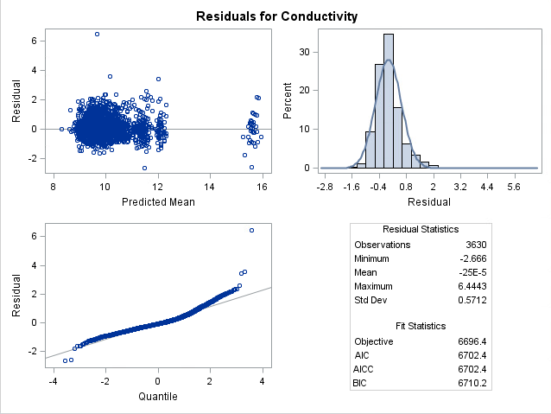

Figure S9: Residual influence diagnostics component of PROC MIXED (SAS) for milk electrical conductivity in the high electrical conductivity group. AIC = Akaike's Information Criterion; AICC = Akaike's Information Criterion correction; BIC = Bayesian information criterion

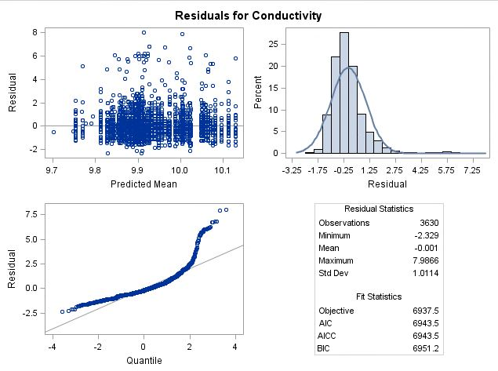

Figure S10: Residual influence diagnostics component of PROC MIXED (SAS) for milk electrical conductivity in the control group. AIC = Akaike's Information Criterion; AICC = Akaike's Information Criterion correction; BIC = Bayesian information criterion

Supplementary Material S1: Examples of SAS codes used for repeated measures analyses (A) and for graphic representation of individual cow EC across milking events (B).

A)
proc mixed data = treatmentsgraph1;
class grambacteria milkings farm Lact_no;
model conductivity = grambacteria milkings farm DIM1 LAct_no grambacteria*milkings/ s;
random animalid;
repeated milkings/ type = cs sub = animalid(farm);
Lsmeans grambacteria/pdiff;
lsmeans milkings/pdiff;
lsmeans grambacteria*milkings/pdiff;
run;

B)
proc mixed data = Totalcalculations3 plots (maxpoints = none) = residualpanel;
class animalid grambacteria DIM milkings farm Lact_no;
model conductivity = grambacteria milkings farm DIM LAct_no grambacteria*milkings/s outpm=resm vciry residual;
random animalid;
repeated milkings/ type = cs sub = animalid(farm);
run;

