Evaluation of three methods to assess the degree of milk-out in dairy cows

D. Meyer, A. Haeussermann, K. Barth, S. Lingner and E. Hartung

Supplementary material for animal journal
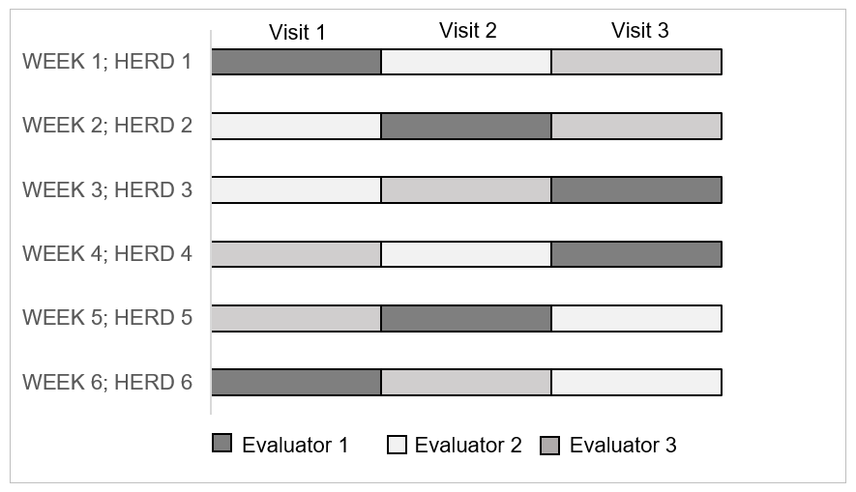Supplementary Figure S1 Randomised temporal organisation of the three evaluators when assessing completeness of milk-out in German Holstein dairy cow herd 1 to 6. All dairy herds were visited once by each evaluator

Supplementary Table S1 Characteristics of six German Holstein dairy cow herds, parlours and parlour settings at the six dairy farms included in the evaluation of completeness of milk-out
 | Farm
 | A | B | C | D | E | F
Herd characteristics
Herd size | 198 | 81 | 390 | 194 | 140 | 303
Mean lactation number | 2.3 | 2.2 | 2.6 | 1.3 | 1.6 | 2.1
Parlour types and technical settings
Milking parlour type | parallel | auto-tandem | parallel | herringbone | herringbone | herringbone
Size of milking parlour | 2x12 | 2x4 | 2x20 | 2x12 | 2x8 | 2x8
Operating vacuum setting (kPa) | 42 | 37 | 44 | 43 | 37 | 43
Pulsation ratio | 60:40 | 60:40 | 60:40 | 65:35 | 60:40 | 60:40
Pulsation rate (cycles/min) | 60 | 60 | 60 | 60 | 60 | 58
Automatic cluster remover setting (ml/min) | 300 | 300 | 480 | 300 | 250 | 750
Delay times (s) | 25 |  | 25 | 30 | 30 | 20
Mean vacuum level at the teat end  during ongoing milk flow (kPa) ¹ | - | 34.4  (n = 32) | 35.1  (n = 44) | 37.6  (n = 32) | 36.7  (n = 28) | -
1 Vacuum measurements conducted in July and August 2017

Supplementary Material S1 Logistic and linear regression model description

A logistic regression model was fitted to analyse the relationship between the outcome of the visual scoring of the degree of quarter filling (VISUAL) (target) and the herd, the evaluators and the strip yield in 60 s (SY60) (predictors). A linear regression model was introduced to analyse the relationship between the outcome of the precisely defined hand milking method (DEFINED) (target) and the method of quantitative assessment of number of easy strips (EASYSTRIPS) (target) and the herd, the evaluators and SY60 (predictors). The models were defined as

$Yi= β0+ β1xi + β2xi +β3xi + εi$
Where
$Y_{i }$is the outcome of the assessment of the cow’s quarters with the VISUAL, the DEFINED or the EASYSTRIPS method
$β0$ is the intercept
$β_{1}xi$ is the effect of the herd
$β_{2}xi$ is the effect of the evaluator
$β_{3}xi$ is the effect of SY60
$ε_{i}$ is the random error for the model

Supplementary Material S2 Exemplary R Code of the linear regression model for the method of quantitative assessment of number of easy strips (EASYSTRIPS)

lmEASYSTRIPS <- lme(EASYSTRIPS ~ SY60 + herd + evaluator, data=data1, random=~1|ID, na.action=na.exclude, weights=varIdent(form=~1|herd*evaluator), method="ML", control=list(maxIter=255,msMaxIter=255,opt="nlminb"))
anova(lmEASYSTRIPS)
summary(lmEASYSTRIPS)

