SUPPLEMENTARY MATERIAL - Animal journal
A Generalized Additive Model to characterize dairy cows responses to heat stress
S. Benni 1, M. Pastell 2, F. Bonora 1, P. Tassinari 1 and D. Torreggiani 1
1 Department of Agricultural and Food Sciences, University of Bologna, V.le Fanin 48, 40127 Bologna, Italy
2 Natural Resources Institute Finland (Luke) Green Technology, Viikinkaari 4, FI-00790 Helsinki, Finland
Corresponding author: Stefano Benni. Email: stefano.benni@unibo.it
Short title: Modelling dairy cows responses to heat stress

Supplementary Tables
Table S1 List of parameters referred to the dairy cows collected in the matrix V, with respective units of measurement and symbols adopted in equations
Parameter | Unit of measurement | Symbol
Average of daily conductivity per milking | cS/m | Cond
Average of daily milk-robot velocity per milking | Liter / Minute | Vel
Average of daily milk temperature per milking | °C | Temp
Average of daily time spent in milking box per milking | Second | Box
Cow Identification Number | -- | --
Daily Cow Body Mass | Kilogram | Cb
Daily Milk Production | Liter | My
Daily Milking Regularity | Hour | Mr
Daily Supplement Feeding | Kilogram | dSf
Date and time of the cow passage | -- | --
Days of Lactation | Day | Ld
Number of milking events per day | -- | Nme
Parity | -- | --

Table S2 Estimated values and standard errors of fixed effects (β₀ and β₁) of the Generalized Additive Model (GAM) for dairy cows. λ and φ represent the coefficient respectively of splines s₁(Ld) and s₂(Sf).
Fixed effect | Estimate | Standard error | p-value
β₀ | 3.698 | 0.191 | <1E-12
β₁ | -0.004077 | 0.00231 | 7.76E-2
λ | 0.3272 | 0.1085 | 2.57E-3
φ | 0.4172 | 0.07799 | 9.18E-8

Table S3 Correlation values between milk production and THI’ of six selected dairy cows: three from the SS group and three from PS group. THI’ is the average of the Temperature-Humidity Index between 12 and 18. SS: Significant Susceptibility; PS: Poor Susceptibility.
Cow Identification Number | Correlation (Bravais-Pearson)
119 (SS) | -0.37
150 (SS) | -0.31
180 (SS) | -0.33
237 (PS) | 0.01
246 (PS) | 0.06
249 (PS) | 0.02

Supplementary Figures

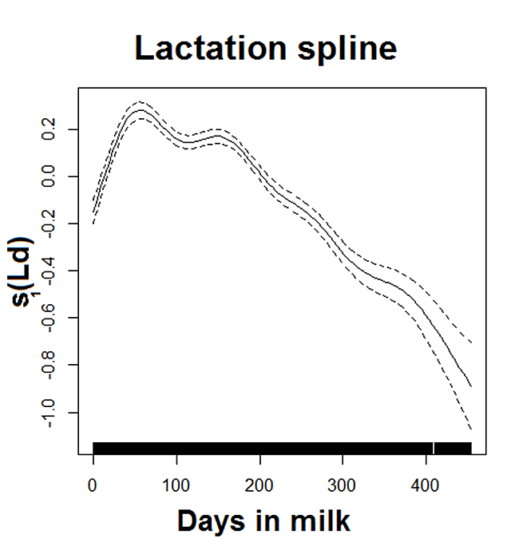
Figure S1 The plot shows the estimated trend of s₁(Ld), i.e. the spline function linking the day of lactation of dairy cows and the daily milk production, and associated point-wise 95% confidence intervals.

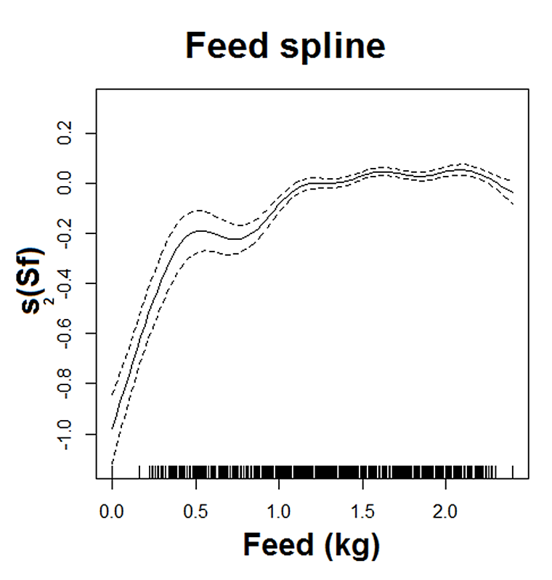
Figure S2 The plot shows the estimated trend of s₂(Sf), i.e. the spline function linking supplement feeding of dairy cows and daily milk production and associated point-wise 95% confidence intervals.

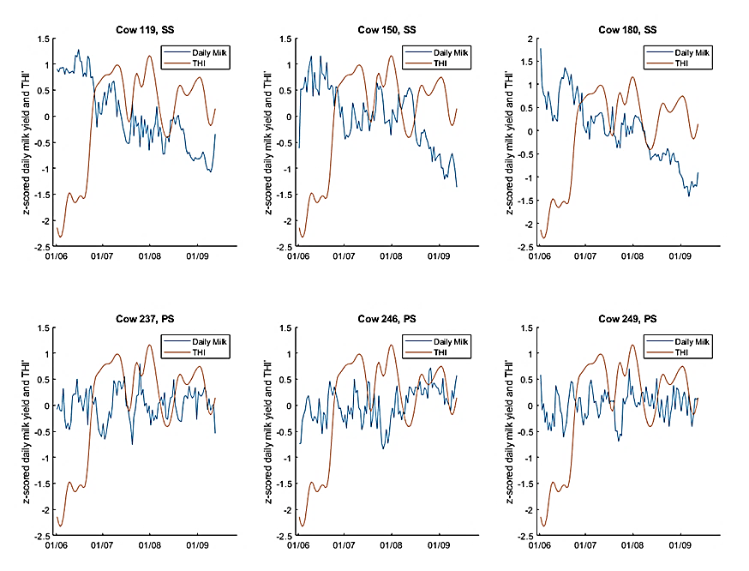

Figure S3 z-scored daily milk yield and THI’ trends of six selected dairy cows, three from SS group (first row) and three from PS one (second row). Z-score is computed as x’=[x–mean(x)]/σ(x). THI’ is the average of the Temperature-Humidity Index between 12 and 18. SS: Significant Susceptibility; PS: Poor Susceptibility.

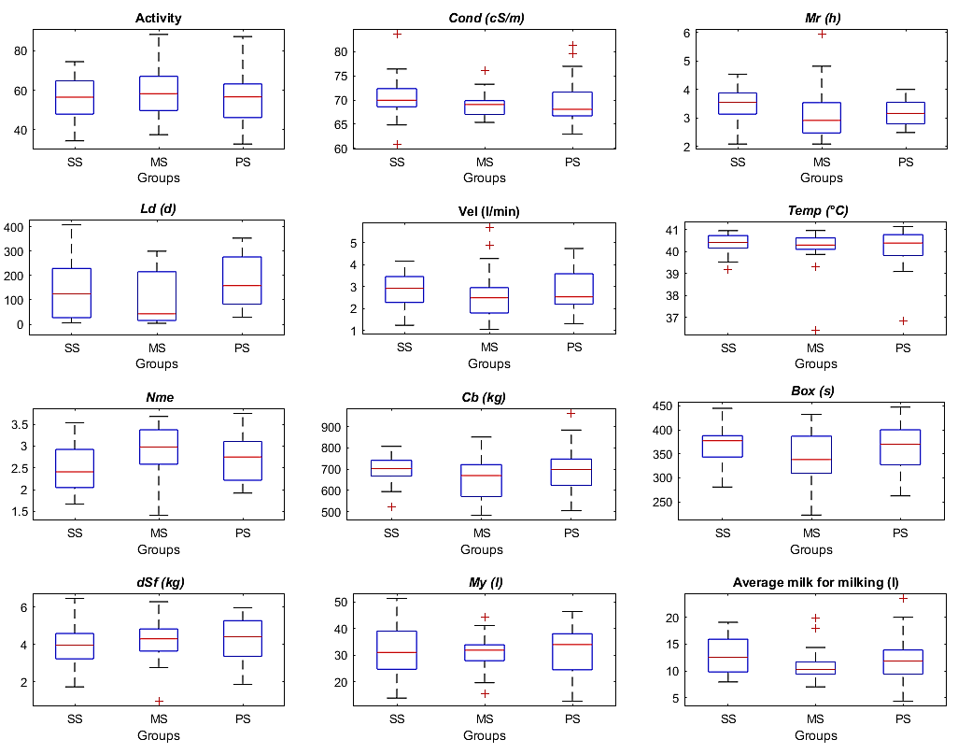Figure S4 Distributions of the parameters describing dairy cows’ health, production and behavior for the three susceptibility groups (symbols are reported in Table S1). SS: Significant Susceptibility; MS: Moderate Susceptibility; PS: Poor Susceptibility.

