Combinations of non-invasive indicators to detect dairy cows submitted to high starch diet challenge
C. Villot, C. Martin, J. Bodin, D. Durand, B. Graulet, A. Ferlay, M.M. Mialon, E. Trevisi, M. Silberberg
animal journal

Supplementary Material S1

Description of statistical techniques

Principal Components analysis (PCA):
This is a multivariate approach that allows the visualization of high dimensional data (also permits dimension reduction through the use of principal component as new variables in PC Regression) in optimal and independent planes. They are optimal as they keep the maximum of the multivariate variability presents in the data (the so-called inertia) and different planes presents independent (uncorrelated) information, in decreasing order of relevance (in terms of proportion of initial inertia displayed on the plane). It constitutes a descriptive, data mining tool to better understand data, without a priori.

Partial Least Squares-Discriminant Analysis (PLS-DA):
The approach resembles the one of the PCA, but the constructed latent variables (analogue to the PCs as initial variables linear combinations) also integrated a criterion for optimal discrimination of groups (defined by a qualitative factor, as SARA in our case) in addition to the conservation of initial inertia. Each latent variable keeps a part of inertia independent from the parts accounted for by other latent variables. The result is a model that can be diagnosed for the goodness-of-fit to the observed data and for its quality to predict “new” unknown similar data.

Mixed models:
The previous methods suppose the independence of the data point, e.g. each observed value is a random sample from the underlying population. In case of repeated measures over the same individuals, as it is the case here across time, this hypothesis doesn’t hold as observations in a same individual are correlated and dependent, they are also called pseudo-replications (an individual with high basal level for a biological feature probably tends to exhibit higher values across time, we partially “replicate” the first value). Mixed models accounted for this kind of study, by partitioning the variability due to these “random factor” in an estimation of the associated variance component. Such models honestly assess the effect of other explanatory variables in a context of pseudo-replications’

Supplementary Table S1. Exhaustive list of variables analyzed during high starch diet (HSD) challenge in dairy cows.
 |  | Control¹(P1) |  | HSD² (P2) |  |  |  |  | Recovery¹ (P3) |  |  | P-value | rsd
Matrix | Variables analyzed | Mean of wk 3,4 |  | wk 6 | wk 7 | wk 8 | wk 9 |  | wk 10 | wk 12 |  | wk | Model
Feces | pH | 6.71 |  | 6.38 | 6.13 | 6.17 | 5.89 |  | 6.41 | 6.41 |  | < 0.001 | 0.24
 | Histamine, ng/mL* | 58.2 |  | 72.3 | ND | ND | ND |  | ND | 127.3 |  | < 0.001 | 38.8
 | Dry matter, % | 12.0 |  | 11.4 | 11.6 | 12.9 | 13.3 |  | 13.3 | 12.4 |  | NS | 1.4
 | Sieving residual (5 mm), % | 5.4 |  | 11.6 | 5.6 | 4.7 | 3.9 |  | 2.8 | 4.4 |  | < 0.001 | 2.0
 | Sieving residual (2 mm), % | 8.3 |  | 7.2 | 12.0 | 10.4 | 11.3 |  | 6.5 | 7.6 |  | < 0.001 | 3.0
 | Sieving residual (5+2 mm), % | 13.7 |  | 18.8 | 17.5 | 15.1 | 15.2 |  | 9.3 | 11.9 |  | < 0.001 | 3.7
 | Density | 0.99 |  | 1.06 | 1.04 | 1.01 | 1.02 |  | 1.01 | 1.01 |  | 0.024 | 0.05
Behavior | RTime, min/d | 485 |  | 500 | 542 | 519 | 507 |  | 521 | 506 |  | 0.016 | 41
 | Drinking act, no./d | 8.0 |  | 6.8 | 6.6 | 7.5 | 7.1 |  | 8.2 | 7.8 |  | < 0.001 | 0.5
 | Activity, index/d | 483 |  | 465 | 473 | 482 | 470 |  | 459 | 498 |  | NS | 29
 | Body weight, kg | 657 |  | ND | ND | ND | 655 |  | ND | 667 |  | NS | 15
 | DMI, kg/d | 19.0 |  | 16.9 | 16.0 | 17.2 | 16.1 |  | 16.1 | 19.2 |  | < 0.001 | 0.9
 | Eating, min/d | 22.5 |  | 28.8 | 23.0 | 29.3 | ND |  | ND | 26.4 |  | NS | 13.4
 | Drinking, min/d | 252 |  | 162 | 160 | 150 | ND |  | ND | 177 |  | 0.001 | 48
 | Immobile standing, min/d | 576 |  | 542 | 534 | 551 | ND |  | ND | 492 |  | NS | 102
 | Lying, min/d | 438 |  | 576 | 586 | 586 | ND |  | ND | 517 |  | 0.007 | 94
Blood | pH | 7.40 |  | 7.34 | ND | 7.39 | 7.40 |  | 7.43 | 7.43 |  | < 0.001 | 0.02
 | pCO2, mm Hg | 54.8 |  | 50.6 | ND | 43.6 | 48.0 |  | 47.0 | 48.4 |  | 0.004 | 6.1
 | pO2, mmHg | 36.2 |  | 34.6 | ND | 45.9 | 37.3 |  | 39.3 | 36.2 |  | < 0.001 | 5.2
 | Bicarbonate, mmol/L | 33.3 |  | 26.6 | ND | 25.6 | 29.2 |  | 30.6 | 31.2 |  | < 0.001 | 3.6
 | White blood cell, 10³/mm³ | 9.41 |  | 9.32 | 8.87 | 9.75 | 8.12 |  | 8.82 | 8.19 |  | NS | 1.39
 | Red blood cells 10⁶/mm³ | 6.35 |  | 6.44 | 6.31 | 5.90 | 6.07 |  | 6.33 | 6.46 |  | < 0.001 | 0.27
 | Platelet, /mL | 324 |  | 336 | 335 | 324 | 276 |  | 319 | 308 |  | NS | 51
 | Hemoglobin, g/dL | 10.3 |  | 10.1 | 10.3 | 9.6 | 10.1 |  | 10.3 | 10.3 |  | 0.001 | 0.4
 | Hematocrit, % | 28.0 |  | 29.1 | 28.7 | 26.9 | 29.3 |  | 30.7 | 31.2 |  | < 0.001 | 1.3
 | Lymphocytes, 10³/mm³ | 1.73 |  | 1.55 | 1.83 | 1.61 | 1.34 |  | 1.52 | 1.50 |  | 0.050 | 0.36
 | Monocytes, 10³/mm³ | 0.78 |  | 0.83 | 0.87 | 0.90 | 0.75 |  | 0.85 | 0.83 |  | NS | 0.12
 | Granulocytes, 10³/mm³ | 6.90 |  | 6.95 | 6.17 | 7.24 | 6.02 |  | 6.45 | 5.86 |  | 0.029 | 1.09
 | Eosinophils, 10³/mm³ | 0.87 |  | 0.82 | 0.58 | 0.93 | 0.62 |  | 0.54 | 0.62 |  | 0.001 | 0.25
 | Riboflavin, mg/L | 6.55 |  | 8.16 | 7.91 | 8.44 | 7.38 |  | 7.64 | 6.85 |  | 0.05 | 1.5
 | Flavin-adenine-dinucleotide, mg/L | 135 |  | 110 | 110 | 118 | 111 |  | 140.4 | 135.1 |  | NS | 26.3
 | Pyridoxal, mg/L | 5.50 |  | 5.04 | 5.11 | 5.40 | 5.59 |  | 4.97 | 4.43 |  | NS | 1.35
 | Pyridoxal-5 phosphate, mg/L | 78.4 |  | 75.1 | 75.4 | 75.2 | 79.6 |  | 77.4 | 65.4 |  | NS | 20.1
 | ALAT, IU/L | 27.6 |  | 23.4 | 24.0 | 25.6 | 23.5 |  | 24.4 | 26.1 |  | 0.001 | 2.4
 | ASAT, IU/L | 75 |  | 95 | 103 | 109 | 112 |  | 109 | 122 |  | < 0.001 | 19
 | GGT, IU/L* | 27.8 |  | 28.7 | 29.6 | 32.7 | 32.7 |  | 36.2 | 35.5 |  | < 0.001 | 4.1
 | ALP, IU/L* | 138 |  | 145 | 169 | 185 | 181 |  | 180 | 155 |  | < 0.001 | 19
 | NEFA, mmol/L* | 0.21 |  | 0.33 | 0.21 | 0.19 | 0.20 |  | 0.36 | 0.18 |  | NS | 0.09
 | BHB, mmol/L | 0.43 |  | 0.24 | 0.23 | 0.31 | 0.33 |  | 0.40 | 0.42 |  | < 0.001 | 0.07
 | Glucose, mmol/L | 4.18 |  | 4.18 | 4.51 | 4.62 | 4.51 |  | 4.34 | 4.23 |  | < 0.001 | 0.22
 | Urea, mmol/L | 3.33 |  | 3.16 | 2.83 | 2.49 | 3.66 |  | 5.16 | 3.83 |  | < 0.001 | 0.66
 | SAA, ng/mL* | 1.26E+05 |  | 9.76E+04 | 3.62E+04 | ND | ND |  | 9.98E+04 | 1.03E+05 |  | NS | 3.53E+04
 | LBP, ng/mL* | 1.08E+04 |  | 9.83E+03 | 5.16E+03 | ND | ND |  | ND | 6.55E+03 |  | NS | 2.39E+03
 | IL1b, µmol/mL* | 247 |  | 196 | ND | ND | 224 |  | 229 | 220 |  | NS | 82.6
 | IL6, pmol/mL* | 1572 |  | 1441 | ND | ND | 2097 |  | 2164 | 1893 |  | NS | 631
 | Cholesterol, mmol/L | 5.08 |  | 3.93 | 3.95 | 4.31 | 4.14 |  | 4.67 | 4.81 |  | < 0.001 | 0.51
 | Ca, mmol/mL | 2.56 |  | 2.43 | 2.51 | 2.54 | 2.51 |  | 2.72 | 2.64 |  | NS | 0.15
 | P, mmol/mL | 1.83 |  | 1.86 | 1.86 | 1.62 | 1.92 |  | 1.92 | 1.89 |  | NS | 0.41
 | Mg, mmol/mL | 1.04 |  | 0.98 | 0.96 | 1.07 | 1.00 |  | 0.99 | 1.02 |  | NS | 0.09
 | Na, mmol/mL | 142 |  | 142 | 142 | 142 | 143 |  | 143 | 144 |  | NS | 1.29
 | K, mmol/mL | 4.13 |  | 4.09 | 4.05 | 3.97 | 3.99 |  | 4.06 | 4.19 |  | NS | 0.310
 | Cl, mmol/mL | 103.0 |  | 104.8 | 102.9 | 106.2 | 104.9 |  | 104.0 | 103.9 |  | < 0.001 | 2.3
 | Ceruloplasmin, µmol/mL | 3.35 |  | 3.55 | 3.45 | 3.60 | 3.54 |  | 3.75 | 3.40 |  | NS | 0.34
 | Total protein, g/L | 86.9 |  | 85.8 | 85.4 | 88.6 | 86.0 |  | 91.1 | 89.1 |  | < 0.001 | 2.7
 | Albumin, g/L | 36.0 |  | 34.1 | 34.3 | 35.4 | 34.4 |  | 36.0 | 35.4 |  | 0.001 | 1.4
 | Globulin, g/L | 50.9 |  | 51.7 | 51.2 | 53.2 | 51.6 |  | 55.1 | 53.7 |  | NS | 3.0
 | Bilirubin, g/L | 1.99 |  | 2.31 | 1.56 | 1.63 | 1.62 |  | 1.99 | 1.62 |  | NS | 0.64
 | Hp, g/L* | 0.35 |  | 0.40 | 0.18 | 0.38 | 0.59 |  | 0.41 | 0.25 |  | NS | 0.35
 | AOPP, µmol/L* | 42.0 |  | 41.5 | 39.3 | 43.4 | 36.7 |  | 36.4 | 37.0 |  | NS | 9.4
 | ROMt, mg H₂O₂/100 mL | 16.8 |  | 17.0 | 16.7 | 17.6 | 17.5 |  | 18.8 | 17.2 |  | NS | 1.5
 | FRAP, µmol/L | 136 |  | 136 | 131 | 139 | 128 |  | 135 | 132 |  | NS | 15
 | Paraoxonase, IU/mL* | 116.1 |  | 107.4 | 110.0 | 116.4 | 112.9 |  | 117.5 | 104.2 |  | NS | 11.9
 | GSH, nmol/mL | 232 |  | 329 | 311 | 310 | 362 |  | 367 | 381 |  | < 0.001 | 30
 | GSSG, nmol/mL* | 215 |  | 156 | 171 | 220 | 194 |  | 171 | 192 |  | 0.001 | 31.4
 | GSH:GSSG, ratio | 1.27 |  | 2.21 | 1.86 | 1.48 | 1.92 |  | 2.36 | 2.07 |  | < 0.001 | 0.44
 | MDA, µg/mL | 0.21 |  | 0.16 | 0.17 | 0.17 | 0.16 |  | 0.18 | 0.20 |  | 0.02 | 0.04
Milk | Yield, kg/d | 27.18 |  | 25.84 | 25.68 | 25.86 | 25.36 |  | 24.90 | 24.58 |  | 0.001 | 1.28
 | Daily yield ratio (am:pm), % | 0.70 |  | 0.73 | 0.72 | 0.71 | 0.74 |  | 0.74 | 0.74 |  | < 0.001 | 0.02
 | Lactoferrin, µg/mL* | 122 |  | 188 | 141 | 166 | 166 |  | 176 | 160 |  | < 0.001 | 42.6
 | Fat, g/L | 39.47 |  | 35.51 | 31.54 | 32.08 | 34.87 |  | 38.36 | 38.88 |  | < 0.001 | 4.19
 | Protein, g/L | 32.77 |  | 34.47 | 33.88 | 33.93 | 34.98 |  | 34.87 | 33.45 |  | < 0.001 | 1.17
 | Fat:Protein ratio | 1.21 |  | 1.02 | 0.92 | 0.94 | 0.99 |  | 1.10 | 1.16 |  | < 0.001 | 0.12
 | Lactose, g/L | 52.7 |  | 52.3 | 52.8 | 52.8 | 52.3 |  | 51.9 | 51.9 |  | NS | 1.0
 | Somatic cell count, /mL* | 8.15E+04 |  | 6.74E+05 | 1.49E+05 | 1.34E+05 | 4.43E+05 |  | 1.33E+05 | 2.52E+05 |  | < 0.001 | 4.80E+05
 | Urea, mmol/L | 4.43 |  | 3.52 | 3.22 | 3.15 | 3.39 |  | 4.89 | 4.71 |  | < 0.001 | 0.35
 | Pyridoxal, mg/L | 0.28 |  | 0.30 | 0.30 | 0.29 | 0.28 |  | 0.27 | 0.26 |  | NS | 0.02
 | Pyridoxamine, µg/L* | 28.44 |  | 28.84 | 26.31 | 23.95 | 24.49 |  | 26.20 | 21.01 |  | 0.02 | 5.32
 | Riboflavin, mg/L | 1.82 |  | 2.10 | 2.00 | 1.92 | 1.95 |  | 2.04 | 1.82 |  | < 0.001 | 0.18
 | Individual FA, g/100 g of total FA
 | iso 13,* | 0.03 |  | 0.03 | 0.04 | 0.02 | 0.03 |  | 0.03 | 0.03 |  | NS | 0.02
 | C13* | 0.90 |  | 0.84 | 0.97 | 0.98 | 0.90 |  | 0.72 | 0.84 |  | NS | 0.24
 | iso 14 | 0.10 |  | 0.08 | 0.07 | 0.06 | 0.07 |  | 0.08 | 0.09 |  | < 0.001 | 0.01
 | iso 15 | 0.24 |  | 0.19 | 0.17 | 0.16 | 0.17 |  | 0.25 | 0.24 |  | < 0.001 | 0.02
 | anteiso 15 | 15.1 |  | 17.3 | 39.5 | 41.7 | 35.0 |  | 10.3 | 12.2 |  | < 0.001 | 31.5
 | C15* | 0.86 |  | 0.73 | 0.96 | 0.97 | 0.88 |  | 0.68 | 0.67 |  | NS | 0.28
 | C17 | 0.81 |  | 0.85 | 0.89 | 0.88 | 0.85 |  | 0.84 | 0.82 |  | NS | 0.09
 | cis-9 C17:1 | 0.27 |  | 0.40 | 0.37 | 0.34 | 0.35 |  | 0.35 | 0.29 |  | < 0.001 | 0.05
 | C18:1 Isomers*
 | trans-9 | 0.21 |  | 0.33 | 0.31 | 0.30 | 0.35 |  | 0.27 | 0.22 |  | < 0.001 | 0.06
 | trans-10 | 0.28 |  | 2.24 | 3.13 | 2.38 | 2.57 |  | 0.81 | 0.36 |  | < 0.001 | 1.33
 | trans-11 | 0.96 |  | 1.33 | 1.11 | 0.98 | 1.05 |  | 1.13 | 0.83 |  | NS | 0.26
 | trans-10:trans-11 | 0.30 |  | 1.57 | 2.66 | 2.25 | 2.28 |  | 0.71 | 0.66 |  | < 0.001 | 1.05
 | trans-13 | 0.56 |  | 0.70 | 0.71 | 0.68 | 0.70 |  | 0.64 | 0.60 |  | 0.050 | 0.12
 | trans-(4,5,6,8,9,10,11,13,16) + cis-14 | 2.54 |  | 5.33 | 6.03 | 5.04 | 5.45 |  | 3.51 | 2.43 |  | < 0.001 | 1.63
 | cis-10 | 0.55 |  | 0.71 | 0.61 | 0.59 | 0.62 |  | 0.69 | 0.62 |  | < 0.001 | 0.08
 | cis-11 | 0.70 |  | 1.04 | 1.03 | 0.93 | 1.01 |  | 0.85 | 0.72 |  | < 0.001 | 0.13
 | cis-12 | 0.22 |  | 0.28 | 0.26 | 0.27 | 0.26 |  | 0.28 | 0.24 |  | NS | 0.05
 | cis-13 | 0.10 |  | 0.18 | 0.14 | 0.14 | 0.14 |  | 0.13 | 0.10 |  | < 0.001 | 0.02
 | trans-16 + cis-14 | 0.30 |  | 0.33 | 0.30 | 0.30 | 0.29 |  | 0.36 | 0.30 |  | NS | 0.05
 | cis-16 C18:1 + cis-9, trans-12 C18:2* | 0.07 |  | 0.07 | 0.09 | 0.08 | 0.09 |  | 0.09 | 0.08 |  | 0.001 | 0.01
 | trans-11, cis-15 C18:2* | 0.15 |  | 0.19 | 0.17 | 0.15 | 0.15 |  | 0.18 | 0.12 |  | NS | 0.04
 | cis-9, trans-11 + trans-7, cis-9 + trans-8, cis-10 CLA* | 0.44 |  | 0.65 | 0.61 | 0.52 | 0.59 |  | 0.55 | 0.43 |  | < 0.001 | 0.11
 | trans, trans mixture-10,12 and 9,11 and 8,10 CLA* | 0.03 |  | 0.04 | 0.04 | 0.04 | 0.04 |  | 0.04 | 0.03 |  | < 0.001 | 0.01
 | SFA | 69.5 |  | 61.6 | 64.0 | 66.9 | 65.0 |  | 63.9 | 67.9 |  | < 0.001 | 2.5
 | Paired SFA | 65.4 |  | 57.6 | 59.6 | 62.5 | 60.9 |  | 60.0 | 64.0 |  | < 0.001 | 2.6
 | Odd SFA* | 2.42 |  | 2.42 | 2.92 | 3.02 | 2.73 |  | 2.29 | 2.38 |  | 0.001 | 0.40
 | Iso SFA | 0.69 |  | 0.58 | 0.49 | 0.36 | 0.36 |  | 0.51 | 0.47 |  | < 0.001 | 0.08
 | anteiso SFA | 1.06 |  | 1.01 | 1.02 | 1.03 | 1.05 |  | 1.18 | 1.13 |  | NS | 0.14
 | MUFA | 25.0 |  | 31.5 | 29.0 | 26.2 | 28.0 |  | 29.2 | 26.0 |  | < 0.001 | 2.1
 | cis MUFA | 22.1 |  | 25.8 | 22.5 | 20.7 | 22.1 |  | 25.3 | 23.1 |  | < 0.001 | 1.8
 | trans MUFA* | 2.58 |  | 5.38 | 6.08 | 5.09 | 5.50 |  | 3.56 | 2.62 |  | < 0.001 | 0.13
 | PUFA | 3.87 |  | 4.88 | 4.81 | 4.76 | 4.82 |  | 4.70 | 4.05 |  | < 0.001 | 0.41
 | Omega-3 PUFA | 0.84 |  | 0.79 | 0.72 | 0.73 | 0.71 |  | 0.87 | 0.84 |  | < 0.001 | 0.07
 | Omega-6 PUFA | 2.00 |  | 2.69 | 2.65 | 2.78 | 2.75 |  | 2.53 | 2.15 |  | < 0.001 | 0.21
Urine | pH | 8.19 |  | 7.72 | 7.93 | 8.11 | 8.02 |  | 8.02 | 7.99 |  | < 0.001 | 0.15
Saliva | pH | 9.04 |  | 8.59 | 8.64 | 8.60 | 8.59 |  | 8.52 | 8.45 |  | < 0.001 | 0.14
 | Glucose, mmol/L | 0.16 |  | 0.01 | 0.03 | 0.13 | 0.03 |  | 0.01 | 0.09 |  | NS | 0.16
 | Urea, mmol/L | 4.04 |  | 2.69 | 2.52 | 2.95 | 3.26 |  | 3.90 | 3.06 |  | < 0.001 | 0.65
 | Ca, mmol/L* | 0.91 |  | 0.42 | ND | ND | 0.46 |  | ND | 0.53 |  | 0.001 | 0.24
 | P, mmol/L | 5.07 |  | 10.18 | ND | ND | 7.66 |  | ND | 9.44 |  | < 0.001 | 2.06
 | Mg, mmol/L* | 1.81 |  | 0.58 | ND | ND | 0.55 |  | ND | 0.70 |  | < 0.001 | 0.30
 | Na, mmol/L | 101.4 |  | 136.3 | ND | ND | 123.2 |  | ND | 137.9 |  | < 0.001 | 14.1
 | K, mmol/L | 21.9 |  | 12.4 | ND | ND | 17.2 |  | ND | 12.8 |  | < 0.001 | 5.1
 | Cl, mmol/L | 31.5 |  | 33.9 | ND | ND | 33.8 |  | ND | 32.8 |  | NS | 2.9
 | Zn, µmol/L* | 1.74 |  | 1.12 | ND | ND | 2.46 |  | ND | 2.61 |  | NS | 2.2
 | Ceruloplasmin, µmol/L | 0.24 |  | 0.17 | ND | ND | 0.28 |  | ND | 0.32 |  | NS | 0.16
 | Total protein, g/L | 1.80 |  | 0.85 | ND | ND | 1.30 |  | ND | 1.18 |  | 0.024 | 0.69
 | Albumin, g/L | 0.26 |  | 0.32 | ND | ND | 0.33 |  | ND | 0.39 |  | 0.009 | 0.08
 | Globulin, g/L | 1.54 |  | 0.53 | ND | ND | 0.96 |  | ND | 0.79 |  | 0.007 | 0.64
 | GGT, IU/L* | 53.4 |  | 21.7 | 34.4 | 49.9 | 42.2 |  | 39.2 | 23.4 |  | 0.011 | 25.9
 | Bilirubin, µmol/L | 1.32 |  | 1.19 | ND | ND | 1.42 |  | ND | 2.29 |  | NS | 1.30
 | ALP, IU/L | 15.3 |  | 7.4 | 21.0 | 13.1 | 14.0 |  | 11.3 | 6.1 |  | NS | 13.5
 | Hp, g/L* | 0.30 |  | 0.17 | ND | ND | 0.39 |  | ND | 0.22 |  | NS | 0.18
 | NEFA, µmol/L* | 0.03 |  | 0.07 | 0.08 | 0.04 | 0.06 |  | 0.06 | 0.09 |  | NS | 0.06
 | BHB, µmol/L | 0.02 |  | 0.01 | 0.00 | 0.01 | 0.01 |  | 0.01 | 0.01 |  | 0.003 | 0.01
 | TG, µmol/L | 0.16 |  | 0.03 | ND | ND | 0.12 |  | ND | 0.10 |  | NS | 0.15
 | Creatinine, µmol/L | 35.38 |  | 31.51 | ND | ND | 36.37 |  | ND | 29.43 |  | NS | 9.91
 | FRAP, µmol/L | 171 |  | 104 | ND | ND | 128 |  | ND | 176 |  | 0.033 | 63
¹ Cows were fed with a low-starch diet (LSD) during the control periods: 32% concentrate + 68% forage, containing 13% starch.
² Cows were fed with a high-starch diet (HSD) to induce the challenge: 54% concentrate + 46% forage, containing 35% starch.
8 week measurements were performed: 2 weeks in period 1 (P1): wk 3 and 4 which were averaged, 4 weeks in period 2 (P2): wk 6,7,8,9 and 2 weeks in period 3 (P3): wk 10 and wk12.
* Statistical analysis was performed on transformed log data
ND = not determined, rsd = relative standard deviation
DMI = dry matter intake, BHB = β-hydroxybutyrate, CLA = conjugated linoleic acid, RTime = rumination time, SAA = serum amyloid A, LBP = lipid-binding protein, IL = interleukin, GSH = glutathione reduced, GSSG = glutathione oxidised, MDA = malondialdehyde, ALAT = alanine aminotransferase, ASAT = aspartate aminotransferase, ALP = alkaline phosphatase, GGT = gamma-glutamyltransferase, FA= fatty acid, SFA = short chain fatty acids, Hp = haptoglobin, MUFA = mono-unsaturated fatty acids, NEFA = non-esterified fatty acids, PUFA = poly-unsaturated fatty acids, TG = triglyceride, FRAP = ferric reducing ability of plasma, AOPP = advanced oxidation protein products, ROMt = reactive oxygen metabolites
136 variables were analyzed and calculated from 5 different matrices: feces, blood, milk, urine and saliva and behaviour analysis.
Week data different from P1 (P < 0.1) for each parameters are in bold characters.

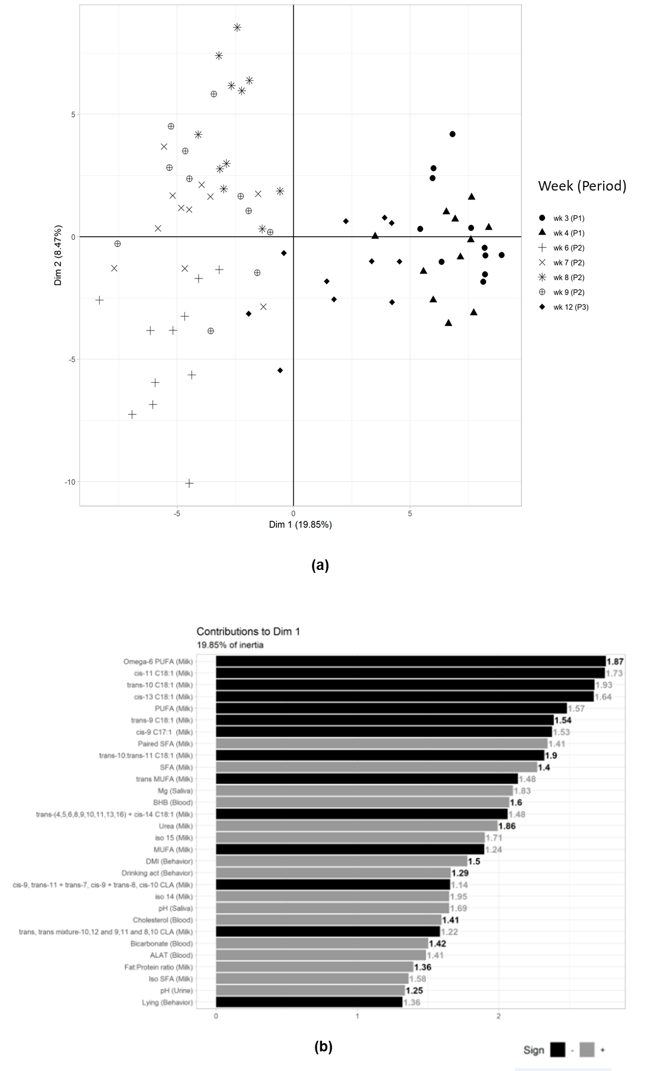
Supplementary Figure S1.
Principal component analysis (PCA) of the 185 variables screened in dairy cows
(a) Score plot of 11 dairy cows for each week of sampling during the low starch diet (LSD) control (P1, wk 3,4), the high starch diet (HSD) challenge (P2, wk 6, 7, 8, 9), and the LSD recovery period (P3, wk 12)
(b) Contribution of the best 40 variables among 136 ranked according to their VIP calculated with a PLS-DA (number at the end of each bar). The grey colour indicates a positive correlation between the variables and the corresponding dimension of the score plot, whereas the black colour indicates a negative correlation between the variables and the corresponding dimension of the score plot.
R² = coefficient indicating the predictive accuracy of the PLS-DA, Q² = coefficient indicating the quality of the leave-one-out cross-validation of the PLS-DA, VIP = variable importance in projection.
Refer to Table S1 for abbreviation description

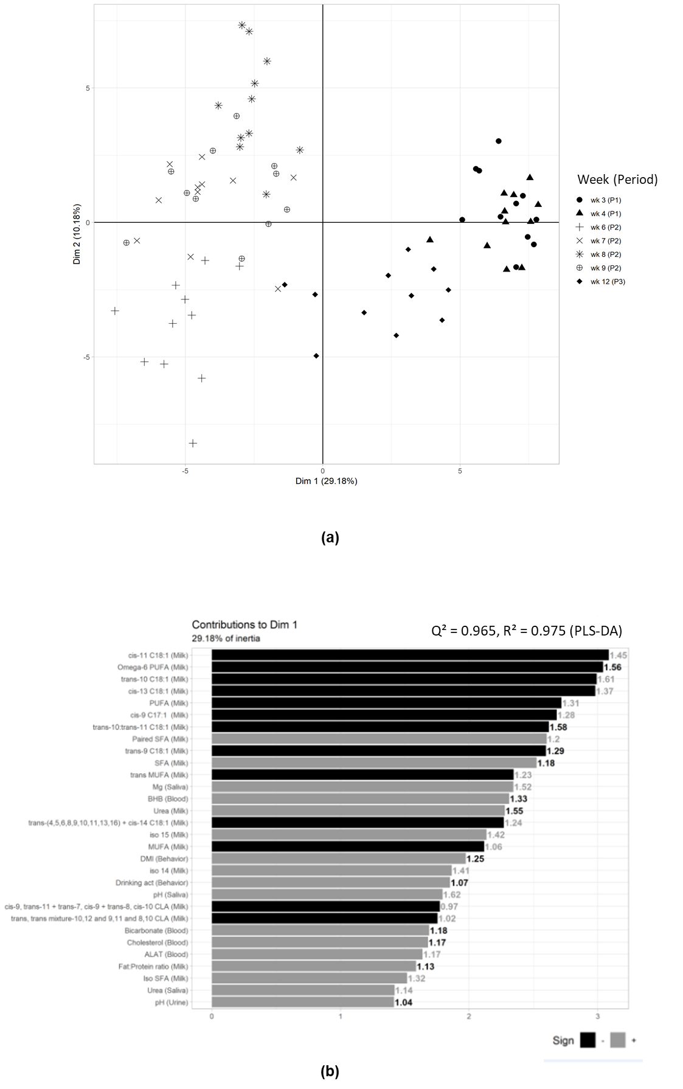
Supplementary Figure S2.
Principal component analysis (PCA) of the 185 variables screened in dairy cows
(a) Score plot of 11 dairy cows for each week of sampling during the LSD control (P1, wk 3,4), the HSD challenge (P2, wk 6, 7, 8, 9), and the LSD recovery (P3, wk 12)
(b) Contribution of the best 40 variables among 85 ranked according to their VIP calculated with a PLS-DA (number at the end of each bar). The grey colour indicates a positive correlation between the variables and the corresponding dimension of the score plot (a), whereas the black colour indicates a negative correlation between the variables and the corresponding dimension of the score plot (a)
R² = coefficient indicating the predictive accuracy of the PLS-DA, Q² = coefficient indicating the quality of the leave-one-out cross-validation of the PLS-DA, VIP = variable importance in projection.
Refer to Table S1 for abbreviation description

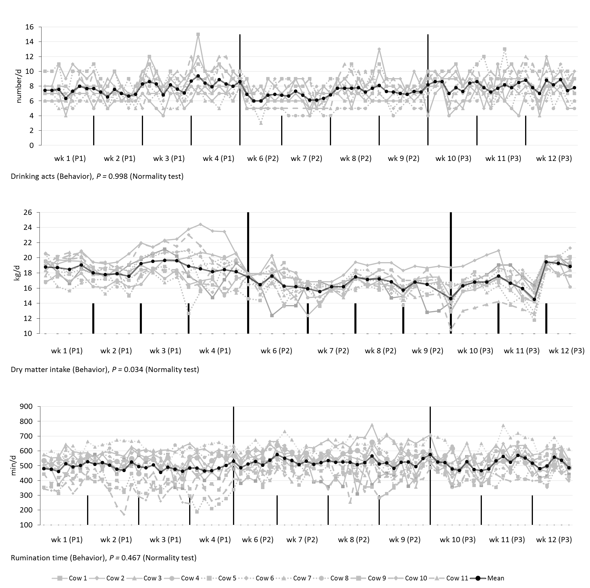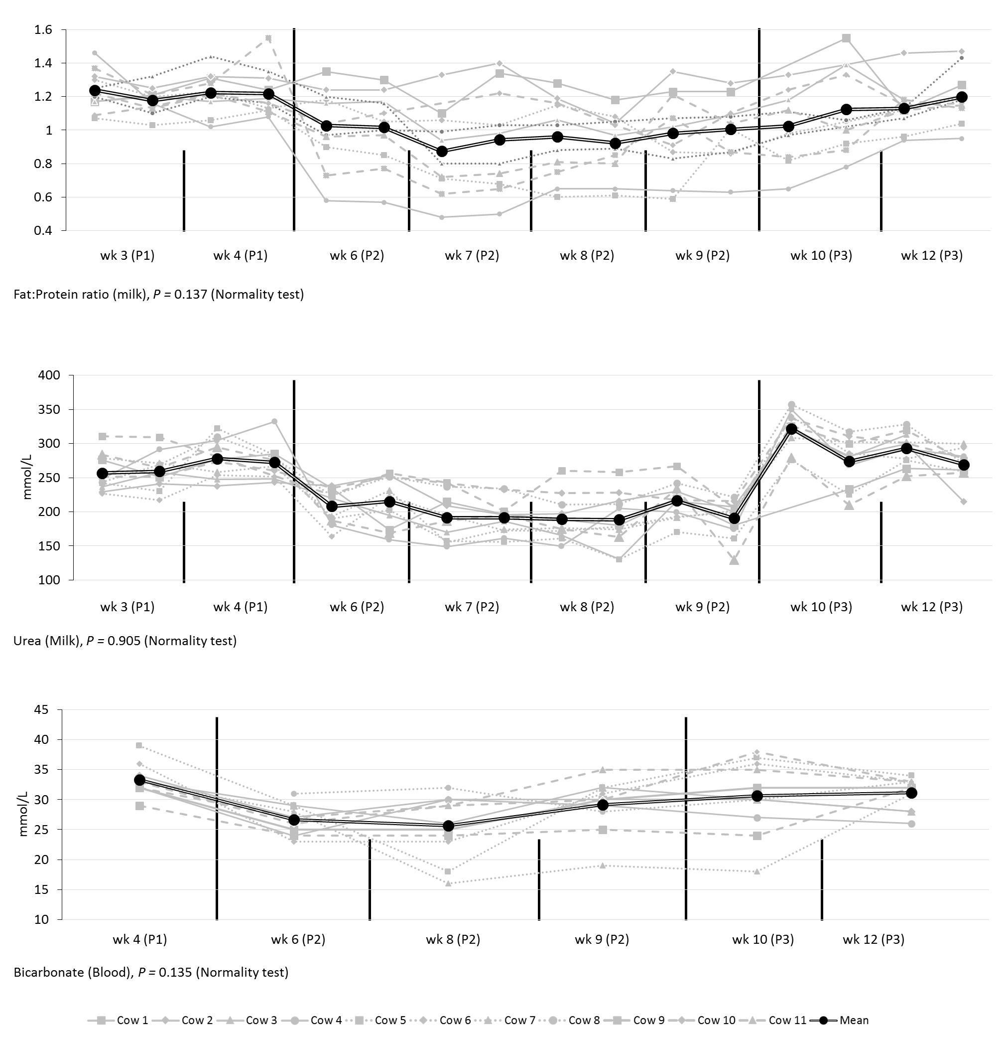

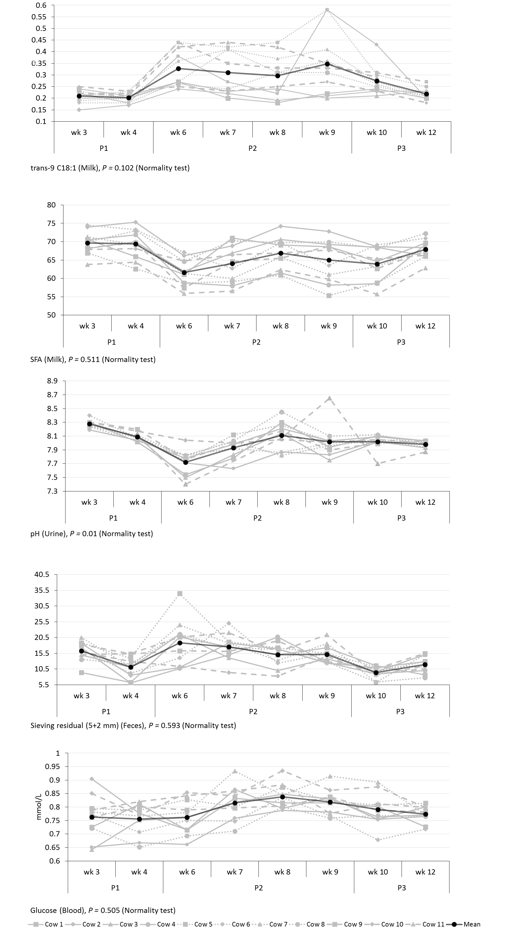
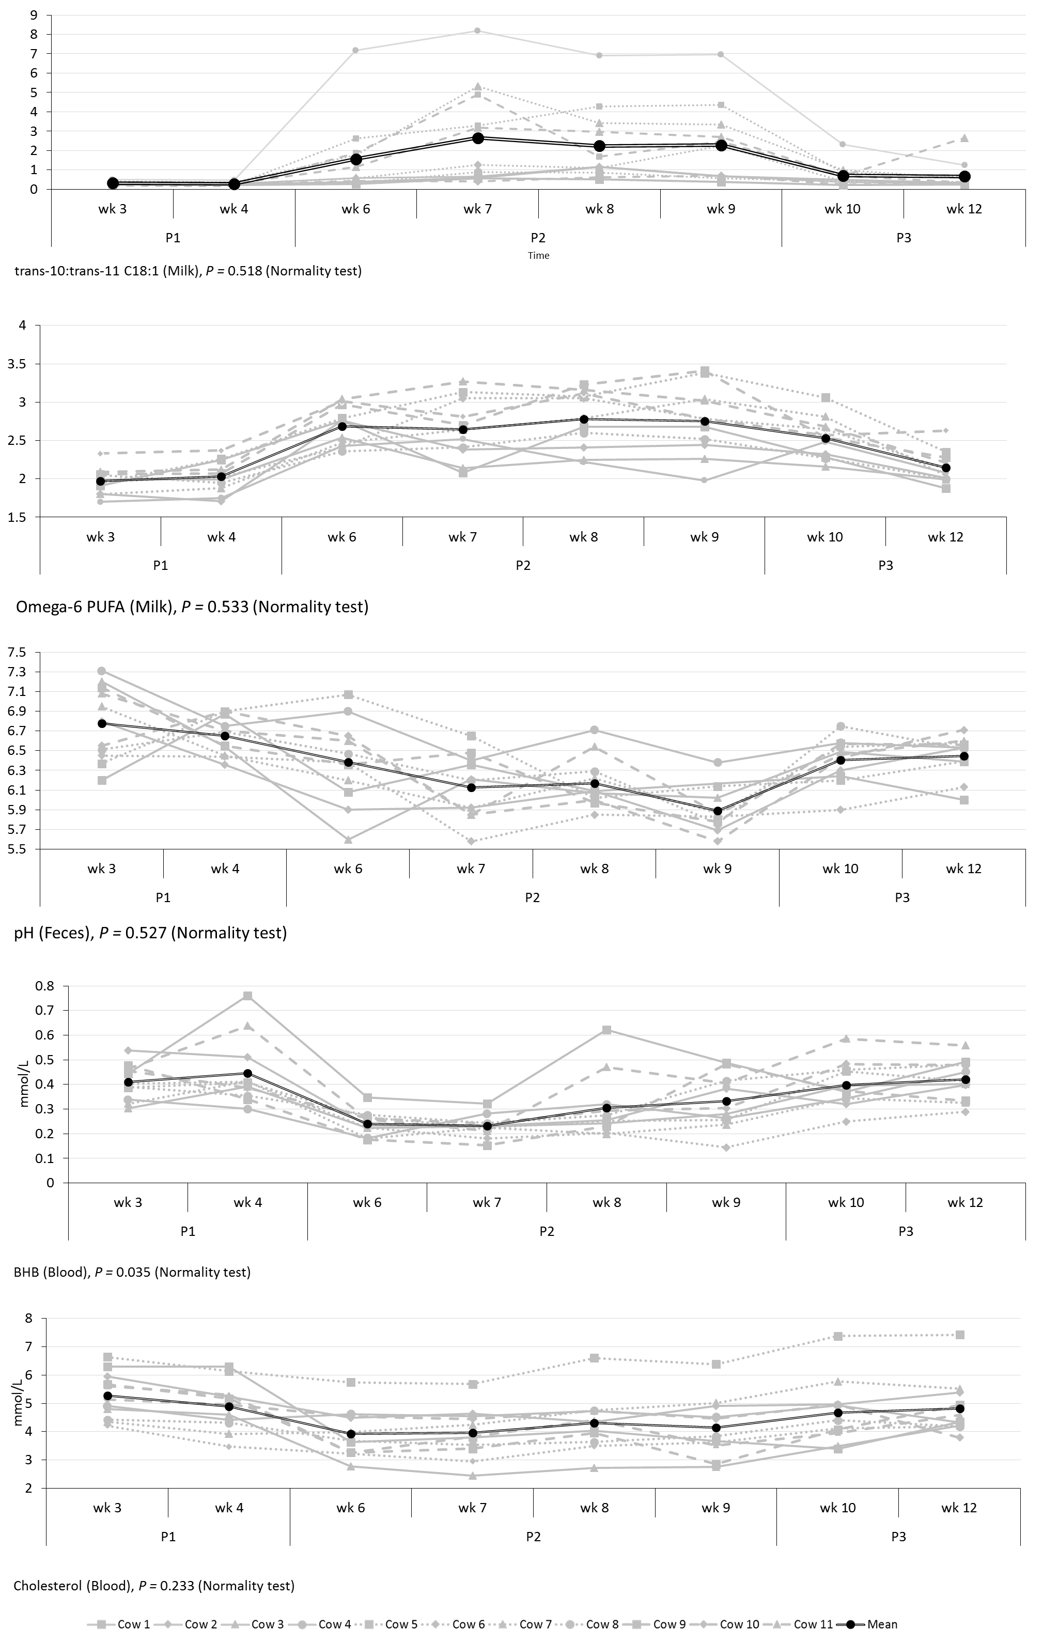
Supplementary Figure S3.
Trajectories of the 16 variables selected for the proposed combinations of non-rumen indicators of dairy cows. Each graph presents weekly means ± SEM (n=11), cow and error variances and the P-value of the normality test (SW= Shapiro-Wilk) on mixed model residuals
Refer to Table S1 for abbreviation description

