Influence of diet and manure management on ammonia and greenhouse gas emissions from dairy barns
N. Edouard, A. Charpiot, P. Robin, E. Lorinquer, J.-B. Dollé, P. Faverdin
animal journal

Supplementary Material

Materials and Methods

Figure S1. Layout (not proper proportions) of the experimental rooms housing three dairy cows each: room A (managed as LM_{tied} - liquid manure, N balance measurements - or LM_{free} - liquid manure, free-stall barn with cubicles) and room B (managed as SM – solid manure, straw-based deep litter) seen from above or from the side (lower right).

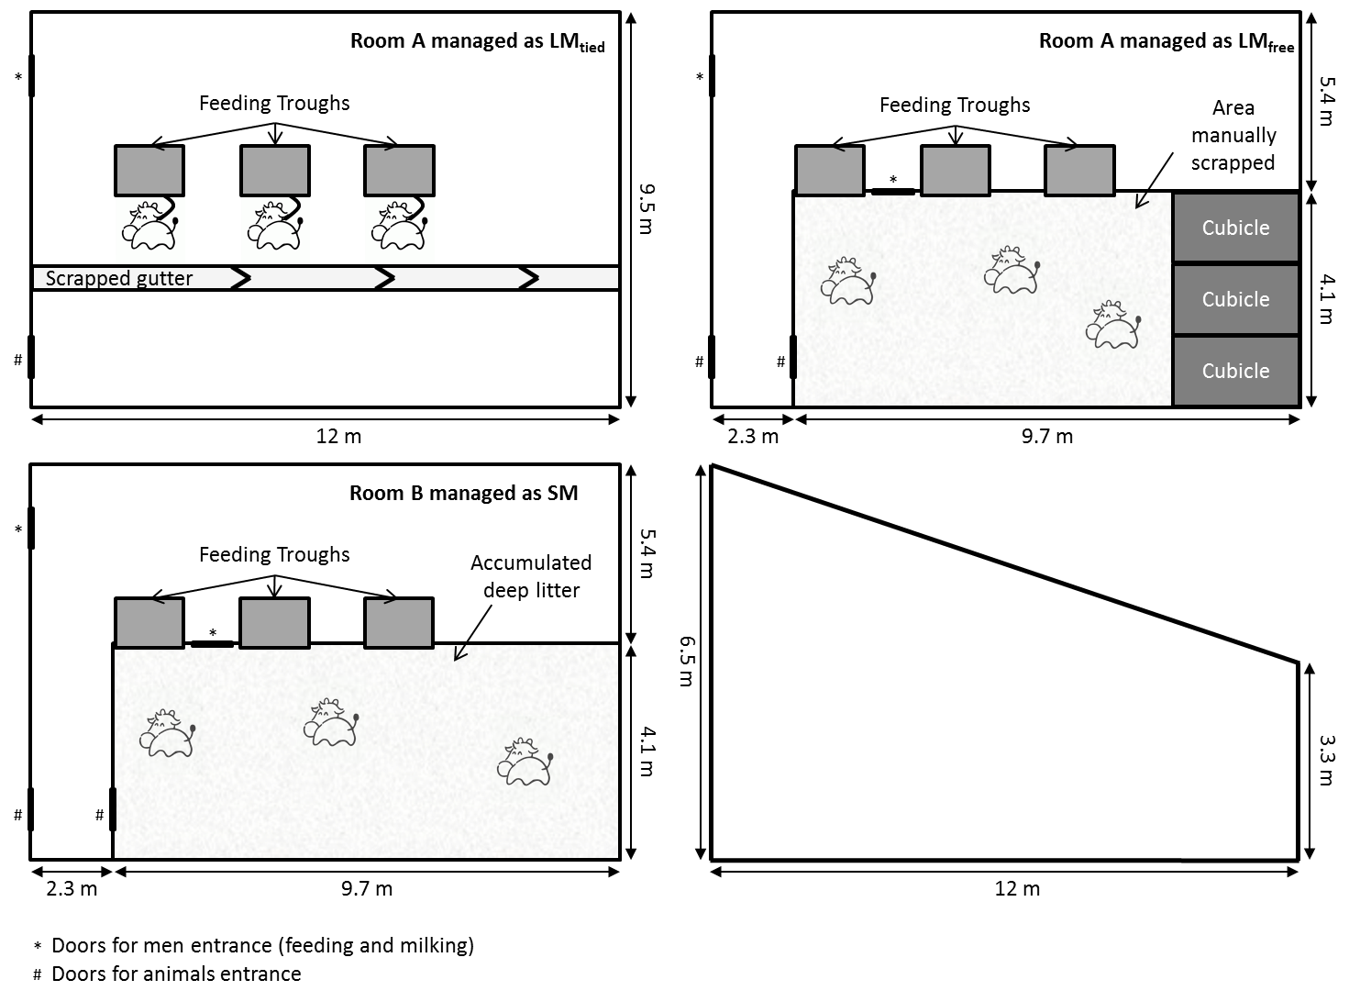

Measurements, samples and analyses
Temperature and humidity. Indoor air temperature and relative humidity were recorded continuously at 15-minute intervals in each room using temperature and relative humidity probes (HMP 45C, Campbell Sci., Courtaboeuf, France) placed at a height of 1.5 m in a central position between the cows and connected to a data acquisition system (CR 1000, Campbell Sci., Courtaboeuf, France).

Table S1 Indoor environmental conditions as a function of the dietary N supply offered to dairy cows (LowN, 120 g CP/kg DM; HighN, 180 g CP/kg DM), the manure management system (LM_{tied}: liquid manure, N balance measurements; LM_{free}: liquid manure, free-stall barn with cubicles; SM: solid manure, straw-based deep litter) and the week of measurement (W1-W4)
 | Manure management | LowN |  |  |  | HighN
Variable¹ |  | W1 | W2 | W3 | W4 | W1 | W2 | W3 | W4 | SEM
Indoor | LM_{tied}
Temp. °C |  | 16.5 | 16.2 |  |  | 17.6 | 16.8 |  |  | 0.2
Hum. % |  | 72.1 | 72.0 |  |  | 63.5 | 68.0 |  |  | 1.4
Indoor | LM_{free}
Temp. °C |  |  |  | 16.1 | 16.0 |  |  | 16.3 | 16.4 | 0.1
Hum. % |  |  |  | 61.9 | 58.2 |  |  | 69.3 | 74.5 | 1.5
Indoor | SM
Temp. °C |  | 16.7 | 16.7 | 16.4 | 16.4 | 17.6 | 17.0 | 16.7 | 16.8 | 1.1
Hum. % |  | 74.8 | 78.8 | 72.7 | 69.1 | 66.9 | 74.4 | 77.8 | 79.7 | 0.7
¹ Mean daily temperature and humidity: 7 days x 2 sub-periods per dietary treatment and manure management

