Animal
Differential hepatic oxidative status in steers with divergent residual feed intake phenotype
A. Casal; M. Garcia-Roche; E.A. Navajas; A. Cassina; M. Carriquiry

Supplementary Material S1
Determination of lipid and protein oxidation markers

Frozen liver samples (300 mg) were homogenized with an extraction buffer (1.5 mL; 150 mM KCl, 20 mM EDTA and 300 mM butyrate hydroxytoluene) using a hand-held Pro200 homogenizer (Pro Scientific Inc, USA) at 10000 rpm during 1 min and the Bradford (Coomassie) assay was used to determine protein concentration of liver homogenates.
The thiobarbituric acid reactive species (TBARS) procedure for the determination of lipid oxidation was adapted from Gatellier et al. (2004). Briefly, 500 µL of liver homogenate was centrifuged at 2000 xg for 10 min and 100 µL of the supernatant was incubated with 100 µL of a 2-thiobarbituric acid (TBA)-trichloroacetic acid (TCA) solution (35 mM TBA and 10% TCA in 125 mMhydrochloric acid; HCl) in a boiling water bath for 30 min. After cooling in an ice bath for 5 min and kept at room temperature for 45 min, the pink chromogen was extracted with 400 µL of n-butanol and phase separation by centrifugation at 3000 xg during 10 min. The absorbance of the supernatant was measured at 535 nm using a Varioskan Flash microplate reader (Thermo Electron Corp., Louisville, CO, USA). The concentration of malondialdehyde (MDA) was calculated using the molar extinction coefficient of the MDA (156000 mol/cm; adjusted for the path length of the solution in the well). Results were expressed as µg MDA/mg of protein.
The protein carbonyl assay, to evaluate protein oxidation, was performed according to Gatellier et al. (2004).Briefly, two aliquots (200 µL each) of liver homogenates were centrifuged at 2000 x g for 10 min and incubated with 200 µL of 2 N HCl (blank) or with 200 µL of 20 mM dinitrophenylhydrazine (DNPH) in 2 N HCl, for 1 h at room temperature with regular stirring. After addition of 20% TCA (200 µL), aliquots were incubated at room temperature for 15 min with regular stirring and centrifuged at 2000 x g for 10 min. Pellets were washed three times with 400 µL of ethanol:ethyl acetate (1:1), centrifuging each time, to eliminate traces of DNPH. Pellets were dissolved in 600 µL of 6 M guanidine HCl with 20 mM KH₂PO₄, pH 2.5, incubated at room temperature for 15 min with regular stirring and centrifugedat 2400 x g for 10 min, the absorbance of the supernatant was measured at 370 nm in a Varioskan Flash microplate reader (Thermo), subtracting the blank and the concentration of DNPH was calculated using the DNPH molar extinction coefficient (22000 mol/cm; adjusted for the path length of the solution in the well). Results were expressed as nmol of DNPH/mg of protein.

Supplementary Material S2
Hepatic antioxidant enzyme activity
The hepatic enzyme activities of glutathione peroxidase (GPX) and total superoxide dismutase (SOD) were determined spectrophotometrically using commercially kits (Ransel for GPX and Ransod for SOD; Randox Laboratories, Antrim, UK) in a Varioskan Flash microplate reader (Thermo) according to Reglero et al. (2009). Briefly, liver (200 mg) was homogenized with 2 mL of ice-cold buffer (1.15% KCl in 10 mM Na-KH₂PO₄buffer, pH 7.4, with 20 mM EDTA) using a hand-held Pro200 homogenizer (PRO Scientific) at 10000 rpm during 1 min, centrifuged at 2000 xg for 10 min and supernatant collected. For GPX activity (Ransel assay, Randox Laboratories), 100 µL of supernatant of liver homogenate were diluted with 200 µL of diluting agent. In the reaction cell at 37°C, 220 µL of a reagent containing 4 mM glutathione, 0.5 U/L glutathione reductase and 0.34 mM NADPH (diluted in 0.05 M phosphate buffer, pH 7.2, with 4.3 mM EDTA) were mixed with 5 µL of diluted sample. Fifteen seconds later, 10 µL of 0.18 mM cumene hydroperoxide was added, and the absorbance was read at 340 nm between 75 and 195 seconds after sample addition. The enzyme activity was calculated by multiplying the increase in the absorbance per min by a factor of 8412.
For SOD activity (Ransod assay, Randox Laboratories), 20 µL supernatant of liver homogenates were diluted with 300 µL of 0.01 M phosphate buffer, pH 7.0. In the reaction cell at 37 °C, 170 µL of mixed substrate (containing 0.05 mM xanthine and 0.025 mM INT (2-(4-Iodophenyl)-3-(4-Nitrophenyl)-5-(Phenyl) Tetrazolium Chloride) was mixed with 5 µL of diluted sample, and 15 s later, 25 µL of 80 U/L of xanthine oxidase was added. The mixed substrate was prepared in 40 mM of N-cyclohexyl-3-aminopropane-sulfonic acid buffer, pH 10.2, with 0.94 mM EDTA. The absorbance was read at 505 nm between 45 and 225 seconds after sample addition and the kinetics of the enzyme activity were calculated based on a calibration curve performed with SOD standards at concentrations ranging from 0.21 to 5.7 UI/mL in 0.01 M phosphate buffer, pH 7. Activity of MnSOD was determined by inhibiting CuZnSOD activity with 3 mM potassium cyanide; CuZnSOD was subsequently determined by subtracting MnSOD activity from total SOD activity.
Supplementary Table S1 Primers used for real time qPCR quantification.
Gene | Accession#¹ |  | Primer sequence² | Length(bp) | Efficiency
ACTB | BT030480 | F | CTCTTCCAGCCTTCCTTCCT | 178 | 1.02
 |  | R | GGGCAGTGATCTCTTTCTGC
GCLC | NM_001083674 | F | CACAAATTGGCAGACAATGC | 211 | 1.20
 |  | R | GGCGACCTTCATGTTCTCAT
GPX1 | NM_17407 | F | ACATTGAAACCCTGCTGTCC | 216 | 1.17
 |  | R | TCATGAGGAGCTGTGGTCTG
GPX3 | NM_174077 | F | TGCAACCAATTTGGAAAACA | 224 | 1.11
 |  | R | TTCATGGGTTCCCAGAAAAG
GPX4 | NM_001346431.1 | F | AGCCAGGGAGTAATGCAGAG | 203 | 1.14
 |  | R | CACACAGCCGTTCTTGTCAA
HPRT1 | XM_580802 | F | TGGAGAAGGTGTTTATTCCTC | 105 | 1.03
 |  | R | CACAGAGGGCCACAATGTGA
PRDX3 | NM_174432.2 | F | CACACCAGAAAAGAGCCACA | 210 | 1.13
 |  | R | CTAGCCATCCATCCACACCT
PRDX5 | NM_174749.2 | F | CCTTCTACCTCAGCCTCGAG | 245 | 1.15
 |  | R | CAACCTTAATCGGGGCCATG
RPL19 | NM_001040516.1 | F | CCCCAATGAGACCAATGAAATC | 156 | 1.09
 |  | R | CAGCCCATCTTTGATCAGCTT
SOD1 | NM_174615 | F | AGAGGCATGTTGGAGACCTG | 189 | 1.14
 |  | R | CAGCGTTGCCAGTCTTTGTA
SOD2 | NM_201527.2 | F | CAGGGACGCTTACAGATTGC | 212 | 1.03
 |  | R | CTGACGGTTTACTTGCTGCA
ACTB = β-actin; GCLC =glutamate-cysteine ligase catalyticsubunit; GPX =glutathioneperoxidase 1; GPX3 = glutathioneperoxidase 3; GPX4 =glutathioneperoxidase 4; HPRT1 = hypoxanthinephosphoribosyltransferase; PRDX3 =peroxiredoxin 3; PRDX5 =peroxiredoxin 5; RPL19 =ribosomalprotein L19; SOD1 =copper zinc superoxidedismutase 1, SOD2 = soluble manganesesuperoxidedismutase 2, mitochondrial
¹Gene bank sequences. ²F = foreword; R = reverse
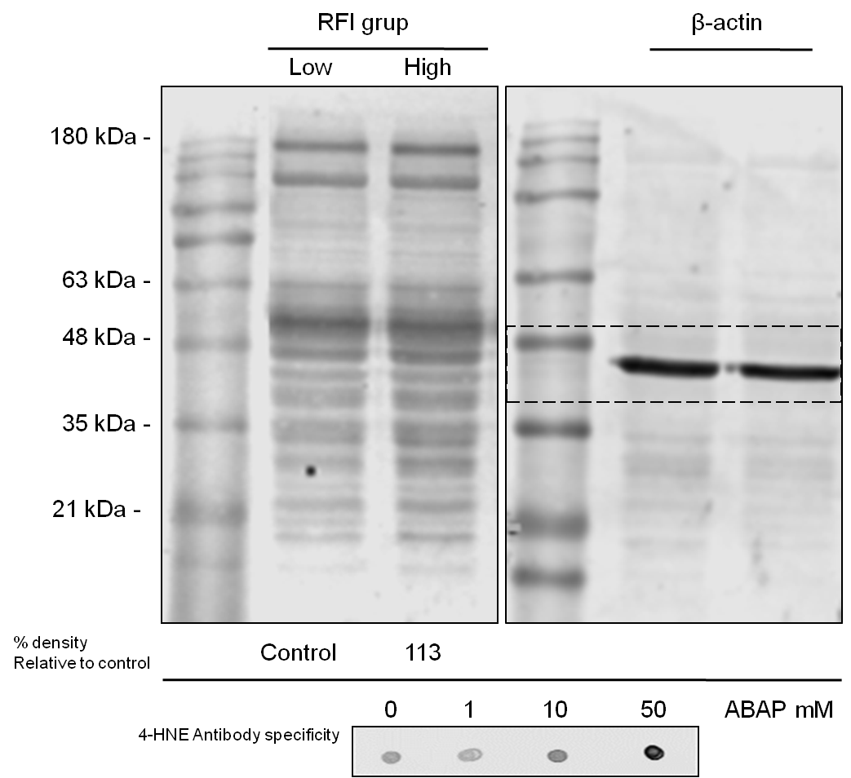

Supplementary Figure S1: Representative western blot analysis of 4-hydroxynonenal protein adduct (4-HNE) in liver. Expressed according to steer residual feed intake (RFI) phenotype. A quantity of 30 μg of proteins were loaded and separated by SDS-PAGE. Immunoblotting was performed with apolyclonal antibody thatrecognized 4-HNE. Data were normalized with β-actin density and normalized values for high-RFI were expressed as a percentage relative to the low-RFI group (Control). Images of 4-HNE (800 nm) and β-actin (680 nm) are from the same membrane.To check the specificity of the anti 4-HNE antibody, a dot blot was performed using liver homogenates incubated with different concentrations of 2,2'-azobis (2-amidinopropane) (ABAP, lipid peroxidation promoter).

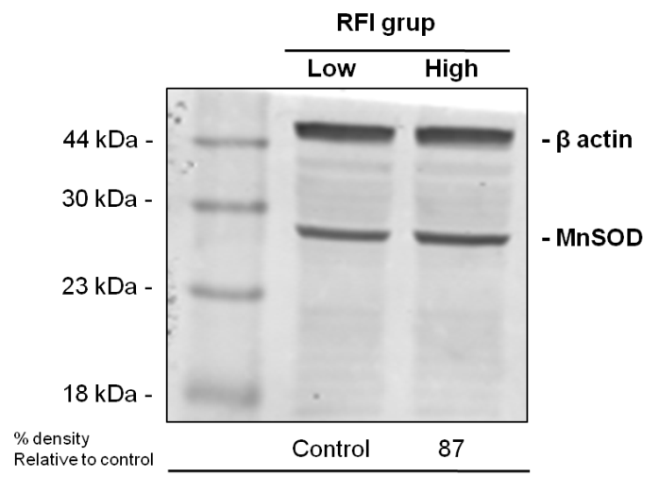
Supplementary Figure S2: Representative western blot analysis of manganese superoxide dismutase (MnSOD) in liver. Expressed according to steer residual feed intake (RFI) phenotype. A quantity of 30 μg of proteins were loaded and separated by SDS-PAGE. Immunoblotting was performed with a monoclonal antibody that recognized MnSOD. Data were normalized with β-actin density and normalized values for high-RFI were expressed as a percentage relative to the low-RFI group (Control). Images of MnSOD and β-actin (both 680 nm) from of the same membrane.

