Animal-based measures on fattening heavy pigs at the slaughterhouse and the association with animal welfare at the farm level: a preliminary study
A. M. Maisano, M. Luini, N. Vitale, S. Rota Nodari, F. Scali, G. L. Alborali and F. Vezzoli
Animal journal
Supplementary Table S1 – Evaluation of the animal-based measures (ABMs) at slaughterhouse in pigs: Welfare Quality principles, description of the ABMs and examples.

PRINCIPLE | ABMS | SCORE | DESCRIPTION | EXAMPLE
Appropriate behaviour | Reluctant to move (ante-mortem) | Presence | Pigs that, during unloading, stop and stay still (no body/head movements or exploration) for at least two seconds (Welfare Quality, 2009; Velarde and Dalmau, 2012). | 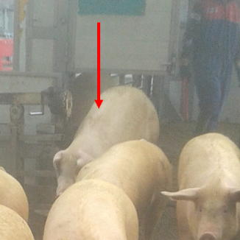
 | Turn in back (ante-mortem) | Presence | Pigs that, during unloading, turn back and face the lorry area (Welfare Quality, 2009; Velarde and Dalmau, 2012).

PRINCIPLE | ABMS | SCORE | DESCRIPTION | EXAMPLE
Good feeding | Non-uniformity of size  (post-mortem) | Presence | Pigs, in the slaughter line, with clear weight differences (more than 30 kg) when compared with the PDO standards (160 to 170 kg of live weight). | 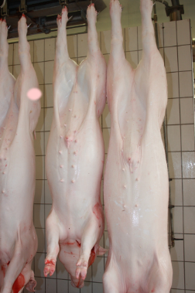
 | Number of different letters within the batch (post-mortem) | Presence | Tattooed letters on the thigh of pigs for the Italian PDO, which allow for the month of birth of the animal to be identified. Thus, within the same batch, pigs that are growing poorly growth can be identified by their tattooed letters. (Only last letter).  (T = January, C = February, B = March, A = April, M = May, P = June, L = July, E = August, S = September, R = October, H = November, D = December) | 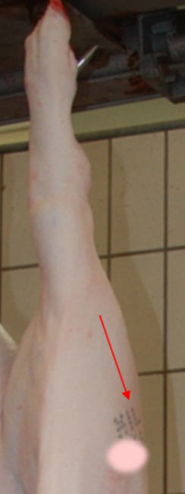

PRINCIPLE | ABMS | SCORE | DESCRIPTION | EXAMPLE
Good housing | Bursitis  (post-mortem) | 0 | No evidence of bursa/swelling (Welfare Quality, 2009; Temple et al., 2012).
 |  | 1 | One or more small bursae (comparable in size to a grape; 1-2 cm), or one larger bursa (comparable in size to a walnut; 3-5 cm) (Welfare Quality, 2009; Temple et al., 2012). | 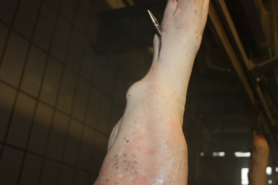
 |  | 2 | More than one large bursa on the same leg, or one very large bursa (comparable in size to a tangerine; >7 cm), or any eroded bursae (Welfare Quality, 2009; Temple et al., 2012).

PRINCIPLE | ABMS | SCORE | DESCRIPTION | EXAMPLE
Good housing | Manure on the body  (ante-mortem) | 0 | Less than 20% of the body surface was soiled (Welfare Quality, 2009; Temple et al., 2012).
 |  | 1 | More than 20% but less than 50% of body surface was soiled (Welfare Quality, 2009; Temple et al., 2012).
 |  | 2 | More than 50% of body surface was soiled (Welfare Quality, 2009; Temple et al., 2012).

PRINCIPLE | ABMS | SCORE | DESCRIPTION | EXAMPLE
Good health-injuries | Lameness  (ante-mortem) | 0 | Pigs with normal gait or pigs with difficulties in walking that still use all their legs (stride may be shortened and/or there may be a swagger of the caudal part of the body when walking) (Welfare Quality, 2009).
 |  | 1 | Pigs severely lame with minimum weight-bearing on the affected limb. The minimum weight-bearing of a limb was considered when, during motion or at rest, the following was observed: intermittent support, support only on the tip, weight shifting on contralateral limb and/or asymmetric walking (Welfare Quality, 2009). | 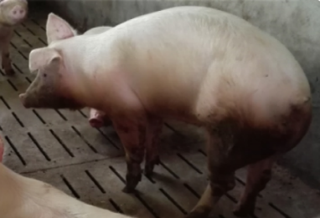
 |  | 2 | No weight-bearing on the affected limb, or pigs unable to walk (Welfare Quality, 2009). | 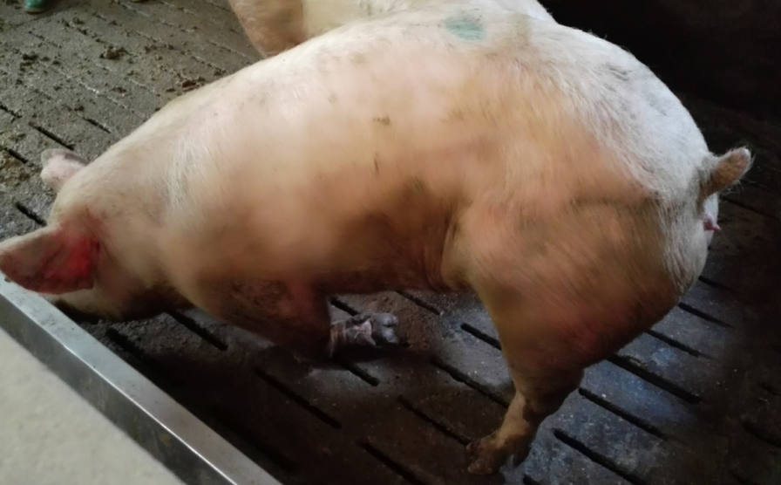

PRINCIPLE | ABMS | SCORE | DESCRIPTION | EXAMPLE
Good health-injuries | Ear injuries  (ante-mortem) | Presence | Was defined as the outcome of wounds such as missing ear parts (for all causes, except man-made ear-notching), biting lesions (scarring, irregular ear profile), otohaematoma (cauliflower ear), or ear necrosis (area of necrosis may have become dry, crusty, and curled over).

PRINCIPLE | ABMS | SCORE | DESCRIPTION | EXAMPLE
Good health-injuries | Tail biting lesion  (ante-mortem) | 0 | No evidence of a tail-biting lesion or indicator of superficial biting along the length of the tail without fresh blood or any swelling; red areas on the tail were not considered to be a wound unless it was associated with fresh blood) (Welfare Quality, 2009). | 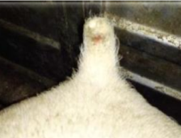
 |  | 1 | Fresh blood visible on the tail was evidence of inflammation (swelling, redness) and /or the presence of exudate (infection), and/or part of the tail tissue was missing and a crust has formed (Welfare Quality, 2009).

PRINCIPLE | ABMS | SCORE | DESCRIPTION | EXAMPLE
Good health-injuries | Wounds on the body  (post-mortem) | Absent | Considering all five body regions that were assessed, no more than four lesions were present (Welfare Quality, 2009).
 |  | Mild | Five to ten lesions in at least one of the five body regions or, at most, 11 to 15 lesions in one body region (Welfare Quality, 2009).
 |  | Severe | More than ten lesions in at least two regions of the body or more than 15 lesions in one region (Welfare Quality, 2009).

PRINCIPLE | ABMS | SCORE | DESCRIPTION | EXAMPLE
Good health-diseases | Dermatitis  (post-mortem) | Presence | When more than 10% of the skin was inflamed (redness) or spotted (e.g., sarcoptic mange) (Welfare Quality, 2009). | 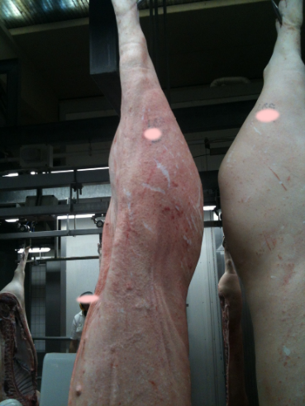
 | Local infection  (post-mortem) | 1 | Some swelling visible but no evidence of inflammation, or one small abscess (comparable in size to a walnut; <5 cm) (Welfare Quality, 2009). | 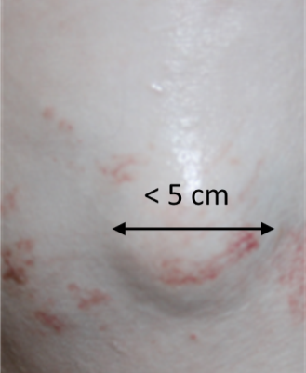
 |  | 2 | More than one small abscess, or one large abscess (comparable in size to a lemon; >5 cm), or any abscess that was open and exuding purulent material (Welfare Quality, 2009). | 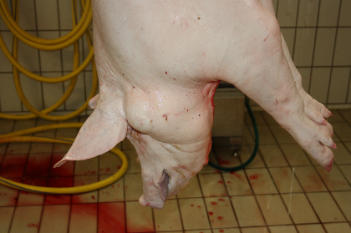

PRINCIPLE | ABMS | SCORE | DESCRIPTION | EXAMPLE
Good health-diseases | Outpouchings  (ante-mortem) | 1 | Presence of umbilical and/or perineal outpouching without bleeding, that is not touching the floor and not affecting locomotion (Welfare Quality, 2009). | 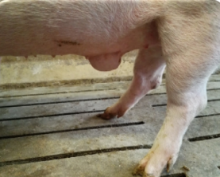
 |  | 2 | Presence of bleeding umbilical and/or perineal outpouching, or outpouching that is touching the floor or affecting locomotion (Welfare Quality, 2009). | 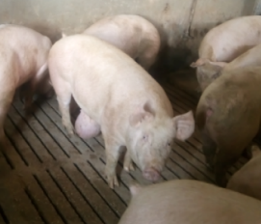
 | Scouring  (ante-mortem) | Presence | Evidence of some liquid manure (fresh dung on the floor) (Welfare Quality, 2009). | 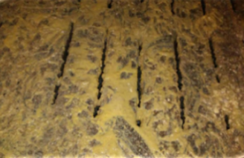
 | Rectal prolapse  (ante-mortem) | Presence | Was considered when the mucosal or full-thickness layer of rectal tissue protruded through the anus (Welfare Quality, 2009). | 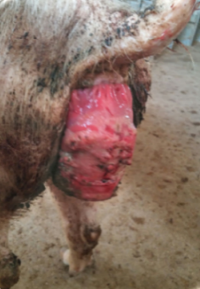

PRINCIPLE | ABMS | SCORE | DESCRIPTION | EXAMPLE
Good health-diseases | Pumping  (ante-mortem) | Presence | Pigs had heavy and laboured breathing and the rising and falling of their chest were clearly noticeable during each breath (Welfare Quality, 2009). | 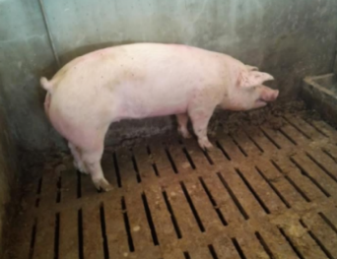
 | Twisted snouts  (ante-mortem) | Presence | Pigs with evidence of twisted snouts from slight deformity of the snout to severe nasal distortion by atrophy of the nasal turbinate and septal deviation (Welfare Quality, 2009). | 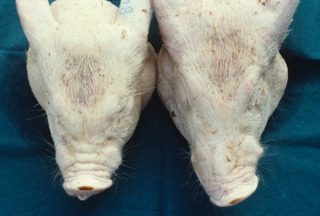

PRINCIPLE | ABMS | SCORE | DESCRIPTION | EXAMPLE
Good health-diseases | Pneumonia  (post-mortem) | Presence | Any evidence of inflammatory processes on the surfaces of the lung and/or consolidation of the parenchyma (Welfare Quality, 2009). | 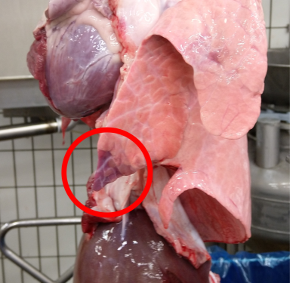
 | Pleurisy  (post-mortem) | Presence | Any evidence of inflammation of the pleurae or when lungs appeared partially or totally destroyed after evisceration due to adhesions of the lungs by the pleura (Welfare Quality, 2009). | 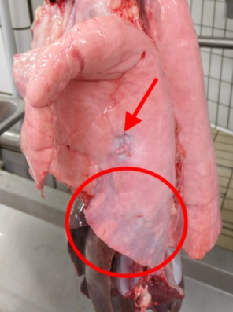  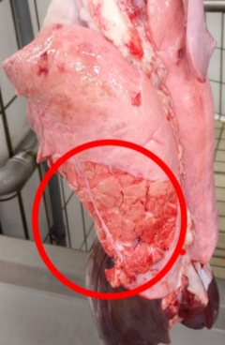
 | Pericarditis  (post-mortem) | Presence | An adhesion between the hearth and the pericardium (Welfare Quality, 2009).
 | White spot on the liver  (post-mortem) | Presence | The presence of at least one milk spot (Welfare Quality, 2009).

PRINCIPLE | ABMS | SCORE | DESCRIPTION | EXAMPLE
Good health-diseases | Carcasses discarded  (ante-mortem and post-mortem) | Presence | The discarded carcasses were registered during the ante-mortem and post-mortem inspections as the percentage of carcasses discarded for any reason. Namely, pigs found dead on arrival, emergency-slaughtered pigs, and carcasses that were discarded during the official veterinary inspections (e.g., jaundice, erysipelas) (Welfare Quality, 2009). | 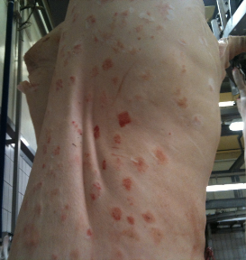
ABM = Animal-based measure; PDO = Protected designation of origin

Supplementary material S1: questionnaire for pig welfare assessment on farm

Animal based measures on fattening heavy pigs at the slaughterhouse and associations with animal welfare at the farm level: a preliminary study

Check-list for assessment of animal welfare in pigs (finishers only)

Date Time ID Farm
Assessor Phone./e-mail.

FARM GENERAL INFORMATION
Name
Address
Phone / E-Mail

Personnel:
Owner
Stockman
Vet

FARM CHARACTERISTICS
Farm type: □ intensive □ organic □ semi-extensive (presence of external areas)
Age groups: □ sows □ boars □ piglets □ weaners □ finishers
Genetic: □ goland □ danbred □ pic □ hypor □ other (specify)______________

No. sows: No. sows in farrowing crates No. sows in pen

No. sows in gestation crates No. gilts No. piglets

No. boars No. boars for artificial insemination

No. weaners

No. finishers

MANAGEMENT PROCEDURES AND STOCKMEN:
N° stockmen:

The animals are inspected at least once a day: □yes □no

Staff is adequately trained: □no □yes □ internal courses □ external courses

The owner or keeper of the animals maintains a record of dead pigs found after each inspection: □yes □no

The owner or the keeper of the pigs maintains a record of any medicinal treatment given: □yes □no

Ear notching: □yes □no □ only for identification

Nose-ringing: □yes □no □ only in outdoor husbandry systems

The animals are killed on farm (euthanasia): □yes □no

Method:

Presence of written euthanasia procedures: □yes □no

FATTENING SECTOR

No. of pens: _______________
No. of different pen types: ___________

Topic | Answer | Notes
Presence of the hospital pen | □yes □no
Presence of dry comfortable bedding in hospital pen | □yes □no
Hospital pen allows the animal to turn around easily | □yes □no
Measures taken to prevent fighting among pigs which goes beyond normal behaviour | □yes □no
Pigs are fed at least once a day | □yes □no
Ad libitum feeding system | □yes □no
Presence of artificial an ventilation system | □yes □no
Presence of a backup system for the artificial ventilation system | □yes □no
Presence of an alarm system for the artificial ventilation system | □yes □no
Daily inspection of automated or mechanical equipment [e.g., feeding, ventilation and alarm systems] | □yes □no

FATTENING PEN
Space allowance – Flooring surface
Compliances (Directive 2008/120/EC):
0.65 m² / pig (85-110 kg) up to 1m² / pig (> 110 kg)
Slatted floors – opening width: ≤18 mm
Slatted floors – slat width: ≥ 80 mm

Pen type No. animals
Pen measures (area):
Opening width: mm Slat width: mm

STABULATION AREAS
Topic | Answer | Notes
Available light > 40 lux for 8 h | □yes □no
Continuous noise < 85 dBA. Avoidance of constant or sudden noise | □yes □no
Presence of adequate shelters for all animals (free-raging pigs only) | □yes □no
Temperature, relative air humidity and dust levels kept within the no-harmful limits | □yes □no
Noxious gas concentrations (e.g. ammonia) kept within the no-harmful limits | □yes □no
Pigs accommodation are constructed and maintained so that there are no sharp edges or protrusions likely to cause injury to the animals | □yes □no
Presence of clean and dry areas that allows all animals to lie down at the same time, rest and get up normally | □yes □no

FOOD AND WATER
Topic | Answer | Notes
All the pigs of the pen can access to the food at the same time | □yes □no
Feeding equipment is designed, constructed and placed to minimize competition between the animals | □yes □no
All pigs have permanent access to a sufficient quantity of fresh water | □yes □no
Presence of functioning bite or nipple drinkers | □yes □no

ENRICHMENT MATERIALS
 | Present? |  | Type and quantity |  |  |  |  |  | Dirtiness |  |  | Accessibility |  |  | Used
 | yes | no | wood | peat | straw | hay | quantity for pen | other  (specify) |  | yes | no |  | yes | no | yes | no
Pen type No. _

ANIMAL BASED MEASURES Age group _________ Weight (kg) ________
Subject | 1 | 2 | 3 | 4 | 5 | 6 | 7 | 8 | 9 | 10 | 11 | 12 | 13 | …
Manure on the body
score 0
score 1
score 2
Non-uniformity of size
Bursitis
Lameness
Wounds on the body
Ear injury
Tail biting lesion
Dermatitis
Local infection
Outpouchings
Scouring
Rectal prolapse
Twisted snouts
Pumping

