The supplementary materials of Animal journal

Genetic and morphology analysis among the pentaploid F₁ hybrid fishes (Schizothorax wangchiachii ♀× Percocypris pingi ♂) and their parents
H. R. Gu¹, Y. F. Wan¹, Y. Yang¹, Q. Ao¹, W. L. Cheng¹, S. H. Deng², D. Y. Pu¹, X. F. He¹, L. Jin¹, Z. J. Wang¹

¹Key Laboratory of Freshwater Fish Reproduction and Development (Ministry of Education), Key Laboratory of Aquatic Science of Chongqing, School of Life Sciences, Southwest University, 400715 Chongqing, China
²Xichang Jiahe Agriculture Company Limited, 615000 Xichang, China

Corresponding author: Zhi Jian Wang. E-mail: wangzj1969@126.com
Supplementary Table S1 Karyotype comparison between Schizothorax fishes
Species | Karyotype formula | 2n | NF | NF/2n | References
S. grahami | 2n=52m+30sm+66st-t | 148 | 230 | 1.55 | Zan et al., 1985
S. taliensis | 2n=48m+30sm+70st-t | 148 | 226 | 1.52 | Zan et al., 1985
S. prenanti | 2n=28m+40sm+36st+44t | 148 | 216 | 1.45 | Li et al., 1987
S. lissolabiatus | 2n=44m+36sm+20st+48t | 148 | 228 | 1.54 | Dai and Han, 2018
S. davidi | 2n=20m+34sm+24st+20t | 98 | 152 | 1.55 | Li et al., 1987
S. waltoni | 2n=26m+28sm+22st+16t | 92 | 146 | 1.59 | Yu and Li, 1990
S. oconnori | 2n=30m+26sm+20st+16t | 92 | 148 | 1.61 | Yu and Li, 1990
S. kozlovi | 2n=18m+14sm+16st+44t | 92 | 124 | 1.34 | Dai and Han, 2018
S. macropogon | / | 90-98 | / | / | Yu, 1989
S. richardsonii | 2n=16m+40sm+42t | 98 | 154 | 1.57 | Lakara et al., 1997
S. kumaonensis | 2n=18m+10sm+70t | 98 | 126 | 1.29 | Lakara et al., 1997
S. curvifrons | 2n=26m+20sm+20st+28t | 94 | 140 | 1.49 | Ganai et al., 2011
S. esocinus | 2n=30m+22sm+10st+36t | 98 | 150 | 1.53 | Ganai et al., 2011
S. labiatus | 2n=24m+20sm+2st+52t | 98 | 142 | 1.45 | Ganai et al., 2011
S. niger | 2n=24m+32sm+22st+20t | 98 | 154 | 1.57 | Ganai et al., 2011
S. plagiostomus | 2n=24m+18sm+54t | 96 | 138 | 1.43 | Ganai et al., 2011
S. zarudnyi | 2n=18m+28sm+50st | 96 | 142 | 1.48 | Kalbassi et al., 2008
S. progastus | 2n=16m+40sm+42t | 98 | 154 | 1.57 | Rishi et al., 1983
S. wangchiachii | 2n=36m+34sm+12st+66t | 148 | 218 | 1.47 | This study
m= metacentric chromosome; sm= submetacentric chromosome; st= subterminal chromosome; t= terminal chromosome. NF= the total numbers of chromosome arms.

Supplementary Table S2 Number of polymorphic loci and the percentage in the hybrid fishes and their parents with a single primer by inter-simple sequence repeat (ISSR) analysis
Primers | No. of amplified bands | No. of polymorphic bands | Percentage of polymorphic bands (%)
(AG)₈G | 8 | 5 | 62.5
(AG)₈T | 7 | 5 | 71.4
(AG)₈C | 20 | 14 | 70.0
(AG)₈YC | 7 | 4 | 57.1
(AG)₈YT | 11 | 10 | 90.9
(AG)₈YA | 10 | 8 | 80.0
(AG)₈GT | 12 | 8 | 66.7
(AG)₈CTA | 17 | 14 | 82.4
(TC)₈C | 4 | 3 | 75.0
(TC)₈RG | 5 | 4 | 80.0
(TG)₈RC | 6 | 6 | 100.0
(CT)₈RG | 3 | 2 | 66.7
(CT)₈A | 6 | 4 | 66.7
(GA)₈YT | 11 | 9 | 81.8
(GA)₈YG | 7 | 5 | 71.4
(GA)₈A | 7 | 6 | 85.7
(GA)₈CTA | 16 | 14 | 87.5
(GACA)₄ | 12 | 11 | 91.7
(GAA)₆ | 13 | 13 | 100.0
Total | 178 | 149 | 83.7
R=(A, G); Y=(C, T).

Supplementary Table S3 The karyotype date of S. wangchiachii
Chromosome No. | Relative length % | Arm ratio L/S | Type | Chromosome No. | Relative length % | Arm ratio L/S | Type
1 | 1.66±0.16 | 1.33±0.18 | m | 38 | 0.67±0.08 | 3.78±0.63 | st
2 | 1.27±0.12 | 1.42±0.25 | m | 39 | 0.63±0.11 | 3.76±0.50 | st
3 | 1.08±0.11 | 1.41±0.19 | m | 40 | 0.59±0.13 | 3.69±0.39 | st
4 | 1.07±0.07 | 1.28±0.23 | m | 41 | 0.58±0.08 | 3.49±0.31 | st
5 | 1.11±0.12 | 1.33±0.23 | m | 42 | 0.74±0.08 | ∞ | t
6 | 1.04±0.12 | 1.37±0.15 | m | 43 | 0.68±0.12 | ∞ | t
7 | 0.88±0.10 | 1.32±0.18 | m | 44 | 0.66±0.12 | ∞ | t
8 | 0.87±0.08 | 1.45±0.18 | m | 45 | 0.60±0.08 | ∞ | t
9 | 0.85±0.08 | 1.43±0.21 | m | 46 | 0.59±0.11 | ∞ | t
10 | 0.77±0.11 | 1.26±0.17 | m | 47 | 0.59±0.10 | ∞ | t
11 | 0.70±0.09 | 1.36±0.21 | m | 48 | 0.58±0.06 | ∞ | t
12 | 0.71±0.10 | 1.28±0.22 | m | 49 | 0.57±0.06 | ∞ | t
13 | 0.68±0.10 | 1.39±0.21 | m | 50 | 0.57±0.07 | ∞ | t
14 | 0.64±0.06 | 1.48±0.14 | m | 51 | 0.57±0.09 | ∞ | t
15 | 0.60±0.09 | 1.23±0.15 | m | 52 | 0.56±0.10 | ∞ | t
16 | 0.59±0.09 | 1.29±0.20 | m | 53 | 0.55±0.05 | ∞ | t
17 | 0.59±0.09 | 1.43±0.18 | m | 54 | 0.54±0.09 | ∞ | t
18 | 0.57±0.07 | 1.32±0.24 | m | 55 | 0.54±0.11 | ∞ | t
19 | 1.63±0.21 | 2.55±0.36 | sm | 56 | 0.53±0.11 | ∞ | t
20 | 1.17±0.11 | 2.44±0.31 | sm | 57 | 0.52±0.12 | ∞ | t
21 | 1.07±0.13 | 2.21±0.30 | sm | 58 | 0.52±0.13 | ∞ | t
22 | 0.93±0.10 | 2.45±0.36 | sm | 59 | 0.51±0.12 | ∞ | t
23 | 0.97±0.12 | 2.52±0.26 | sm | 60 | 0.50±0.11 | ∞ | t
24 | 0.89±0.12 | 2.20±0.27 | sm | 61 | 0.48±0.06 | ∞ | t
25 | 0.87±0.12 | 2.41±0.46 | sm | 62 | 0.46±0.11 | ∞ | t
26 | 0.84±0.10 | 2.22±0.27 | sm | 63 | 0.45±0.08 | ∞ | t
27 | 0.71±0.06 | 2.25±0.44 | sm | 64 | 0.45±0.07 | ∞ | t
28 | 0.67±0.11 | 2.43±0.34 | sm | 65 | 0.44±0.08 | ∞ | t
29 | 0.65±0.12 | 2.28±0.28 | sm | 66 | 0.44±0.03 | ∞ | t
30 | 0.63±0.08 | 2.40±0.39 | sm | 67 | 0.43±0.06 | ∞ | t
31 | 0.58±0.07 | 2.92±0.49 | sm | 68 | 0.41±0.09 | ∞ | t
32 | 0.58±0.08 | 2.26±0.40 | sm | 69 | 0.41±0.10 | ∞ | t
33 | 0.56±0.09 | 2.36±0.37 | sm | 70 | 0.40±0.08 | ∞ | t
34 | 0.53±0.08 | 2.84±0.60 | sm | 71 | 0.39±0.08 | ∞ | t
35 | 0.51±0.11 | 2.77±0.47 | sm | 72 | 0.37±0.09 | ∞ | t
36 | 0.90±0.09 | 3.73±0.41 | st | 73 | 0.36±0.07 | ∞ | t
37 | 0.71±0.11 | 3.71±0.52 | st | 74 | 0.27±0.10 | ∞ | t
m= metacentric chromosome; sm= submetacentric chromosome; st= subterminal chromosome; t= terminal chromosome. L/S= long arm/short arm

Supplementary Table S4 The karyotype date of the hybrid fishes
Chromosome No. | Relative length % | Arm ratio L/S | Type | Chromosome No. | Relative length % | Arm ratio L/S | Type
1 | 1.54±0.08 | 1.63±0.10 | m | 63 | 0.75±0.03 | 2.43±0.12 | sm
2 | 1.53±0.02 | 1.43±0.06 | m | 64 | 0.75±0.03 | 2.22±0.12 | sm
3 | 1.53±0.03 | 1.32±0.04 | m | 65 | 0.71±0.04 | 2.13±0.16 | sm
4 | 1.25±0.04 | 1.53±0.03 | m | 66 | 0.71±0.04 | 2.43±0.22 | sm
5 | 1.25±0.07 | 1.61±0.05 | m | 67 | 0.70±0.03 | 2.31±0.26 | sm
6 | 1.10±0.07 | 1.61±0.07 | m | 68 | 0.89±0.04 | 3.53±0.27 | st
7 | 1.08±0.05 | 1.59±0.07 | m | 69 | 0.85±0.09 | 3.49±0.22 | st
8 | 1.08±0.03 | 1.69±0.12 | m | 70 | 0.85±0.13 | 3.57±0.18 | st
9 | 1.03±0.04 | 1.42±0.14 | m | 71 | 0.78±0.10 | 3.12±0.09 | st
10 | 1.03±0.05 | 1.45±0.09 | m | 72 | 0.64±0.06 | 3.11±0.18 | st
11 | 1.02±0.04 | 1.33±0.05 | m | 73 | 0.87±0.04 | ∞ | t
12 | 1.01±0.04 | 1.20±0.12 | m | 74 | 0.87±0.07 | ∞ | t
13 | 1.01±0.06 | 1.59±0.09 | m | 75 | 0.85±0.11 | ∞ | t
14 | 0.98±0.04 | 1.60±0.03 | m | 76 | 0.85±0.05 | ∞ | t
15 | 0.97±0.03 | 1.55±0.02 | m | 77 | 0.84±0.06 | ∞ | t
16 | 0.95±0.02 | 1.05±0.04 | m | 78 | 0.80±0.02 | ∞ | t
17 | 0.95±0.01 | 1.32±0.03 | m | 79 | 0.79±0.03 | ∞ | t
18 | 0.94±0.03 | 1.64±0.07 | m | 80 | 0.79±0.01 | ∞ | t
19 | 0.93±0.03 | 1.40±0.08 | m | 81 | 0.77±0.02 | ∞ | t
20 | 0.93±0.02 | 1.40±0.06 | m | 82 | 0.77±0.05 | ∞ | t
21 | 0.90±0.03 | 1.42±0.15 | m | 83 | 0.76±0.02 | ∞ | t
22 | 0.88±0.06 | 1.34±0.10 | m | 84 | 0.75±0.02 | ∞ | t
23 | 0.88±0.02 | 1.51±0.04 | m | 85 | 0.75±0.04 | ∞ | t
24 | 0.87±0.02 | 1.03±0.03 | m | 86 | 0.75±0.02 | ∞ | t
25 | 0.87±0.03 | 1.50±0.03 | m | 87 | 0.75±0.02 | ∞ | t
26 | 0.86±0.04 | 1.48±0.04 | m | 88 | 0.75±0.01 | ∞ | t
27 | 0.81±0.08 | 1.54±0.05 | m | 89 | 0.74±0.04 | ∞ | t
28 | 0.81±0.06 | 1.52±0.03 | m | 90 | 0.73±0.02 | ∞ | t
29 | 0.81±0.04 | 1.42±0.07 | m | 91 | 0.73±0.03 | ∞ | t
30 | 0.80±0.03 | 1.23±0.04 | m | 92 | 0.72±0.02 | ∞ | t
31 | 0.79±0.02 | 1.44±0.11 | m | 93 | 0.72±0.05 | ∞ | t
32 | 0.79±0.04 | 1.65±0.06 | m | 94 | 0.71±0.01 | ∞ | t
33 | 0.76±0.03 | 1.35±0.10 | m | 95 | 0.70±0.02 | ∞ | t
34 | 0.76±0.02 | 1.61±0.15 | m | 96 | 0.69±0.03 | ∞ | t
35 | 0.75±0.02 | 1.44±0.05 | m | 97 | 0.69±0.01 | ∞ | t
36 | 0.75±0.03 | 1.24±0.10 | m | 98 | 0.68±0.03 | ∞ | t
37 | 0.72±0.04 | 1.67±0.06 | m | 99 | 0.68±0.03 | ∞ | t
38 | 0.72±0.04 | 1.24±0.05 | m | 100 | 0.67±0.05 | ∞ | t
39 | 0.69±0.04 | 1.37±0.12 | m | 101 | 0.67±0.04 | ∞ | t
40 | 1.54±0.12 | 1.93±0.10 | sm | 102 | 0.66±0.05 | ∞ | t
41 | 1.50±0.08 | 2.23±0.08 | sm | 103 | 0.65±0.03 | ∞ | t
42 | 1.42±0.05 | 2.87±0.13 | sm | 104 | 0.65±0.06 | ∞ | t
43 | 1.02±0.03 | 2.74±0.23 | sm | 105 | 0.63±0.02 | ∞ | t
44 | 1.01±0.05 | 2.14±0.13 | sm | 106 | 0.63±0.01 | ∞ | t
45 | 0.96±0.04 | 1.77±0.03 | sm | 107 | 0.61±0.05 | ∞ | t
46 | 0.93±0.04 | 2.84±0.23 | sm | 108 | 0.59±0.03 | ∞ | t
47 | 0.93±0.05 | 2.80±0.14 | sm | 109 | 0.58±0.03 | ∞ | t
48 | 0.92±0.02 | 2.53±0.14 | sm | 110 | 0.57±0.03 | ∞ | t
49 | 0.92±0.03 | 1.75±0.06 | sm | 111 | 0.56±0.01 | ∞ | t
50 | 0.91±0.04 | 2.66±0.11 | sm | 112 | 0.55±0.02 | ∞ | t
51 | 0.91±0.07 | 2.76±0.12 | sm | 113 | 0.55±0.01 | ∞ | t
52 | 0.90±0.04 | 2.84±0.10 | sm | 114 | 0.54±0.04 | ∞ | t
53 | 0.88±0.04 | 2.56±0.06 | sm | 115 | 0.54±0.03 | ∞ | t
54 | 0.84±0.04 | 1.85±0.11 | sm | 116 | 0.53±0.02 | ∞ | t
55 | 0.81±0.04 | 1.84±0.07 | sm | 117 | 0.53±0.04 | ∞ | t
56 | 0.80±0.04 | 1.85±0.11 | sm | 118 | 0.52±0.01 | ∞ | t
57 | 0.80±0.03 | 1.85±0.12 | sm | 119 | 0.50±0.03 | ∞ | t
58 | 0.80±0.04 | 1.85±0.11 | sm | 120 | 0.44±0.03 | ∞ | t
59 | 0.79±0.05 | 2.61±0.07 | sm | 121 | 0.41±0.06 | ∞ | t
60 | 0.79±0.05 | 2.63±0.04 | sm | 122 | 0.33±0.05 | ∞ | t
61 | 0.79±0.08 | 2.83±0.17 | sm | 123 | 0.31±0.04 | ∞ | t
62 | 0.76±0.08 | 1.81±0.06 | sm
The chromosomes are not paired. m= metacentric chromosome; sm= submetacentric chromosome; st= subterminal chromosome; t= terminal chromosome. L/S= long arm/short arm.

Supplementary Table S5 Genitic distance based on inter-simple sequence repeat (ISSR) between 24 individuals of the hybrid fishes and their parents
 | P1 | P2 | P3 | P4 | P5 | P6 | P7 | P8 | S1 | S2 | S3 | S4 | S5 | S6 | S7 | S8 | PS1 | PS2 | PS3 | PS4 | PS5 | PS6 | PS7 | PS8
P1 | ****
P2 | 0.0674 | ****
P3 | 0.0733 | 0.0388 | ****
P4 | 0.0445 | 0.0674 | 0.0969 | ****
P5 | 0.0164 | 0.0616 | 0.0674 | 0.0388 | ****
P6 | 0.0332 | 0.0674 | 0.0969 | 0.0220 | 0.0275 | ****
P7 | 0.0791 | 0.0559 | 0.0850 | 0.0559 | 0.0616 | 0.0445 | ****
P8 | 0.1090 | 0.0733 | 0.1029 | 0.0733 | 0.0910 | 0.0733 | 0.0388 | ****
S1 | 0.9383 | 0.9109 | 0.8711 | 0.9109 | 0.9245 | 0.9109 | 0.9109 | 0.8974 | ****
S2 | 0.9109 | 0.9383 | 0.8711 | 0.9383 | 0.9245 | 0.9109 | 0.9383 | 0.9245 | 0.0910 | ****
S3 | 0.9109 | 0.9383 | 0.8974 | 0.9383 | 0.9245 | 0.9109 | 0.9383 | 0.9245 | 0.0910 | 0.0559 | ****
S4 | 0.9109 | 0.9383 | 0.8974 | 0.9383 | 0.9245 | 0.9109 | 0.9383 | 0.9245 | 0.0910 | 0.0559 | 0.0000 | ****
S5 | 0.8711 | 0.8711 | 0.8582 | 0.8974 | 0.8842 | 0.8711 | 0.8711 | 0.8582 | 0.1335 | 0.0733 | 0.0850 | 0.0850 | ****
S6 | 0.9245 | 0.9245 | 0.8842 | 0.9808 | 0.9383 | 0.9245 | 0.9523 | 0.9664 | 0.1212 | 0.1212 | 0.0850 | 0.0850 | 0.1273 | ****
S7 | 0.9109 | 0.9109 | 0.8711 | 0.9383 | 0.9245 | 0.9109 | 0.8842 | 0.8711 | 0.1398 | 0.1523 | 0.1273 | 0.1273 | 0.1460 | 0.1460 | ****
S8 | 0.8455 | 0.8711 | 0.8582 | 0.8711 | 0.8582 | 0.8455 | 0.8205 | 0.8082 | 0.1335 | 0.1335 | 0.1090 | 0.1090 | 0.1273 | 0.1523 | 0.1090 | ****
PS1 | 0.5610 | 0.5998 | 0.6300 | 0.5802 | 0.5900 | 0.5421 | 0.5421 | 0.5705 | 0.4028 | 0.3551 | 0.3551 | 0.3551 | 0.3171 | 0.3787 | 0.3397 | 0.3321 | ****
PS2 | 0.5802 | 0.5610 | 0.5900 | 0.5421 | 0.5705 | 0.5421 | 0.5236 | 0.5328 | 0.4191 | 0.3866 | 0.3551 | 0.3551 | 0.3474 | 0.3787 | 0.3551 | 0.3321 | 0.1273 | ****
PS3 | 0.5236 | 0.5610 | 0.5705 | 0.5236 | 0.5328 | 0.4875 | 0.5054 | 0.5328 | 0.4528 | 0.4028 | 0.3866 | 0.3866 | 0.3947 | 0.3947 | 0.3707 | 0.3787 | 0.0910 | 0.0791 | ****
PS4 | 0.5145 | 0.5705 | 0.5802 | 0.5328 | 0.5421 | 0.5145 | 0.5145 | 0.5236 | 0.3787 | 0.3629 | 0.3474 | 0.3474 | 0.3397 | 0.3551 | 0.3474 | 0.2950 | 0.0850 | 0.0969 | 0.0850 | ****
PS5 | 0.5610 | 0.5421 | 0.5328 | 0.5802 | 0.5705 | 0.5610 | 0.5236 | 0.5328 | 0.3707 | 0.3551 | 0.3707 | 0.3707 | 0.3474 | 0.3629 | 0.3246 | 0.3171 | 0.1651 | 0.1523 | 0.1651 | 0.1587 | ****
PS6 | 0.5515 | 0.5705 | 0.5802 | 0.5515 | 0.5421 | 0.5328 | 0.4964 | 0.5236 | 0.3787 | 0.3787 | 0.3629 | 0.3629 | 0.3707 | 0.3707 | 0.3171 | 0.3551 | 0.1212 | 0.1335 | 0.0969 | 0.0791 | 0.1460 | ****
PS7 | 0.5236 | 0.5236 | 0.5515 | 0.5421 | 0.5328 | 0.5236 | 0.4875 | 0.5145 | 0.3866 | 0.3707 | 0.3866 | 0.3866 | 0.3321 | 0.3787 | 0.3397 | 0.2877 | 0.1911 | 0.1911 | 0.1780 | 0.1587 | 0.0910 | 0.1460 | ****
PS8 | 0.5515 | 0.5515 | 0.5802 | 0.5515 | 0.5610 | 0.5515 | 0.5145 | 0.5236 | 0.3474 | 0.3629 | 0.3629 | 0.3629 | 0.3397 | 0.3707 | 0.3171 | 0.3246 | 0.1977 | 0.1715 | 0.1977 | 0.1780 | 0.0850 | 0.1651 | 0.0850 | ****
P=P. ping; S=S. wangchiachii; PS=The hybrid fishes.
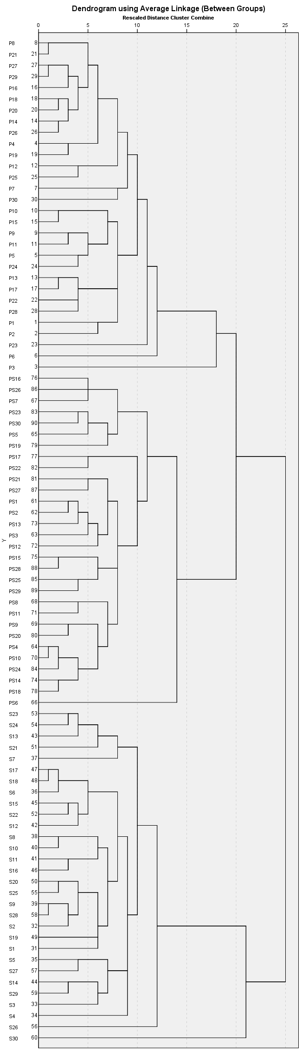

Supplementary Figure S1 The morphological clustering by euclidean distance in the hybrid fishes and their parents; P=P. pingi, n=30; S=S. wangchiachii, n=30; PS= the hybrid fishes, n=30.
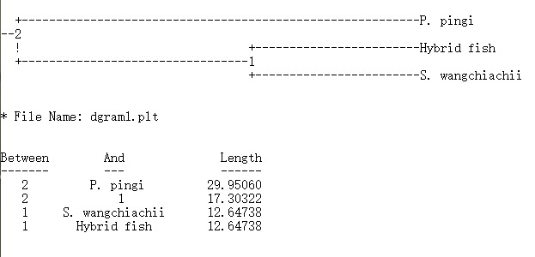

Supplementary Figure S2 The original inter-simple sequence repeat (ISSR) genetic clustering based on unweighted pair group method average (UPGMA) in the hybrid fishes and their parents by Popgen 1.32; P. pingi, n=8; S. wangchiachii, n=8; the hybrid fishes, n=30

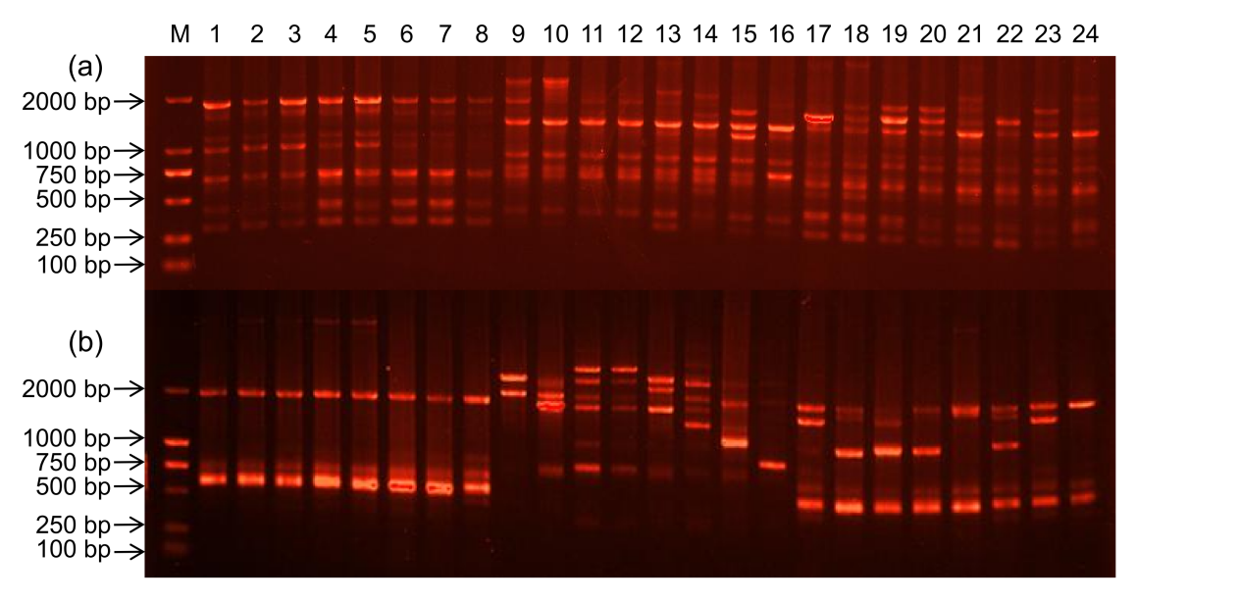

Supplementary Figure S3 The inter-simple sequence repeat (ISSR) patterns in the hybrid fishes and their parents; (a) ISSR pattern amplified by primer (GA)₈CTA; (b) ISSR pattern amplified by primer (GAA)₆; 1-8: P. pingi; 9-16: S. wangchiachii; 17-24: the hybrid fishes
References
Dai YG and Han FH 2018. Karyological Analysis of Two Species in the Subfamily Schizothoracinae (Cypriniformes: Cyprinidae) from China, with Notes on Karyotype Evolution in Schizothoracinae. Turkish Journal of Fisheries and Aquatic Sciences 18, 175-186.
Ganai FA, Yousuf AR, Dar SA, Tripathi NK and Wani SU 2011. Cytotaxonomic status of Schizothoracine fishes of Kashmir Himalaya (Teleostei: Cyprinidae). Caryologia 64, 435-445.
Kalbassi MR, Hosseini SV and Tahergorabi R 2008. Karyotype analysis in Schizothorax zarudnyi from Hamoon Lake, Iran. Turkish Journal of Fisheries and Aquatic Sciences 8, 335-340.
Lakara WS, John G and Barat A 1997. Cytogenetic studies on endangered and threatened fishes. II karyotypes of two species of snow-trout, Schizothorax richardsonii (Gray) and S. kumaonensis (Menon). Proceedings of the National Academy of Sciences India Section B (Biological Sciences) 67, 79-81.
Li Y, Li K, Gui J and Zhou D 1987. Studies on the karyotypes of Chinese Cyprinid fishes XI. Karyotypes of two species of Schizothoracinae and three species of Gobiobotinae. Acta Hydrobiologica Sinica 11, 184-186.
Rishi KK, Singh J and Kaul MM 1983. Chromosomal analysis of Schizothoraichthys progastus (McClelland) (Cyprinidae: Cypriniformes). Chromosome Information Service 34, 12-13.
Yu X and Li Y 1900. Karyotype studies of cyprinid fishes in china-Comparative study of the karyotypes of 8 species of Schizothoracine fishes. Journal of Wuhan University (Natural Science Edition) 2, 97-104.
Yu X, Zhou D, Li Y, Li K 1989. Chromosomes of Chinese fresh-water fishes. Science Press, Beijing, China.
Zan R, Liu W and Song Z 1985. Tetraploid-hexaploid relationship in Schizothoracinae. Journal Genetics Genomics 12, 137-142+167-168.

