A genome-wide association study for feed efficiency-related traits in a crossbred pig population
É. F. Silva, M.S. Lopes, P.S. Lopes and E. Gasparino
Animal: An International Journal of Animal Bioscience

Supplementary material

Supplementary Table S1 Formulated diet composition and nutrient content for the diets at each phase of the trial, e.g. start, grower and finisher (as-fed basis), used during the test period in a crossbred pig (Sus scrofa) population
Item | Starter  (days 0 to 25) | Grower  (days 26 to 67) | Finisher  (days 68 to 107)
Ingredients, g/kg
Wheat | 321.9 | 400.0 | 350.0
Soybean meal (48% CP) | 100.0 | 21.5
Barley | 200.0 | 100.0 | 150.0
Wheat middlings |  | 50.0 | 125.0
Peas | 120.0 | 29.4
Rapeseed meal (34% CP) | 63.0 | 80.0 | 100.0
Sunflower meal (38% CP) | 80.0 | 80.0 | 21.9
Molasses cane | 30.0 | 50.0 | 50.0
Corn gluten feed |  | 50.0 | 50.0
Palm kernel meal |  | 50.0 | 50.0
Soybean oil | 25.0
Poultry fat |  | 27.5 | 29.4
Soybean hulls |  | 14.3 | 50.0
Aminoacid premix¹ | 12.5 | 10.2 | 6.7
Limestone | 10.9 | 8.9 | 4.0
Lysine + Tryptophan premix | 4.3 | 3.6
Lysine HCl (L 79%) | 3.8 | 4.3 | 3.3
Methionine (DL 99%) | 1.3 | 0.7 | 0.1
Threonine (L 98%) | 1.7 | 1.6 | 0.9
Valine 10% | 1.4
Monocalcium phosphate | 5.3
Palm oil | 17.3 | 16.0 | 5.0
Phytase premix² | 5.0 | 5.0 | 1.9
Vitamin-trace mineral premix 1³ | 4.0 | 4.0 | 4.0
Salt | 2.1 | 1.8 | 2.1
Sodium bicarbonate | 1.1 | 1.0
Vitamin-trace mineral premix 2⁴ | 1.0
Vitamin premix⁵ | 1.0
Analyzed content, g/kg
Moisture | 120.0 | 119.0 | 115.0
Ash | 51.7 | 47.0 | 42.2
CP | 186.8 | 163.0 | 144.0
Crude fat | 55.0 | 66.0 | 60.0
Starch | 366.0 | 304.0 | 338.0
Calculated composition
Net energy, MJ/kg | 9.9 | 9.5 | 9.5
NSP, g/kg⁶ | 171.9 | 245.2 | 243.6
SID Lysine, g/kg | 11.1 | 9.1 | 6.8
SID Lysine:Net energy | 1.1 | 1.0 | 0.7
SID Methionine + Cysteine, g/kg | 6.6 | 5.6 | 4.6
SID Threonine,g/kg | 7.1 | 6.0 | 4.7
Digestible P, g/kg | 3.0 | 1.9 | 1.5
Ca, g/kg | 6.9 | 5.5 | 3.8
CP = Crude protein; NSP = Non-starch polysaccharide; SID = Standard ileal digestibility.
¹ Provided lysine, methionine, threonine, tryptophan and valine to equalize the dietary contents.
² Provided 500 phytase unit phytase/kg.
³ Supplied per kilogram of premix: 0.4 g of Ca, 15 mg of Cu (copper sulfate), 80 mg of Fe (ferrous sulfate), 24 mg of Mn (manganous oxide), 62 mg of Zn (zinc oxide), 0.04 mg of Co (cobalt oxide), 0.4 mg of I (potassium iodide), 0.2 mg of Se (sodium selenite), 7 500 IU of vitamin A, 1 500 IU of vitamin D3 , 25 IU of vitamin E, 4 mg of vitamin B2 , 6 mg of pantothenate, 30 mg of niacin, 0.02 mg of vitamin B12 and 0.752 mg of vitamin K3 (Mervit START M220; NuScience, Utrecht, the Netherlands).
⁴ Supplied per kilogram of feed: 12 mg of Fe (ferrous sulfate), 10 mg of Mn (manganous oxide), 0.04 mg of Co cobalt oxide), 0.12 g of Ca, 0.0501 g of P, 0.04 mg of I (potassium iodide), 1 000 IU of vitamin A, 100 IU of vitamin D3 , 5 IU of vitamin E, 0.4 mg of vitamin B1, 0.8 mg of vitamin B2, 2 mg of pantothenic acid, 4 mg of niacin, 0.4 mg of vitamin B6 , 0.2 mg of folate, 0.003 mg of vitamin B12, 10 mg of vitamin C, 0.01 mg of biotin, 0.2 mg of vitamin K3 and 40 mg of choline (Mervit Sporavit; PreMervo).
⁵ Supplied per kilogram of feed: 2 500 IU of vitamin A, 500 IU of vitamin D3 and 5 IU of vitamin E (Mervit AD3E; PreMervo, Utrecht, the Netherlands).
⁶ NSP (g/kg) = 1 000 − ash – crude protein − crude fat − starch − sugar * 0.97 – moisture.
Supplementary Table S2 Characterization of the single nucleotide polymorphisms (SNPs) with significant effect on average daily gain (ADG) and average daily feed intake (ADFI) during the test period in a crossbred pig (Sus scrofa) population using a genomic relationship matrix in GCTA software
Trait | SSC | SNPs | Position (Mb) | Effect | SEM | -log10
 |  |  |  |  |  | (P-value)
ADG | 1 | ALGA0006599¹ | 177.01 | -18.57 | 3.39 | 7.35
 |  | WU_10.2_1_177201808¹ | 177.20 | 18.13 | 3.54 | 6.53
 |  | ALGA0006623¹ | 178.02 | 18.89 | 3.58 | 6.87
 |  | WU_10.2_1_180054118¹ | 180.05 | -15.50 | 3.13 | 6.12
 |  | WU_10.2_1_180284104¹ | 180.28 | -17.21 | 3.35 | 6.55
ADG | 12 | WU_10.2_12_2865907¹ | 2.87 | -15.23 | 3.11 | 6.01
 |  | ALGA0064359¹ | 2.88 | -15.07 | 3.11 | 5.90
 |  | WU_10.2_12_2922849¹ | 2.92 | -16.46 | 3.13 | 6.84
 |  | WU_10.2_12_3079587¹ | 3.08 | -15.07 | 3.11 | 5.90
 |  | ALGA0118028¹ | 3.10 | -15.37 | 3.16 | 5.92
 |  | WU_10.2_12_3118577¹ | 3.12 | -15.37 | 3.16 | 5.92
 |  | WU_10.2_12_3139862¹ | 3.14 | -15.37 | 3.16 | 5.92
 |  | WU_10.2_12_3211882¹ | 3.21 | -15.06 | 3.11 | 5.90
 |  | WU_10.2_12_3221756¹ | 3.22 | -15.06 | 3.11 | 5.90
 |  | ASGA0089013 | 3.31 | -14.96 | 3.09 | 5.90
ADFI | 1 | ALGA0006599¹ | 177.01 | -47.47 | 8.45 | 7.71
 |  | WU_10.2_1_177201808 | 177.20 | 44.81 | 8.83 | 6.41
 |  | ALGA0006623 | 178.02 | 45.99 | 8.96 | 6.55
 |  | MARC0013872¹ | 179.33 | -50.71 | 8.95 | 7.84
 |  | H3GA0003149 | 179.78 | -40.55 | 7.94 | 6.49
 |  | WU_10.2_1_180284104¹ | 180.28 | -47.19 | 8.30 | 7.88
 |  | WU_10.2_1_180358223¹ | 180.36 | -38.00 | 7.27 | 6.76
SSC = Sus scrofa chromosome; Position = position in Mega basis (Mb); Effect = allele substitution effect; SEM: standard error of mean.
¹ SNPs that were also significant in the pedigree-based single-SNP genome-wide association study in ASReml software.

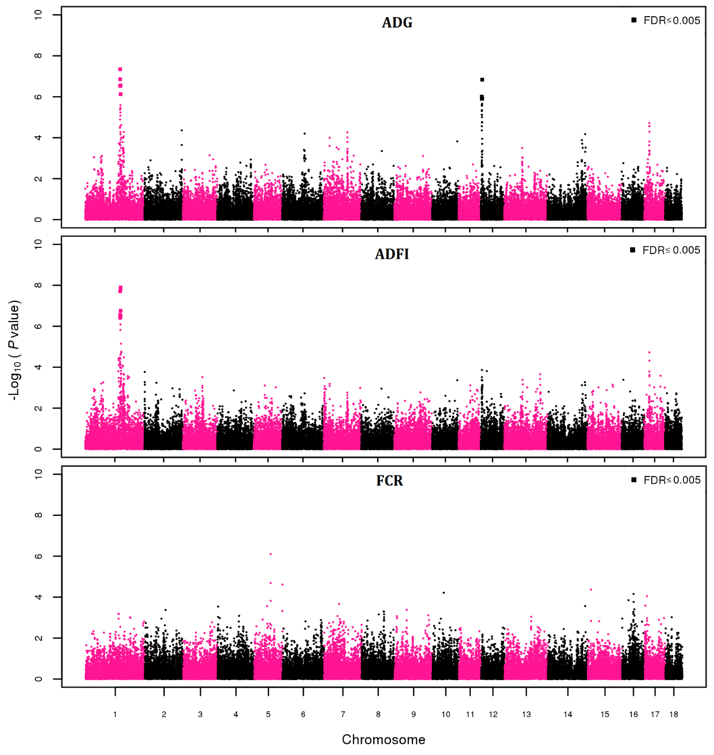
Supplementary Figure S1 Genome-wide association study for feed efficiency-related traits during the test period in a crossbred pig (Sus scrofa) population using a genomic relationship matrix in GCTA software, represented by –log₁₀ (P-values) single nucleotide polymorphisms (SNPs) association with the traits average daily gain (ADG), average daily feed intake (ADFI) and feed conversion ratio (FCR) (axis y), on physical SNPs position on 18 autosomal chromosomes (axis x). Little squares (□) represents the SNPs associated with respective trait, considering a false discovery rate (FDR) ≤ 0.005.

