Supplementary material

Animal
Grazing behaviour of dairy cows on biodiverse mountain pastures is more influenced by slope than cow breed

M. Koczura, B. Martin, M. Bouchon, G. Turille, J. Berard, A. Farruggia, M. Kreuzer, M. Coppa

Supplementary Figure S1. Map of the cows’ experimental pasture areas (2 cm = 100 m) and zones (Z1, Z2, Z3) in the high biodiversity areas.
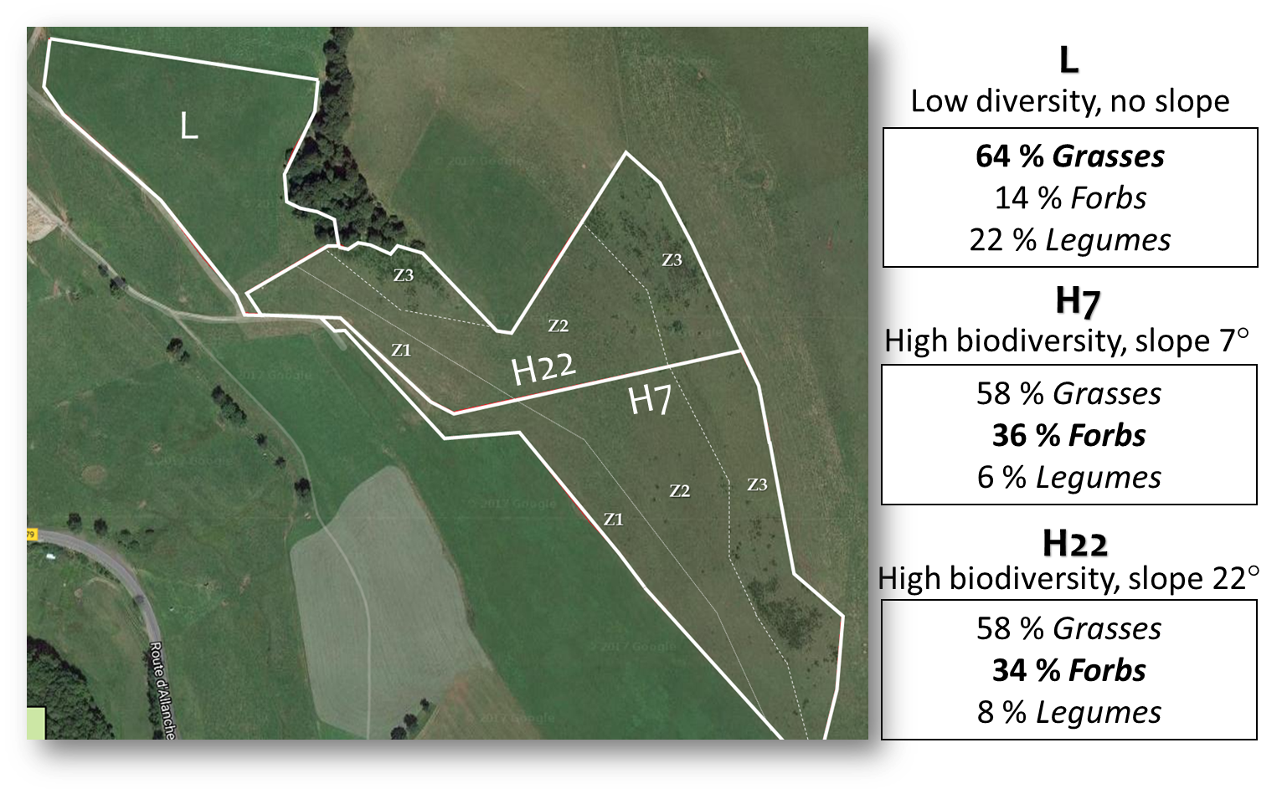
Supplementary Table S1. Characterisation of the swards by pasture type (low/high diversity (div.) and average slopes) during each cows’ grazing period (arithmetic means and standard error of the mean).
Grazing period | Early 1st grazing |  |  |  | Late 1st grazing |  |  |  | Early 2nd grazing
Pasture type | Low div. 2° | High div. 7° | High div. 22° |  | Low div. 2° | High div. 7° | High div. 22° |  | Low div. 2° | High div. 7° | High div. 22° | SEM
Vegetation types theoretically available for bites (%)
Short vegetative | 5 | 18 | 29 |  | 48 | 36 | 48 |  | 53 | 63 | 45 | 18.6
Tall vegetative | 86 | 59 | 51 |  | 48 | 48 | 44 |  | 40 | 24 | 29 | 13.5
Mature vegetation | 9 | 22 | 20 |  | 4 | 16 | 8 |  | 7 | 13 | 26 | 10.1
Grasses | 68 | 66 | 62 |  | 67 | 55 | 65 |  | 57 | 52 | 42 | 9.1
Legumes | 17 | 9 | 8 |  | 22 | 5 | 7 |  | 27 | 5 | 9 | 3.7
Forbs | 15 | 25 | 30 |  | 10 | 41 | 28 |  | 16 | 43 | 49 | 11.8
Sward composition (g/kg DM)
Organic matter | 900 | 939 | 926 |  | 902 | 925 | 920 |  | 901 | 922 | 910 | 3.7
CP | 156 | 103 | 115 |  | 123 | 83 | 82 |  | 153 | 89 | 93 | 7.0
NDF | 581 | 601 | 606 |  | 609 | 602 | 641 |  | 590 | 645 | 647 | 25.5
ADF | 274 | 307 | 293 |  | 312 | 335 | 342 |  | 301 | 341 | 339 | 9.2
Nutritional value
Digestibility | 0.702 | 0.635 | 0.651 |  | 0.645 | 0.583 | 0.585 |  | 0.649 | 0.559 | 0.567 | 0.013
NEL (MJ/kg DM) | 5.6 | 5.1 | 5.2 |  | 5.0 | 4.5 | 4.5 |  | 5.1 | 4.3 | 4.3 | 0.11
PDIE (g/kg DM) | 92.0 | 79.3 | 82.0 |  | 82.0 | 70.0 | 69.0 |  | 88.0 | 69.0 | 69.3 | 3.26
PDIN (g/kg DM) | 103.0 | 68.0 | 76.3 |  | 81.0 | 55.3 | 54.3 |  | 102.0 | 59.0 | 61.3 | 6.43
Low div. 2°: low botanical diversity, slope 2°; High div. 22°: high botanical diversity, slope 22°; High div 7°: high botanical diversity, slope 7°.
NEL: net energy for lactation; PDIE: absorbable protein at the duodenum according to supply with fermentable energy and rumen undegradable protein; PDIN: absorbable protein at the duodenum according to supply with rumen degradable protein.

Supplementary Table S2. Characterisation of the zones of high diversity pastures during each cows’ grazing period (arithmetic means and standard error of the mean).
Grazing period | Early 1st grazing |  |  |  | Late 1st grazing |  |  |  | Early 2nd grazing
Zone | Z1 (n=2) | Z2 (n=2) | Z3 (n=2) |  | Z1 (n=2) | Z2 (n=2) | Z3 (n=2) |  | Z1 (n=2) | Z2 (n=2) | Z3 (n=2) | SEM
Vegetation types theoretically available for bites (%)
Short vegetative | 9 | 14 | 48 |  | 38 | 42 | 46 |  | 42 | 53 | 68 | 18.7
Tall vegetative | 52 | 67 | 47 |  | 47 | 46 | 45 |  | 32 | 30 | 16 | 19.5
Mature vegetation | 39 | 19 | 6 |  | 15 | 11 | 9 |  | 26 | 17 | 16 | 9.9
Grasses | 71 | 67 | 54 |  | 67 | 54 | 58 |  | 59 | 48 | 34 | 9.4
Legumes | 14 | 5 | 8 |  | 10 | 4 | 3 |  | 11 | 7 | 2 | 3.8
Forbs | 15 | 28 | 38 |  | 23 | 42 | 39 |  | 29 | 45 | 64 | 10.8
Sward composition (g/kg DM)
Organic matter | 935 | 930 | 932 |  | 920 | 923 | 924 |  | 916 | 919 | 914 | 11.6
CP | 108 | 114 | 106 |  | 80 | 88 | 80 |  | 88 | 88 | 95 | 9.4
NDF | 614 | 602 | 594 |  | 643 | 624 | 597 |  | 679 | 657 | 602 | 39.9
ADF | 304 | 293 | 303 |  | 340 | 338 | 338 |  | 355 | 343 | 321 | 13.7
Nutritional value
Digestibility | 0.640 | 0.653 | 0.636 |  | 0.585 | 0.587 | 0.580 |  | 0.551 | 0.562 | 0.578 | 0.027
NEL (MJ/kg DM) | 5.2 | 5.3 | 5.1 |  | 4.5 | 4.6 | 4.5 |  | 4.2 | 4.3 | 4.5 | 0.2
PDIE (g/kg DM) | 80 | 83 | 79 |  | 69 | 71 | 68.5 |  | 67.5 | 69 | 71 | 4.0
PDIN (g/kg DM) | 71 | 76 | 69.5 |  | 53 | 59 | 52.5 |  | 58.5 | 58.5 | 63.5 | 6.5
Low div. 2°: low botanical diversity, slope 2°; High div. 22°: high botanical diversity, slope 22°; High div 7°: high botanical diversity, slope 7°.
NEL: net energy for lactation; PDIE: absorbable protein at the duodenum according to supply with fermentable energy and rumen undegradable protein; PDIN: absorbable protein at the duodenum according to supply with rumen degradable protein.

Supplementary Table S3. Least Square means for overall effects on cow’s behaviour, diet selection, faecal composition and performance.*
 | Pasture type |  |  |  | Grazing period
 | Low div. 2° | High div. 7° | High div. 22° |  | Early  1st grazing | Late  1st grazing | Early  2nd grazing | SEM
Time allocated to activities (%)
Resting time | 32 | 34 | 37 |  | 45ª | 37^{b} | 21^{c} | 2.0
Grazing time | 59 | 53 | 57 |  | 47^{b} | 53^{b} | 69ª | 2.0
Other activities | 9^{b} | 13ª | 6^{b} |  | 8 | 10 | 9 | 1.9
Time spent in Z1 | ‒ | 40ª | 27^{b} |  | 45ª | 32^{b} | 24^{c} | 1.6
Time spent in Z2 | ‒ | 29^{b} | 48ª |  | 51ª | 25^{c} | 40^{b} | 2.0
Time spent in Z3 | ‒ | 30ª | 24^{b} |  | 3^{c} | 43ª | 36^{b} | 5.1
Vegetation types in the bites (%)
Short vegetation | 42^{c} | 59ª | 52^{b} |  | 27^{c} | 51^{b} | 75ª | 6.1
Tall vegetation | 44ª | 33^{b} | 41ª |  | 62ª | 35^{b} | 22^{c} | 2.0
Mature vegetation | 13ª | 8^{b} | 6^{b} |  | 12ª | 14ª | 2^{b} | 2.1
Grasses | 77ª | 71^{b} | 67^{b} |  | 74 | 72 | 70 | 1.4
Legumes | 16ª | 2^{c} | 4^{b} |  | 7^{ab} | 6^{b} | 9ª | 1.6
Forbs | 8^{b} | 27ª | 29ª |  | 19 | 22 | 22 | 3.1
Jacob’s index of selectivity (-1 < IS < 1)
Short vegetation | 0.25^{b} | 0.46ª | 0.36^{ab} |  | 0.50ª | 0.12^{b} | 0.45ª | 0.090
Tall vegetation | -0.32^{b} | -0.21^{ab} | -0.10ª |  | -0.17 | -0.23 | -0.23 | 0.045
Mature vegetation | 0.13ª | -0.54^{b} | -0.55^{b} |  | -0.29^{b} | 0.09ª | -0.76^{c} | 0.145
Grasses | 0.31 | 0.26 | 0.19 |  | 0.14^{b} | 0.22^{b} | 0.40ª | 0.032
Legumes | -0.22ª | -0.41^{b} | -0.40^{b} |  | -0.35^{ab} | -0.41^{b} | -0.27ª | 0.070
Forbs | -0.38^{b} | -0.19ª | -0.12ª |  | -0.06ª | -0.21^{b} | -0.42^{c} | 0.036
Faeces composition (g/kg DM)
CP | 136ª | 125^{b} | 127^{b} |  | 145ª | 116^{c} | 126^{b} | 2.1
ADF | 328^{b} | 349ª | 351ª |  | 338^{b} | 351ª | 338^{b} | 4.7
Calculated OMD† | 0.717ª | 0.697^{b} | 0.698^{b} |  | 0.725ª | 0.683^{c} | 0.703^{b} | 0.003
Milk (kg) | 14.3ª | 12.3^{b} | 13.2^{b} |  | 17.2ª | 12.6^{b} | 9.9^{c} | 0.28
Δ Milk yield (kg) | -1.9ª | -3.3^{b} | -3.1^{b} |  | 0.1ª | -3.9^{b} | -4.6^{b} | 0.29
Milk fat (g) | 571ª | 483^{b} | 517^{b} |  | 681ª | 485^{b} | 405^{c} | 12.7
Milk protein (g) | 457ª | 397^{b} | 411^{b} |  | 567ª | 386^{b} | 312^{c} | 18.4
BW (kg) | 613 | 617 | 610 |  | 618ª | 615^{ab} | 608^{b} | 4.8
Low div. 2°: low botanical diversity, slope 2°; High div. 22°: high botanical diversity, slope 22°; High div 7°: high botanical diversity, slope 7°.
P-values are reported in Table 2. ^{a-c} Within same trait and effect, values without common superscripts differ. †Organic matter digestibility

