An investigation into the effectiveness of compressed straw blocks in reducing abnormal behaviours in growing pigs

A. Haigh, J. Yun-Chou, and K. O’Driscoll

**Supplementary material S1:** The number of pigs that died or were removed during the trial, the stage at which they were removed or died and the cause.

|  |  |  |  |  |  |
| --- | --- | --- | --- | --- | --- |
| **Repetition** | **Stage** | **Mortality** | **Removal** | **Causes** | **Removal due to tail biting and score** |
| 1 | 1st stage weaners | 6 | 6 | Lameness, potbelly, meningitis, thin, twisted gut | 0 |
| 1 | 2nd stage weaners | 0 | 8+22 (removed to bring numbers to 400 at finisher stage-smallest pigs) | Tail biting and lameness | 7- score of 3 |
| 1 | Finishers | 5 | 2 | Sudden death, lameness, belly lesion, thin | 0 |
| 2 | 1st stage weaners | 7 | 1 | Meningitis and lameness | 0 |
| 2 | 2nd stage weaners | 0 | 36-(removed to bring numbers to 400 at finisher stage-smallest pigs) |  |  |
| 2 | Finishers | 0 | 0 | 0 | 0 |



**Supplementary material S2.** A) Image of the compressed straw blocks B) The holders used to support the straw blocks during the first and second stage weaner accommodation, and C) Image of pigs interacting with the straw blocks and holder

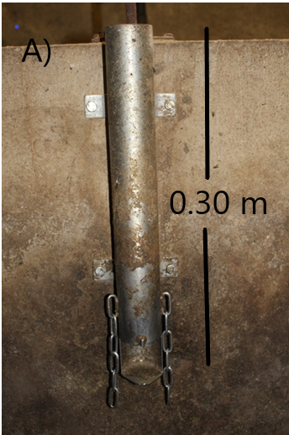 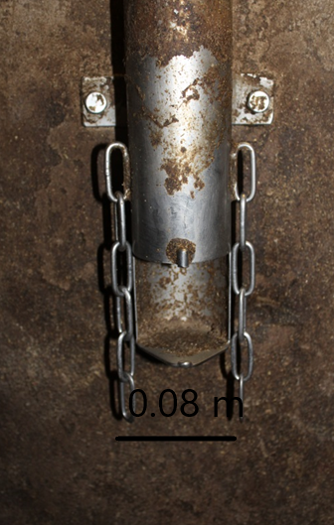

B)

A)

**Supplementary material S3.** A) Image of the entire straw holder used in the finisher pens, and B) Close up of the opening where the straw block was available to the pigs.

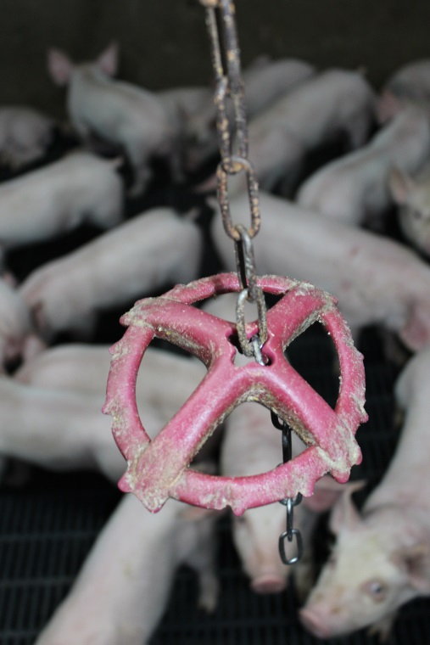 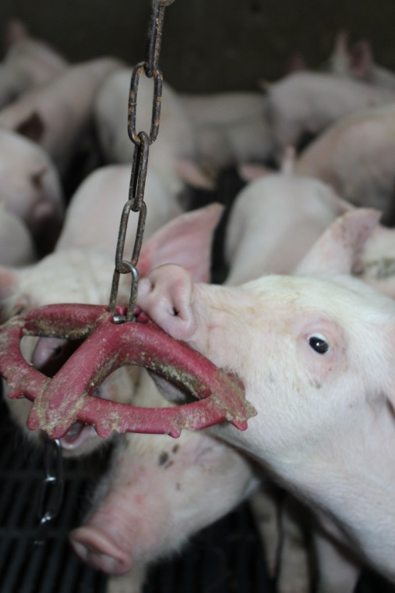

B)

A)

**Supplementary material S4.** A) The ‘Porcichew’ hanging enrichment device, and B) A pig interacting with the ‘Porcichew’ device in the first stage weaners.

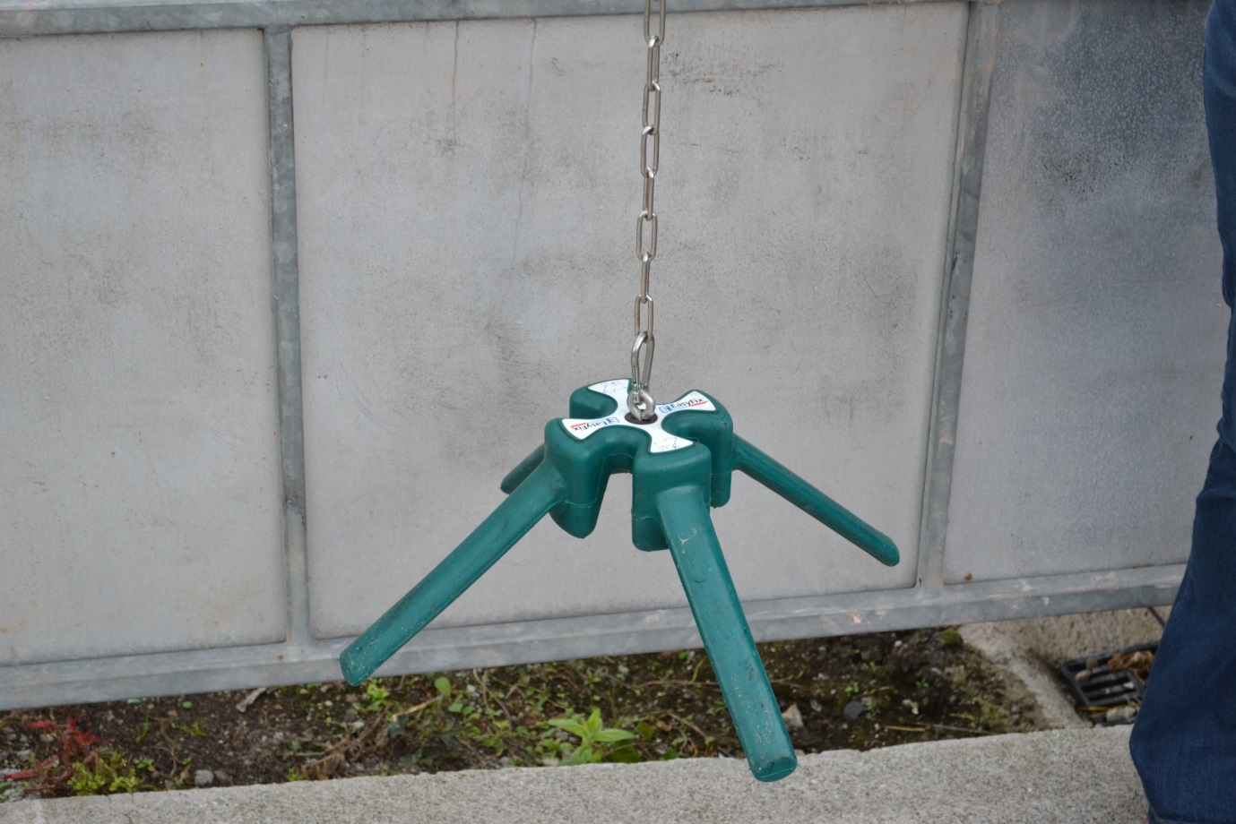

**Supplementary material S5.** The ‘Easyfix’ hanging enrichment device which was offered to pigs in the finisher stage.

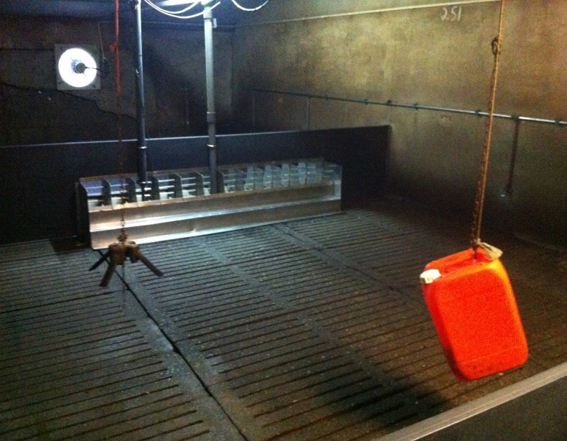

**Supplementary material S6.** A hanging barrel (41 x 64 cm) like that which was offered to pigs in the second weaner stage.

Supplementary material S7: SAS code for analysis of tail lesion scores in the weaner stage pigs. The same model was used for analysis of tail lesion scores in the finisher stage, and ear lesion scores in both stages.

**proc** **glimmix** data=tailsw;

by test;

class rep treatment sex penid pigid test;

Model lesionscore = treatment|sex rep /ddfm = kr2 link = cumlogit dist = multinomial oddsratio;

random penid/;

ods output tests3 = tests3 oddsratios = oddsratios ;

title 'tail lesions - weaner';

**run**;

SAS code for analysis of body lesion scores

**proc** **glimmix** data=body ;

class treatment sex penid pigid ;

Model heads = treatment|sex /ddfm = kr2 link = cumlogit dist = multinomial oddsratio;

random penid/;

ods output tests3 = tests3 oddsratios = oddsratios ;

title 'head lesions';

**run**;

SAS code for analysis of behaviour data (example shows interaction with the enrichment device)

**proc** **mixed** data=avgtoy;

class treatment sex obs rep pen ;

Model toy = treatment|sex|obs rep /ddfm = kr residual ;

repeated obs/ subject = pen(treatment sex) type = ar(**1**);;

random pen(treatment sex);

LSmeans treatment|sex|obs / pdiff = all adjust = tukey;

ods output LSmeans =means Diffs =Pdiffs;

title 'interaction with device';

**run**;

SAS code for analysis of cortisol data

**proc** **mixed** data=weaner;

class rep stage testday treatment sex realpen;

Model cortisol = treatment|sex|testday rep /ddfm = kr residual ;

repeated testday/ subject = realpen(treatment sex rep) type = ar(**1**);

random realpen;

LSmeans treatment type sex/ pdiff = all adjust = tukey;

ods output LSmeans =means Diffs =Pdiffs;

title 'cortisol weaners';

**run**;