animal
The Genetic Background of Clinical Mastitis in Holstein-Friesian Cattle
J. Szyda, M. Mielczarek, M. Frąszczak, G. Minozzi, J.L. Williams, and K.Wojdak-Maksymiec

Supplementary Figure S1. The number of “somatic” Single nucleotide polymorphisms (SNPs) detected per half-sib pair.
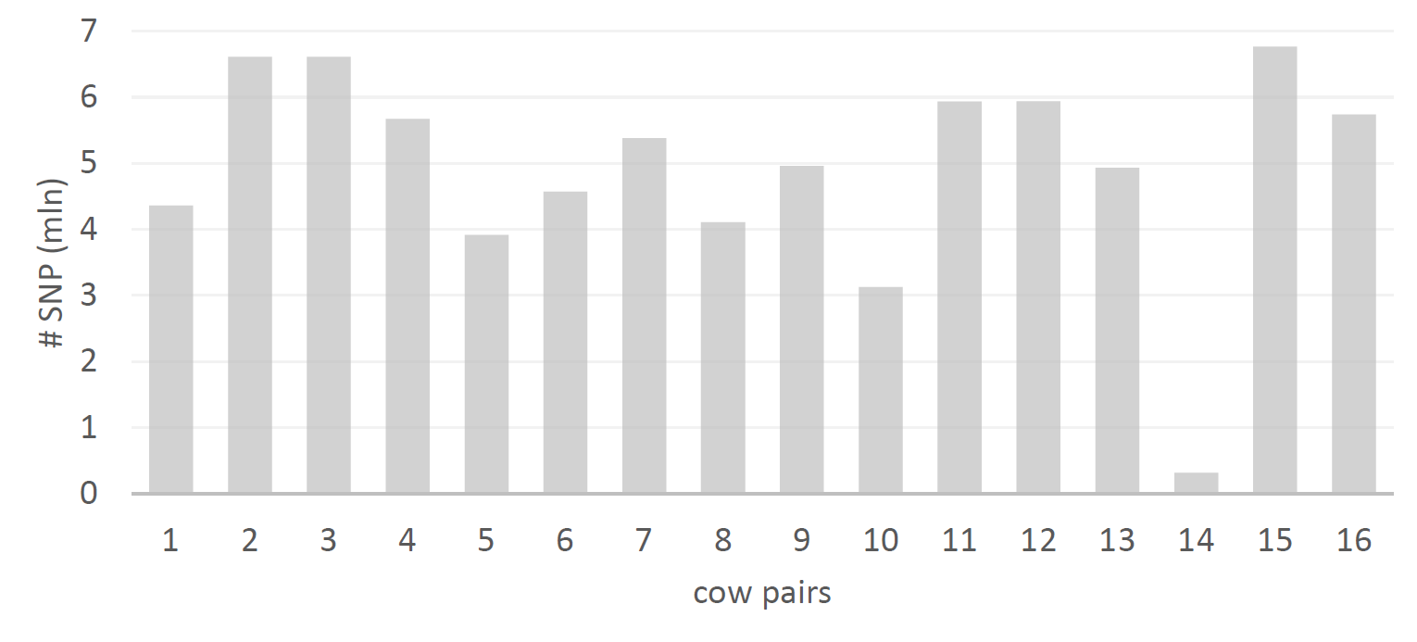

Supplementary Figure S1. The total number of copy number variants (CNVs) identified for the 26 individuals. DUP = duplications; DEL = deletions.
