Animal journal

**Temporal fermentation and microbial community dynamics in rumens of sheep grazing a ryegrass-based pasture offered either in the morning or in the afternoon**

R.E. Vibart, S. Ganesh, M.R. Kirk, S. Kittelmann, S.C. Leahy, P.H. Janssen, D. Pacheco

*AgResearch, Grasslands Research Centre, Tennent Drive, Private Bag 11008, Palmerston North 4442, New Zealand.*

Corresponding author: Ronaldo Vibart. Email: [ronaldo.vibart@agresearch.co.nz](mailto:ronaldo.vibart@agresearch.co.nz)

Short title: Ruminal fermentation dynamics in sheep

This supporting information contains all additional data related to the article.

**Effect of timing of sample collection relative to feeding**

*Statistical analysis*

Discriminant analyses (partial least squares - PLSDA) of fermentation characteristics and of bacterial, archaeal and protozoal community composition data were used to identify the impact of the ‘early vs. late’ ruminal sample collection, i.e., samples collected ≤ 8 hours (2, 4, 6, 8 hours) vs. samples collected ≥ 14 hours (14, 16, 18, 20) after a new allocation of a fresh strip of grass. Boxplots of discriminant scores and clustered image maps of association scores in canonical dimensional space between ‘early/late’ factor and fermentation characteristics and microbial community composition data, were used for further exploration.

*Results*

Greater variability in the early period (particularly at 4 hours post allocation for the microbial community composition and at 6 hours post allocation for the fermentation characteristics measured) was found, compared with the late period (Figure S2). The coefficients (often referred to as loadings) of the measurements that make up the linear function to form the PLSDA dimension show that digesta pH has a large and positive loading, whereas ammonia concentration, along with propionate and butyrate concentrations, have negative loadings (Figure S2).

Table S1. Sequencing metrics and details of operational taxonomic units (OTUs) and taxa in microbial community analyses from rumens of sheep grazing a ryegrass-based pasture.

|  |  |  |  |
| --- | --- | --- | --- |
| Metric | Microbial group | | |
| Bacteria | Archaea | Ciliate protozoa |
| No. of samples | 96 | 96 | 95 |
| Forward primer name | Ba9f | Ar915aF | Reg841F |
| Reverse primer name | Ba515Rmod1 | Ar1386R | Reg1302R |
| Variable regions covered | V1 - V3 | V6 - V8 | V5 - V7 |
| Length of amplified region (bp) | 525 | 492 | 511 |
| Product length (bp) | 598 | 565 | 584 |
| Total number of reads | 365396 | 116244 | 115942 |
| Mean no. of reads/sample (± SD) | 3806 ± 2402 | 1211 ± 756 | 1220 ± 521 |
| Filtered sequence length (nt)1 | 524 | 501 | 512 |
| Total no. of OTUs | 73881 | 248 | 47145 |
| Mean no. of OTUs/sample (± SD) | 1859 ± 890 | 27 ± 9 | 639 ± 255 |
| Total no. of taxa | 460 | 9 | 17 |
| Mean no. of taxa/sample (± SD) | 115.5 ± 25.6 | 4.8 ± 0.8 | 6.3 ± 0.7 |

1Mean length of sequences passing quality filters.

Table S2. Relative abundance of selected bacteria, archaea and ciliate protozoa, and quantification of bacterial 16S rRNA genes using quantitative polymerase chain reaction (qPCR) to enumerate the total number of bacterial cells present (expressed relative to the amount of freeze-dried rumen sample used for the DNA extraction) in the rumen of sheep offered a ryegrass-based pasture either in the morning (AM) or in the afternoon (PM).

|  |  |  |  |  |  |  |
| --- | --- | --- | --- | --- | --- | --- |
| Rumen microorganisms | Allocation (A)1 | | SE | *P* ≤ | | |
| AM | PM | A | Time (T)2 | A x T |
| Bacteria – taxon: order/family/genus |  |  |  |  |  |  |
| *Bacteroidales*/*Prevotellaceae*/*Prevotella* 1 | 0.457 | 0.416 | 0.014 | 0.04 | <0.001 | 0.04 |
| *Clostridiales*/*Christensenellaceae*/R-7 group | 0.027 | 0.035 | 0.005 | 0.26 | <0.001 | 0.92 |
| *Bacteroidales*/BS11/all | 0.029 | 0.039 | 0.005 | 0.16 | 0.05 | 0.05 |
| *Bacteroidales*/*Rikenellaceae*/RC9 gut group | 0.027 | 0.036 | 0.004 | 0.14 | <0.001 | 0.004 |
| *Bacteroidales*/RF16 group/all | 0.054 | 0.029 | 0.006 | 0.005 | <0.001 | 0.05 |
| *Erysipelotrichales*/*Erysipelotrichaceae*/*Kandleria* spp. | 0.003 | 0.051 | 0.016 | 0.04 | <0.001 | <0.001 |
| *Clostridiales*/*Ruminococcaceae/Ruminococcus* 1 | 0.028 | 0.024 | 0.002 | 0.25 | <0.001 | 0.70 |
| *Bacteroidales/Prevotellaceae*/*Prevotellaceae* UCG-003 | 0.027 | 0.028 | 0.007 | 0.95 | 0.54 | 0.19 |
| *Clostridiales*/*Ruminococcaceae*/*Ruminococcaceae* NK4A214 group | 0.019 | 0.023 | 0.003 | 0.39 | <0.001 | 0.003 |
| *Bacteroidales*/*Prevotellaceae*/*Prevotellaceae* UCG-001 | 0.027 | 0.024 | 0.005 | 0.68 | 0.15 | 0.88 |
| *Fibrobacterales*/*Fibrobacteraceae*/*Fibrobacter* spp. | 0.023 | 0.016 | 0.001 | 0.008 | 0.10 | 0.38 |
| *Mollicutes*/*Mollicutes* RF9 group/all | 0.017 | 0.012 | 0.003 | 0.21 | 0.02 | 0.34 |
| *Clostridiales*/*Ruminococcaceae*/*Ruminococcaceae* UCG-014 | 0.016 | 0.011 | 0.002 | 0.18 | 0.31 | 0.17 |
| Unknown/Unknown/*Candidatus Saccharimonas* | 0.013 | 0.008 | 0.002 | 0.14 | 0.08 | 0.32 |
| *Clostridiales/Lachnospiraceae/Lachnospiraceae* NK3A20 group | 0.0069 | 0.0083 | 0.0013 | 0.45 | 0.01 | 0.68 |
| *Clostridiales/Ruminococcaceae/[Eubacterium] coprostanoligenes* | 0.0085 | 0.0097 | 0.0006 | 0.26 | <0.001 | 0.19 |
| *Clostridiales/Ruminococcaceae/Saccharofermentans* | 0.0086 | 0.0089 | 0.0005 | 0.65 | 0.06 | 0.19 |
| *Clostridiales/Lachnospiraceae/Pseudobutyrivibrio* | 0.0073 | 0.0091 | 0.0013 | 0.34 | 0.01 | 0.02 |
| *Bacteroidales/Bacteroidales* S24-7 group/Other | 0.0082 | 0.0076 | 0.0007 | 0.58 | <0.001 | <0.001 |
| *Clostridiales/Lachnospiraceae/Lachnospiraceae* AC2044 group | 0.0084 | 0.0079 | 0.0006 | 0.60 | 0.10 | 0.005 |
| *Clostridiales/Lachnospiraceae/[Eubacterium] ruminantium* group | 0.0097 | 0.0074 | 0.0009 | 0.11 | 0.04 | 0.05 |
| *Clostridiales/Ruminococcaceae/Ruminococcus* 2 | 0.0048 | 0.0079 | 0.0009 | 0.04 | <0.001 | 0.008 |
| *Erysipelotrichales/Erysipelotrichaceae/Erysipelotrichaceae* UCG-004 | 0.0088 | 0.0068 | 0.0012 | 0.29 | <0.001 | 0.07 |
| *Clostridiales/Ruminococcaceae/Ruminococcaceae* UCG-010 | 0.0047 | 0.0068 | 0.0009 | 0.12 | <0.001 | 0.08 |
| *Coriobacteriales/Coriobacteriaceae/Atopobium* | 0.0062 | 0.0048 | 0.0019 | 0.62 | <0.001 | 0.99 |
| *Gastranaerophilales*/Other/Other | 0.0082 | 0.0066 | 0.0008 | 0.17 | <0.001 | 0.01 |
| *Anaeroplasmatales/Anaeroplasmataceae/Anaeroplasma* | 0.0074 | 0.0072 | 0.0008 | 0.88 | 0.004 | 0.63 |
| *Clostridiales/Lachnospiraceae/Roseburia* | 0.0041 | 0.0050 | 0.0004 | 0.18 | 0.01 | 0.03 |
| *Clostridiales/Lachnospiraceae/Butyrivibrio* 2 | 0.0054 | 0.0068 | 0.0009 | 0.30 | 0.03 | 0.06 |
| *Clostridiales/Ruminococcaceae/Ruminococcaceae* UCG-005 | 0.0031 | 0.0042 | 0.0005 | 0.16 | 0.04 | 0.07 |
| *Rhodospirillales/Rhodospirillaceae/Thalassospira* | 0.0057 | 0.0056 | 0.0011 | 0.95 | 0.05 | 0.56 |
| *Clostridiales/Lachnospiraceae/[Ruminococcus] gauvreauii* group | 0.0058 | 0.0039 | 0.0011 | 0.25 | <0.001 | 0.10 |
| *Spirochaetales/Spirochaetaceae/Treponema* 2 | 0.0056 | 0.0049 | 0.0005 | 0.36 | 0.06 | 0.24 |
| *Clostridiales/Lachnospiraceae/Acetitomaculum* | 0.0029 | 0.0028 | 0.0007 | 0.92 | 0.06 | 0.69 |
| *Clostridiales/Ruminococcaceae/Ruminiclostridium* 9 | 0.0043 | 0.0031 | 0.0011 | 0.45 | 0.005 | 0.09 |
| *Clostridiales/Lachnospiraceae/Lachnospiraceae* XPB1014 group | 0.0028 | 0.0044 | 0.0007 | 0.11 | 0.002 | 0.65 |
| Candidate division SR1/Other/Other/Other/Other | 0.0048 | 0.0044 | 0.0012 | 0.81 | 0.002 | 0.05 |
| *Erysipelotrichales/Erysipelotrichaceae/Erysipelotrichaceae* UCG-009 | 0.0029 | 0.0031 | 0.0006 | 0.73 | 0.01 | 0.71 |
| *Clostridiales/Lachnospiraceae/Lachnospiraceae* NK4A136 group | 0.0041 | 0.0033 | 0.0006 | 0.35 | 0.25 | 0.68 |
| *Clostridiales*/Family XIII/*Mogibacterium* | 0.0018 | 0.0027 | 0.0004 | 0.16 | <0.001 | 0.31 |
| *Clostridiales/Ruminococcaceae/Ruminiclostridium* 6 | 0.0029 | 0.0036 | 0.0006 | 0.36 | 0.17 | 0.09 |
| *Clostridiales/Ruminococcaceae/Ruminococcaceae* UCG-001 | 0.0033 | 0.0026 | 0.0009 | 0.63 | <0.001 | 0.31 |
| *Victivallales/Victivallaceae/Victivallis* | 0.0029 | 0.0030 | 0.0006 | 0.85 | 0.02 | 0.04 |
| *Bacteroidales/Prevotellaceae*/uncultured | 0.0033 | 0.0034 | 0.0009 | 0.93 | 0.008 | 0.53 |
| *Selenomonadales/Veillonellaceae/Quinella* | 0.0021 | 0.0029 | 0.0010 | 0.65 | 0.16 | 0.20 |
| *Bacteroidales/Prevotellaceae/Prevotella* 7 | 0.0030 | 0.0028 | 0.0007 | 0.82 | <0.001 | <0.001 |
| *Clostridiales/Lachnospiraceae*/probable genus 10 | 0.0022 | 0.0020 | 0.0004 | 0.74 | 0.36 | 0.03 |
| *Bacteroidales/Prevotellaceae/Prevotellaceae* YAB2003 group | 0.0035 | 0.0020 | 0.0009 | 0.33 | 0.01 | 0.05 |
| *Lactobacillales/Streptococcaceae/Streptococcus* | 0.0011 | 0.0019 | 0.0008 | 0.27 | 0.03 | 0.09 |
| *Bacteroidales/Prevotellaceae/Prevotellaceae* NK3B31 group | 0.0015 | 0.0011 | 0.0004 | 0.42 | 0.007 | 0.05 |
| *Erysipelotrichales/Erysipelotrichaceae/Solobacterium* | 0.0010 | 0.0008 | 0.0002 | 0.49 | 0.59 | 0.58 |
| *Erysipelotrichales/Erysipelotrichaceae/[Anaerorhabdus] furcosa* group | 0.0004 | 0.0002 | 0.0001 | 0.35 | 0.40 | 0.34 |
| Sum of other taxa | 0.0566 | 0.0652 | 0.0030 | 0.09 | <0.001 | 0.74 |
| Archaea – taxa |  |  |  |  |  |  |
| *Methanobrevibacter gottschalkii* clade | 0.678 | 0.652 | 0.032 | 0.57 | 0.36 | 0.08 |
| *Methanobrevibacter ruminantium* clade | 0.097 | 0.141 | 0.022 | 0.08 | <0.001 | 0.41 |
| Other *Methanobrevibacter* spp. | 0.0023 | 0.0024 | 0.0007 | 0.93 | 0.54 | 0.64 |
| *Methanosphaera* | 0.086 | 0.080 | 0.010 | 0.67 | 0.003 | 0.008 |
| *Methanomassiliicoccaceae* | 0.132 | 0.129 | 0.022 | 0.92 | <0.001 | 0.02 |
| Protozoa – genus |  |  |  |  |  |  |
| *Entodinium* | 0.393 | 0.347 | 0.038 | 0.43 | 0.006 | <0.001 |
| *Dasytricha* | 0.369 | 0.285 | 0.041 | 0.20 | <0.001 | <0.001 |
| *Epidinium* | 0.075 | 0.190 | 0.051 | 0.20 | 0.02 | 0.26 |
| *Isotricha* | 0.099 | 0.080 | 0.032 | 0.70 | 0.09 | 0.20 |
| *Eudiplodinium* | 0.031 | 0.051 | 0.011 | 0.25 | <0.001 | 0.40 |
| *Anoplodinium-Diplodinium* | 0.031 | 0.044 | 0.017 | 0.60 | 0.007 | 0.04 |
| Bacterial qPCR data |  |  |  |  |  |  |
| Mean number of gene copies (per g of dried rumen contents)3 | 11.59 | 11.62 | 0.06 | 0.76 | 0.03 | 0.005 |

1Time of allocation of a fresh strip of pasture (AM 0800 h vs. PM 1600 h).

2Time of sampling relative to allocation (0 to 24 hours).

3Log-transformed data.



Isobutyrate concentration (m*M*)

Isovalerate concentration (m*M*)

a)

b)

Figure S1. Twenty-four hour patterns of branched-chain volatile fatty acid concentrations a) isobutyrate and b) isovalerate (in m*M*) from sheep grazing a ryegrass-based pasture allocated either in the morning (AM; ○) or in the afternoon (PM; ●). Patterns described relative to the time of new allocation of pasture. The full length of the error bars (above and below mean values) represents 2 SE.

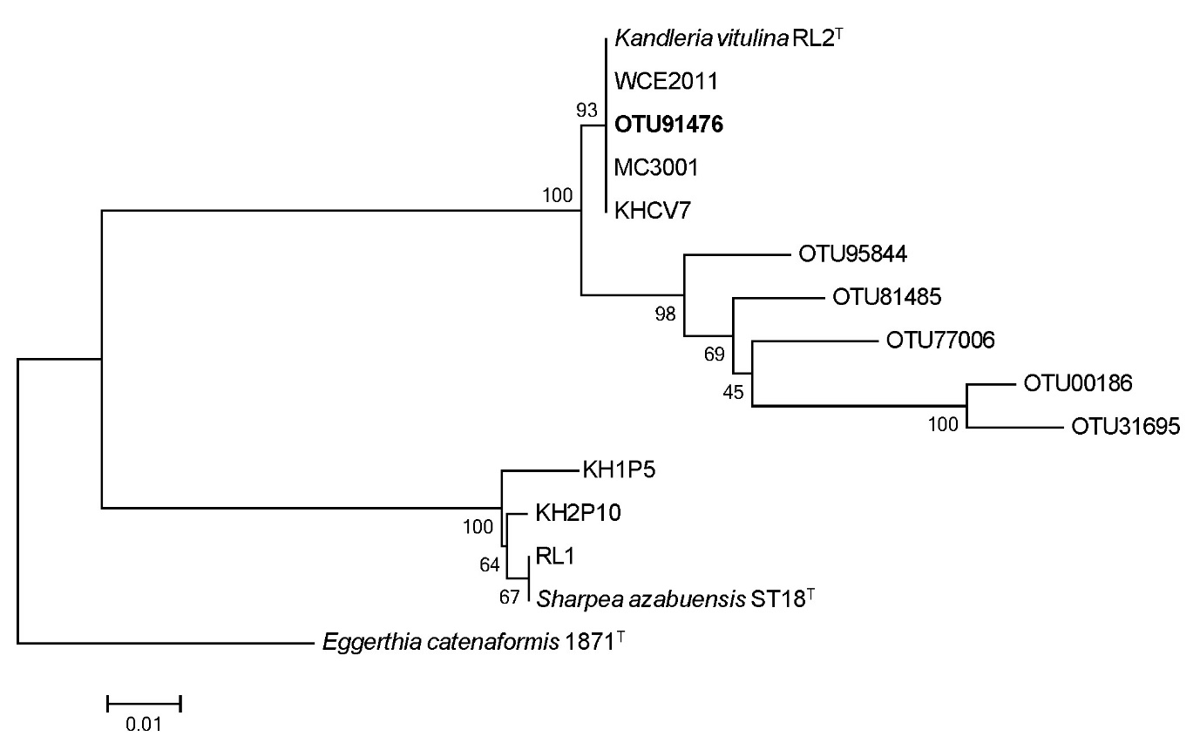

Figure S2. Phylogenetic tree of 16S rRNA gene sequences of *Kandleria* spp., *Sharpea* spp., and sequences from the six largest operational taxonomic units (OTUs) assigned to *Kandleria* (prefixed OTU) from rumens of sheep grazing a ryegrass-based pasture. The OTU with the largest number of sequences (87.5% of all *Kandleria* reads) is shown in bold. T = type strain. The percentage of replicate trees in which the associated sequences clustered together in the bootstrap test (1000 replicates) are shown next to the branches. The scale bar represents 0.01 changes per nucleotide position. The 16S rRNA gene of *Eggerthia catenaformis* strain 1871 (GenBank accession AJ621549.1) was used as an outgroup sequence.

Figure S3. Boxplots of discriminant scores to illustrate the effects of early vs. late sample collection [i.e., samples collected ≤8 hours (2, 4, 6, 8 hours) vs. samples collected ≥14 hours (14, 16, 18, 20)] after a new allocation of a fresh strip of grass using discriminant analyses (partial least squares - PLSDA). Samples were collected from rumens of sheep grazing a ryegrass-based pasture. Microbial community composition (‘Taxonomy’) and fermentation characteristics (‘Fermentation’) were used to assess the impact of early vs. late sample collection.

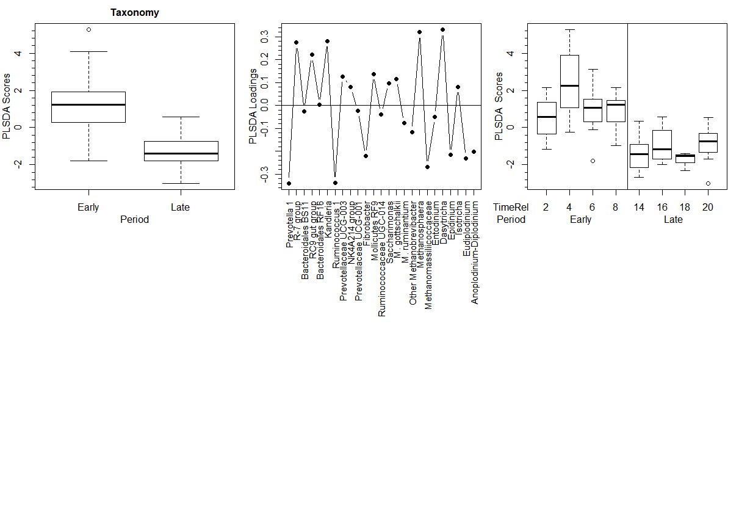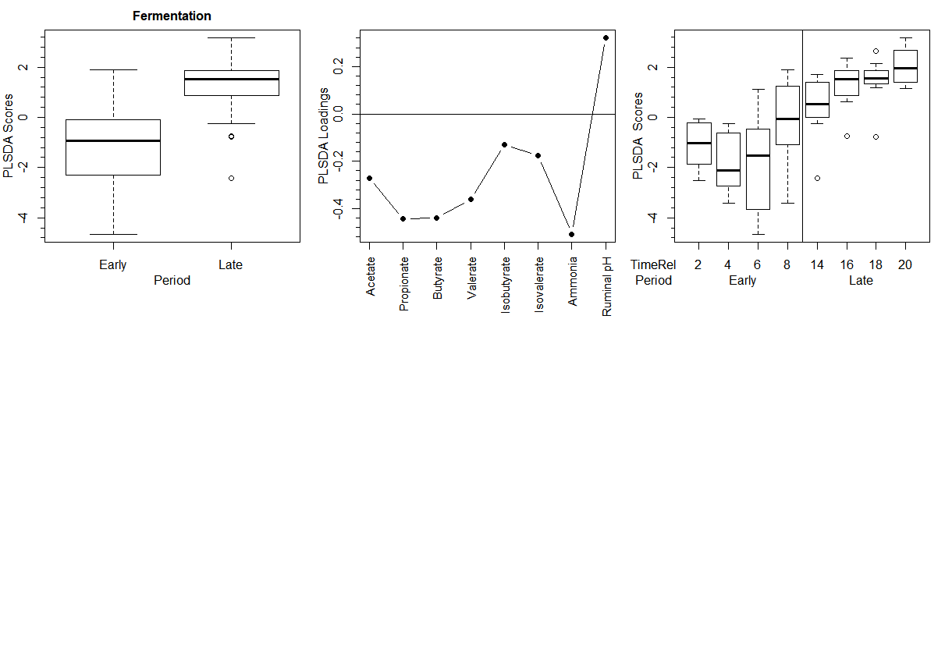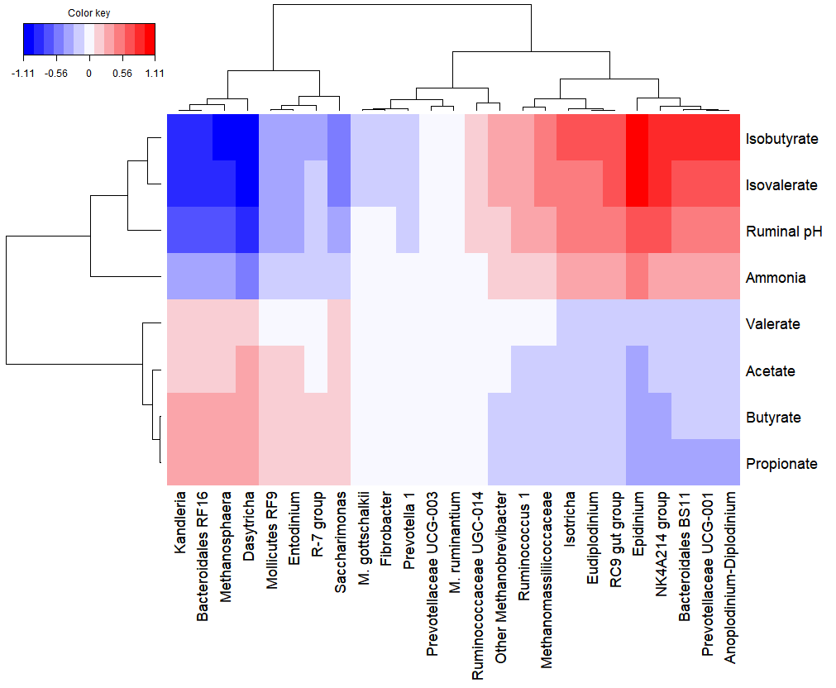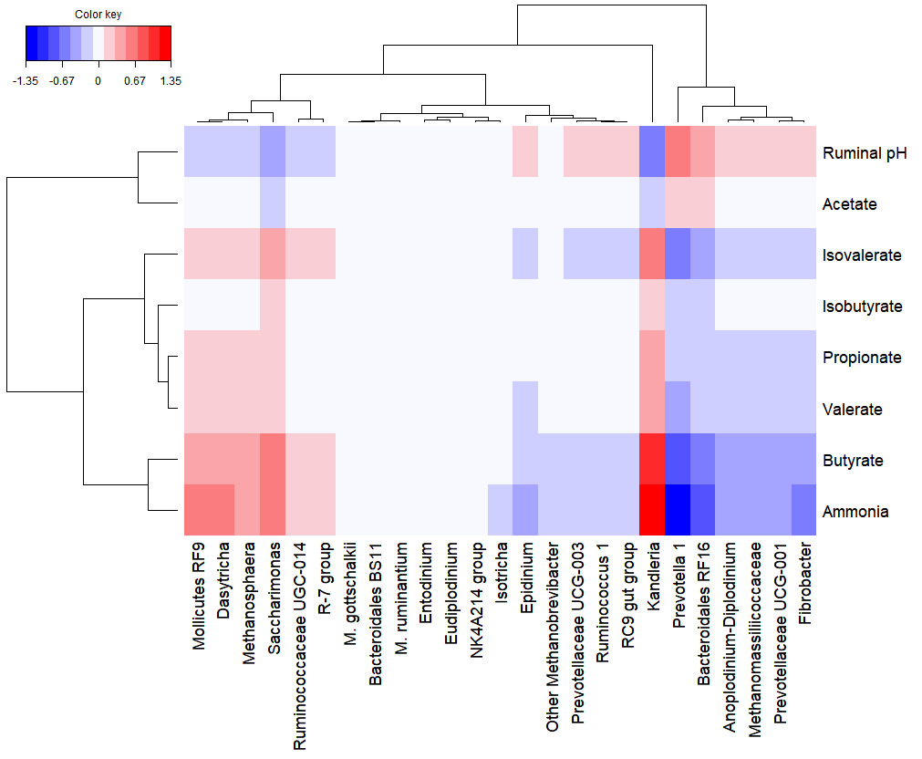

a)

b)

Figure S4. First canonical dimension of measures of ruminal fermentation and relative taxonomic abundance of selected bacteria, archaea and ciliate protozoa in rumens of sheep grazing a ryegrass-based pasture allocated either in the morning (a) or in the afternoon (b).