Association between nutritional values of hays fed to horses and sensory properties as perceived by human sight, touch and smell
S. Julliand¹, C. Dacremont², C. Omphalius³, C. Villot^{3,a} and V. Julliand⁴

¹ Lab To Field, 26 Boulevard Docteur Petitjean, 21000 Dijon, France
² Centre des Sciences du Goût et de l’Alimentation, UMR 6265 / UMR A1324 University of Burgundy – CNRS – INRA, 9E Boulevard Jeanne d'Arc, 21000 Dijon, France
³ AgroSupDijon, 26 Boulevard Docteur Petitjean, 21000 Dijon, France
⁴ UMR A 102-02 PAM-PMB, University of Burgundy / AgroSup Dijon, 1 Esplanade Erasme, 21000 Dijon, France

ª Present address: Department of Agricultural, Food and Nutritional Science, University of Alberta, Edmonton, AB T6G 2P5, Canada

Corresponding author: Samy Julliand. E-mail: samy.julliand@lab-to-field.com

Animal Journal

Supplementary Material S1. Method used for building the descriptive terms matrix.

During the free sorting task method, each participant was asked to sort hays by similarity and then to describe the groups that he made with his own terminology (Faye et al., 2004). With 54 participants a very large range of words or verbal expressions was observed. Most of the descriptive terms were only used by one participant. These single-used terms are not statistically relevant. Thus, the first step for building the descriptive terms matrix consisted in grouping the initially given terms by spelling. All reported terms that referred to the same word but with incorrect spelling, singular/plural differences, or grammatical gender differences were grouped. For instance, “vert”, “verts”, “verte”, and “vertes”, which all mean “green” were all joined under the same group “green”. Then, descriptive terms were grouped by semantic meaning. This step was performed individually by the five authors. When the grouping was not consensual between all authors, discussions were necessary to decide unanimously the selected grouping. During this step, descriptive terms like “appétent”, and “appétissant”, were grouped together under the same label “appétent” which means palatable. Finally, with 54 participants, we decided to keep only the descriptive terms that were cited by at least five different participants, which corresponded to 10% of total panel.

The successive steps required to build the descriptive terms matrix are illustrated in the Table S1 to S3.

Supplementary Table S1. Example of the raw table for one hay evaluation through appearance modality
French descriptive terms | Participant 1 | Participant 2 | Participant 3 | ... | Participant 54 | Total
Absence de tige |  |  |  |  |  | 2
Absence de tiges | 1 |  |  |  |  | 2
Agréable |  | 1 | 1 |  |  | 14
Allongé |  |  |  |  |  | 1
Apétent |  |  | 1 |  |  | 1
Appétant |  |  |  |  | 1 | 11
Appétante |  |  |  |  |  | 2
Appétissant |  |  |  |  |  | 2
...
Vert |  | 1 | 1 |  |  | 20
Verte |  |  |  |  |  | 1
Verts |  |  |  |  |  | 1
Vert bleu |  |  |  |  |  | 2
Vert bleuté |  |  |  |  |  | 1
Vert/Jaune |  |  |  |  |  | 6
Vert jaune |  |  |  |  |  | 1
Vert clair |  |  |  |  | 1 | 1
Vert pâle |  |  |  |  |  | 2
Vieux | 1 |  |  |  |  | 1

Supplementary Table S2. Extract of the table after “spelling” grouping for one hay evaluation through appearance modality
French descriptive terms | Participant 1 | Participant 2 | Participant 3 | ... | Participant 54 | Total
Absence de tiges  (= absence de tiges + absence de tige) | 1 |  |  |  |  | 4
Agréable |  | 1 | 1 |  |  | 14
Allongé |  |  |  |  |  | 1
Appétant  (= apétent + appétant + appétant + appétissant) |  |  |  |  | 1 | 16
...
Vert  (vert + verte + verts) |  | 1 | 1 |  |  | 22
Vert bleu |  |  |  |  |  | 2
Vert bleuté |  |  |  |  |  | 1
Vert/Jaune |  |  |  |  |  | 6
Vert jaune |  |  |  |  |  | 1
Vert clair |  |  |  |  | 1 | 1
Vert pâle |  |  |  |  |  | 2
Vieux | 1 |  |  |  |  | 1

Supplementary Table S3. Extract of the table after “spelling” and “semantic meaning” grouping for one hay evaluation through appearance modality
French descriptive terms | Participant 1 | Participant 2 | Participant 3 | ... | Participant 54 | Total
Absence de tiges  (= absence de tige + absence de tiges + pas de tiges) |  |  |  |  |  | 7
Agréable  (= agréable + plaisant + plaisante) |  | 1 | 1 |  |  | 25
Allongé |  |  |  |  |  | 1
Appétant  (= apétent + appétant + appétant + appétissant) |  |  |  |  |  | 16
...
Vert  (= vert + verte + verts + couleur verte) |  | 1 | 1 |  |  | 26
Vieux  (= vieux + foin vieux + passé) | 1 |  |  |  |  | 3

Supplementary Figure S1 – Tree-diagram resulting from the hierarchical correspondence analysis for odour clustering of the 21 hays

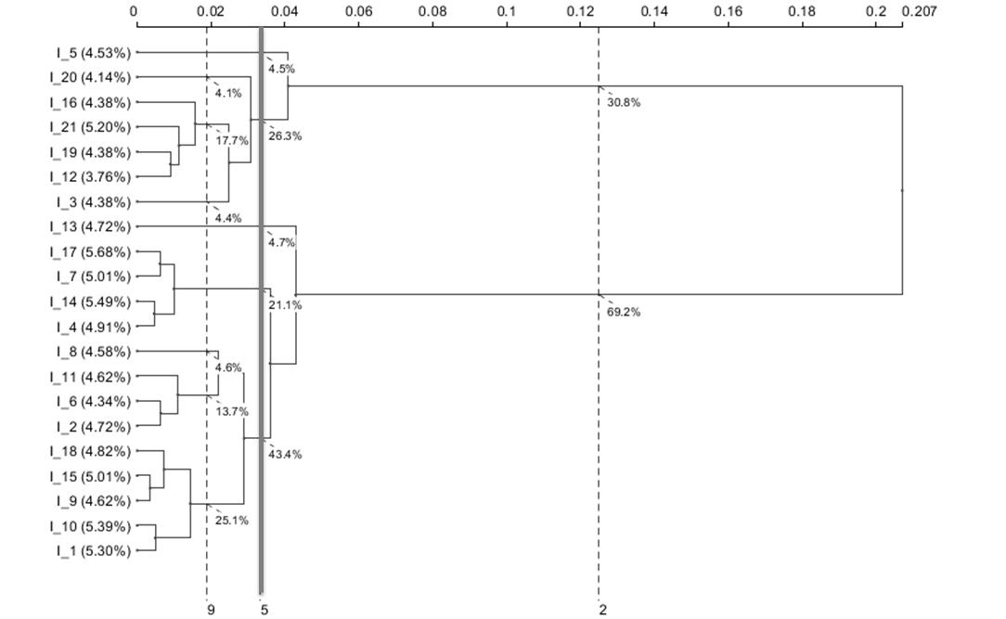
Supplementary Figure S2 – Tree-diagram resulting from the hierarchical correspondence analysis for texture clustering of the 21 hays

