^{ANIMAL JOURNAL}
Extending the interval between second vaccination and slaughter: II. Changes in the reproductive capacity of immunocastrated ram lambs.
T. Needham^{1,2}, H. Lambrechts¹ and L.C. Hoffman^{1,3}

¹Department of Animal Sciences, University of Stellenbosch, Private Bag X1, Matieland, Stellenbosch, 7602, South Africa.
²Department of Animal Science and Food Processing, Faculty of Tropical AgriSciences, Czech University of Life Sciences Prague, Kamýcká 961/129, Prague 165 21, Czech Republic.
³Centre for Nutrition and Food Sciences, Queensland Alliance for Agriculture and Food Innovation (QAAFI). The University of Queensland, Health and Food Sciences Precinct, 39 Kessels Rd, Coopers Plains 4108. Australia.

Corresponding author: Louw Hoffman. louwrens.hoffman@uq.edu.au

Deterioration of semen in immunocastrated rams

Table S1 Scoring system used to evaluate the appearance quality and mass motility of semen samples collected from immunocastrated (n = 5), Burdizzo-castrated (n = 5) and intact ram (n = 5) Dohne Merino lambs, as adapted from Hafez and Hafez (2008) and Ramsem (2017).
Score | Class | Appearance | Motility
5 | Excellent | Thick, creamy. | Dense, very rapidly moving waves; 90% of sperm are motile.
4 | Good | Creamy. | Vigorous wave movement; 70-85% of sperm cells are active.
3 | Fair | Thin, creamy. | General but slow-moving waves; 45-65% sperm are motile.
2 | Poor | Milky. | Slow movement with no waves; 20-40% poor motility.
1 | Very poor | Thin, milky. | Only weak individual movement; only about 10% motile.
0 | Unsatisfactory | Transparent | Total immobility.

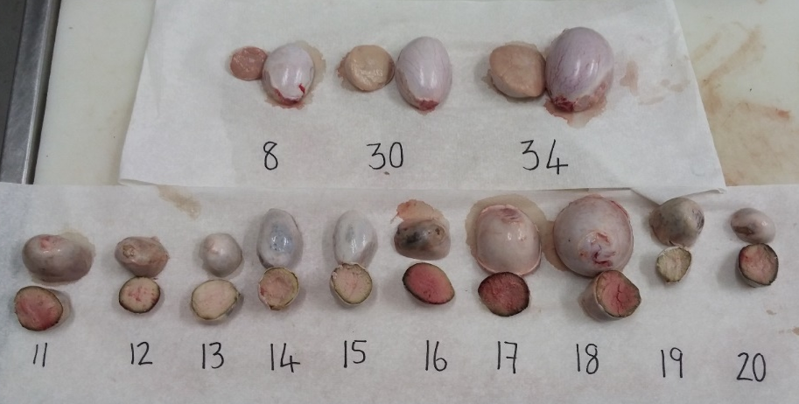
Figure S1 The timmed testes cut in half for surface colour measurement indicating the differences in size and colour between castrated lamb treatments. Testes 8 and 30 were from Dohne Merino lambs immunocastrated with a six or four-week interval between second vaccination and slaughter, respectively. Testes 34 was collected from an intact ram, while testes 11 to 20 represent the entirety of the Burdizzo-castrated treatment group.

Figure S2 The average (± SE) serum androstenedione concentrations (ng/mL) measured in lambs immunocastrated with either six (ICS6; n = 10) or four (ICS4; n = 10) weeks between second vaccination and slaughter, Burdizzo-castrated lambs (B; n = 10) and intact control rams (R; n = 10). Vaccinations are indicated by arrows. Letters indicate significant differences between means at a significance level of 5 %.

