animal Journal
Supplementary materials
Title: Intraflock variability in the body reserve dynamics of meat sheep by analyzing body weight and body condition score variations over multiple production cycles
Authors: T. Macé, E. González-García, F. Carrière, S. Douls, D. Foulquié, C. Robert-Granié, D. Hazard
Corresponding author: Tiphaine Macé (tiphaine.mace@inra.fr)

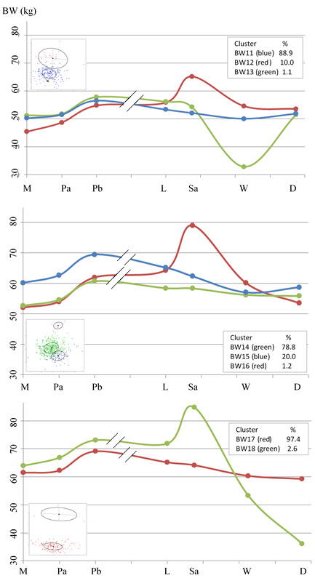
Supplementary Figure S1. Cluster profiles for Body Weight in Romane ewes lambing and suckling twins (Litter 3) over their production cycles 1 (at the top), 2 (in the middle) and 3 (at the bottom). The scatter plot on the left of each graph represents the individual coordinates on the two first principal components of the functional principal component analysis (FPCA). The textbox on the right of each graph indicates the proportion of animals in each cluster, which is given in percentage.
M, Mating; Pa, Early pregnancy; Pb, Mid-Pregnancy; L, Lambing; Sa, Beginning of suckling; W, Weaning; D, Dry-off; BW, Body Weight.

