Supplementary material to ANIMAL journal, paper: ANIMAL-18-50819 R2

Effect of lactation trimester and parity on eating behavior, milk production and efficiency traits of dairy cows
Y. A. Ben Meir, M. Nikbachat, S. Jacoby, Y. Portnik, H. Levit, A. Kleinjan Elazary, E. Gershon, G. Adin, M. Cohen Zinder, A. Shabtay, M. Zachut, S. J. Mabjeesh, I. Halachmi and J. Miron*.
*Corresponding author: Joshua Miron. Email: jmiron@agri.gov.il

Supplementary Material S1. Meal time-criteria definition.
Meal definition was calculated according to the methology proposed by Devries et al (2003) (which comply with Tolkamp et al 1998) with some modification to determine meal time criteria since its better fit our data of intervals between visits.
The figure below describes the pooled interval between visits based on our data. X is sqrt of intervals in minutes and Y is normal log of visits frequency. We used the Microsoft Excel trendline tool to fit line to each part of the figure (left side “within meals” and right side “between meals”) and found X where Y is equal. The solution to the equation is 5.4353 means Tc=29.54 min (maximal interval in minutes between visits), similar to Tc for pooled data found by DeVries et al (2003) (Tc=27.74).
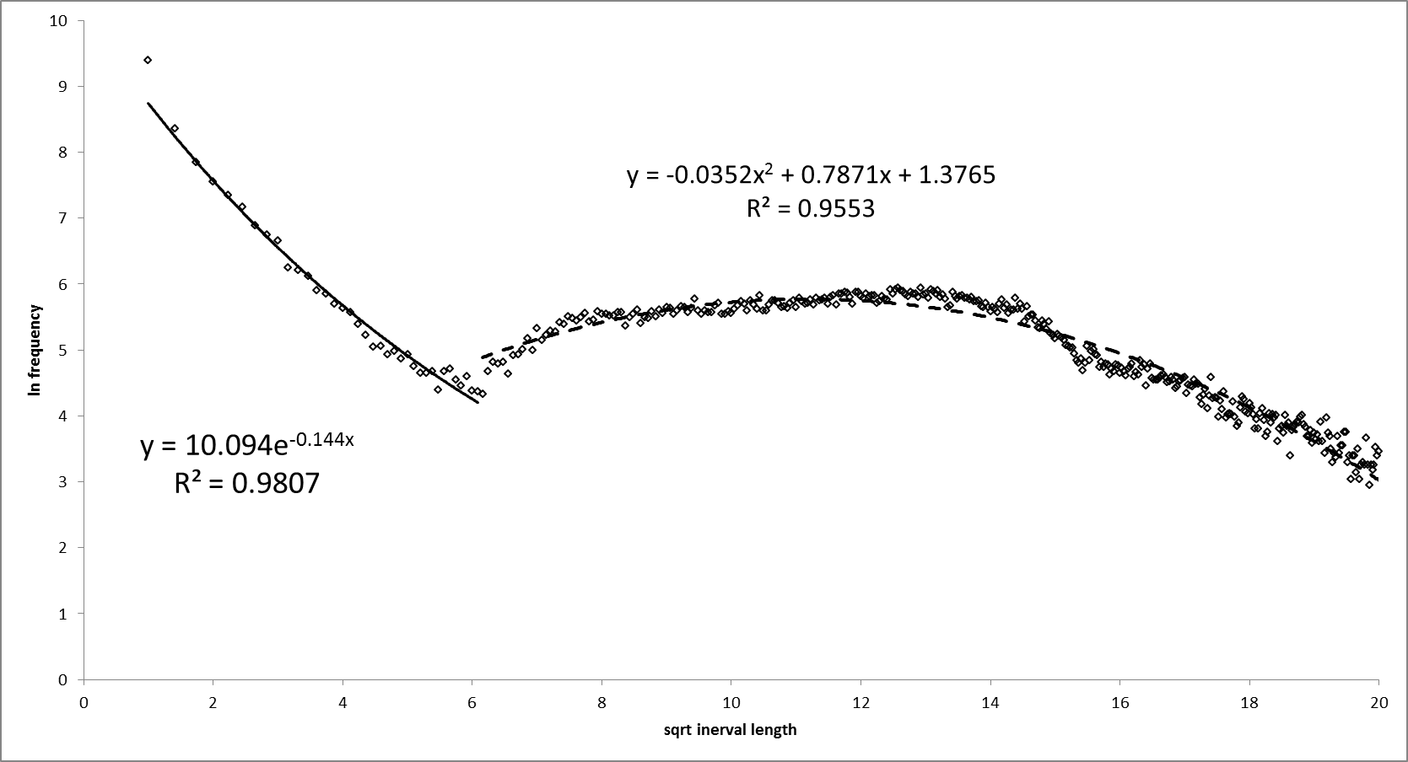

Figure S1: frequency of time between ends of visit to start of the following visit, used to determine meal criteria in dairy cows.

Supplementary Material S2.Equations of energy corrected milk and energy balance calculation
Energy corrected milk (ECM): ECM (kg/d) = milk yield (kg/d) × (0.3887× %fat+0.2356 × %protein + 0.1653 × % lactose)/3.1338.
Total daily net energy utilized (NE_{T}) was calculated as NE_{T} = net energy lactation + net energy maintenance + net energy growth.
Metabolic energy intake (MEI) was calculated as: MEI (Mcal/d) = dry matter intake (kg/d) × [(1.01×DE (Mcal/kg)-0.45+0.0046×(EE-3)],
Where: DE (digestible energy, Mcal/kg DM) = (digestible NFC/100×4.2) + (digestible NDF/100×4.2) + (digestible CP/100×5.6) + (digestible EE/100×9.4) - 0.3 (NRC, 2001). In this equation, NFC=non-fiber carbohydrate, NDF = neutral detergent fiber, CP = crude protein, EE = ether extract.
In vivo digestibility values of each dietary component in high efficient, mid efficient and low efficient cows fed this diet were measured in a previous study (Ben-Meir et al., 2018).

Supplementary Material S3. Additional figure and table

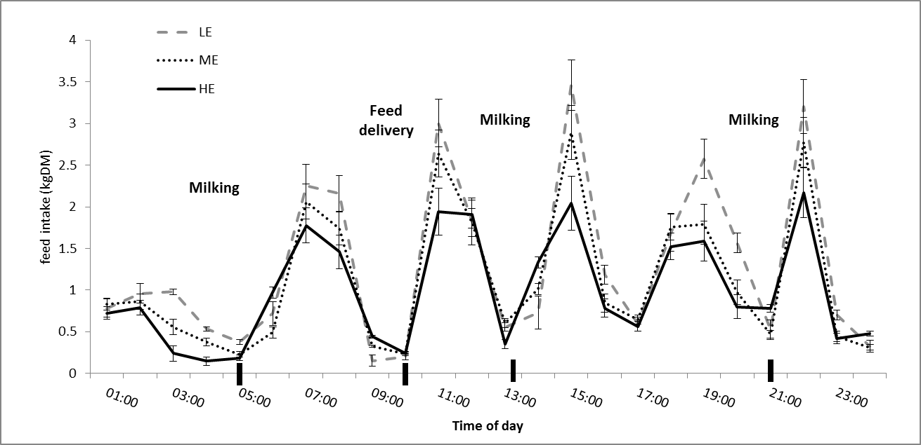

Figure S2: Diurnal feed intake distribution of LE (low efficient), ME (mid efficient) and HE (high efficient) cows at the 2nd trimester of lactation. Black rectangles mark the time of the external events written (milking or feed delivery). Bars represent ±SE in each hour of the day for each group.

Table S1: A comparison of energy balance between high efficient (HE), low efficient (LE) and mid efficiency (ME) cows within each trimester of lactation.
 | 1st Trimester |  |  |  |  | 2nd Trimester |  |  |  |  | 3rd Trimester
 | HE | ME | LE | SEM |  | HE | ME | LE | SEM |  |  | HE | ME | LE | SEM
N | 19 | 57 | 19 |  |  | 31 | 93 | 31 |  |  |  | 18 | 54 | 18
NE_{M}, Mcal/d | 9.78 | 9.68 | 10.04 | 0.09 |  | 9.83 | 9.84 | 9.91 | 0.06 |  |  | 10.2 | 10.1 | 10.3 | 0.07
NE_{G}, Mcal/d | -0.51^{b} | 1.37ª | 2.13ª | 0.36 |  | -0.10^{b} | 1.76ª | 0.77^{ab} | 0.28 |  |  | 1.26 | 0.81 | -0.02 | 0.30
NE_{L}, Mcal/d | 31.6 | 31.3 | 33.1 | 0.47 |  | 29.8^{b} | 30.9^{ab} | 32.3ª | 0.35 |  |  | 27.5^{b} | 28.3^{ab} | 29.9ª | 0.34
NE_{T}, Mcal/d | 40.9^{b} | 42.4^{ab} | 45.3ª | 0.61 |  | 39.6^{b} | 42.6ª | 43.0ª | 0.46 |  |  | 38.9 | 39.3 | 40.1 | 0.41
MEI, Mcal/d | 66.7^{c} | 75.5^{b} | 84.2ª | 0.96 |  | 68.6^{c} | 78.5^{b} | 87.9ª | 0.84 |  |  | 65.0^{c} | 73.7^{b} | 82.5ª | 0.90
HP+E loss Mcal/d | 25.8^{c} | 33.1^{b} | 38.9ª | 0.68 |  | 29.0^{c} | 35.9^{b} | 44.9ª | 0.61 |  |  | 26.1^{c} | 34.4^{b} | 42.4ª | 0.78
NE_{T}/MEI | 0.61ª | 0.56^{b} | 0.54^{c} | 0.004 |  | 0.58ª | 0.54^{b} | 0.49^{c} | 0.003 |  |  | 0.60ª | 0.54^{b} | 0.49^{c} | 0.003
^{abc}- Within rows and lactation trimester, means marked by different superscripts differ at p<0.05.
NE_{M} = Net energy for maintenance (Mcal/d) =0.08*BW^{0.75}, (NRC 2001).
NE_{G} = Net energy retained in BW gain for average BCS of 3.5 (NRC 2001).
NE_{L} =Net energy retained in milk (NRC 2001).
NE_{T} = Sum of energy used for maintenance, BW gain and milk production
MEI = Metabolic energy intake based on intake and in vivo digestible energy data (Ben-Meir et al., 2018).
HP+E loss = Heat production and energy loss in urine, breathing and sweating.

