Relative abilities of young sheep and goats to self-medicate with tannin-rich sainfoin when infected with gastrointestinal nematodes

E. Gaudin, M. Costes-Thiré, J.J. Villalba, H. Hoste, V. Gerfault and C. Ginane
animal journal

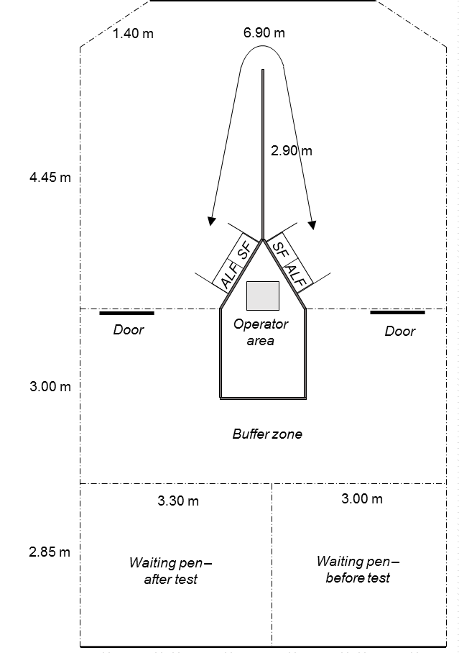
Figure S1. Schematic overhead view of the experimental arena for the operant-conditioning trial run with lambs and kids. “SF” represents the bowl filled with SF_{exp} (experimental sainfoin) and “ALF” represents the bowl filled with ALF_{exp} (experimental alfalfa). Dotted lines represent openwork fences while solid lines represent solid fences.

Table S1. Cafeteria trial – Significance (P values) of the effects of host species (lambs and kids (Sp)), parasitic status (parasitized and non-parasitized (St)), period (P1, P2, P3 (Pe)) and their interactions
 | Main effects |  |  |  | Interactions
 | Species | Status | Period |  | Sp*St | Sp*Pe | St*Pe | Sp*St*Pe
SF_{exp} DMI | 0.0002 | 0.22 | 0.025 |  | 0.36 | 0.18 | 0.037 | 0.23
ALF_{exp} DMI | 0.006 | 0.020 | 0.64 |  | 0.96 | 0.008 | 0.31 | 0.41
SF_{exp} preference | 0.25 | 0.11 | 0.041 |  | 0.26 | 0.16 | 0.72 | 0.32
Total DMI | 0.0007 | 0.071 | 0.54 |  | 0.76 | 0.006 | 0.048 | 0.44
SF_{exp} = experimental sainfoin; ALF_{exp} = experimental alfalfa; DMI= dry matter intake.

