Published in Animal Journal
Heritability of phenotypic udder traits to improve resilience to mastitis in Texel ewes

R.E. Crump¹, S. Cooper², E.M. Smith^{2a}, C. Grant², L.E. Green^{1b}

¹School of Life Sciences and Zeeman Institute for Systems Biology and Infectious Disease Epidemiology Research, University of Warwick, Coventry, CV4 7AL
²School of Life Sciences, University of Warwick, Coventry, CV4 7AL

ªPresent address: The British Texel Sheep Society Ltd, Stoneleigh Park, Kenilworth, CV8 2LG.
^{b}Present address: College of Life and Environmental Sciences, University of Birmingham, Edgbaston B15 2TT

Corresponding author: Laura Green. Email: l.e.green.1@bham.ac.uk

Table S1 Deviance information criteria (DIC) for individual animal models for ewe heritability of udder phenotypes with various combinations of fixed effects

Phenotype |  | Fixed effects tested for inclusion in the model
 | FSD | FSD, EA | FSD, DIM | FSD, EA, DIM
Teat placement | 2022.61 | 2019.92 | 2022.49 | 2019.37
Udder drop | 1718.41 | 1708.25 | 1719.69 | 1708.94
Degree of separation | 2290.07 | 2291.51 | 2291.11 | 2292.41
Udder width | 2907.05 | 2894.59 | 2899.37 | 2884.11
Left teat length | 725.71 | 725.93 | 719.12 | 722.22
Chronic mastitis | 902.48 | 904.66 | 904.3 | 906.46
Left teat lesion | 531.3 | 533.24 | 531.97 | 533.87
Right teat lesion | 572.57 | 573.2 | 574.07 | 574.71
Any teat lesion | 699.28 | 702.33 | 701.04 | 704.08
FSD = Flock observation date, EA = ewe age, DIM = days in milk. The lowest value of DIC for each phenotype was included in the model.

Table S2 Marginal posterior distributions of variance components, heritabilities and repeatabilities of continuous traits for heritability of ewe udder phenotypic traits estimated with an individual animal model with repeated records

Trait | Parameter | Mean | SD | Percentiles |  |  | MAP
 |  |  |  | 2.5% | 50% | 97.5%
Teat placement | $σ_{e}^{2}$₁ | 0.634 | 0.0634 | 0.518 | 0.632 | 0.76 | 0.628
 | $σ_{a}^{2}$₂ | 0.422 | 0.0819 | 0.276 | 0.418 | 0.588 | 0.411
 | $σ_{pe}^{2}$₃ | 0.0003 | 0.0015 | 0 | 0.0001 | 0.0017 | 0
 | h² | 0.401 | 0.0369 | 0.33 | 0.401 | 0.474 | 0.401
 | r | 0.401 | 0.0369 | 0.33 | 0.401 | 0.475 | 0.402
Udder drop | $$σ_{e}^{2}$$ | 0.307 | 0.0415 | 0.23 | 0.305 | 0.387 | 0.298
 | $$σ_{a}^{2}$$ | 0.156 | 0.0532 | 0.0664 | 0.153 | 0.267 | 0.15
 | $$σ_{pe}^{2}$$ | 0.166 | 0.0544 | 0.0798 | 0.162 | 0.275 | 0.151
 | h² | 0.244 | 0.0439 | 0.162 | 0.243 | 0.597 | 0.517
 | r | 0.517 | 0.0418 | 0.434 | 0.518 | 0.597 | 0.517
Degree of separation | $$σ_{e}^{2}$$ | 1.04 | 0.12 | 0.81 | 1.04 | 1.27 | 1.04
 | $$σ_{a}^{2}$$ | 0.526 | 0.15 | 0.251 | 0.519 | 0.828 | 0.503
 | $$σ_{pe}^{2}$$ | 0.201 | 0.141 | 0.0461 | 0.16 | 0.526 | 0.0447
 | h² | 0.272 | 0.0443 | 0.189 | 0.27 | 0.362 | 0.268
 | r | 0.42 | 0.0465 | 0.329 | 0.42 | 0.51 | 0.424
Udder width | $$σ_{e}^{2}$$ | 2.32 | 0.211 | 1.88 | 2.33 | 2.69 | 2.36
 | $$σ_{a}^{2}$$ | 0.422 | 0.179 | 0.144 | 0.397 | 0.823 | 0.278
 | $$σ_{pe}^{2}$$ | 0.187 | 0.194 | 0.0295 | 0.0968 | 0.698 | 0.0294
 | h² | 0.129 | 0.0394 | 0.0621 | 0.126 | 0.214 | 0.115
 | r | 0.234 | 0.0494 | 0.141 | 0.232 | 0.334 | 0.239
Left teat length | $$σ_{e}^{2}$$ | 0.0992 | 0.0111 | 0.0793 | 0.0988 | 0.121 | 0.098
 | $$σ_{a}^{2}$$ | 0.085 | 0.0153 | 0.0577 | 0.0843 | 0.116 | 0.0833
 | $$σ_{pe}^{2}$$ | 0.0002 | 0.0005 | 0 | 0.0001 | 0.0015 | 0
 | h² | 0.462 | 0.036 | 0.391 | 0.462 | 0.533 | 0.472
 | r | 0.463 | 0.036 | 0.392 | 0.533 | 0.472 | 0.463

MAP = maximum a posteriori probability

¹$σ_{e}^{2}$₌ variance of e = vector of random residual effects

²$σ_{a}^{2}$ ₌ variance of a = vector of random animal effects

₃$σ_{pe}^{2}$₌ variance of u = vector of random permanent environmental effects associated with ewes
h² ⁼ heritability
Table S3 Marginal posterior distributions of variance components, heritabilities and repeatabilities of binary traits for udder phenotypes in ewes estimated with an individual animal model with repeated records

Trait | Parameter | Mean | SD | Percentiles |  |  | MAP
 |  |  |  | 2.50% | 50% | 97.50%
Chronic mastitis | $σ_{a}^{2}$₁ | 0.36278 | 0.23669 | 0.04078 | 0.31901 | 0.92031 | 0.21607
 | $σ_{pe}^{2}$₂ | 0.0005 | 0.00242 | 0.00001 | 0.00007 | 0.00174 | 0.00002
 | h²₃ | 0.09666 | 0.05219 | 0.02226 | 0.0884 | 0.21917 | 0.05832
 | r | 0.09671 | 0.05219 | 0.0223 | 0.08844 | 0.21919 | 0.05925
Left teat Lesion | $$σ_{a}^{2}$$ | 0.48234 | 0.35379 | 0.04008 | 0.40653 | 1.39118 | 0.19756
 | $$σ_{pe}^{2}$$ | 0.00038 | 0.00165 | 0.00001 | 0.00007 | 0.00166 | 0.00002
 | h² | 0.12342 | 0.07273 | 0.023 | 0.11073 | 0.29431 | 0.06695
 | r | 0.12346 | 0.07273 | 0.02306 | 0.11076 | 0.29435 | 0.06692
Right teat Lesion | $$σ_{a}^{2}$$ | 0.56167 | 0.3806 | 0.0598 | 0.4863 | 1.48308 | 0.33203
 | $$σ_{pe}^{2}$$ | 0.00035 | 0.00152 | 0.00001 | 0.00007 | 0.00162 | 0.00002
 | h² | 0.14128 | 0.07426 | 0.03278 | 0.1304 | 0.31263 | 0.10039
 | r | 0.14132 | 0.07425 | 0.03283 | 0.13045 | 0.31267 | 0.10042
Any teat lesion | $$σ_{a}^{2}$$ | 0.37653 | 0.26795 | 0.03245 | 0.32027 | 1.06284 | 0.16672
 | $$σ_{pe}^{2}$$ | 0.00044 | 0.00203 | 0.00001 | 0.00007 | 0.00167 | 0.00002
 | h² | 0.09919 | 0.05885 | 0.01841 | 0.08897 | 0.23909 | 0.05199
 | r | 0.09923 | 0.05884 | 0.01846 | 0.089 | 0.23918 | 0.06561

MAP = maximum a posteriori probability

¹$σ_{a}^{2}$ ₌ variance of a = vector of random animal effects

₂$σ_{pe}^{2}$₌ variance of u = vector of random permanent environmental effects associated with ewes
³h² ⁼ heritability

Table S4 Marginal distributions of variance components and heritabilities from an individual animal model INLA analyses of continuous udder traits in ewes with a fixed effect of litter size either included or excluded from the model

Trait | Litter size in model | Parameter | Mean | SD |  | Percentiles |  | MAP
 |  |  |  |  | 2.50% | 50% | 97.50%
Teat placement | Yes | $σ_{e}^{2}$₁ | 0.714 | 0.078 | 0.571 | 0.712 | 0.868 | 0.71
 |  | $σ_{a}^{2}$₂ | 0.302 | 0.089 | 0.15 | 0.296 | 0.487 | 0.284
 |  | h² | 0.303 | 0.042 | 0.223 | 0.302 | 0.387 | 0.303
 | No | $$σ_{e}^{2}$$ | 0.713 | 0.078 | 0.571 | 0.711 | 0.867 | 0.71
 |  | $$σ_{a}^{2}$$ | 0.302 | 0.089 | 0.15 | 0.296 | 0.486 | 0.284
 |  | h² | 0.303 | 0.042 | 0.224 | 0.303 | 0.387 | 0.299
Udder drop | Yes | $$σ_{e}^{2}$$ | 0.494 | 0.048 | 0.403 | 0.494 | 0.586 | 0.497
 |  | $$σ_{a}^{2}$$ | 0.108 | 0.051 | 0.029 | 0.102 | 0.218 | 0.084
 |  | h² | 0.187 | 0.044 | 0.108 | 0.185 | 0.278 | 0.189
 | No | $$σ_{e}^{2}$$ | 0.496 | 0.05 | 0.403 | 0.496 | 0.591 | 0.499
 |  | $$σ_{a}^{2}$$ | 0.122 | 0.053 | 0.039 | 0.117 | 0.237 | 0.1
 |  | h² | 0.206 | 0.044 | 0.126 | 0.204 | 0.297 | 0.199
Degree of separation | Yes | $$σ_{e}^{2}$$ | 1.292 | 0.15 | 1.02 | 1.29 | 1.583 | 1.295
 |  | $$σ_{a}^{2}$$ | 0.504 | 0.171 | 0.228 | 0.49 | 0.862 | 0.454
 |  | h² | 0.288 | 0.044 | 0.205 | 0.288 | 0.377 | 0.284
 | No | $$σ_{e}^{2}$$ | 1.285 | 0.15 | 1.014 | 1.283 | 1.575 | 1.286
 |  | $$σ_{a}^{2}$$ | 0.513 | 0.171 | 0.235 | 0.499 | 0.87 | 0.465
 |  | h² | 0.293 | 0.044 | 0.209 | 0.292 | 0.381 | 0.294
Udder width | Yes | $$σ_{e}^{2}$$ | 2.533 | 0.193 | 2.152 | 2.535 | 2.91 | 2.544
 |  | $$σ_{a}^{2}$$ | 0.323 | 0.172 | 0.085 | 0.292 | 0.732 | 0.213
 |  | h² | 0.106 | 0.038 | 0.043 | 0.103 | 0.191 | 0.097
 | No | $$σ_{e}^{2}$$ | 2.583 | 0.204 | 2.187 | 2.584 | 2.982 | 2.594
 |  | $$σ_{a}^{2}$$ | 0.368 | 0.189 | 0.094 | 0.336 | 0.81 | 0.26
 |  | h² | 0.116 | 0.039 | 0.051 | 0.113 | 0.203 | 0.106
Left teat length | Yes | $$σ_{e}^{2}$$ | 0.111 | 0.014 | 0.085 | 0.111 | 0.139 | 0.111
 |  | $$σ_{a}^{2}$$ | 0.076 | 0.018 | 0.046 | 0.075 | 0.113 | 0.072
 |  | h² | 0.405 | 0.04 | 0.328 | 0.405 | 0.484 | 0.405
 | No | $$σ_{e}^{2}$$ | 0.11 | 0.014 | 0.084 | 0.11 | 0.138 | 0.11
 |  | $$σ_{a}^{2}$$ | 0.08 | 0.018 | 0.049 | 0.079 | 0.117 | 0.077
 |  | h² | 0.421 | 0.039 | 0.344 | 0.421 | 0.498 | 0.423

INLA = Integrated Nested Laplace Approximation

MAP = maximum a posteriori probability

¹$σ_{e}^{2}$₌ variance of e = vector of random residual effects

²$σ_{a}^{2}$ ₌ variance of a = vector of random animal effects
h² ⁼ heritability

Table S5 Marginal distributions of sire and additive genetic variances and heritabilities from the sire model INLA analyses of binomial udder traits in ewes with a fixed effect of litter size either included or excluded from the model

Trait | Litter size included | Parameter | Mean | SD |  | Percentiles |  | MAP
 |  |  |  |  | 2.50% | 50% | 97.50%
Chronic mastitis | Yes | $σ_{s}^{2}$₁ | 0.158 | 0.109 | 0.015 | 0.136 | 0.428 | 0.09
 |  | $σ_{a}^{2}$₂ | 0.632 | 0.435 | 0.061 | 0.544 | 1.712 | 0.359
 |  | h² | 0.18 | 0.117 | 0.019 | 0.159 | 0.46 | 0.113
 | No | $$σ_{s}^{2}$$ | 0.148 | 0.105 | 0.013 | 0.126 | 0.416 | 0.079
 |  | $$σ_{a}^{2}$$ | 0.593 | 0.42 | 0.054 | 0.504 | 1.664 | 0.315
 |  | h² | 0.169 | 0.113 | 0.016 | 0.148 | 0.449 | 0.1
Left teat lesion | Yes | $$σ_{s}^{2}$$ | 0.114 | 0.075 | 0.007 | 0.102 | 0.267 | 0.03
 |  | $$σ_{a}^{2}$$ | 0.454 | 0.3 | 0.03 | 0.407 | 1.067 | 0.121
 |  | h² | 0.132 | 0.084 | 0.009 | 0.12 | 0.3 | 0.038
 | No | $$σ_{s}^{2}$$ | 0.114 | 0.075 | 0.008 | 0.105 | 0.265 | 0.031
 |  | $$σ_{a}^{2}$$ | 0.458 | 0.298 | 0.03 | 0.418 | 1.059 | 0.123
 |  | h² | 0.133 | 0.084 | 0.009 | 0.123 | 0.298 | 0.04
Right teat lesion | Yes | $$σ_{s}^{2}$$ | 0.221 | 0.165 | 0.016 | 0.182 | 0.636 | 0.098
 |  | $$σ_{a}^{2}$$ | 0.882 | 0.66 | 0.065 | 0.728 | 2.543 | 0.392
 |  | h² | 0.243 | 0.168 | 0.02 | 0.21 | 0.648 | 0.127
 | No | $$σ_{s}^{2}$$ | 0.229 | 0.17 | 0.018 | 0.191 | 0.661 | 0.108
 |  | $$σ_{a}^{2}$$ | 0.918 | 0.679 | 0.071 | 0.764 | 2.645 | 0.432
 |  | h² | 0.253 | 0.171 | 0.022 | 0.22 | 0.669 | 0.139
Any teat lesion | Yes | $$σ_{s}^{2}$$ | 0.113 | 0.075 | 0.007 | 0.1 | 0.266 | 0.03
 |  | $$σ_{a}^{2}$$ | 0.452 | 0.3 | 0.03 | 0.401 | 1.065 | 0.12
 |  | h² | 0.131 | 0.084 | 0.009 | 0.118 | 0.299 | 0.038
 | No | $$σ_{s}^{2}$$ | 0.13 | 0.086 | 0.008 | 0.114 | 0.304 | 0.034
 |  | $$σ_{a}^{2}$$ | 0.514 | 0.345 | 0.034 | 0.455 | 1.216 | 0.138
 |  | h² | 0.149 | 0.096 | 0.01 | 0.134 | 0.338 | 0.044

INLA = Integrated Nested Laplace Approximation

MAP = maximum a posteriori probability

¹$σ_{s}^{2}$₌ variance of s = vector of random sire effects

²$σ_{a}^{2}$ ₌ variance of a = vector of random animal effects
h² ⁼ heritability
Table S6 Correlations between maximum a posteriori estimated breeding value udder traits of sires with more than 5 ewe offspring

 | 1 | 2 | 3 | 4 | 5 | 6 | 7 | 8
2. Udder drop | 0.24
3. Degree of separation | -0.29 | -0.13
4. Udder width | -0.21 | -0.57 | 0.31
5. Left teat length | 0.09 | -0.26 | 0.00 | 0.20
6. Udder coded | -0.18 | -0.08 | -0.25 | -0.06 | 0.22
7. Left teat coded | -0.09 | -0.12 | -0.12 | -0.16 | 0.01 | -0.04
8. Right teat coded | -0.17 | -0.16 | -0.05 | 0.07 | -0.10 | 0.17 | 0.44
9. Teats coded | -0.13 | -0.13 | -0.10 | -0.01 | -0.18 | -0.04 | 0.69 | 0.86
1 = Teat placement

Supplementary Figure S1 Mode and 95% confidence interval of posterior marginal distribution of heritability of continuous traits of udder morphology in Texel sheep as the mode and informativeness of the prior distribution of heritability varies
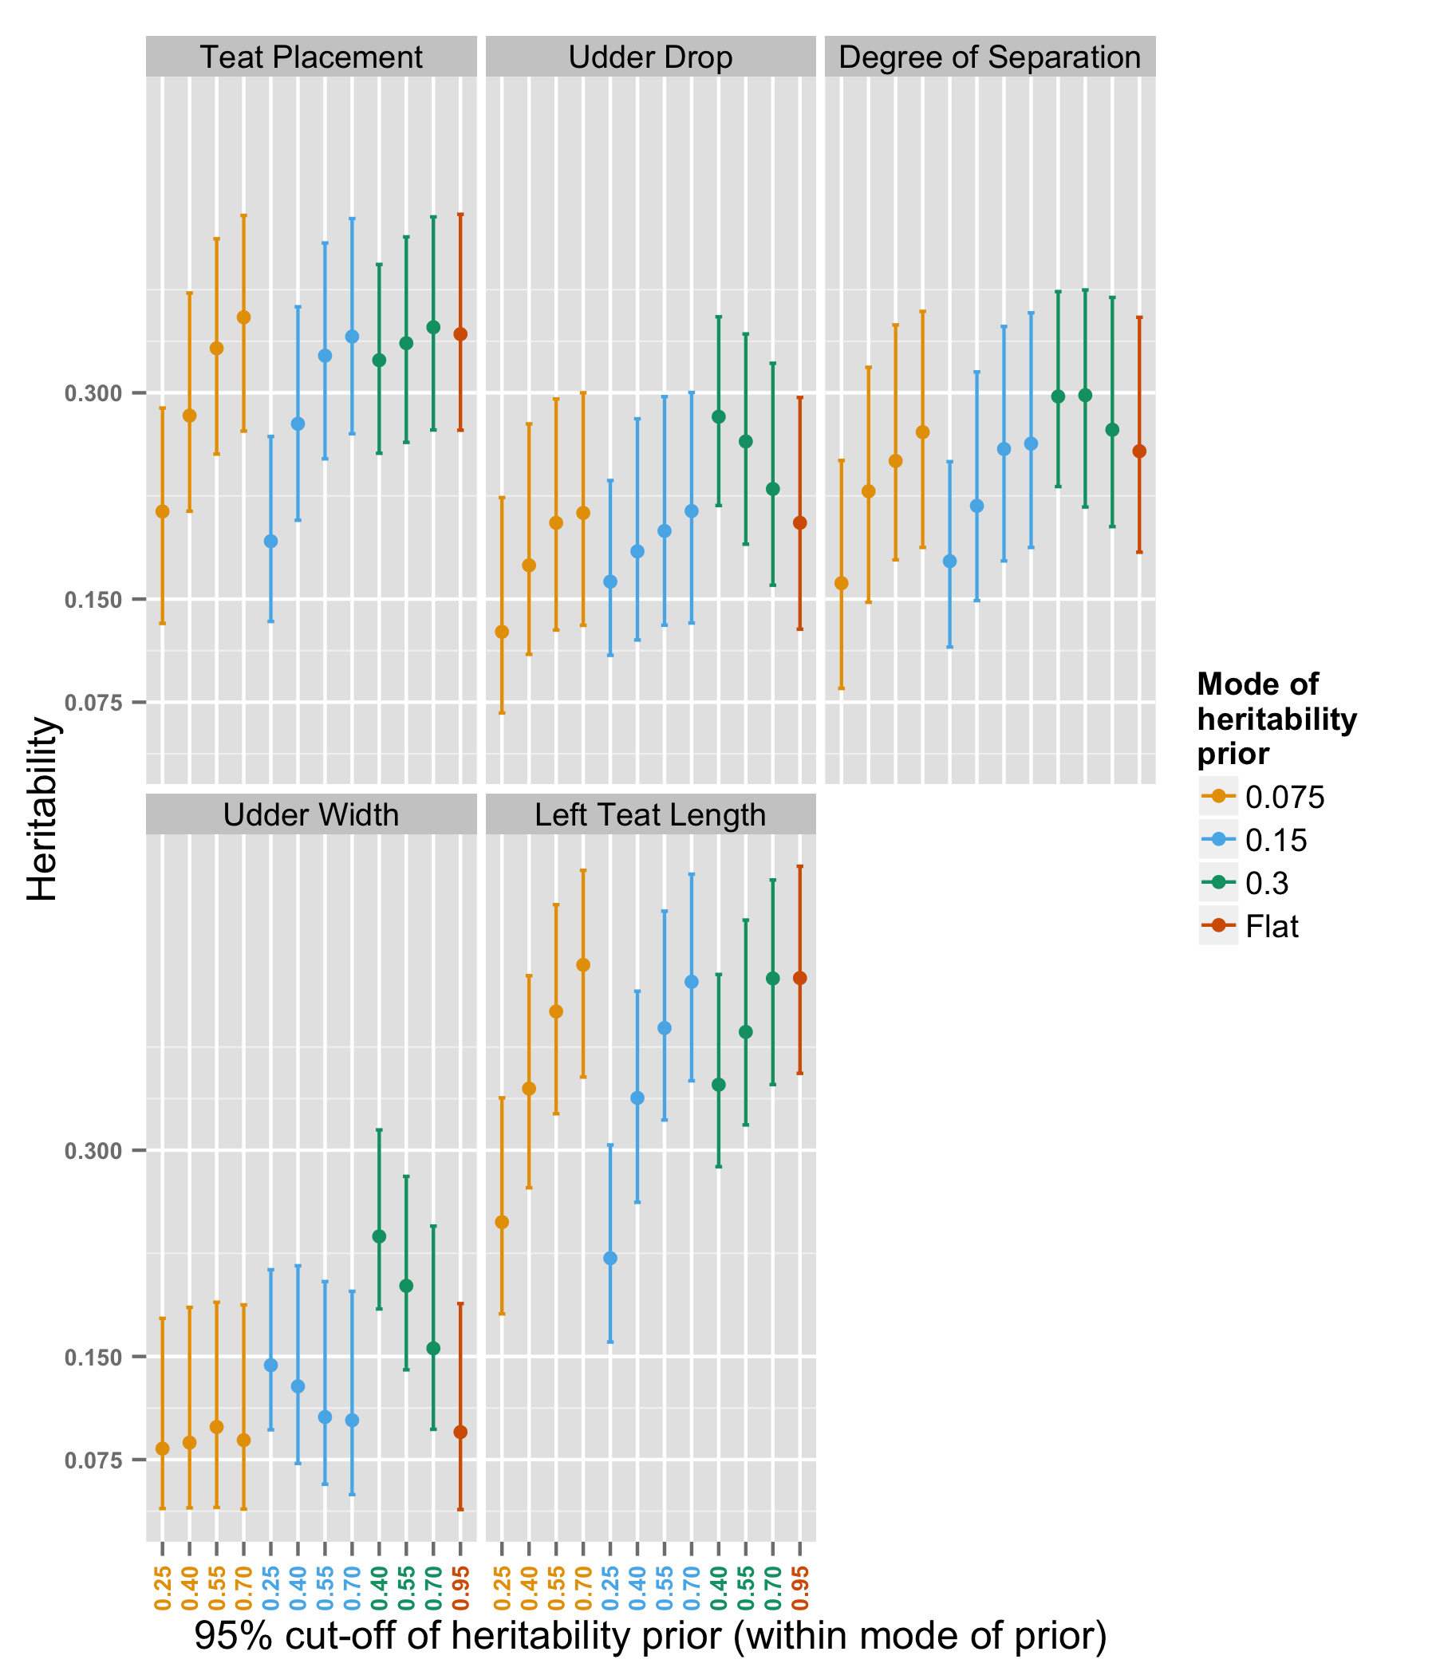
Supplementary Figure S2 Mode and 95% confidence interval of posterior marginal distribution of heritability of binary phenotypic udder traits in Texel ewes as the mode and informativeness of the prior distribution of heritability varies
