Supplementary material
Characteristics of boli formed by dairy cows upon ingestion of fresh ryegrass, lucerne or chicory
E. M. K. Minnee 1, G. C. Waghorn 1, P. Gregorini 2, R. H. Bryant ² and D. F. Chapman 3
Submitted to: Animal

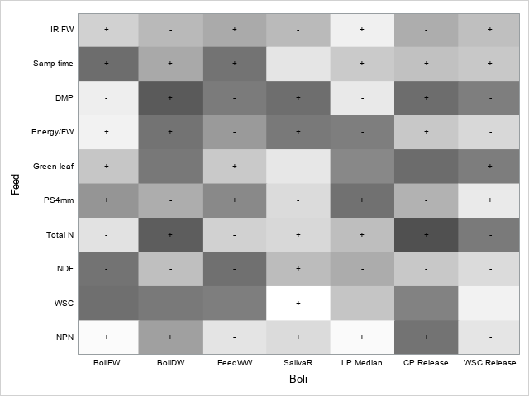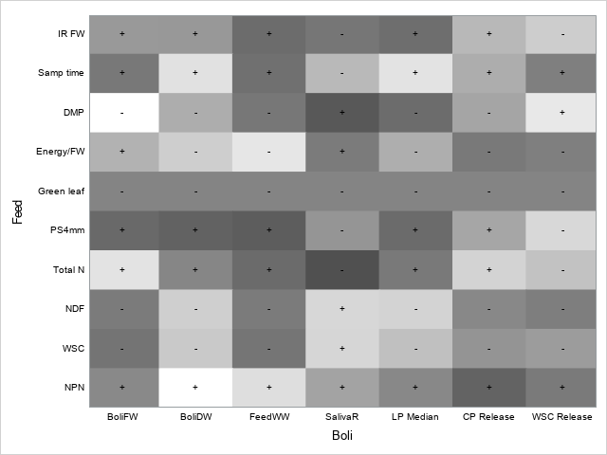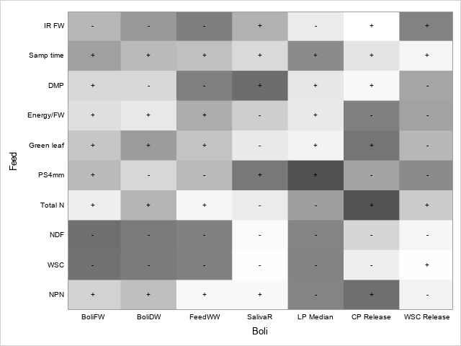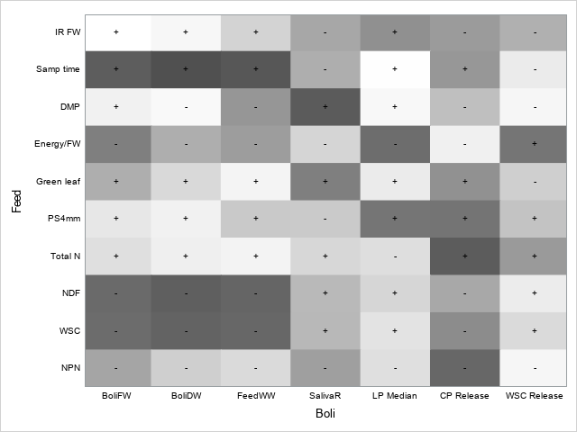
Supplementary Figure S1 Heat map diagrams describing the associations between feed characteristics and boli characteristics from dairy cattle (Bos taurus) for (a) all forages, (b) chicory, (c) lucerne, and (d) ryegrass. Colour scale represents the absolute strength of the correlation (from white if |r| close to 0, to dark grey if |r| close to 1) and the sign indicates whether the correlation is negative or positive.
(c)
(d)
(b)
(a)
Abbreviations: IRFW, Intake rate of fresh material; Samp time, sample time; DMP, herbage dry matter percent; Energy/FW, energy required to macerate fresh material; Green leaf, percentage of green leaf material in herbage; PS4mm, percentage of particles greater than 4 mm; Total N, herbage nitrogen concentration; NDF, neutral detergent fibre; WSC, water soluble carbohydrate; NPN, non protein nitrogen; BoliFW, fresh weight of boli; BoliDW, dry weight of boli; FeedWW, feed wet weight consumed; SalivaR, saliva content of boli; LP Median, median length of large particles; CP release, crude protein release; WSC release, water soluble carbohydrate released.

