A systematic literature mapping and meta-analysis of animal-based traits as indicators of production diseases in pigs
S. Stravakakis, F. Loisel, P. Sakkas, N. Le Floc'h, I. Kyriazakis, G. Stewart and L. Montagne

animal journal

Supplementary materials

Supplementary Material S1. Search terms used in Web of Science Core collection
Splayleg
(TS=(pig OR pigs OR sow OR sows OR piglet OR piglets OR swine OR swines OR boar OR boars OR porcine OR gilt OR gilts OR pork) NOT TS=("guinea$pig" OR "guinea$pigs"OR "pig$nosed turtle*")) AND LANGUAGE: (English OR French) AND DOCUMENT TYPES: (Article)(TS=("splay$leg*" OR "splayleg*" OR "myofibrillar hypoplas*")) AND LANGUAGE: (English OR French) AND DOCUMENT TYPES: (Article)
Osteochondrosis
(TS=((((osteochondrosis) OR (osteochondros*)) OR (osteochondritis)) OR (osteochondrist*)) AND LANGUAGE: (English OR French) AND DOCUMENT TYPES: (Article)(TS=(pig OR pigs OR sow OR sows OR piglet OR piglets OR swine OR swines OR boar OR boars OR porcine OR gilt OR gilts OR pork) NOT TS=("guinea$pig" OR "guinea$pigs"OR "pig$nosed turtle*")) AND LANGUAGE: (English OR French)
Arthrosis (osteoarthrosis)
(TS=(arthrosis OR arthrose OR arthroses)) AND LANGUAGE: (English OR French) AND DOCUMENT TYPES: (Article)(TS=(pig OR pigs OR sow OR sows OR piglet OR piglets OR swine OR swines OR boar OR boars OR porcine OR gilt OR gilts OR pork) NOT TS=("guinea$pig" OR "guinea$pigs"OR "pig$nosed turtle*")) AND LANGUAGE: (English OR French)
Pododermatitis
TS= (pododerma* OR pododermatitis) AND TS= (pig OR pigs OR sow OR sows OR piglet OR piglets OR swine OR swines OR boar OR boars OR porcine OR gilt OR gilts OR pork) NOT TOPIC: ("guinea$pig" OR "guinea$pigs"OR "pig$nosed turtle*") Refined by: LANGUAGES: ( ENGLISH )
Arthitis-polyarthritis-osteoarthritis
(TS=(polyarthritis OR "poly$arthritis" OR polysarthrit* OR "poly$arthrit*" OR arthritis or arthrit*) AND (TS=(pig OR pigs OR sow OR sows OR piglet OR piglets OR swine OR swines OR boar OR boars OR porcine OR gilt OR gilts OR pork) NOT TS=("guinea$pig" OR "guinea$pigs"OR "pig$nosed turtle*"))) AND DOCUMENT TYPES: (Article) AND LANGUAGE: (English OR French)
Panaritum (Foot Rot)
(TS=(panaritium OR whitlow OR panaritum* OR panari* Or whitlow*) AND (TS=(pig OR pigs OR sow OR sows OR piglet OR piglets OR swine OR swines OR boar OR boars OR porcine OR gilt OR gilts OR pork) NOT TS=("guinea$pig" OR "guinea$pigs"OR "pig$nosed turtle*"))) AND DOCUMENT TYPES: (Article) AND LANGUAGE: (English OR French)
Rectal prolapse
"TOPIC: (""rectal*$prolaps*"" OR ""prolapsus of the rectum"" or ""rectum$prolaps*"") AND TOPIC: (pig OR pigs OR sow OR sows OR piglet OR piglets OR swine OR swines OR porcine OR gilt OR gilts OR pork) NOT TOPIC: (""guinea$pig"" OR ""guinea$pigs""OR ""pig$nosed turtle*"")
Refined by: LANGUAGES: ( ENGLISH OR FRENCH ) AND DOCUMENT TYPES: ( ARTICLE ) "
Organ torsion
TOPIC: (torsion*) AND TOPIC: (organ* OR splenic OR spleen OR digestive OR "gastro$intestinal$tract*" OR "intestin*" OR liver OR digest*) AND TOPIC: (pig OR pigs OR sow OR sows OR piglet OR piglets OR swine OR swines OR porcine OR gilt OR gilts OR pork) NOT TOPIC: ("guinea$pig" OR "guinea$pigs"OR "pig$nosed turtle*") Refined by: LANGUAGES: ( ENGLISH OR FRENCH ) AND DOCUMENT TYPES: ( ARTICLE )
Colitis
TOPIC: (colitis or colitides) AND TOPIC: (pig OR pigs OR piglet OR piglets OR swine OR swines OR porcine OR pork) NOT TOPIC: ("guinea$pig" OR "guinea$pigs"OR "pig$nosed turtle*")efined by: LANGUAGES=( ENGLISH OR FRENCH ) AND DOCUMENT TYPES=( ARTICLE )Indexes=SCI-EXPANDED, SSCI, A&HCI, CPCI-S, CPCI-SSH, CCR-EXPANDED, IC Timespan=All years
Ulcers
TOPIC: (ulcer OR ulcers) AND TOPIC: (pig OR pigs OR piglet OR piglets OR swine OR swines OR porcine OR pork) NOT TOPIC: ("guinea$pig" OR "guinea$pigs"OR "pig$nosed turtle*") NOT TOPIC: ("skin$ulcer$")Refined by: LANGUAGES: ( ENGLISH OR FRENCH ) AND DOCUMENT TYPES: ( ARTICLE )Indexes=SCI-EXPANDED, SSCI, A&HCI, CPCI-S, CPCI-SSH, CCR-EXPANDED, IC Timespan=All years
Post-weaning diarhea
TOPIC: ("post$weaning" OR "post$wean*") AND TOPIC: (diarrhoea* OR syndrom* OR diarrhea*) AND TOPIC: (pig OR pigs OR sow OR sows OR piglet OR piglets OR swine OR swines OR porcine OR gilt OR gilts OR pork) NOT TOPIC: ("guinea$pig" OR "guinea$pigs"OR "pig$nosed turtle*" OR "post$weaning multi$systemic?wasting?syndrom*" OR "circovirus") Refined by: LANGUAGES: ( ENGLISH ) AND DOCUMENT TYPES: ( ARTICLE )
Porcine Respiratory Disease Complex
TOPIC: ("porcine respiratory disease complex" OR "porcine respirator* disease* complex*" OR "porcine$respirator*$disease*$complex*" OR "respirator* disease* complex*") AND TOPIC: (pig OR pigs OR sow OR sows OR piglet OR piglets OR swine OR swines OR porcine OR gilt OR gilts OR pork OR boar OR boars OR weaner OR grower* OR finisher*) NOT TOPIC: ("guinea$pig" OR "guinea$pigs"OR "pig$nosed turtle*") Refined by: LANGUAGES: ( ENGLISH ) AND DOCUMENT TYPES: ( ARTICLE OR PROCEEDINGS PAPER OR CORRECTION ) Timespan: 1976-2015. Indexes: SCI-EXPANDED, SSCI, A&HCI, CPCI-S, CPCI-SSH.
Pleuropneumonia
TOPIC: ("Pleuropneumonia" AND "Actinobacillus pleuropneumoniae" AND "respirator*") AND TOPIC: (pig OR pigs OR sow OR sows OR piglet OR piglets OR swine OR swines OR porcine OR gilt OR gilts OR pork OR boar OR boars OR weaner OR grower* OR finisher*) NOT TOPIC: ("guinea$pig" OR "guinea$pigs"OR "pig$nosed turtle*") Refined by: DOCUMENT TYPES: ( ARTICLE ) AND LANGUAGES: ( ENGLISH ) Timespan: 1976-2015. Indexes: SCI-EXPANDED, SSCI, A&HCI, CPCI-S, CPCI-SSH.

Supplementary Material S2. Description of the type of interventions applied in studies included in the database

Management interventions: management practices such as stocking density, climate, ventilation, hygiene and litter conditions directly affect the development of production diseases. As such, studies that employed different management procedures inducing a production disease were included.

Nutritional interventions: quantitative or qualitative unbalance of feed or nutrient intake are strongly associated with the risk of production diseases. Namely, vitamins A, B, C, D and K, Ca and P dietary supplementation levels are crucial for bone health and abnormalities. As such, studies might employ different nutritional procedures to induce a production disease.

Administration of pathogens: many production diseases are characterized by the presence of pathogens that being either opportunistic or the causative factor. Administration of pathogens can be used to experimentally reproduce those diseases and can provide meaningful results in relation to their effect on production traits. Those studies were included when the inoculation of the pathogen was used to reproduce the specific production disease of interest. In these studies, the pathogens inoculation was often associated with other etiological factors (animal density, hygiene degradation, and coinfection).

Administration of toxins, adjuvants or other compounds: contamination of the feed by mycotoxins present is responsible for the development of production diseases. Only studies involving the administration of toxins that clearly induced the development of specific production diseases were included. Similarly studies where adjuvants, hormones or other compounds were administered to induce specific production diseases were included.

Supplementary Material S3. List of published articles used in the meta-analyses
Alaviuhkola T, Hautala M, Suomi K, Vuorenmaa J 1993. Effect of barley grinding method and sodium polyacrylate supplement in the diet on the performance and stomach ulcer development of growing-finishing pigs. Agricultural Science in Finland 2, 481-487.
Aleksic Z, Knezevic M, Jovanovic M, Todorovic D 1993. Localization and distribution of endocrinoenteric cells in the stomach of pigs developing esophagogastric ulcer. Acta Veterinaria-Beograd 43, 199-204.
Baarsch MJ, Foss DL, Murtaugh MP 2000. Pathophysiologic correlates of acute porcine pleuropneumonia. American Journal of Veterinary Research 61, 684-690.
Baarsch MJ, Scamurra RW, Burger K, Foss DL, Maheswaran SK, Murtaugh MP 1995. Inflammatory cytokine expression in swine experimentally infected with actinobacillus-pleuropneumoniae. Infection and Immunity 63, 3587-3594.
Balemba OB, Mortensen K, Semuguruka WD, Hay-Schmidt A, Johansen MV, Dantzer V 2002. Neuronal nitric oxide synthase activity is increased during granulomatous inflammation in the colon and caecum of pigs infected with Schistosoma japonicum. Autonomic Neuroscience-Basic & Clinical 99, 1-12.
Boettcher D, Paul S, Bennewitz J, Swalve HH, Thaller G, Maak S 2007. Exclusion of NFYB as candidate gene for congenital splay leg in piglets and radiation hybrid mapping of further five homologous porcine genes from human chromosome 12 (HSA12). Cytogenetic and Genome Research 118, 67-71.
Bontempo V, Jiang XR, Cheli F, Lo Verso L, Mantovani G, Vitari F, Domeneghini C, Agazzi A 2014. Administration of a novel plant extract product via drinking water to post-weaning piglets: effects on performance and gut health. Animal 8, 721-730.
Brockmeier SL, Loving CL, Nicholson TL, Palmer MV 2008. Coinfection of pigs with porcine respiratory coronavirus and Bordetella bronchiseptica. Veterinary Microbiology 128, 36-47.
Brockmeier SL, Loving CL, Vorwald AC, Kehrli ME, Baker RB, Nicholson TL, Lager KM, Miller LC, Faaberg KS 2012. Genomic sequence and virulence comparison of four Type 2 porcine reproductive and respiratory syndrome virus strains. Virus Research 169, 212-221.
Bubenick GA, Ayles HL, Friendship RM, Brown GM, Ball RO 1998. Relationship between melatonin levels in plasma and gastrointestinal tissues and the incidence and severity of gastric ulcers in pigs. Journal of Pineal Research 24, 62-66.
Campbell JM, Fahey GC, Lichtensteiger CA, Demichele SJ, Garleb KA 1997. An enteral formula containing fish oil, indigestible oligosaccharides, gum arabic and antioxidants affects plasma and colonic phospholipid fatty acid and prostaglandin profiles in pigs. Journal of Nutrition 127, 137-145.
Chen Q, Le GW, Shi YH, Zhang SM, Jin X 2007. Effect of iron supplementation on intestinal function and oxidative stress in piglets with induced colitis. Journal of Animal and Feed Sciences 16, 205-213.
Deblanc C, Gorin S, Queguiner S, Gautier-Bouchardon AV, Ferre S, Amenna N, Cariolet R, Simon G 2012. Pre-infection of pigs with Mycoplasma hyopneumoniae modifies outcomes of infection with European swine influenza virus of H1N1, but not H1N2, subtype. Veterinary Microbiology 157, 96-105.
Draper DD, Rothschild MF, Christian LL 1991. Effects of divergent selection for limb weakness on bone and muscle cross-sectional areas in Duroc swine. American Journal of Veterinary Research 52, 164-168.
Draper DD, Rothschild MF, Christian LL 1992. Effects of divergent selection for leg weakness on muscle and bone caracteristics in Duroc swine. Genetics Selection Evolution 24, 363-374.
Eisemann JH, Argenzio RA 1999. Effects of diet and housing density on growth and stomach morphology in pigs. Journal of Animal Science 77, 2709-2714.
Frantz NZ, Friesen KG, Andrews GA, Tokach MD, Yamka RM, Loughin TL, Nelssen, JL, Dritz SS 2010. Use of serum biomarkers to predict the development and severity of osteochondrosis lesions in the distal portion of the femur in pigs. American Journal of Veterinary Research 71, 946-952.
Giacominelli-Stuffler R, Marruchella G, Storelli MM, Sabatucci A, Angelucci CB, Maccarrone M 2012. 5-Lipoxygenase and cyclooxygenase-2 in the lungs of pigs naturally affected by enzootic pneumonia and porcine pleuropneumonia. Research in Veterinary Science 93, 898-903.
Giang HH, Viet TQ, Ogle B, Lindberg JE 2012 Growth performance, digestibility, gut environment and health status in weaned piglets fed a diet supplemented with potentially probiotic complexes of lactic acid bacteria. Livestock Science 129, 95-103.
Goedegebuure SA, Rothschild MF, Christian LL, Ross RF 1988. Severity of osteochondrosis in 3 genetic lines of Duroc swine divergently selected for front-leg weakness. Livestock Production Science 19, 487-498.
Gomez-Laguna J, Islas A, Munoz D, Ruiz A, Villamil A, Carrasco L, Quezada M, 2014. Infection dynamics and acute phase response of an Actinobacillus pleuropneumoniae field isolate of moderate virulence in pigs. Veterinary Microbiology 173, 332-339.
Harding SV, Adegoke OAJ, Fraser KG, Marliss EB, Chevalier S, Kimball SR, Jefferson LS, Wykes LJ 2010. Maintaining Adequate Nutrition, Not Probiotic Administration, Prevents Growth Stunting and Maintains Skeletal Muscle Protein Synthesis Rates in a Piglet Model of Colitis. Pediatric Research 67, 268-273.
Hedde RD, Lindsey TO, Parish RC, Daniels HD, Morgenthien EA, Lewis HB 1985. Effect of diet particle-size and feeding of H-2-receptor antagonists on gastric-ulcers in swine. Journal of Animal Science 61, 179-186.
Heinonen M, Oravainen J, Orro T, Seppa-Lassila L, Ala-Kurikka E, Virolainen J, Tast A, Peltoniemi OAT 2006. Lameness and fertility of sows and gilts in randomly selected loose-housed herds in Finland. Veterinary Record 159, 383-387.
Heo JM, Kim JC, Hansen CF, Mullan BP, Hampson DJ, Maribo H, Kjeldsen N, Pluske JR, 2010a. Effects of dietary protein level and zinc oxide supplementation on the incidence of post-weaning diarrhoea in weaner pigs challenged with an enterotoxigenic strain of Escherichia coli. Livestock Science 133, 210-213.
Heo JM, Kim JC, Hansen CF, Mullan BP, Hampson DJ, Pluske JR 2010b. Feeding a diet with a decreased protein content reduces both nitrogen content in the gastrointestinal tract and post-weaning diarrhoea, but does not affect apparent nitrogen digestibility in weaner pigs challenged with an enterotoxigenic strain of Escherichia coli. Animal Feed Science and Technology 160, 148-159.
Hontecillas R, Wannemeulher MJ, Zimmerman DR, Hutto DL, Wilson JH, Ahn DU, Bassaganya-Riera J 2002. Nutritional regulation of porcine bacterial-induced colitis by conjugated linoleic acid. Journal of Nutrition 132, 2019-2027.
Ibuki M, Fukui K, Kanatani H, Mine Y 2014. Anti-Inflammatory Effects of Mannanase-Hydrolyzed Copra Meal in a Porcine Model of Colitis. Journal of Veterinary Medical Science 76, 645-651.
Kerr CA, Eamens GJ, Briegel J, Sheehy PA, Giles LR, Jones MR 2003. Effects of combined Actinobacillus pleuropneumoniae challenge and change in environmental temperature on production, plasma insulin-like growth factor I (IGF-I), and cortisol parameters in growing pigs. Australian Journal of Agricultural Research 54, 1057-1064.
Kien CL, Murray RD, Qualman SJ, Marcon M 1999. Lactulose feeding in piglets - A model for persistent diarrhea and colitis induced by severe sugar malabsorption. Digestive Diseases and Sciences 44, 1476-1484.
Kim CJ, Kovacs-Nolan J, Yang C, Archbold T, Fan MZ, Mine Y 2009. L-cysteine supplementation attenuates local inflammation and restores gut homeostasis in a porcine model of colitis. Biochimica et Biophysica Acta-General Subjects 1790, 1161-1169.
Kim CJ, Kovacs-Nolan JA, Yang CB, Archbold T, Fan MZ, Mine Y, 2010. L-Tryptophan exhibits therapeutic function in a porcine model of dextran sodium sulfate (DSS)-induced colitis. Journal of Nutritional Biochemistry 21, 468-475.
Kim D, Kim CH, Han K, Seo HW, Oh Y, Park C, Kang I, Chae C, 2011. Comparative efficacy of commercial Mycoplasma hyopneumoniae and porcine circovirus 2 (PCV2) vaccines in pigs experimentally infected with M. hyopneumoniae and PCV2. Vaccine 29, 3206-3212.
Kopinski JS, Fogarty R, McVeigh J, 2007. Effect of s-methylmethionine sulphonium chloride on oesophagogastric ulcers in pigs. Australian Veterinary Journal 85, 362-367.
Laenoi W, Rangkasenee N, Uddin MJ, Cinar MU, Phatsara C, Tesfaye D, Scholz AM, Tholen E, Looft C, Mielenz M, Sauerwein H, Wimmers K, Schellander K, 2012. Association and expression study of MMP3, TGF beta 1 and COL10A1 as candidate genes for leg weakness-related traits in pigs. Molecular Biology Reports 39, 3893-3901.
Laenoi W, Uddin MJ, Cinar MU, Phatsara C, Tesfaye D, Scholz AM, Tholen E, Looft C, Mielenz M, Sauerwein H, Schellander K, 2010. Molecular characterization and methylation study of matrix gla protein in articular cartilage from pig with osteochondrosis. Gene 459, 24-31.
Lee M, Kovacs-Nolan J, Archbold T, Fan MZ, Juneja LR, Okubo T, Mine Y, 2009a. Therapeutic potential of hen egg white peptides for the treatment of intestinal inflammation. Journal of Functional Foods 1, 161-169.
Lee M, Kovacs-Nolan J, Yang CB, Archbold T, Fan MZ, Mine Y, 2009b. Hen egg lysozyme attenuates inflammation and modulates local gene expression in a porcine model of dextran sodium sulfate (DSS)-induced colitis. Journal of Agricultural and Food Chemistry 57, 2233-2240.
Maak S, Boettcher D, Tetens J, Swalve HH, Wimmers K, Thaller G, 2010. Expression of microRNAs is not related to increased expression of ZDHHC9 in hind leg muscles of splay leg piglets. Molecular and Cellular Probes 24, 32-37.
Maak S, Boettcher D, Tetens J, Wensch-Dorendorf M, Nurnberg G, Wimmers K, Swalve HH, Thaller G, 2009. Identification of candidate genes for congenital splay leg in piglets by alternative analysis of DNA microarray data. International Journal of Biological Sciences 5, 331-337.
Mackenzie ML, Warren MR, Wykes LJ, 2003. Colitis increases albumin synthesis at the expense of muscle protein synthesis in macronutrient-restricted piglets. Journal of Nutrition 133, 1875-1881.
Magnusson U, Wilkie B, Artursson K, Mallard B, 1999. Interferon-alpha and haptoglobin in pigs selectively bred for high and low immune response and infected with Mycoplasma hyorhinis. Veterinary Immunology and Immunopathology 68, 131-137.
Magnusson U, Wilkie B, Mallard B, Rosendal S, Kennedy B, 1998. Mycoplasma hyorhinis infection of pigs selectively bred for high and low immune response. Veterinary Immunology and Immunopathology 61, 83-96.
Mall AS, Merrifield E, Fourie J, McLeod H, Hickman R, 1997. Alterations in porcine gastric mucin during the development of experimental ulceration. Digestion 58, 138-146.
Millet S, Kumar S, De Boever J, Ducatelle R, De Brabander D, 2012. Effect of feed processing on growth performance and gastric mucosa integrity in pigs from weaning until slaughter. Animal Feed Science and Technology 175, 175-181.
Opriessnig T, Thacker EL, Yu S, Fenaux M, Meng XJ, Halbur PG, 2004. Experimental reproduction of postweaning multisystemic wasting syndrome in pigs by dual infection with Mycoplasma hyopneamoniae and porcine circovirus type 2. Veterinary Pathology 41, 624-640.
Papatsiros VG, Tassis PD, Tzika ED, Papaioannou DS, Petridou E, Alexopoulos C, Kyriakis SC, 2011. Effect of benzoic acid and combination of benzoic acid with a probiotic containing Bacillus Cereus var. toyoi in weaned pig nutrition. Polish Journal of Veterinary Sciences 14, 117-125.
Park C, Seo HW, Han K, Chae C, 2014. Comparison of Four Commercial One-Dose Porcine Circovirus Type 2 (PCV2) Vaccines Administered to Pigs Challenged with PCV2 and Porcine Reproductive and Respiratory Syndrome Virus at 17 Weeks Postvaccination To Control Porcine Respiratory Disease Complex under Korean Field Conditions. Clinical and Vaccine Immunology 21, 1021-1021.
Rangkasenee N, Murani E, Schellander K, Cinar MU, Ponsuksili S, Wimmers K, 2013. Gene expression profiling of articular cartilage reveals functional pathways and networks of candidate genes for osteochondrosis in pigs. Physiological Genomics 45, 856-865.
Reddy NRJ, Wilkie BN, Borgs P, Mallard BA, 2000. Cytokines in Mycoplasma hyorhinis-induced arthritis in pigs bred selectively for high and low immune responses. Infection and Immunity 68, 1150-1155.
Roets E, Burvenich C, Curvers P, Hoorens J, 1989. Determination of beta-adrenoceptors and cAMP in muscle from normal and splayleg Belgian Landrace pigs. Veterinary Research Communications 13, 273-286.
Skovgaard K, Mortensen S, Poulsen KT, Angen O, Heegaard PMH, 2007. Validation of putative reference genes for qRT-PCR normalization in tissues and blood from pigs infected with Actinobacillus pleuropneumoniae. Veterinary Immunology and Immunopathology 118, 140-146.
Sodhi SS, Kim JH, Sharma N, Cho KK, Kim JY, Kim KB, Jeong CY, Yoon YM, Oh SJ, Jeong DK, 2014. Korean Beechwood Creosote as a substitute to an antibiotic for post weaning diarrhea in piglets. Pakistan Veterinary Journal 34, 341-346.
Sugiyama T, Kusuhara S, Chung TK, Yonekura H, Azem E, Hayakawa T, 2013. Effects of 25-hydroxy-cholecalciferol on the development of osteochondrosis in swine. Animal Science Journal 84, 341-349.
Tapper KR, Johnson AK, Karriker LA, Stalder KJ, Parsons RL, Wang C, Millman ST, 2013. Pressure algometry and thermal sensitivity for assessing pain sensitivity and effects of flunixin meglumine and sodium salicylate in a transient lameness model in sows. Livestock Science 157, 245-253.
Thomson JR, Smith WJ, Murray BP, McOrist S, 1997. Pathogenicity of three strains of Serpulina pilosicoli in pigs with a naturally acquired intestinal flora. Infection and Immunity 65, 3693-3700.
Timoney JF, Yarkoni U, 1976. Immunoglobulins IgG and IgM in synovial-fluids of swine with erysipelothrix polyarthritis. Veterinary Microbiology 1, 467-474.
Tucek S, Svoboda T, Ricny J, Bass A, Soukup T., Vitek V, 1985. The concentration of choline and the activities of cholinesterases, creatine-kinase and lactate-dehydrogenase in the blood-plasma of piglets with the syndrome of splayleg (congenital myofibrillar hypoplasia). Zentralblatt Fur Veterinarmedizin Reihe A-Journal of Veterinary Medicine Series A-Animal Physiology Pathology and Clinical Veterinary Medicine 32, 1-10.
van Grevenhof EM, Heuven HCM, van Weeren PR, Bijma P, 2012. The relationship between growth and osteochondrosis in specific joints in pigs. Livestock Science 143, 85-90.
Wang QJ, Hou YQ, Yi D, Wang L, Ding BY, Chen X, Long MH, Liu YL, Wu GY, 2013. Protective effects of N-acetylcysteine on acetic acid-induced colitis in a porcine model. BMC Gastroenterology 13, 133.
Wei H, Lenz SD, Van Alstine WG, Stevenson GW, Langohr IM, Pogranichniy RM, 2010. Infection of Cesarean-Derived Colostrum-Deprived Pigs with Porcine Circovirus Type 2 and Swine Influenza Virus. Comparative Medicine 60, 45-50.
Willbrenning GS, Hiss S, Theune C, Mielenz M, Schellander K, Sauerwein H, 2010. Gelatinase activities and haptoglobin concentrations in healthy and in degenerative articular cartilage of pigs. Journal of Animal Physiology and Animal Nutrition 94, 757-766.
Wondra KJ, Hancock JD, Behnke KC, Stark CR, 1995a. Effects of mill type and particule-size uniformity on growth-performance, nutrient digestibility, and stomach morphology in finishing pigs. Journal of Animal Science 73, 2564-2573.
Wondra KJ, Hancock JD, Kennedy GA, Hines RH, Behnke KC, 1995b. Reducing particule-size of corn in lactation diest from1, 200 to 400 micrometers improves sow and litter performance. Journal of Animal Science 73, 421-426.
Yamaguchi M, Takemoto T, Sakamoto K, Asano T, Uchimura M, Masuda I, 1981. Prevention of gastric-ulcers in swine by feeding of sodium polyacrylate. American Journal of Veterinary Research 42, 960-962.
Young D, Ibuki M, Nakamori T, Fan M, Mine Y, 2012. Soy-Derived Di- and Tripeptides Alleviate Colon and Ileum Inflammation in Pigs with Dextran Sodium Sulfate-Induced Colitis. Journal of Nutrition 142, 363-368.
Zelena J, Jirmanova I, 1979. Degenerative changes in skeletal-muscles of piglets with congenital myofibrillar hypoplasia. Zentralblatt Fur Veterinarmedizin Reihe A-Journal of Veterinary Medicine Series A-Animal Physiology Pathology and Clinical Veterinary Medicine 26, 652-665.

Table S1. Categorisation and examples of traits recorded in the database
Groups of traits | General | Specific
Productive | Growth performance | Feed intake (daily or per period of measurement): As fed, Dry mater, Gross energy, Digestible energy, Total Nitrogen, Digestible Nitrogen, Digestible dry matter)  Average daily gain, BW, Empty BW, BW change  Feed conversion ratio  Digestibility (DM, Organic matter, Gross energy, Protein, Amino acids, Crude fibre)
 | Production performance | Morbidity, Mortality
 | Reproductive performance | Cyclicity (Return to œstrus)  Litter characteristics : Survivability, BW, BW gain, Size
Entire animal | Anatomical | Back fat thickness and change
 | Digestive tract characteristic | Digestive tract weight
 | Leg characteristic | Foot lift response to pressure, Thermal sensitivity, Front movement score, Front structure score, Rear hock structure score, Rear movement score, Rear toe size
 | Physiological | D mannitol absorption
Biochemical | Blood characteristic | Albumin, Globulin, Albumin/globulin ratio, Fibrinogen, Haemoglobin, Platelet  Erythrocyte, Lymphocyte, Macrophage  Total plasma concentration
 | Bone characteristic | Concentrations of calcium, of phosphorous
 | Enzyme activity | Acetylcholinesterase, Alanine amino transferase, Alkaline phosphatase, Butyryl-cholinesterase, Catalase, Cholinesterase, Creatine kinase, Glutathione peroxidase, Lactacte dehydrogenase, Matrix metalloproteinases-MMP 2 and 9, Myeloperoxidase, Superoxyde-dismutase
 | Hormone concentration | Insulin, Cortisol, Melatonin, Prostaglandin E2, 6-keto-prostaglandin F1a
 | Immune | Acute phase protein : C reactive protein, Haptoglobin  Immunoglobulins A, G, M  Interleukins, Lymphatic follicle number  lymphocytes : CD (Cluster of differentiation) 3, CD4, CD 4+CD5,CD 8a  Transforming growth factor -alpha, Tumor Necrosis Factor-alpha
 | Metabolite concentration | Total protein, Amino acids (Total, Aromatic, Branched chain, Essential, No essential, individual), Urea, Nitrogen from urea  Glucose, Lactic acid, Phospholipid fatty acid, Choline, D-xylose  Minerals : Phosphorus, Potassium, Sodium  Vitamins A, C, E, D  Osteocalcine  Carboxy-terminal telopeptide of type II collagen, Comp cartilage oligomeric matrix protein, C-propeptide of type II collagen, Chondritin sulfate epitope, Carboxy-terminal cross-linked telopeptide fragment of type II collagen, Ictp carboxy-terminal cross-linked telopeptide of type I collagen, Ntx amino-terminal telopeptide of type I collagen, Pyrodinoline cross-link
 | Microbiological count | Clostridia, Escherichia coli, Enterobacteriacae, Lactic acid bacteria, Lactobacillus
 | Mucus characteristic | Ratio : Fucose/galactose, GalNac/gal, GluNac/gal, Glycopeptides/protein  Mucin concentration, Protein concentration
 | Oxidative status | Hydroperoxydes  Blood antioxidant potential
 | Protein concentration | Claudine1
 | Protein metabolism | Absolute or fractional synthesis rate of protein (albumin, fibrinogen), Protein turnover
Carcass | Bone characteristic | Cross sectional area, Density, Length, Mineral concentration, Weight, Width, Angle
 | Carcass yield | Back fat thickness, Length, Percent lean bone, Yield
 | Cells characteristic | Beta-adrenoreceptor affinity Kd, nb beta-adrenoreceptorn binding site  Cell apoptosis, Cell density, Cell proliferation
 | Digestive tract characteristic | Length, Weight empty, Weight full, Organ weight, Total or organ contents, pH, Mature and immature crypt cells/ratio, Endocrine cells density, Goblet cells, Crypt depth, Villus length, Ratio villus length/ crypt depth, Mucosal thickness, Muscle thickness, Epithelial erosion, Intra epithelial lymphocyte  Acetic, butyric, propionic acid branched chain fatty acid, Total acid concentrations, Nitric oxyde
 | Enzyme activity | Adenylate cyclase, Inducible nitric oxide synthase
 | Metabolite concentration | AMPc
 | Muscle characteristic | Myo fibre diameter, Weight, Length, Cross sectional area, Lean colour
Molecular | Gene characterisation | Matrix gamma-carboxyglutamate protein methylation
 | Gene expression | Numerous (as an example Caspase, Mucin, Mediators for immunity, NFYB, TLR, ZDHHC9…)
 | Protein expression | Interleukins, Tumor Necrosis factor-alpha
 | Protein metabolism | Phosphylated Akt, mTOR, S6K1 and Ribosomal protein S6

Table S2 Screening process of articles
 |  | Physiological system and production disease
 |  |  | Locomotory system |  |  |  |  |  |  | Digestive system |  |  |  |  |  |  | Respiratory system
Number of |  |  | Splay-leg | Osteo-chondrosis | Podo-dermatitis | Arthritis | Arthrosis/Osteoarthrosis |  | Rectal prolapse |  | Organ torsion | Peptic ulcer | Colitis | PWD |  |  |  | PRDC | Pleuro-pneumonia |  | Total
Records identified through database searching |  |  | 45 | 178 | 5 | 573 | 32 |  | 22 |  | 24 | 592 | 427 | 256 |  |  |  | 88 | 96 |  | 2338
Records excluded after title and abstract examination |  |  | 9 | 79 | 5 | 502 | 28 |  | 12 |  | 22 | 531 | 339 | 178 |  |  |  | 60 | 69 |  | 1834
Full text articles assessed for eligibility |  |  | 36 | 99 | / | 71 | 4 |  | 10 |  | 2 | 61 | 88 | 78 |  |  |  | 28 | 27 |  | 504
Records excluded after full text examination |  |  | 30 | 88 | / | 66 | 4 |  | 10 |  | 2 | 50 | 73 | 72 |  |  |  | 21 | 21 |  | 437
Studies for construction of the systematic map |  |  | 6 | 11 | / | 5 | 0 |  | 0 |  | 0 | 11 | 15 | 6 |  |  |  | 7 | 6 |  | 67
PWD: post weaning diseases; PRDC: Porcine Respiratory Disease Complex.

Table S3 Number of occurrence of traits by trait group for each pig disease
Physiological system and  disease | Group of traits
 | Productive | Entire Animal | Biochemical | Carcass | Molecular |  | Total
Locomotor system  Arthritis  Lameness  Leg weakness  Osteochondrosis  Splayleg | 2  /  /  4  / | /  4  /  5  / | 9  /  2  16  6 | /  /  17  4  6 | 6  /  /  12  16 |  | 17  4  19  41  28
Total | 6 | 9 | 33 | 27 | 34 |  | 109
Digestive system  Colitis  Post-weaning diarrhoea  Peptic ulcer | 36  25  58 | 4  /  3 | 87  33  15 | 27  25  13 | 45  /  / |  | 199  83  89
Total | 119 | 7 | 135 | 65 | 45 |  | 371
Respiratory system
Respiratory disease complex | 9 | / | / | / | 10 |  | 19
Pleuropneumonia | 3 | / | 10 | / | 12 |  | 25
Total | 12 | 0 | 10 | 0 | 22 |  | 44

Table S4 Categorization of traits recorded across studies for each physiological system of the pig
 | Physiological system
Groups of traits | Digestive | Locomotor | Respiratory
Productive
Growth performance | 108 | 6 | 12
Production performance | 1 | / | /
Reproductive performance | 8 | / | /
Total | 119 | 6 | 12
Entire animal
Anatomical | 3 | / | /
Digestive tract characteristic | 3 | / | /
Leg characteristic | / | 9 | /
Physiological | 1 | / | /
Total | 7 | 9 | 0
Biochemical
Blood characteristic | 15 | 2 | 4
Bone characteristic | / | 2 | /
Enzyme activity | 17 | 7 | 2
Hormone concentration | 10 | / | 2
Immunological | 14 | 8 | /
Metabolite concentration | 38 | 13 | 2
Microbiological count | 7 | / | /
Mucus characteristic | 6 | / | /
Oxidative status | 4 | / | /
Protein concentration | 1 | / | /
Protein metabolism | 23 | 1 | /
Total | 135 | 33 | 10
Carcass
Bone characteristic | / | 13 | /
Carcass yield | 2 | 4 | /
Cells characteristic | / | 2 | /
Digestive tract characteristic | 62 | / | /
Enzyme activity | / | 1 | /
Metabolite concentration | / | 1 | /
Muscle characteristic | 1 | 6 | /
Total | 65 | 27 | 0
Molecular
Gene characterisation | / | 1 | /
Gene expression | 36 | 26 | 22
Protein expression | 4 | 7 | /
Protein metabolism | 5 | / | /
Total | 45 | 34 | 22
Total | 371 | 109 | 44

Figures S1 – S14
Forest plot showing the results of the comparison of traits between infected and healthy using coded effect size with 95% confidence intervals (CI), for studies included in meta-analysis. The coded effect size for each studies and overall effect for different product groups are indicated at the right of the figures. SMD is the Standardized Mean Difference between infected and healthy groups of pigs and corresponds to the summary effect size. The effect size was coded as 1 when the difference was between 0 and 5%, 2 when it was between 5 and 15% and 3 when it was greater than 15%. Sign of the effect size indicates if the analysed parameter is higher (+) or lower (-) in infected pigs. *** P < 0.001, ** P < 0.01, * P < 0.05, NS: no significant
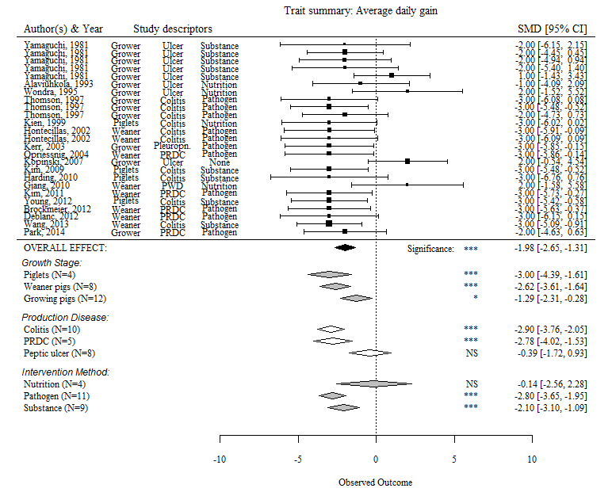
Figure S1
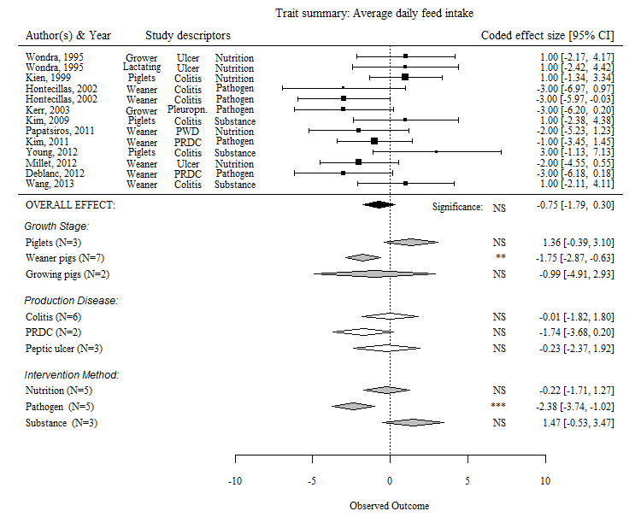
Figure S2
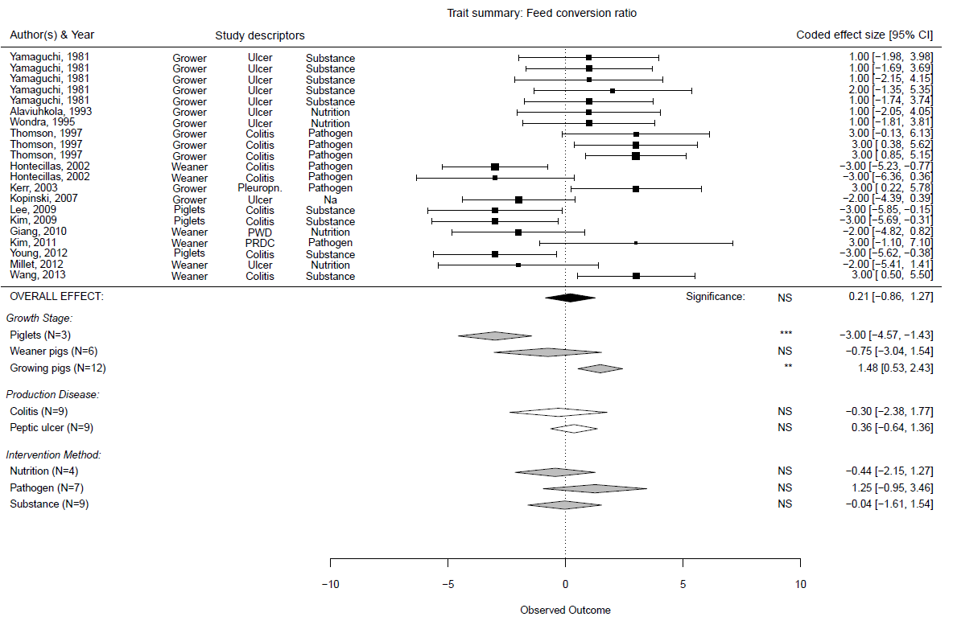
Figure S3

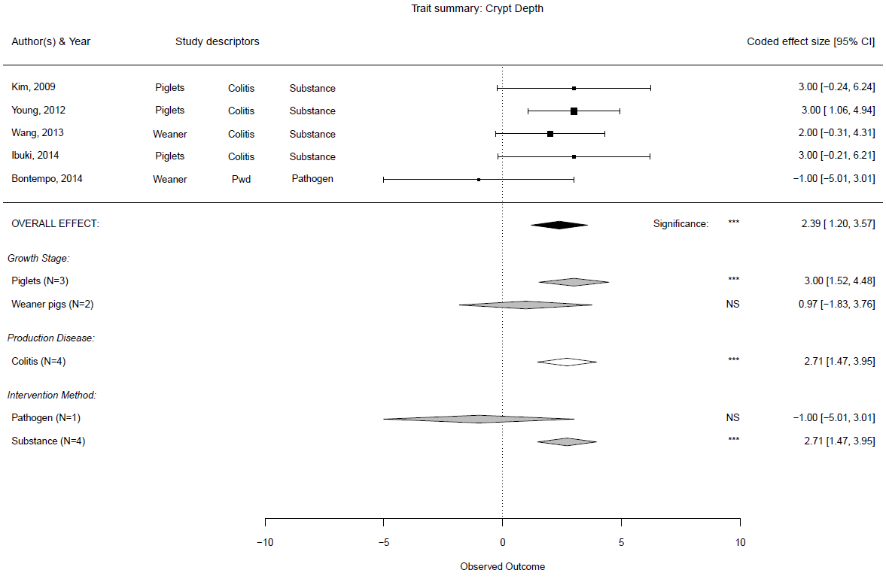
Figure S4

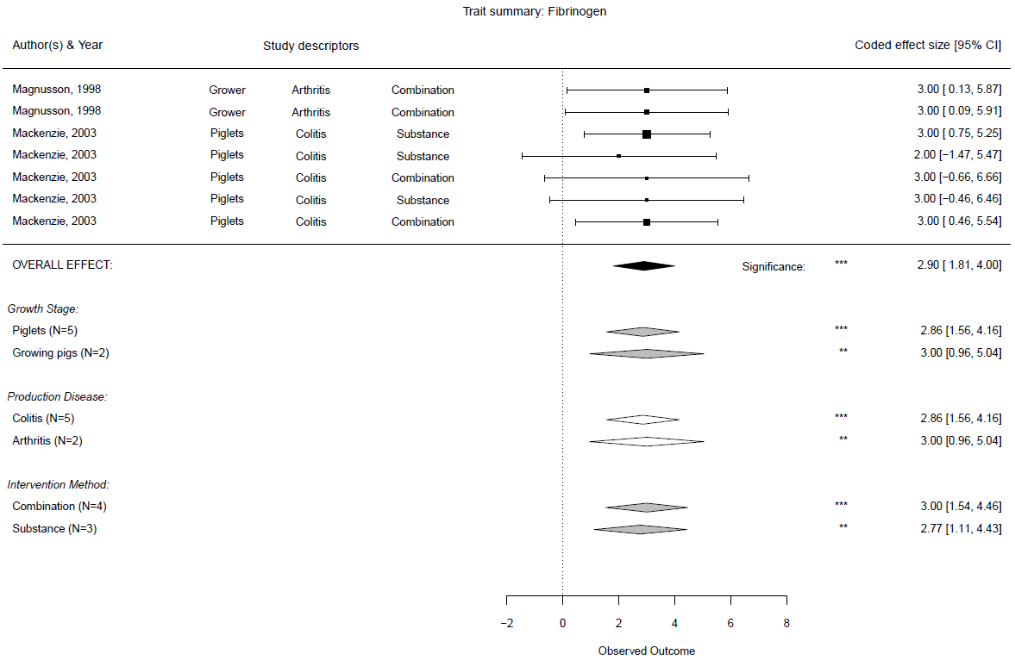
Figure S5

Figure S6
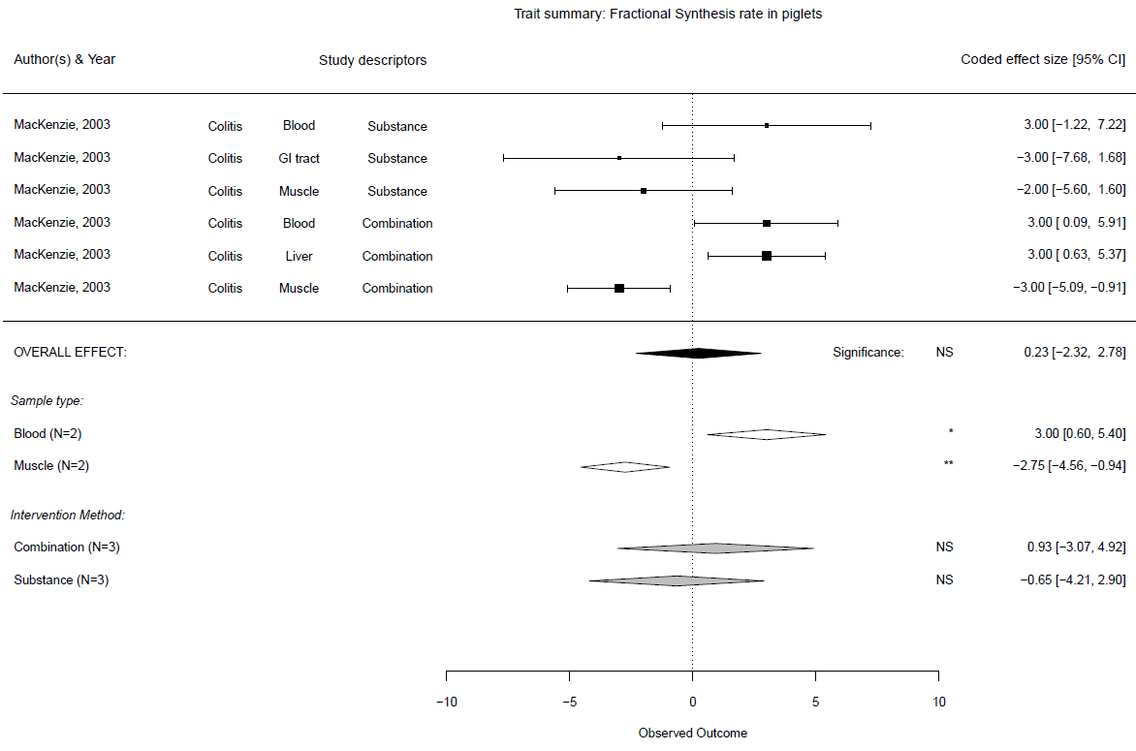

Figure S7
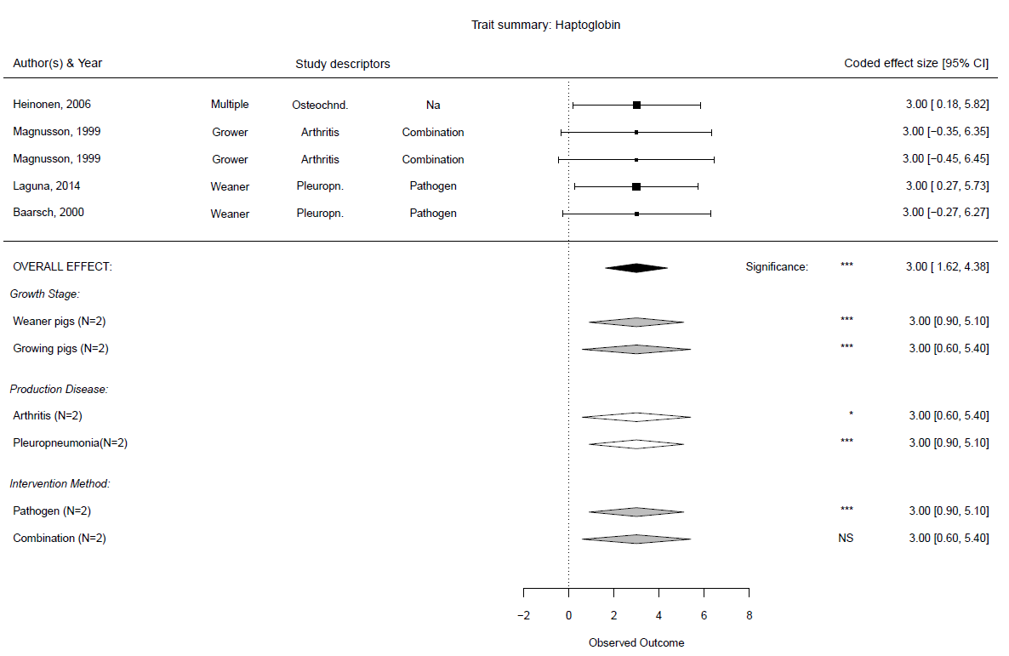

Figure S8
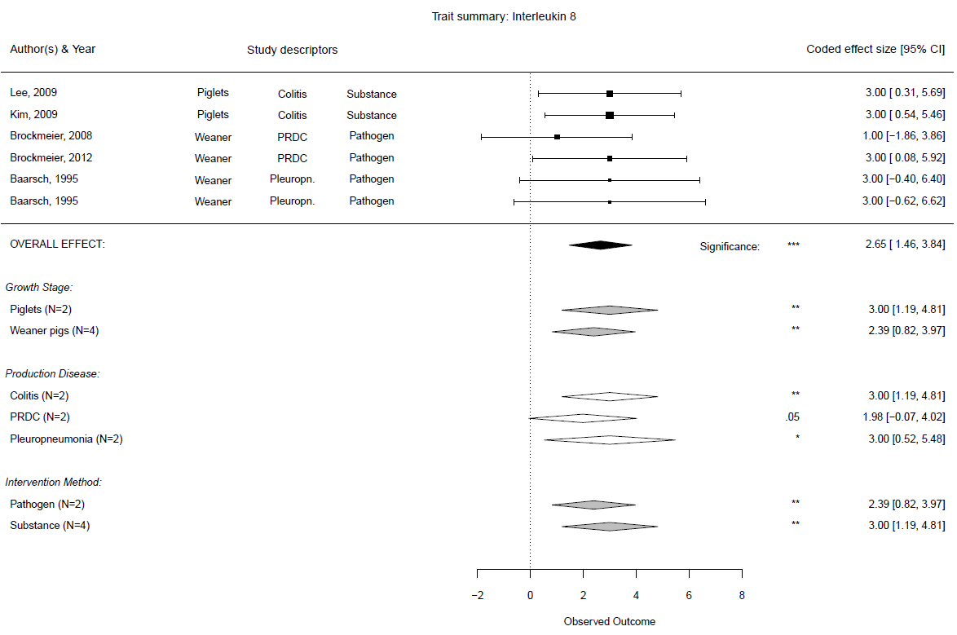

Figure S9
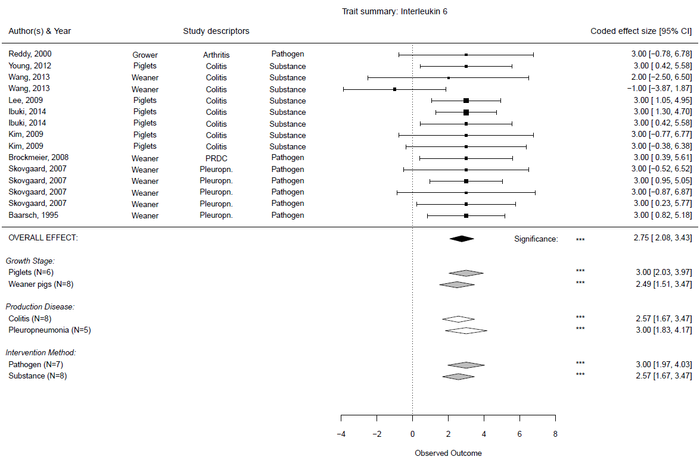

Figure S10
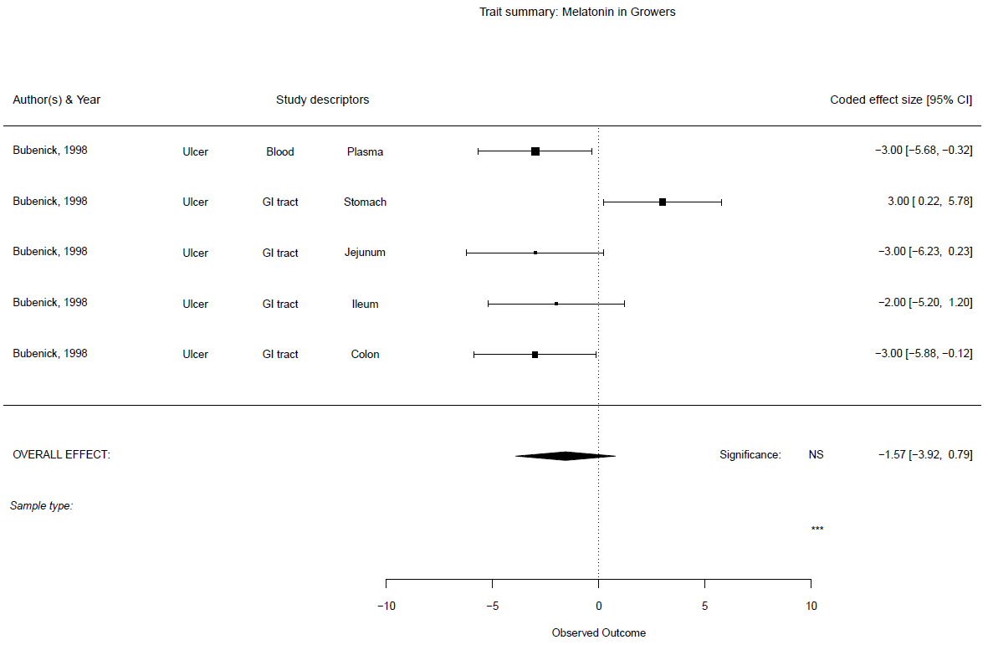

Figure S11
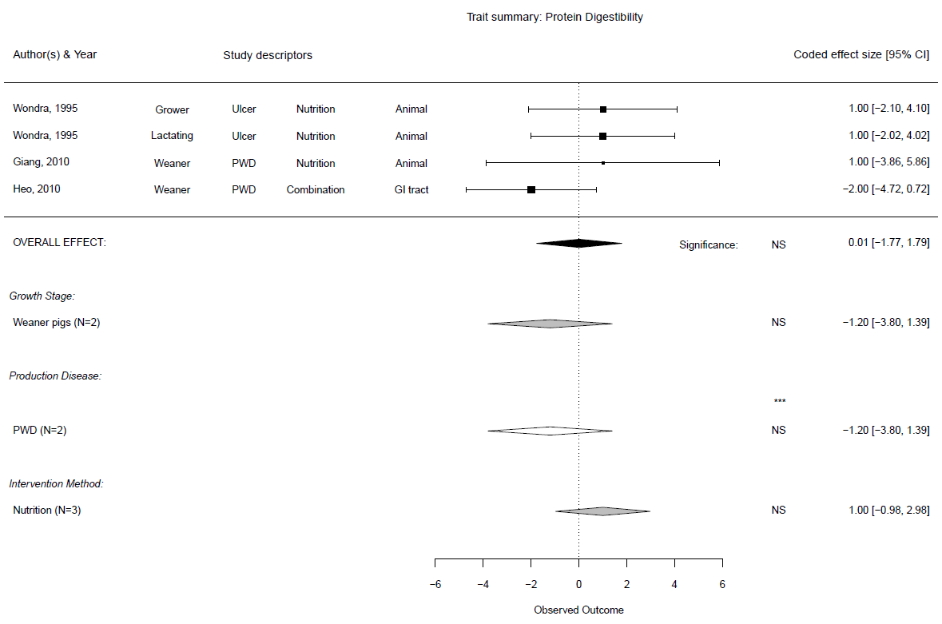

Figure S12
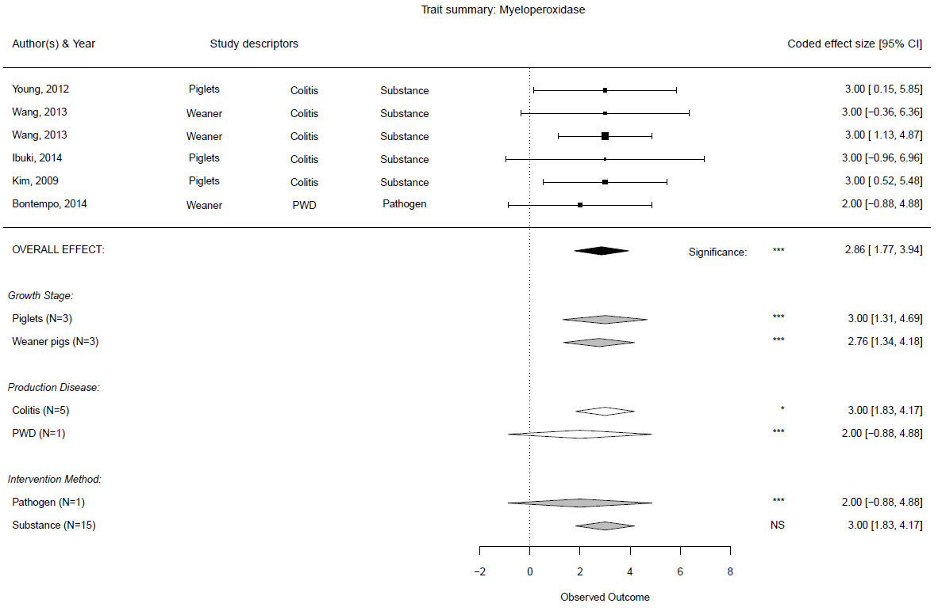

Figure S13
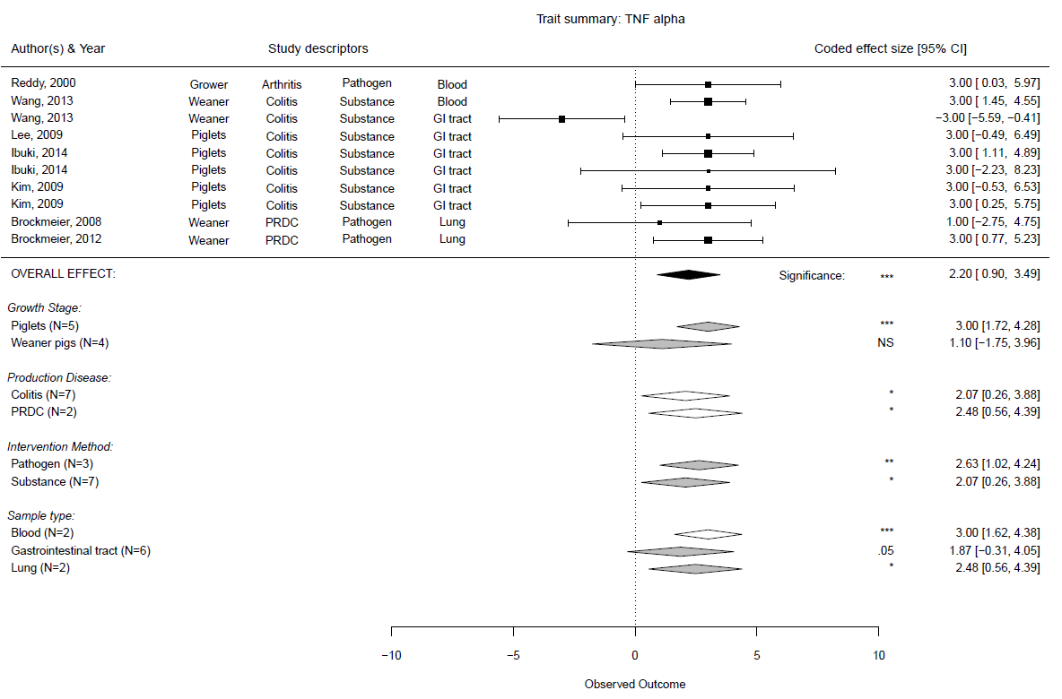

Figure S14
