Supplementary Material S1

LiGAPS-Beef, a mechanistic model to explore potential and feed-limited beef production 3. Model evaluation

A. van der Linden1,2, G.W.J. van de Ven2, S.J. Oosting1, M.K. van Ittersum2, and I.J.M. de Boer1

1 Animal Production Systems group , Wageningen University & Research, P.O. Box 338, 6700 AH Wageningen, The Netherlands
2 Plant Production Systems group, Wageningen University & Research, P.O. Box 430, 6700 AK Wageningen, The Netherlands

Corresponding author: Aart van der Linden. Email: aart.vanderlinden@wur.nl

animal journal
Contents
1. Beef production in Australia 1
1.1. Model calibration 2
1.2. Model evaluation 7
2. Beef production in Uruguay 31
2.1. Model calibration 31
2.2. Model evaluation 32
3. Beef production in the Netherlands 37
References 40

1. Beef production in Australia

Beef production in Austalia is based on experiments described in the papers of Petty et al. (1998), Petty and Poppi (2008 and 2012), Dixon and Coates (2008), Hill et al. (2009), and Evans and Hacker (1992). These experiments are numbered as experiments 1-6 in the main paper (Table 1). For information on the experiments, model calibration, and model evaluation, see the text and Table 1 in the main paper. The graphs below show total body weights (TBWs), feed intake, and the factors that define and limit growth over time, both for treatments used for model calibration (section 1.1) and for model evaluation (section 1.2). Simulated (sim.) and measured (meas.) average daily gain (ADG) are expressed in kg live weight per day in the figures.

1.1. Model calibration
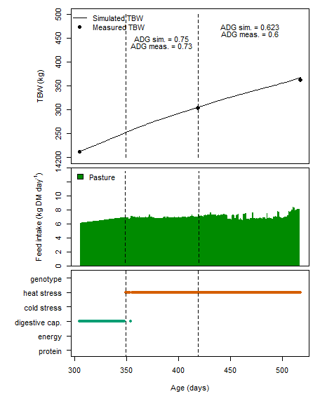
Figure S1. Total body weight (TBW), feed intake, and the defining and limiting factors for growth in experiment 1. This experiment with ¾ Brahman × ¼ Shorthorn cattle was conducted in Australia, as described by Petty et al. (1998). Cattle were grazing pastures. This simulation was used for calibration. The period up to 349 days is an adaptation period. The dry season is from day 350 up to day 419, and the wet season starts at day 420. ADG = average daily gain (kg live weight day⁻¹)

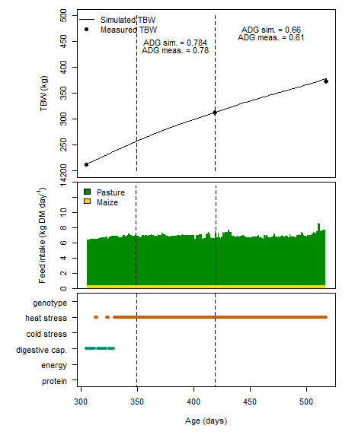
Figure S2. Total body weight (TBW), feed intake, and the defining and limiting factors for growth in experiment 1. This experiment with ¾ Brahman × ¼ Shorthorn cattle was conducted in Australia, as described by Petty et al. (1998). Cattle were grazing pastures and were supplemented with 0.5 kg fresh matter maize head⁻¹ day⁻¹. This simulation was used for calibration. The period up to 349 days is an adaptation period. The dry season is from day 350 up to day 419, and the wet season starts at day 420. ADG = average daily gain (kg live weight day⁻¹)
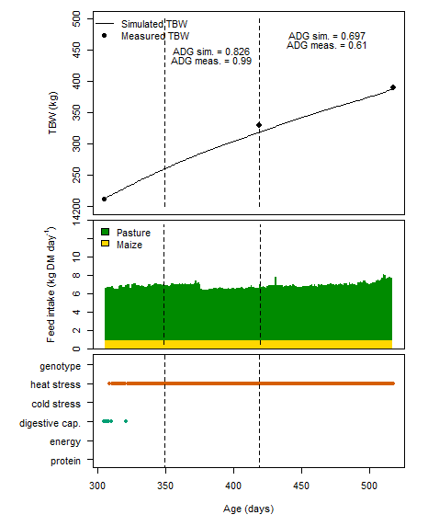
Figure S3. Total body weight (TBW), feed intake, and the defining and limiting factors for growth in experiment 1. This experiment with ¾ Brahman × ¼ Shorthorn cattle was conducted in Australia, as described by Petty et al. (1998). Cattle were grazing pastures and were supplemented with 1.0 kg fresh matter maize head⁻¹ day⁻¹. This simulation was used for calibration. The period up to 349 days is an adaptation period. The dry season is from day 350 up to day 419, and the wet season starts at day 420. ADG = average daily gain (kg live weight day⁻¹)

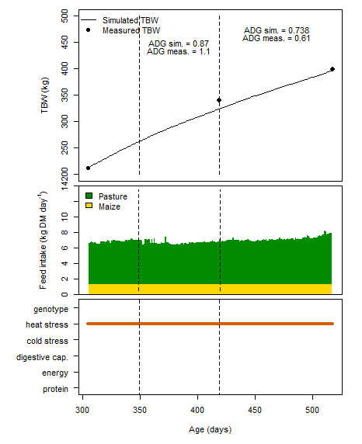
Figure S4. Total body weight (TBW), feed intake, and the defining and limiting factors for growth in experiment 1. This experiment with ¾ Brahman × ¼ Shorthorn cattle was conducted in Australia, as described by Petty et al. (1998). Cattle were grazing pastures and were supplemented with 1.5 kg fresh matter maize head⁻¹ day⁻¹. This simulation was used for calibration. The period up to 349 days is an adaptation period. The dry season is from day 350 up to day 419, and the wet season starts at day 420. ADG = average daily gain (kg live weight day⁻¹)

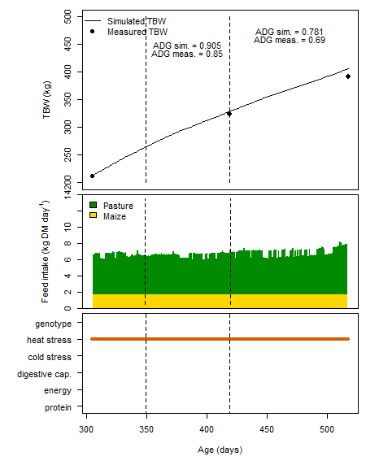
Figure S5. Total body weight (TBW), feed intake, and the defining and limiting factors for growth in experiment 1. This experiment with ¾ Brahman × ¼ Shorthorn cattle was conducted in Australia, as described by Petty et al. (1998). Cattle were grazing pastures and were supplemented with 2.0 kg fresh matter maize head⁻¹ day⁻¹. This simulation was used for calibration. The period up to 349 days is an adaptation period. The dry season is from day 350 up to day 419, and the wet season starts at day 420. ADG = average daily gain (kg live weight day⁻¹)

1.2. Model evaluation

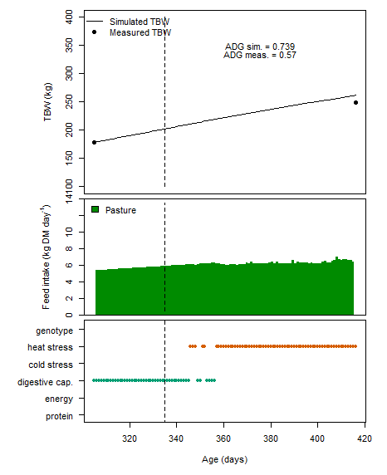
Figure S6. Total body weight (TBW), feed intake, and the defining and limiting factors for growth in experiment 2. This experiment with ¾ Brahman × ¼ Shorthorn cattle was conducted in Australia, as described by Petty and Poppi (2008). Cattle were grazing pastures. This simulation was used as independent data for model evaluation. The dashed line indicates the shift between the adaptation period (day 305-334) and the experiment (day 335-415). ADG = average daily gain (kg live weight day⁻¹)

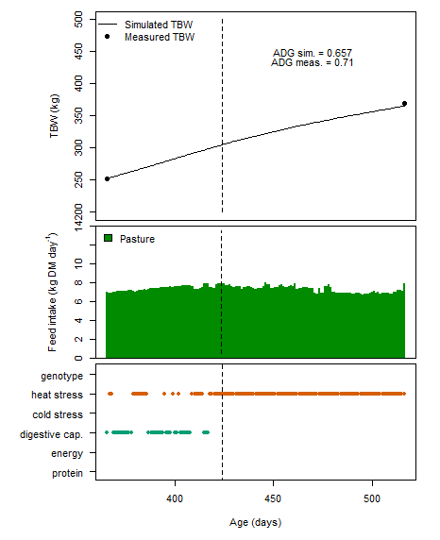
Figure S7. Total body weight (TBW), feed intake, and the defining and limiting factors for growth in experiment 3. This experiment with ¾ Brahman × ¼ Shorthorn cattle was conducted in Australia, as described by Petty and Poppi (2012). Cattle were grazing pastures. This simulation was used as independent data for model evaluation. The dashed line indicates the shift between the adaptation period (day 366-423) and the experiment (day 424-515). ADG = average daily gain (kg live weight day⁻¹)

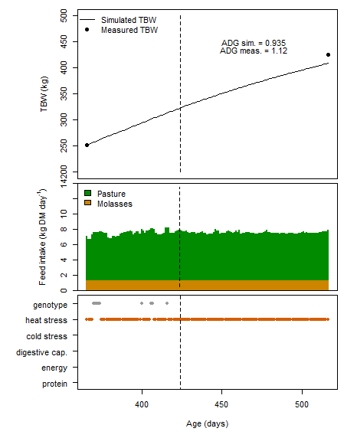
Figure S8. Total body weight (TBW), feed intake, and the defining and limiting factors for growth in experiment 3. This experiment with ¾ Brahman × ¼ Shorthorn cattle was conducted in Australia, as described by Petty and Poppi (2012). Cattle were grazing pastures and were supplemented with 1.25 kg molasses head⁻¹ day⁻¹. This simulation was used as independent data for model evaluation. The dashed line indicates the shift between the adaptation period (day 366-423) and the experiment (day 424-515). ADG = average daily gain (kg live weight day⁻¹)

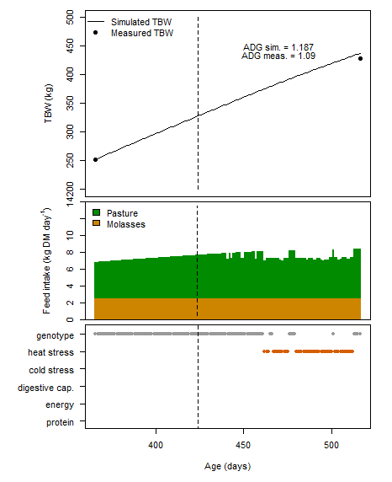
Figure S9. Total body weight (TBW), feed intake, and the defining and limiting factors for growth in experiment 3. This experiment with ¾ Brahman × ¼ Shorthorn cattle was conducted in Australia, as described by Petty and Poppi (2012). Cattle were grazing pastures and were supplemented with 2.50 kg molasses head⁻¹ day⁻¹. This simulation was used as independent data for model evaluation. The dashed line indicates the shift between the adaptation period (day 366-423) and the experiment (day 424-515). ADG = average daily gain (kg live weight day⁻¹)

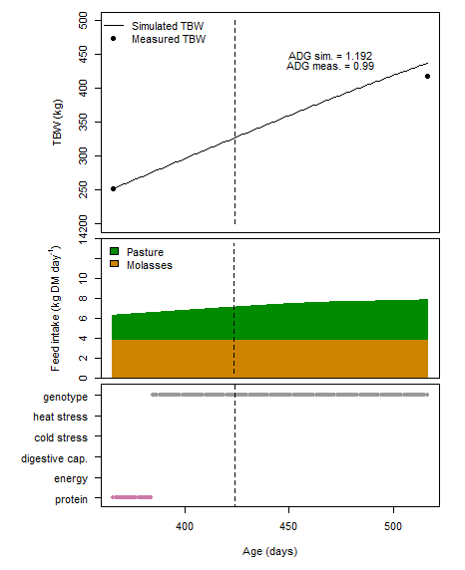
Figure S10. Total body weight (TBW), feed intake, and the defining and limiting factors for growth in experiment 3. This experiment with ¾ Brahman × ¼ Shorthorn cattle was conducted in Australia, as described by Petty and Poppi (2012). Cattle were grazing pastures and were supplemented with 3.75 kg molasses head⁻¹ day⁻¹. This simulation was used as independent data for model evaluation. The dashed line indicates the shift between the adaptation period (day 366-423) and the experiment (day 424-515). ADG = average daily gain (kg live weight day⁻¹)

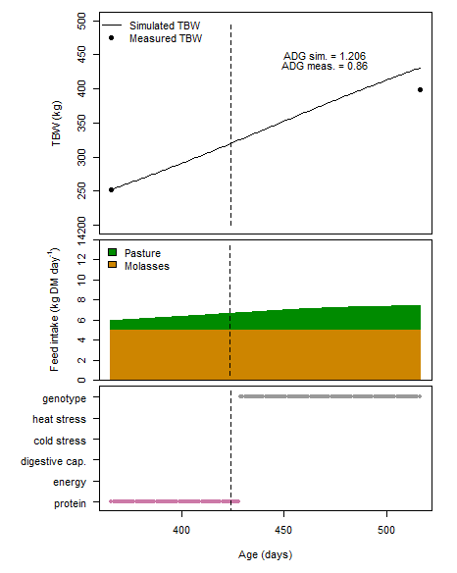
Figure S11. Total body weight (TBW), feed intake, and the defining and limiting factors for growth in experiment 3. This experiment with ¾ Brahman × ¼ Shorthorn cattle was conducted in Australia, as described by Petty and Poppi (2012). Cattle were grazing pastures and were supplemented with 5.00 kg molasses head⁻¹ day⁻¹. This simulation was used as independent data for model evaluation. The dashed line indicates the shift between the adaptation period (day 366-423) and the experiment (day 424-515). ADG = average daily gain (kg live weight day⁻¹)

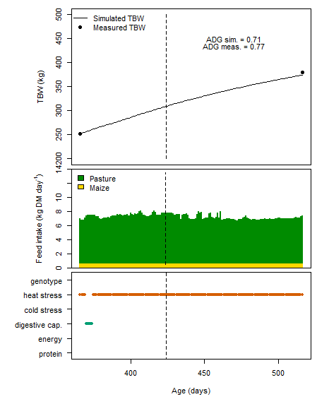
Figure S12. Total body weight (TBW), feed intake, and the defining and limiting factors for growth in experiment 3. This experiment with ¾ Brahman × ¼ Shorthorn cattle was conducted in Australia, as described by Petty and Poppi (2012). Cattle were grazing pastures and were supplemented with 0.75 kg fresh matter maize head⁻¹ day⁻¹. This simulation was used as independent data for model evaluation. The dashed line indicates the shift between the adaptation period (day 366-423) and the experiment (day 424-515). ADG = average daily gain (kg live weight day⁻¹)

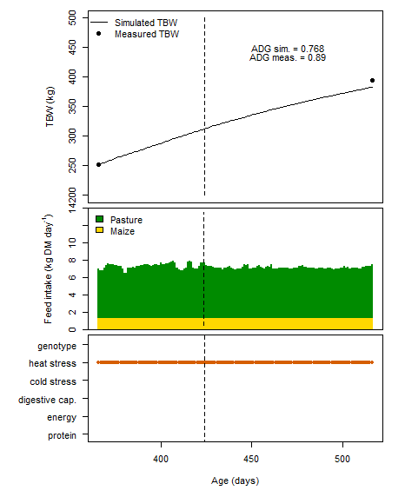
Figure S13. Total body weight (TBW), feed intake, and the defining and limiting factors for growth in experiment 3. This experiment with ¾ Brahman × ¼ Shorthorn cattle was conducted in Australia, as described by Petty and Poppi (2012). Cattle were grazing pastures and were supplemented with 1.50 kg fresh matter maize head⁻¹ day⁻¹. This simulation was used as independent data for model evaluation. The dashed line indicates the shift between the adaptation period (day 366-423) and the experiment (day 424-515). ADG = average daily gain (kg live weight day⁻¹)

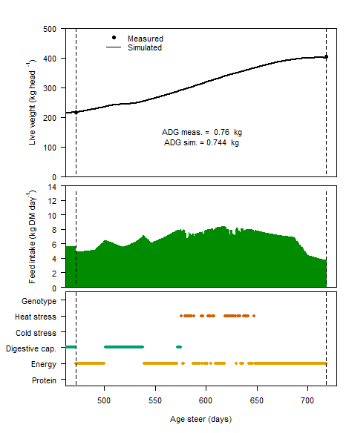
Figure S14. Live weight, feed intake, and the defining and limiting factors for growth in experiment 4. This experiment with crossbred B. indicus cattle was conducted in Australia, as described by Dixon and Coates (2008). Cattle were grazing pastures with leucaena (Leucaena leucocephala cv. Cunningham) and pangola (Digitaria eriantha cv. Steudel) in the year 2002-2003. This simulation was used as independent data for model evaluation. The dashed lines indicate the start (day 472) and end (day 718) of the experiment. ADG = average daily gain (kg live weight day⁻¹)
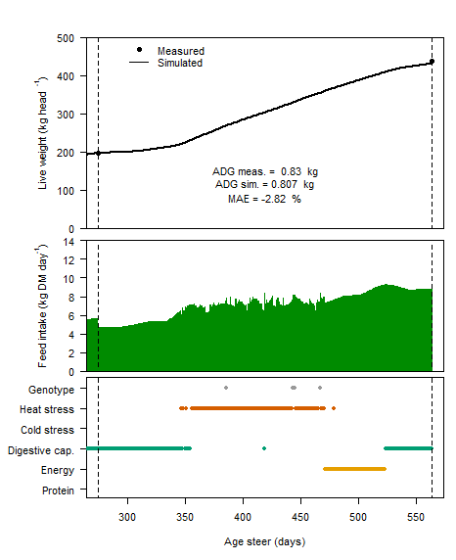
Figure S15. Live weight, feed intake, and the defining and limiting factors for growth in experiment 4. This experiment with crossbred B. indicus cattle was conducted in Australia, as described by Dixon and Coates (2008). Cattle were grazing pastures with leucaena (Leucaena leucocephala cv. Cunningham) and pangola (Digitaria eriantha cv. Steudel) in the year 2003-2004. This simulation was used as independent data for model evaluation. The dashed lines indicate the start (day 275) and end (day 564) of the experiment. ADG = average daily gain (kg live weight day⁻¹)
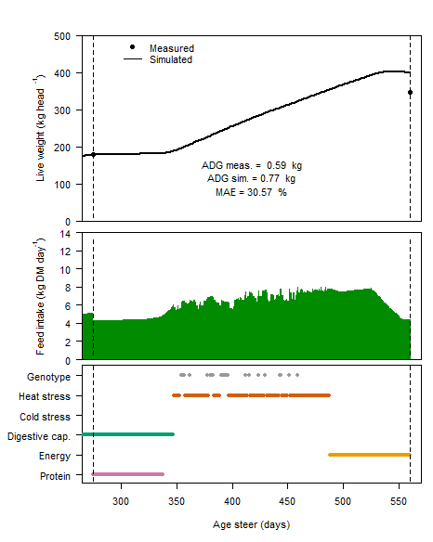
Figure S16. Live weight, feed intake, and the defining and limiting factors for growth in experiment 4. This experiment with crossbred B. indicus cattle was conducted in Australia, as described by Dixon and Coates (2008). Cattle were grazing pastures with leucaena (Leucaena leucocephala cv. Cunningham) and pangola (Digitaria eriantha cv. Steudel) in the year 2004-2005. This simulation was used as independent data for model evaluation. The dashed lines indicate the start (day 275) and end (day 560) of the experiment. ADG = average daily gain (kg live weight day⁻¹)
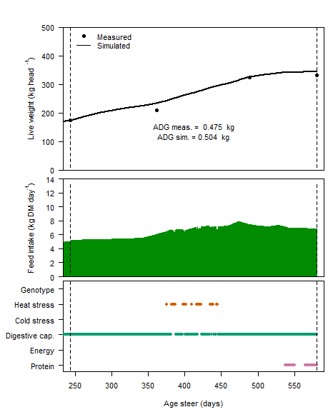
Figure S17. Live weight, feed intake, and the defining and limiting factors for growth in experiment 5. This experiment with crossbred Brahman cattle was conducted in Australia, as described by Hill et al. (2009). Cattle were grazing pastures without legumes in the year 2003-2004. This simulation was used as independent data for model evaluation. The dashed lines indicate the start (day 244) and end (day 580) of the experiment. ADG = average daily gain (kg live weight day⁻¹)
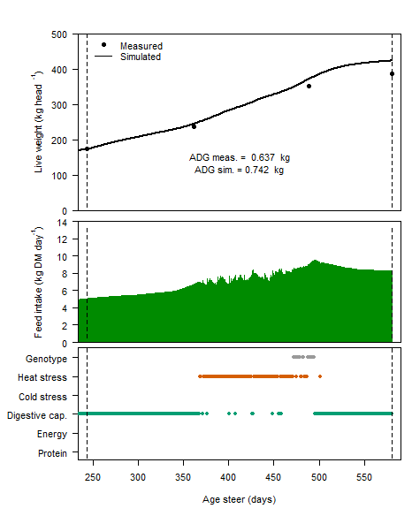
Figure S18. Live weight, feed intake, and the defining and limiting factors for growth in experiment 5. This experiment with crossbred Brahman cattle was conducted in Australia, as described by Hill et al. (2009). Cattle were grazing pastures with butterfly pea (Clitoria ternatea) in the year 2003-2004. This simulation was used as independent data for model evaluation. The dashed lines indicate the start (day 244) and end (day 580) of the experiment. ADG = average daily gain (kg live weight day⁻¹)
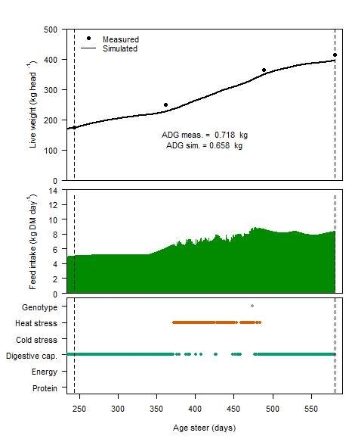
Figure S19. Live weight, feed intake, and the defining and limiting factors for growth in experiment 5. This experiment with crossbred Brahman cattle was conducted in Australia, as described by Hill et al. (2009). Cattle were grazing pastures with stylo (Stylosanthes seabrana) in the year 2003-2004. This simulation was used as independent data for model evaluation. The dashed lines indicate the start (day 244) and end (day 580) of the experiment. ADG = average daily gain (kg live weight day⁻¹)
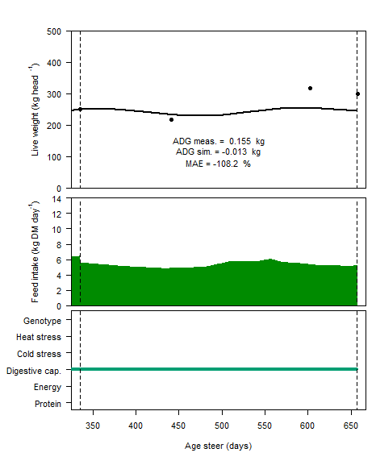
Figure S20. Live weight, feed intake, and the defining and limiting factors for growth in experiment 5. This experiment with crossbred Brahman cattle was conducted in Australia, as described by Hill et al. (2009). Cattle were grazing pastures without legumes in the year 2004-2005. This simulation was used as independent data for model evaluation. The dashed lines indicate the start (day 335) and end (day 657) of the experiment. ADG = average daily gain (kg live weight day⁻¹)
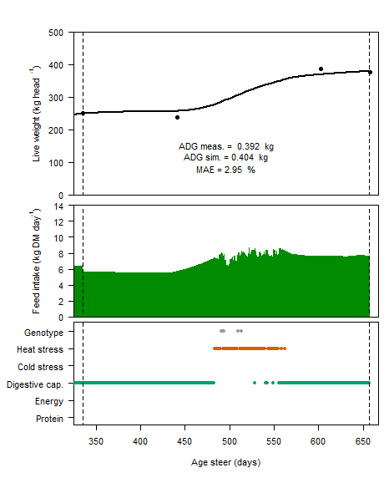
Figure S21. Live weight, feed intake, and the defining and limiting factors for growth in experiment 5. This experiment with crossbred Brahman cattle was conducted in Australia, as described by Hill et al. (2009). Cattle were grazing pastures with low amounts of butterfly pea (Clitoria ternatea) and Desmanthus virgatus in the year 2004-2005. This simulation was used as independent data for model evaluation. The dashed lines indicate the start (day 335) and end (day 657) of the experiment. ADG = average daily gain (kg live weight day⁻¹)
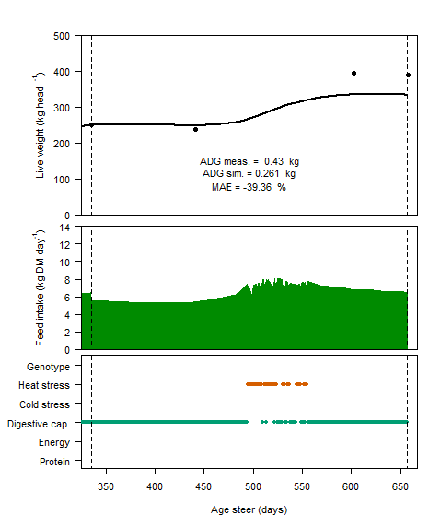
Figure S22. Live weight, feed intake, and the defining and limiting factors for growth in experiment 5. This experiment with crossbred Brahman cattle was conducted in Australia, as described by Hill et al. (2009). Cattle were grazing pastures with moderate amounts of butterfly pea (Clitoria ternatea) in the year 2004-2005. This simulation was used as independent data for model evaluation. The dashed lines indicate the start (day 335) and end (day 657) of the experiment. ADG = average daily gain (kg live weight day⁻¹)
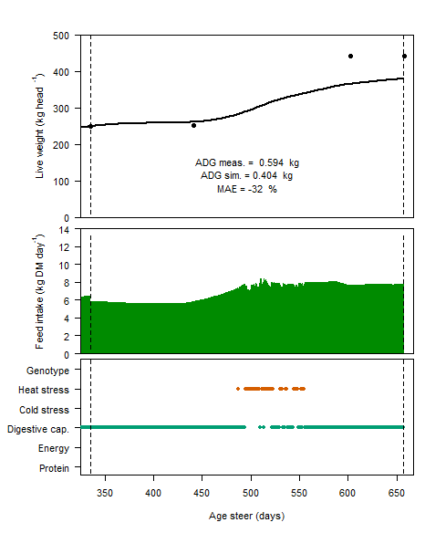
Figure S23. Live weight, feed intake, and the defining and limiting factors for growth in experiment 5. This experiment with crossbred Brahman cattle was conducted in Australia, as described by Hill et al. (2009). Cattle were grazing pastures with stylo (Stylosanthes seabrana) in the year 2004-2005. This simulation was used as independent data for model evaluation. The dashed lines indicate the start (day 335) and end (day 657) of the experiment. ADG = average daily gain (kg live weight day⁻¹)
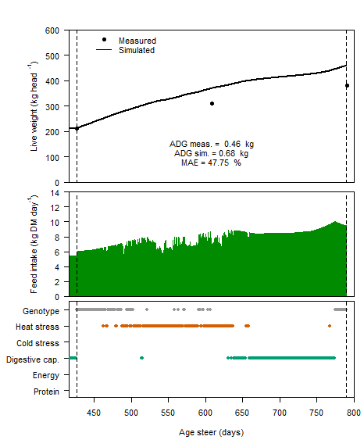
Figure S24. Live weight, feed intake, and the defining and limiting factors for growth in experiment 6. This experiment with Hereford cattle was conducted in Australia, as described by Evans and Hacker (1992). Cattle were grazing pastures with Splendida (Setaria phacelata var. splendida) in the year 1972-1973. This simulation was used as independent data for model evaluation. The dashed lines indicate the start (day 426) and end (day 790) of the experiment. ADG = average daily gain (kg live weight day⁻¹)
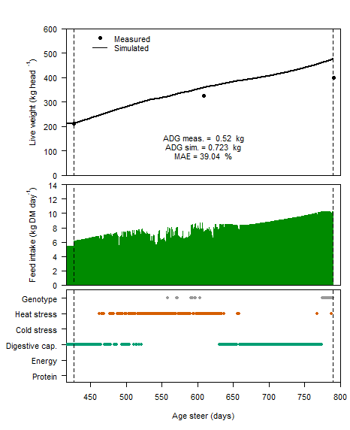
Figure S25. Live weight, feed intake, and the defining and limiting factors for growth in experiment 6. This experiment with Hereford cattle was conducted in Australia, as described by Evans and Hacker (1992). Cattle were grazing pastures with Nandi (Setaria phacelata var. serica cvv. Nandi) in the year 1972-1973. This simulation was used as independent data for model evaluation. The dashed lines indicate the start (day 426) and end (day 790) of the experiment. ADG = average daily gain (kg live weight day⁻¹)
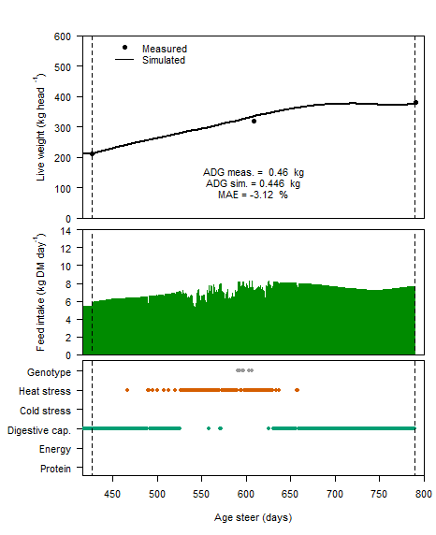
Figure S26. Live weight, feed intake, and the defining and limiting factors for growth in experiment 6. This experiment with Hereford cattle was conducted in Australia, as described by Evans and Hacker (1992). Cattle were grazing pastures with Kazungula (Setaria phacelata var. serica cvv. Kazungula) in the year 1972-1973. This simulation was used as independent data for model evaluation. The dashed lines indicate the start (day 426) and end (day 790) of the experiment. ADG = average daily gain (kg live weight day⁻¹)
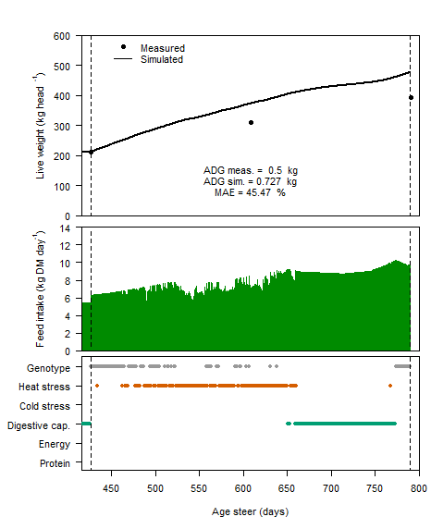
Figure S27. Live weight, feed intake, and the defining and limiting factors for growth in experiment 6. This experiment with Hereford cattle was conducted in Australia, as described by Evans and Hacker (1992). Cattle were grazing pastures with Narok (Setaria phacelata var. serica cvv. Narok) in the year 1972-1973. This simulation was used as independent data for model evaluation. The dashed lines indicate the start (day 426) and end (day 790) of the experiment. ADG = average daily gain (kg live weight day⁻¹)
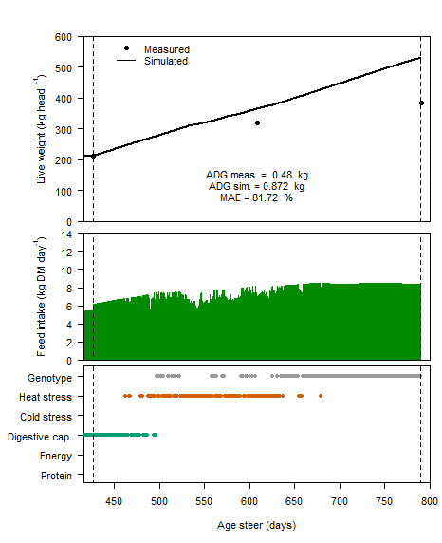
Figure S28. Live weight, feed intake, and the defining and limiting factors for growth in experiment 6. This experiment with Hereford cattle was conducted in Australia, as described by Evans and Hacker (1992). Cattle were grazing pastures with kikuyu grass (Pennisetum clandestinum cv. Whittet) in the year 1972-1973. This simulation was used as independent data for model evaluation. The dashed line indicates the start (day 426) and end (day 790) of the experiment. ADG = average daily gain (kg live weight day⁻¹)
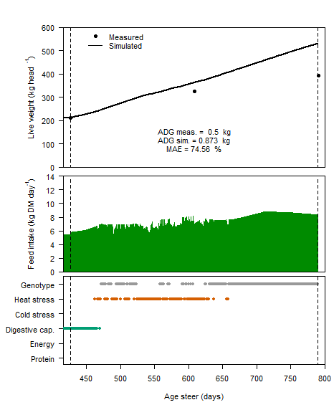
Figure S29. Live weight, feed intake, and the defining and limiting factors for growth in experiment 6. This experiment with Hereford cattle was conducted in Australia, as described by Evans and Hacker (1992). Cattle were grazing pastures with pangola grass (Digitaria eriantha ssp. pentzii) in the year 1972-1973. This simulation was used as independent data for model evaluation. The dashed lines indicate the start (day 426) and end (day 790) of the experiment. ADG = average daily gain (kg live weight day⁻¹)

2. Beef production in Uruguay

Beef production in Uruguay is based on the paper of Beretta et al. (2006), which corresponds to experiment 7. For an information on the experiments, model calibration, and model evaluation, see the text in the paper. The graphs below show the body weights, feed intake, and the factors that define and limit growth over time, both for model calibration (section 2.1) and model evaluation (section 2.2).

2.1. Model calibration

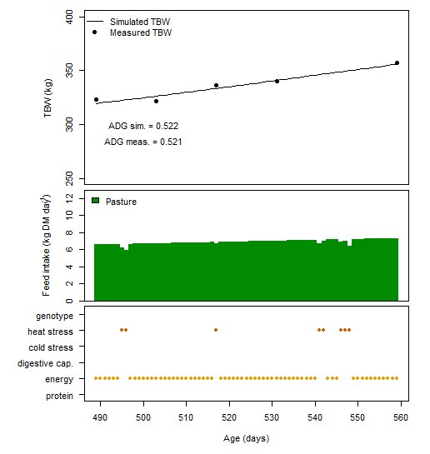
Figure S30. Total body weight (TBW), feed intake, and the defining and limiting factors for growth in experiment 7. This experiment with Hereford cattle was conducted in Uruguay, as described by Beretta et al. (2006). Cattle were grazing pastures (3 kg DM pasture per 100 kg total body weight). This simulation was used for calibration. ADG = average daily gain (kg live weight day⁻¹)

2.2. Model evaluation

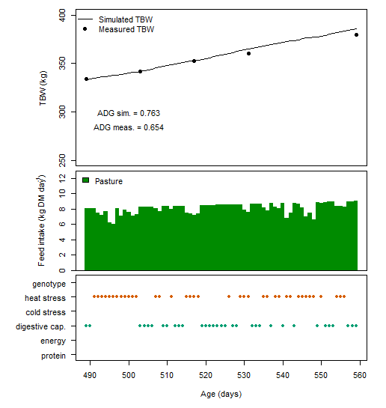
Figure S31. Total body weight (TBW), feed intake, and the defining and limiting factors for growth in experiment 7. This experiment with Hereford cattle was conducted in Uruguay, as described by Beretta et al. (2006). Cattle were grazing pastures (6 kg DM pasture per 100 kg total body weight). This simulation was used as independent data for model evaluation. ADG = average daily gain (kg live weight day⁻¹)
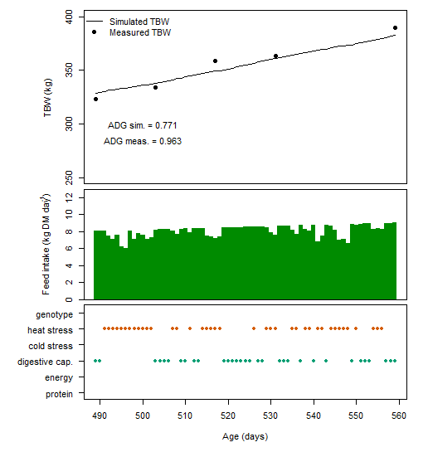
Figure S32. Total body weight (TBW), feed intake, and the defining and limiting factors for growth in experiment 7. This experiment with Hereford cattle was conducted in Uruguay, as described by Beretta et al. (2006). Cattle were grazing pastures (9 kg DM pasture per 100 kg total body weight). This simulation was used as independent data for model evaluation. ADG = average daily gain (kg live weight day⁻¹)
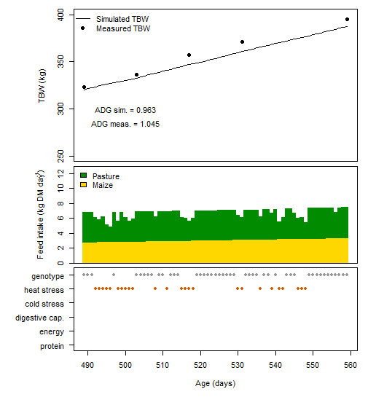
Figure S33. Total body weight (TBW), feed intake, and the defining and limiting factors for growth in experiment 7. This experiment with Hereford cattle was conducted in Uruguay, as described by Beretta et al. (2006). Cattle were grazing pastures (3 kg DM pasture and 1 kg fresh matter maize per 100 kg total body weight). This simulation was used as independent data for model evaluation. ADG = average daily gain (kg live weight day⁻¹)
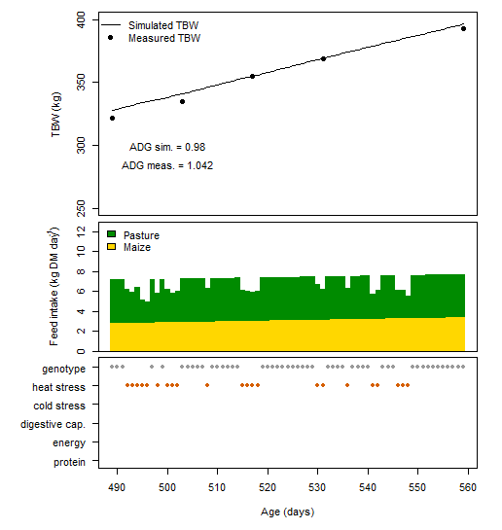
Figure S34. Total body weight (TBW), feed intake, and the defining and limiting factors for growth in experiment 7. This experiment with Hereford cattle was conducted in Uruguay, as described by Beretta et al. (2006). Cattle were grazing pastures (6 kg DM pasture and 1 kg fresh matter maize per 100 kg total body weight). This simulation was used as independent data for model evaluation. ADG = average daily gain (kg live weight day⁻¹)

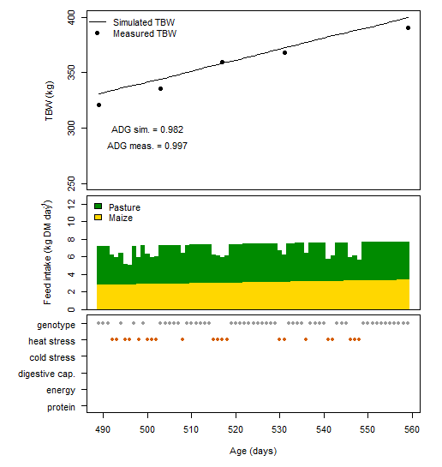
Figure S35. Total body weight (TBW), feed intake, and the defining and limiting factors for growth in experiment 7. This experiment with Hereford cattle was conducted in Uruguay, as described by Beretta et al. (2006). Cattle were grazing pastures (9 kg DM pasture and 1 kg fresh matter maize per 100 kg total body weight). This simulation was used as independent data for model evaluation. ADG = average daily gain (kg live weight day⁻¹)

3. Beef production in the Netherlands

Beef production in the Netherlands is based on the paper of Wallis de Vries (1996), which corresponds to experiment 8. For information on the experiments, model calibration, and model evaluation, see the text in the main paper. The graphs below show the total body weights (TBWs), feed intake, and the factors that define and limit growth over time, both for model calibration and model evaluation. For an explanation of the defining and limiting factors, see the text in the paper. The metabolisable energy (ME) content of feed was measured in the experiment of Wallis de Vries (1996).
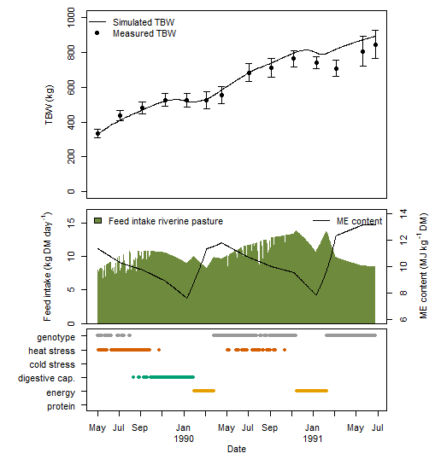
Figure S36. Total body weight (TBW), feed intake, and the defining and limiting factors for growth in experiment 8. This experiment with Meuse-Rhine-Yssel cattle was conducted in the Netherlands, as described by Wallis de Vries (1996). Cattle were grazing pastures in a riverine area. The model was calibrated for September 1989 (fourth TBW measurement). This simulation was partly used as independent data for model evaluation. Bars indicate confidence intervals. ME = metabolisable energy

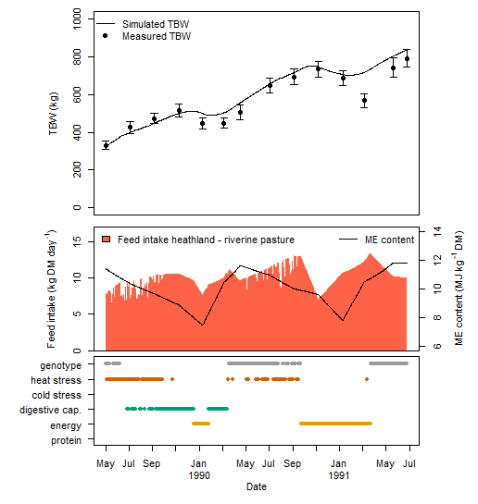
Figure S37. Total body weight (TBW), feed intake, and the defining and limiting factors for growth in experiment 8. This experiment with Meuse-Rhine-Yssel cattle was conducted in the Netherlands, as described by Wallis de Vries (1996). Cattle were grazing in an heathland area during winter, and in a riverine area with pasture during summer. This simulation was used as independent data for model evaluation. Bars indicate confidence intervals. ME = metabolisable energy

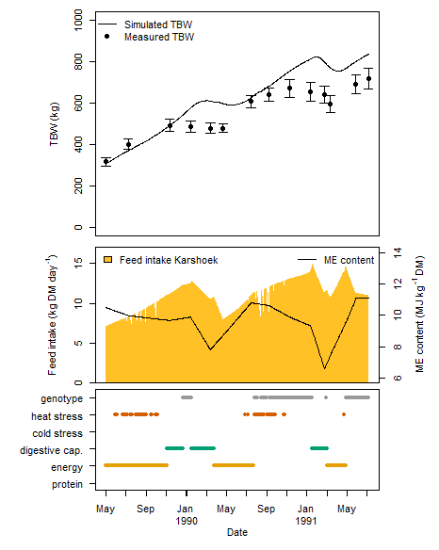
Figure S38. Total body weight (TBW), feed intake, and the defining and limiting factors for growth in experiment 8. This experiment with Meuse-Rhine-Yssel cattle was conducted in the Netherlands, as described by Wallis de Vries (1996). Cattle were grazing in an area with heathland and a riverine pasture connected to each other (Karshoek). This simulation was used as independent data for model evaluation. Bars indicate confidence intervals. ME = metabolisable energy

References

Beretta V, Simeone A, Elizalde JC and Baldi F 2006. Performance of growing cattle grazing moderate quality legume-grass temperate pastures when offered varying forage allowance with or without grain supplementation. Australian Journal of Experimental Agriculture 46, 793-797.
Dixon RM and Coates DB 2008. Diet quality and liveweight gain of steers grazing Leucaena-grass pasture estimated with faecal near infrared reflectance spectroscopy (F.NIRS). Australian Journal of Experimental Agriculture 48, 835-842.
Evans TR and Hacker JB 1992. An evaluation of the production potential of 6 tropical grasses under grazing. 2. Assessment of quality using variable stocking rates. Australian Journal of Experimental Agriculture 32, 29-37.
Hill JO, Coates DB, Whitbread AM, Clem RL, Robertson MJ and Pengelly BC 2009. Seasonal changes in pasture quality and diet selection and their relationship with liveweight gain of steers grazing tropical grass and grass-legume pastures in northern Australia. Animal Production Science 49, 983-993.
Petty SR and Poppi DP 2008. Effect of muddy conditions in the field on the liveweight gain of cattle consuming Leucaena leucocephala-Digitaria eriantha pastures in north-west Australia. Australian Journal of Experimental Agriculture 48, 818-820.
Petty SR and Poppi DP 2012. The liveweight gain response of heifers to supplements of molasses or maize while grazing irrigated Leucaena leucocephala / Digitaria eriantha pastures in north-west Australia. Animal Production Science 52, 619-623.
Petty SR, Poppi DP and Triglone T 1998. Effect of maize supplementation, seasonal temperature and humidity on the liveweight gain of steers grazing irrigated Leucaena leucocephala / Digitaria eriantha pastures in north-west Australia. Journal of Agricultural Science 130, 95-105.
Wallis de Vries MF 1996. Nutritional limitations of free-ranging cattle: The importance of habitat quality. Journal of Applied Ecology 33, 688-702.

