Layer Pullet Preference for Light Colors of Light-Emitting Diode (LED)
Guoming Li, Baoming Li, Yang Zhao, Zhengxiang Shi, Yu Liu, and Weichao Zheng

Supplementary material

Table S1 Irradiance and light intensities (human-perceived and chicken-perceived) for the light colors used during the preference test
Light units | White | Red | Green | Blue
Irradiance (watt·m⁻²) | 0.1±0.0 | 0.10±0.0 | 0.1±0.0 | 0.1±0.0
Human-perceived light intensity (lux) | 24.8±0.1 | 5.4±0.1 | 40.1±0.1 | 6.1±0.1
Chicken-perceived light intensity (clux) | 36.9±0.2 | 14.2±0.3 | 42.3±0.2 | 33.8±0.1

Table S2 Lighting and housing conditions of Jinfen layer pullets from 1 to 7 weeks of age
Age |  | Lighting schedule (L:D) | Light intensity (lux) | Temperature (°C) | Relative humidity (%)
Days of age | 1-3 | 24L:0D | 60 | 36 | 60
 | 4-7 | 22L:2D | 30 | 34 | 58
Weeks of age | 2 | 20L:4D | 30 | 32 | 58
 | 3 | 18L:6D | 30 | 30 | 58
 | 4 | 16L:8D | 30 | 28 | 58
 | 5 | 14L:10D | 30 | 26 | 58
 | 6 | 12L:12D | 30 | 24 | 58
 | 7 | 12L:12D | 30 | 22 | 58

Table S3 Light colors assigned to different compartments during the acclimation period
Day of age | C1 | C2 | C3 | C4
50 | White | Red | Blue | Green
51 | Red | White | Green | Blue
52 | Blue | Green | White | Red
53 | Green | Blue | Red | White
C1-C4 in the table mean the numbers of compartment in the LPTS.

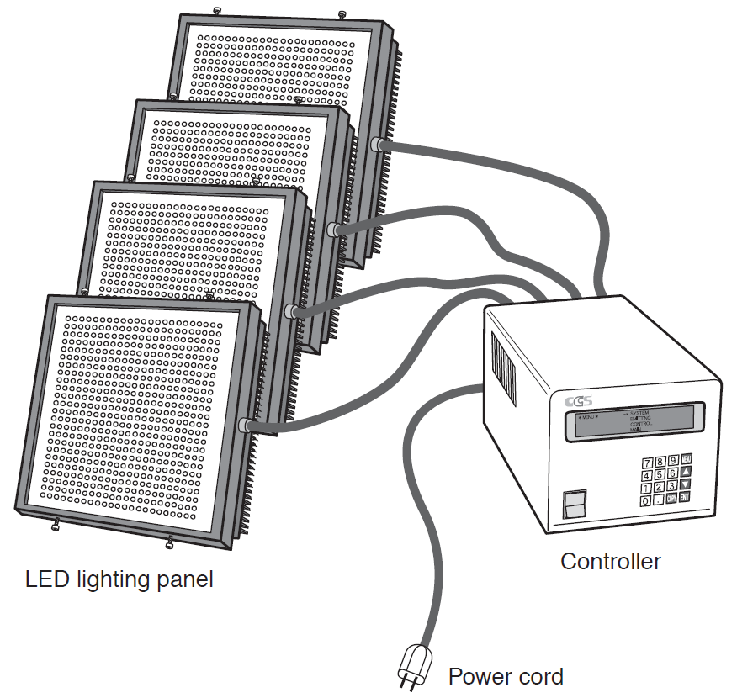
Figure S1 Schematic drawing of light-emitting diode (LED) lighting control system

Material S1 GLM procedure and model description
A two-way generalized linear model (GLM) procedure was introduced to analyze the light colors effect, compartment effect and their interaction on behavioral responses during the preference test. The model is defined as
$$Y_{ijk}=μ+α_{i}+β_{j}+{αβ}_{ij}+ε_{ijk}$$
Where
$Y_{ijk}$ is the measured behavioural responses during the preference test
$μ$ is the overall mean
$α_{i}$ is the main effect of light colors, $i=1, 2, 3, 4$
$β_{j}$ is the main effect of compartment, $j=1, 2, 3, 4$
${αβ}_{ij}$ is the interaction effect of light colors and compartment
$ε_{ijk}$ is the random error for the model

Material S2 SAS code for daily time spent (DTS) in data analysis
PROC IMPORT OUT= WORK.Dailytimespent
DATAFILE= "path of data file"
DBMS=EXCEL REPLACE;
RANGE="DTS$";
GETNAMES=YES;
MIXED=NO;
SCANTEXT=YES;
USEDATE=YES;
SCANTIME=YES;
RUN;
PROC GLM DATA=Dailytimespent;
CLASS color compartment;
MODEL DTS=color compartment color*compartment;
MEANS color compartment color*compartment/TUKEY CLDIFF;
RUN;
PROC MEANS DATA=Dailytimespent MEAN STDERR;
CLASS color;
RUN;

