Animal Journal
Follicular development of sows at weaning in relation to estimated breeding value for within-litter variation in piglet birth weight
N. G. J. Costermans1,2, K. J. Teerds1, J. Keijer1, E. F. Knol³ , R. E. Koopmanschap², B. Kemp2, N. M. Soede².

1 Human and Animal Physiology, Wageningen University and Research, De Elst 1, 6708WD, Wageningen, The Netherlands
2 Adaptation Physiology Group, Wageningen University and Research, De Elst 1, 6708WD, Wageningen, The Netherlands
3 Topigs Norsvin Research Center B. V.,Schoenaker 6, 6641 SZ, Beuningen, The Netherlands

Corresponding author: Natasja Costermans. Email: natasja.costermans@wur.nl

Short title: Follicular development and birth weight variation

 | EBV |  | PAR |  | RMSE | P-values¹
Parameter | High | Low | 3 | 4 + 5 |  | EBV | PAR
Right ovary
Av. follicle size (mm) | 5.11 | 5.00 | 5.22 | 4.89 | 0.74 | 0.70 | 0.24
Av. follicle size 1-5 (mm)² | 6.21 | 6.04 | 6.34 | 5.92 | 0.78 | 0.59 | 0.18
Av. follicle size 6-10 (mm)² | 4.93 | 4.84 | 5.06 | 4.72 | 0.79 | 0.77 | 0.29
Av. follicle size 11-15 (mm)² | 4.17 | 4.10 | 4.28 | 4.00 | 0.78 | 0.81 | 0.37
Variation (SD) in follicle size (mm) | 1.01 | 0.93 | 1.03 | 0.92 | 0.27 | 0.41 | 0.30
Av. follicle size of 10 largest healthy follicles (mm) | 5.18 | 5.06 | 5.27 | 4.97 | 0.83 | 0.73 | 0.39
Healthy follicles (%) | 64.8 | 66.0 | 67.8 | 66.6 | 17.9 | 0.73 | 0.87
Left ovary
Healthy COCs (%) | 71.6 | 73.2 | 76.8 | 67.9 | 21 | 0.85 | 0.32
Follicular fluid (µl) | 375 | 367 | 421 | 321 | 149 | 0.89 | 0.10
Supplemental Table S1 Effects of estimated breeding value classes for within-litter variation in piglet birth weight (estimated breeding value (EBV); High vs. Low) and parity classes (PAR; 3 vs. 4+5) on follicular parameters of the 15 largest follicles of the left and right ovary and average follicle size of the 10 largest healthy follicles in sows. All values are presented as LS means.
COCs = cumulus-oocyte complexes.
¹Interactions between EBV and parity were never significant.
²Average follicle size of the largest follicles (follicles 1-5), medium-sized follicles (follicles 6-10) and smallest follicles (follicles 11-15) of the 15 largest follicles.

Supplemental Table S2 Effects of average sow follicle size classes (FS; Small <5.0 mm (N=15) vs. Large>5.1 mm (N=14)) and parity classes (PAR; 3 (N=14) vs. 4+5 (N=15)) on follicular parameters of the 15 largest follicles of the left and right ovary. All values are presented as LS means.
 | FS |  | PAR |  | RMSE | P-values¹
Parameter | Small | Large | 3 | 4 + 5 |  | FS | PAR
Right ovary
Average follicle size (mm) | 4.43 | 5.62 | 5.07 | 4.98 | 0.41 | <0.001 | 0.59
Average follicle size 1-5 (mm)² | 5.49 | 6.70 | 6.19 | 6.01 | 0.48 | <0.001 | 0.34
Average follicle size 6-10 (mm)² | 4.22 | 5.50 | 4.89 | 4.84 | 0.44 | <0.001 | 0.77
Average follicle size 11-15 (mm)² | 3.56 | 4.67 | 4.13 | 4.10 | 0.54 | <0.001 | 0.88
Variation (SD) in follicle size (mm) | 0.94 | 1.00 | 1.03 | 0.91 | 0.27 | 0.56 | 0.24
Av. follicle size of 10 largest healthy follicles (mm) | 4.36 | 5.71 | 5.02 | 5.05 | 0.48 | <0.001 | 0.87
Healthy follicles (%) | 61.3 | 72.5 | 66.5 | 67.3 | 16.9 | 0.10 | 0.90
Left ovary
Healthy COCs (%) | 75.7 | 69.6 | 77.7 | 67.6 | 21 | 0.47 | 0.24
Follicular fluid (µl) | 334 | 405 | 412 | 327 | 145 | 0.21 | 0.14
COCs = cumulus-oocyte complexes.
¹Interactions between FS and PAR were never significant.
²Average follicle size of the largest follicles (follicles 1-5), medium-sized follicles (follicles 6-10) and smallest follicles (follicles 11-15) of the 15 largest follicles.

 | VARFS |  | PAR |  | RMSE | P-values¹
Parameter | Small | Large | 3 | 4 + 5 |  | VARFS | PAR
Right ovary
Average follicle size (mm) | 5.02 | 5.07 | 5.23 | 4.87 | 0.74 | 0.86 | 0.21
Average follicle size 1-5 (mm)² | 5.84 | 6.38 | 6.28 | 5.94 | 0.73 | 0.07 | 0.23
Average follicle size 6-10 (mm)² | 4.87 | 4.91 | 5.07 | 4.71 | 0.79 | 0.91 | 0.25
Average follicle size 11-15 (mm)² | 4.36 | 3.93 | 4.34 | 3.95 | 0.75 | 0.15 | 0.17
Variation (SD) in follicle size (mm) | 0.74 | 1.18 | 0.98 | 0.95 | 0.15 | <0.001 | 0.60
Av. follicle size of 10 largest healthy follicles (mm) | 5.18 | 5.06 | 5.29 | 4.95 | 0.8 | 0.70 | 0.30
Healthy follicles (%) | 72.5 | 62.2 | 69.6 | 65.2 | 17.1 | 0.13 | 0.51
Left ovary
Healthy COCs (%) | 67.1 | 76.7 | 74.7 | 69.2 | 21 | 0.26 | 0.51
Follicular fluid (µl) | 336 | 404 | 412 | 327 | 145 | 0.23 | 0.14
Supplemental Table S3 Effects of average sow variation (SD) in follicle size classes (VARFS; Small <0.09 mm (N=14) vs. Large>0.09 mm (N=15)) and parity classes (PAR; 3 (N=14) vs. 4+5 (N=15)) on follicular parameters of the 15 largest follicles of the left and right ovary. All values are presented as LS means.
COCs = cumulus-oocyte complexes.
¹Interactions between VARFS and PAR were never significant.
²Average follicle size of the largest follicles (follicles 1-5), medium-sized follicles (follicles 6-10) and smallest follicles (follicles 11-15) of the 15 largest follicles.

A
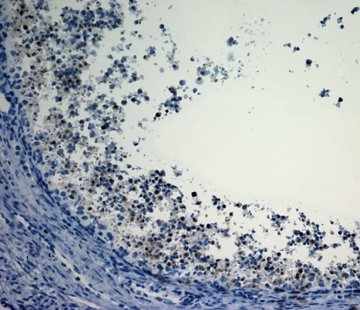
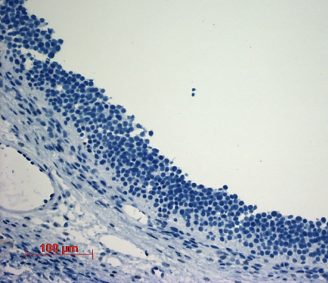
B

Supplemental Figure S1 Immunostaining for cleaved-caspase 3 as a marker of cells in apoptosis and used to determine percentage healthy follicles in sows. Representative staining of A healthy and B unhealthy follicles under 20x magnification (insert 40 x magnification) using light microscopy (Axioskop 2, Carl Zeiss Microscopy, Thornwood, NY, US) and imaged using imaging software (Axiovision 4.8, Carl Ziess Microscopy).
A

Supplemental Figure S2 Regression equation (β) for the relation between backfat thickness at parturition (mm) and backfat loss during lactation (mm). No interactions with parity class (PAR) have been found.
A

