Animal journal

Supplementary file

Consistency is key: interactions of current and previous farrowing system on litter size and piglet mortality
R.L. King¹, E.M. Baxter², S.M. Matheson¹ and S.A. Edwards¹

Supplementary Methods
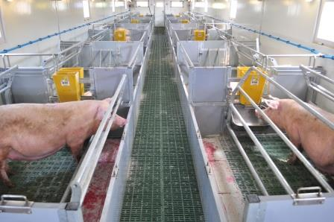

Figure S1. Sow temporary confinement 360s illustrating the crates in both the open (left) and closed (right) position (image courtesy of EM Baxter).

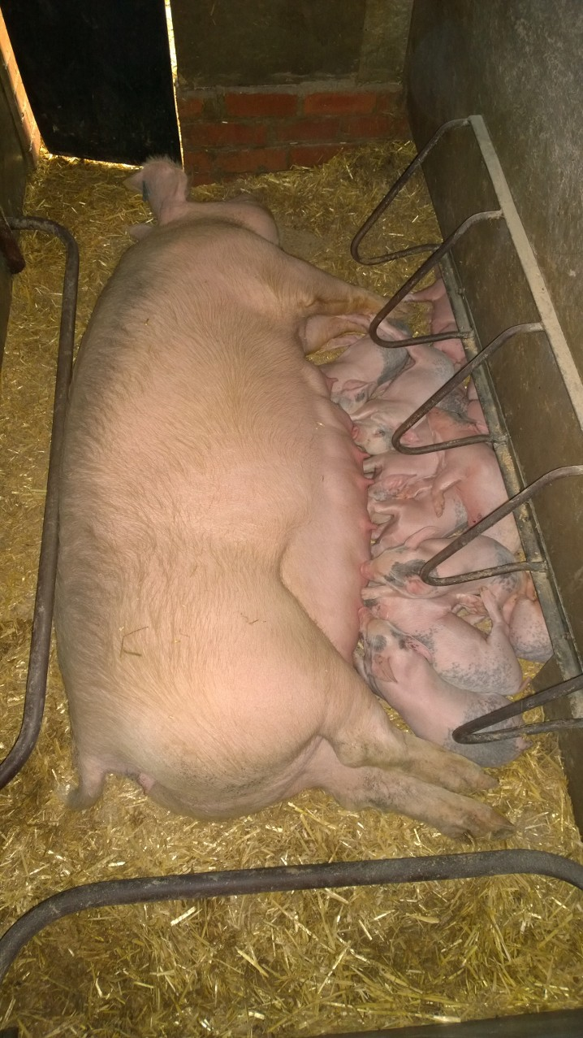
Figure S2. Indoor nest area of straw-based sow farrowing pen, with creep located to the right (image courtesy of RL King).

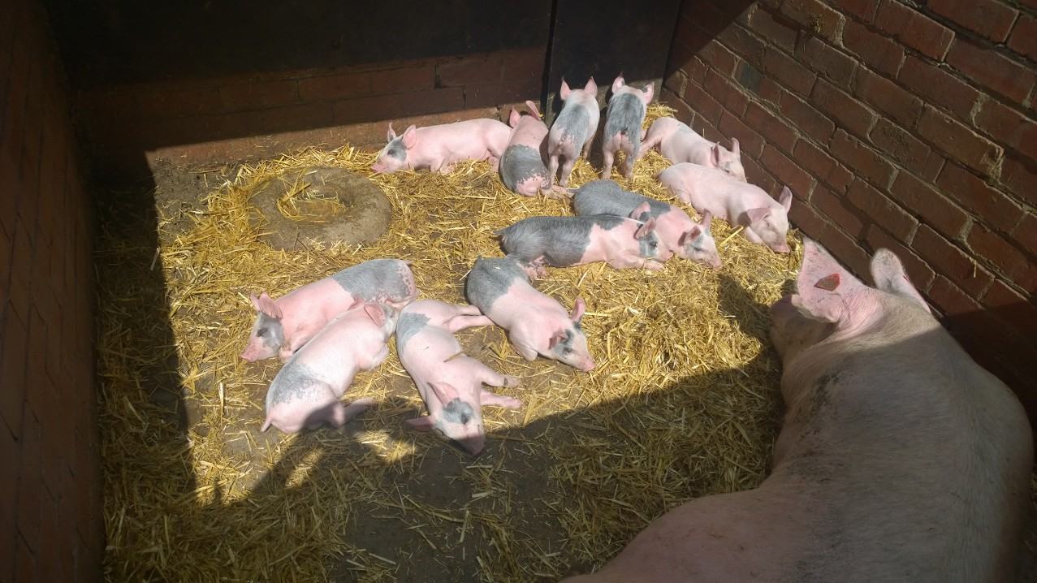
Figure S3. Outdoor dunging area of straw-based sow farrowing pen, including drinking water source (raised circle; image courtesy of RL King).

