Evaluation of reference lactation length in Chios dairy sheep
Z. Basdagianni1*, E. Sinapis¹ and G. Banos2,3

¹ School of Agriculture, Department of Animal production, Aristotle University of Thessaloniki, 54124 Thessaloniki, Greece
² School of Veterinary Medicine, Department of Animal Production, Ichthyology, Ecology and Environmental Protection,
Aristotle University of Thessaloniki, 54124 Thessaloniki, Greece
³ Scotland’s Rural College and The Roslin Institute, University of Edinburgh, Easter Bush, Midlothian EH25 9RG, UK

Corresponding author: Zoitsa Basdagianni. E-mail: basdagianni@agro.auth.gr

Supplementary materials
Results shown pertain to the animal model

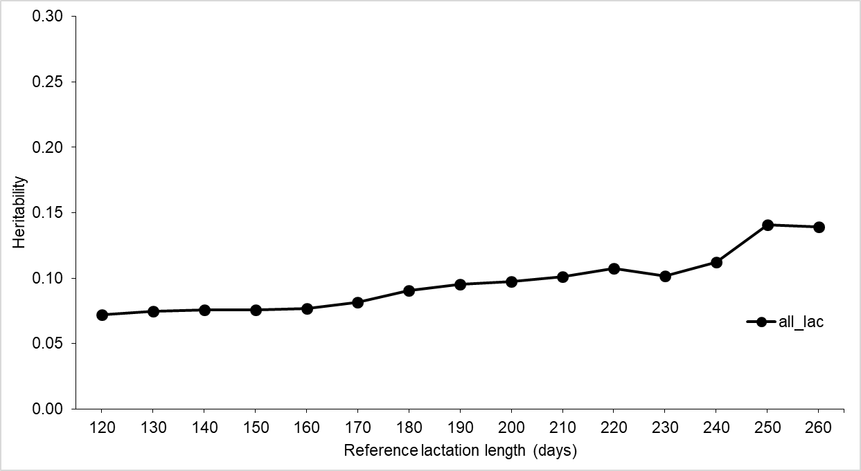
Supplementary Figure S1 Heritability estimates of milk yield in different reference lactation lengths in Chios dairy sheep; standard errors range from 0.01 to 0.06 for all lactations.

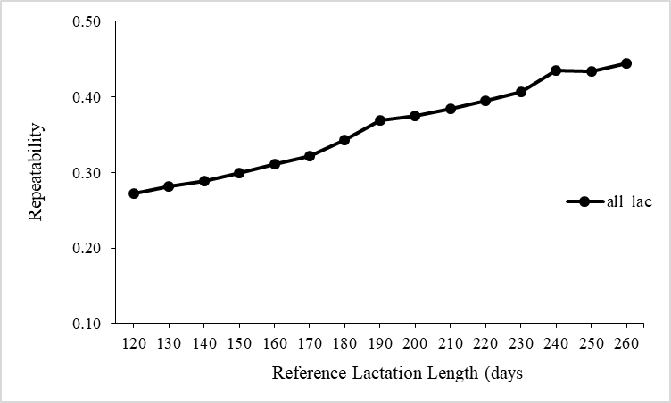
Supplementary Figure S2 Repeatability estimates of milk yield in different reference lactation lengths in Chios dairy sheep; standard errors range from 0.01 to 0.03 for all lactations.

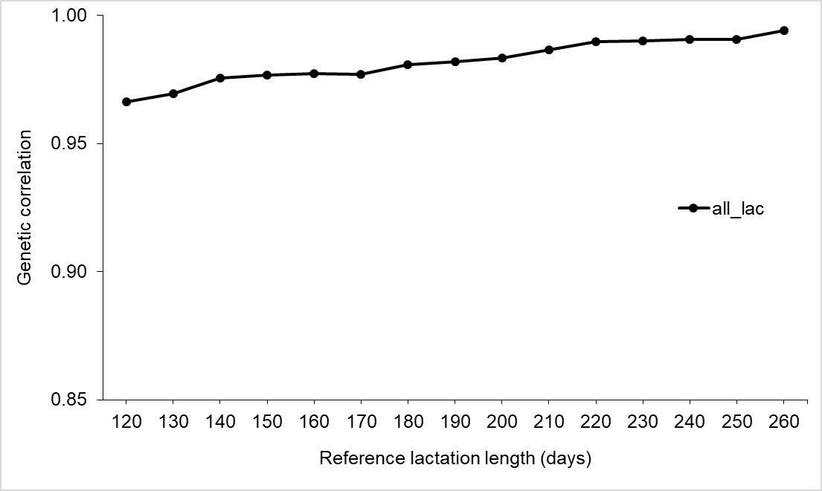
Supplementary Figure S3 Genetic correlation estimates between milk yield in different reference lactation lengths and actual lactation yield in Chios dairy sheep; standard errors range from 0.00 to 0.01 for all lactations.

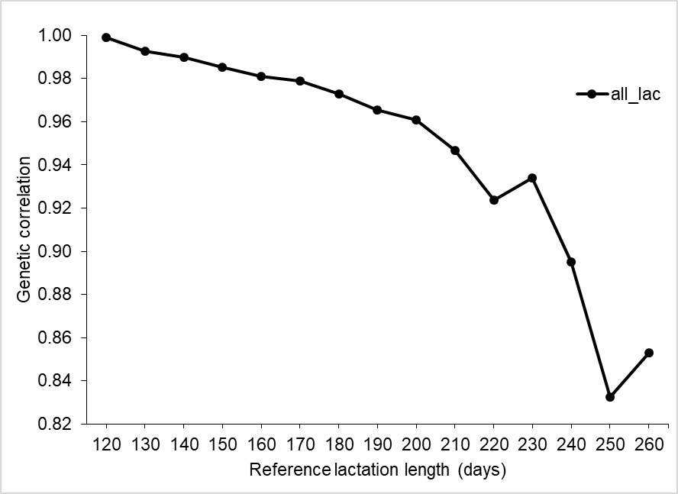
Supplementary Figure S4 Genetic correlation estimates between milk yield in different reference lactation lengths and first test-day record milk yield in Chios dairy sheep; standard errors range from 0.01 to 0.10 for all lactations.

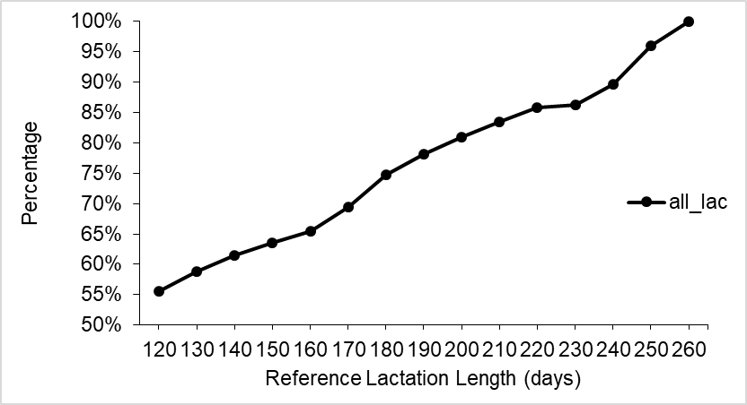
Supplementary Figure S5 Correlated response in reference lactation milk yield to selection based on the first test-day record milk yield in Chios dairy sheep, expressed as a percentage relatively to response in highest reference length of 260 days for all lactations.

