Rearing conditions and life history influence the progress of gametogenesis and reproduction performances in pikeperch males and females.
A. Khendek, A. Chakraborty, J. Roche, Y. Ledoré, A. Personne, T. Policar, D. Zarski, R. Mandiki, P. Kestemont, S. Milla, P. Fontaine

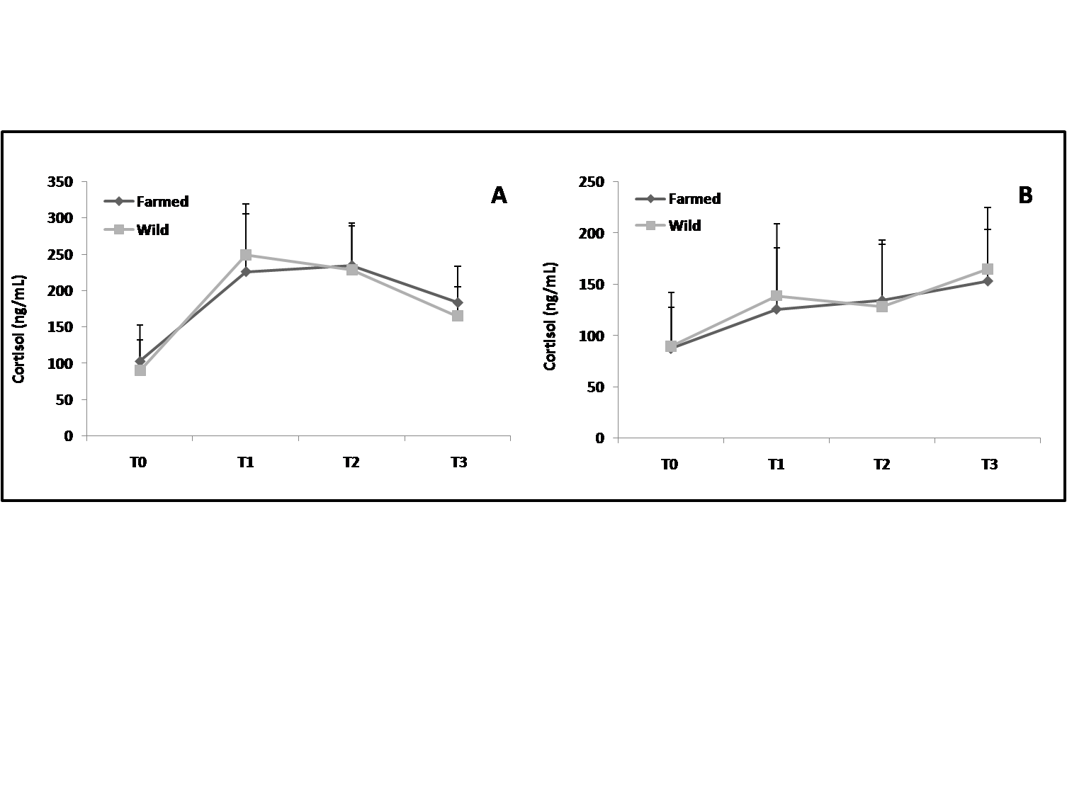Supplementary Figure S1. Cortisol levels variation (ng/mL) in (A) females and (B) males. (mean + standard deviation). (n= 6) Sampling times T0, T1, T2 and T3 correspond respectively to days 0, 32, 153 and 295 after the beginning of the photothermal program. The asterisk (*) represents a significant difference (p<0.05).

