Supplementary files for “Investigating the population structure and genetic differentiation of livestock guard dog breeds”
D. Bigi, S.P. Marelli, L. Liotta, S. Frattini, A. Talenti, G. Pagnacco, M. Polli, P. Crepaldi

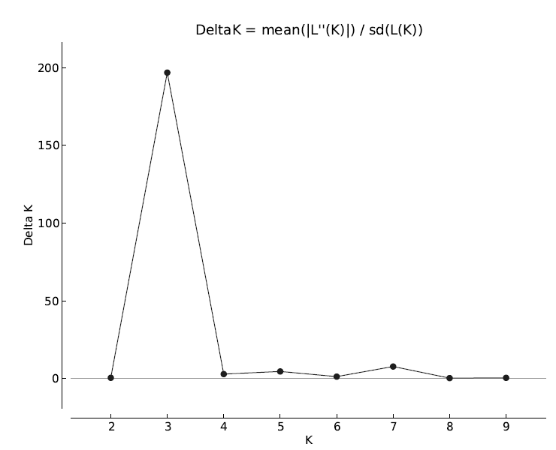
Figure S1 Graph of ΔK averaged over ten runs at each value of K, which was calculated according to the method of Evanno et al. (2005).

Locus | Breed | Allele | Freq
AHTH 121 | CAD | 90 | 0,063
AHTH 260 | CAD | 252 | 0,042
CXX 279 | CAD | 114 | 0,042
CXX 279 | CAD | 132 | 0,021
CXX 279 | CAD | 134 | 0,042
FH2054 | CAD | 158 | 0,023
FH 2848 | CAD | 246 | 0,042
INU 030 | CAD | 154 | 0,063
INU 055 | CAD | 198 | 0,021
REN 162C04 | CAD | 190 | 0,021
REN 162C04 | CAD | 192 | 0,042
REN 162C04 | CAD | 196 | 0,063
REN 162C04 | CAD | 216 | 0,021
REN 169D01 | CAD | 222 | 0,021
REN 247M23 | CAD | 258 | 0,021
REN 247M23 | CAD | 282 | 0,021
FH2054 | COR | 162 | 0,014
FH2054 | COR | 174 | 0,157
REN 54P11 | COR | 224 | 0,014
AHTH 121 | MAN | 92 | 0,068
AHTH 121 | MAN | 114 | 0,017
CXX 279 | MAN | 128 | 0,008
INU 055 | MAN | 208 | 0,076
REN 247M23 | MAN | 264 | 0,051
AHT 137 | MSD | 155 | 0,023
AHTK 253 | MSD | 296 | 0,023
CXX 279 | MSD | 122 | 0,023
CXX 279 | MSD | 188 | 0,045
INU 005 | MSD | 104 | 0,136
AHTH 121 | SIL | 84 | 0,100
AHTH 121 | SIL | 88 | 0,020
AHTK 253 | SIL | 300 | 0,019
FH 2848 | SIL | 228 | 0,019
INU 030 | SIL | 158 | 0,019
REN 169D01 | SIL | 204 | 0,135

Table S1 Private alleles for the six studied breeds: Locus, Breed, Allele, Frequency.

