Impact of Hermetia illucens larvae meal on the chemical and nutritional characteristics of rainbow trout fillets
S. Mancini, I. Medina, V. Iaconisi, F. Gai, A. Basto and G. Parisi

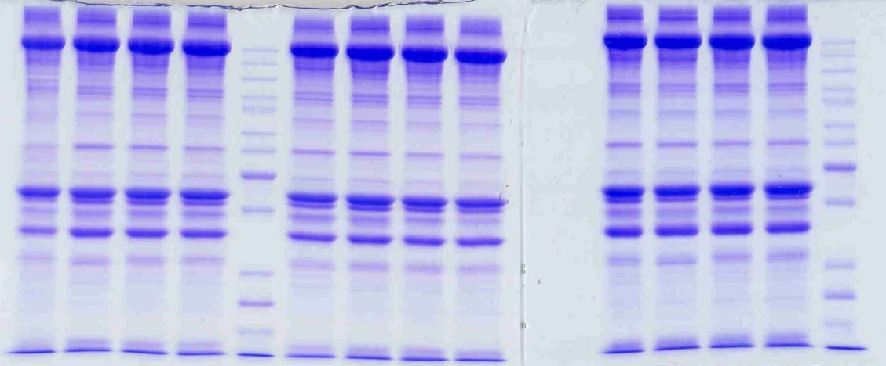

Supplementary Figure S1. Scanned gel of myofibrillar proteins.
From left to right: C C C C ST Hi25 Hi25 Hi25 Hi25 ----- Hi50 Hi50 Hi50 Hi50 ST

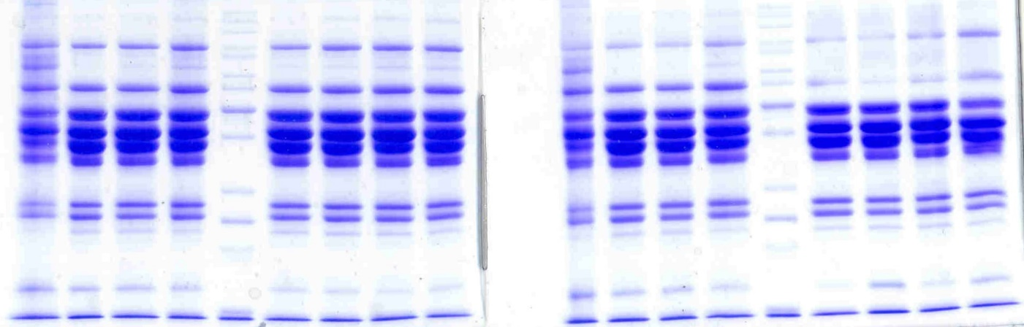

Supplementary Figure S2. Scanned gel of sarcoplasmic proteins.
From left to right: C C C C ST Hi25 Hi25 Hi25 Hi25 ----- C C C C ST Hi50 Hi50 Hi50 Hi50

