Supplementary material

Analysis of pre-weaning feeding policies and other risk factors influencing growth rates of calves on eleven commercial dairy farms
K. F. Johnson, N. Chancellor, C. C. Burn and D. C. Wathes
Department of Pathobiology and Population Sciences, Royal Veterinary College, Hawkshead Lane, North Mymms, Hatfield, Herts, AL9 7TA, UK

Supplementary Table S1 Milk powder and typical whole milk composition (dry), fed to calves in the study
Milks fed |  | Protein  (%) | Oil  (%) | Ash  (%) | Fibre  (%) | Lactose  (%) | Total Solids  (%)
Milk Powders¹ | A | 20.6 | 17.5 | 7.7 | 0.5 | 53.6 | Mixing rates of 10 -15% used
 | B | 23.2 | 17.9 | 7.4 | 0 | 51.6
 | C | 24 | 18.8 | 7.3 | 0 | 50
 | D | 27.1 | 16.7 | 7.3 | 0 | 49
Typical Holstein milk¹ |  | 24.1 | 28.3 | 6.3 | 0 | 41.3 | 12.7
Typical Holstein colostrum² |  | 54 | 24.2 | 0.2 | 0 | 21.6 | 27.6

¹Milk powders: A, Shine Once a day (Bonanza Calf Nutrition Ltd, Dundalk IE); B, Mole Valley Multistart (Mole Valley Farmers Ltd, South Molton, UK). C and D, Blossom and Heiferlac (Volac Ltd, Royston, UK). Gross analysis was provided in the product technical materials. The lactose% for milk powder was estimated by subtracting other components from 100% of dry matter.
²Mature milk data were taken from the USDA (2016) annual survey data.
³Holstein colostrum data was taken from a survey by Kehoe et al. (2007). Transition milk will have a composition intermediate between milk and colostrum.
References
Kehoe SI, Jayarao BM and Heinrichs AJ 2007. A survey of bovine colostrum composition and colostrum management practices on Pennsylvania dairy farms 1. Journal of Dairy Science 90, 4108–4116.
USDA. Summary of 2016 DHI herd averages DHI Report K-3. Retrieved on 1 March 2017 from https://www.uscdcb.com/publish/dhi/current/hax.html
Supplementary Table S2 Summary of potential explanatory variables tested in the models for growth rates and size for 492 dairy heifer calves on 11 farms recruited to the study in their first week of life
 | Variable¹ | Description | Incidence (n, %)² | Mean ± SD or range and median² | Final variable tested for inclusion in model
Farm |  |  | 11 farms |  | Random factor, included in all models
Dam and calving related | Dam perinatal disease | Milk fever, mastitis, metritis, retained fetal membranes | 34 (6.9%) cows |  | Binary Y/N
 | Dystocia | Unassisted, manual assistance, traction, uterine torsion | 68 (13.8%) assisted calvings |  | Binary Y/N
 | Supplementary colostrum feeding | Calves given supplementary colostrum by bottle or tube | 173 (35.2%) calves supplemented |  | Binary Y/N
 | Calf breed | Holstein, Friesian, Jersey Ayrshire, Crossbred | H 351 (71.3%); F 37 (7.5 %); J 24 (4.9%); A 9 (1.8 %);C 71, (14.4%) calves |  | Categorical and  Binary Holstein/Other
Calf husbandry | Calving pattern³ | Autumn block or all-year-round | AB 153 (31.1%), AYR 339 (68.9%) calves |  | Categorical
 | Calving intensity³ | No. of calves born on that farm in the week of recruitment |  | Range 1 - 21, median 6 | Log transformation of continuous data
 | Environmental temperature³ | Mean temperature in the month of birth ºC |  | Range 4.4 -16.6, median 9.5 | Log transformation of continuous data
 | Movement | Pre-weaning movement of calves to another farm | 288 (58.5%) calves did not move |  | Binary Y/N
 | Group size | Single pens, small group (<7 calves), medium group (7-12 calves), large group (> 12 calves) | S 62 (12.6%); SG 131 (26.6%); MG 135 (27.4 %); LG 164 (33.3 %) calves |  | Categorical
 | Group mixing | Pre-weaned calves moved between groups | 155/492 (31.5 %) calves were mixed |  | Binary Y/N
 | Age at disbudding | <3 weeks, 3-6 weeks, >6 weeks | <3 14 (2.8%); 3-6 237 (48.2%0; >6 241 (49.0%) calves |  | Categorical
Calf feeding | Feeding Frequency | 3 feeds/day on automated feeders, bucket twice daily, bucket once daily (from 3 weeks), continuous supply of waste milk | x3 206 (41.9%); x2 200 (40.7%); x1 86 (17.4%); cont 96 (19.5%) calves |  | Categorical
 | Age at weaning | Days |  | 64.3 ± 9.4 | Continuous
 | Milk solids fed days 1-35 | Kg⁴ |  | 20.5 ± 5.0 | Continuous
 | Milk solids fed days 1-63 | Kg⁴ |  | 34.5 ± 10.8 | Continuous
Calf size and growth | Weight at recruitment | Kg |  | 39.6 ± 8.8 | Continuous
 | Height at recruitment | Cm |  | 76.4 ± 4.1 | Continuous
 | Length at recruitment | Cm |  | 61.9 ± 4.6 | Continuous
 | Ponderal index at recruitment | Kg/m³ |  | 14.8 ± 2.4 | Continuous
 | Age at recruitment | Days |  | 4.5 ± 2.9 | Continuous
 | ADG days 1-63⁵ | Kg/day |  | 0.62 ± 0.174 | Continuous
 | Height increase days 1-63⁵ | Cm/day |  | 0.21 ± 0.081 | Continuous
 | Estimated weight at 63 days⁵ | Kg |  | 74.6 ± 10.9 | Continuous
 | Estimated height at 63 days⁵ | Cm |  | 88.9 ± 5.0 | Continuous
Calf blood measurements | Serum total protein at recruitment | mg/ml |  | 56.7 ± 10.3 | Continuous
 | Serum IgG at recruitment | mg/ml |  | 19.0 ± 9.9 | Continuous
 | Plasma IGF-1 at recruitment | ng/ml |  | Range <1.8 – 177, median 47.0 | Log transformation of continuous variable
 | Plasma IGF-1 week 5 | ng/ml |  | Range <1.8 – 560, median 52.4 | Log transformation of continuous variable
 | Plasma IGF-1 week 9⁵ | ng/ml |  | Range <1.8 – 303.6, median 57.6 | Log transformation of continuous variable
Calf health weeks 1-9 | BRD | Any BRD | 226/492 (45.9%) calves |  | Binary Y/N
 | BRD | Total score above the threshold for diagnosis |  | Range 0-15, median 0 | Raw data⁶
 | BRD | No. weeks with disease |  | Range 1-6, median 0 | Raw data⁶
 | Diarrhoea | Any diarrhoea | 237/492 (48.2%) calves |  | Binary Y/N
 | Diarrhoea | Total score above the threshold for diagnosis |  | Range 0-6, median 0 | Raw data⁶
 | Diarrhoea | No. weeks with disease |  | Range 0-6, median 0 | Raw data⁶
 | Umbilical disease | Any umbilical disease | 141/492 (28.7%) calves |  | Binary Y/N
 | Umbilical disease | Total score above the threshold for diagnosis |  | Range 0-11, median 0 | Raw data⁶
 | Umbilical disease | No. weeks with disease |  | Range 0-8, median 0 | Raw data⁶
¹Variables which were remained in at least one of the final models tested are shaded.
²For categorical data the count and percentage of calves in each group are shown. Normally distributed data are presented as mean ± SD. Other continuous data are given as the range and median.
³The high degree of correlation between the environmental temperature, calving pattern and the heifer calving intensity meant that only one of these variables could be included in any model without convergence errors. Therefore only the variable which most improved the model was included in the final model.
⁴Calculated as described in Materials and methods
⁵These variables were only tested for inclusion in size and growth models from 63-229 days.
⁶Treating the data as an ordered factor was tested but using the raw data significantly improved the model in all cases.

Supplementary Table S3 Calf size by breed from recruitment in week 1 to 7.5 months of age¹
Breed² | n³ | Recruitment | 63 days | 229 days
Weight (kg)
H | 351 | 41.2 ± 7.7ª | 77.4 ± 10.5ª | 220 ± 24.5
A | 9 | 41.8 ± 8.7ª | 78.6 ± 21.7ª | 191.3 ± 29.5
F | 37 | 40.8 ± 6.6 ª | 72.4 ± 7.3^{ab} | 206.5 ± 19.6
J | 24 | 22 ± 7.1^{c} | 63.6 ± 7.6^{b} | 169 ± 17.7
SRX | 43 | 39.5 ± 5.8ª | 74.7 ± 12.3^{ab} | 209.7 ± 33.2
FXO | 4 | 36 ± 7.4^{ab} | 74.8 ± 8.1^{ab} | 195 ± 35.4
JXO | 11 | 34.1 ± 7.7^{ab} | 77.1 ± 7.8ª | 206.6 ± 14.7
FXJ | 13 | 29.1 ± 8.9^{bc} | 69 ± 8.4^{ab} | 172.5 ± 23.2
Height (cm)
H | 351 | 77.2 ± 3.8ª | 90.6 ± 5.2ª | 116.2 ± 5.3ª
A | 9 | 76.1 ± 3.4^{abc} | 87.1 ± 2.7^{bc} | 109.1 ± 4.4^{ab}
F | 37 | 74.3 ± 3.4^{bc} | 86.5 ± 3.1^{bc} | 111.5 ± 4.8^{ab}
J | 24 | 70.7 ± 3.8^{c} | 82.3 ± 3.5^{c} | 108.8 ± 5.7^{b}
SRX | 43 | 76.6 ± 3.3^{ab} | 88 ± 4^{bc} | 116.7 ± 5.6^{ab}
FXO | 4 | 76.3 ± 3.6^{abc} | 88.8 ± 2.8^{abc} | 113.8 ± 4.3^{ab}
JXO | 11 | 74.1 ± 3.9^{bc} | 89 ± 5^{ab} | 113 ± 4.4^{ab}
FXJ | 13 | 72.7 ± 3.2^{c} | 83 ± 4.1^{bc} | 110.2 ± 2.6^{ab}
¹All results are presented as mean ± SD. Within columns a>b>c, P<0.05 by ANOVA with Tukey post-hoc testing.
²A, Ayrshire; F, Friesian; FXJ, Friesian cross Jersey; FXO, Friesian cross other breed; H, Holstein; J, Jersey; JXO, Jersey cross other; SRX, Scandinavian red cross black and white breed.
³ Number of animals recruited at birth. As there were deaths in the study the number of animals surviving at 63 days and 229 days was lower than the total recruited.

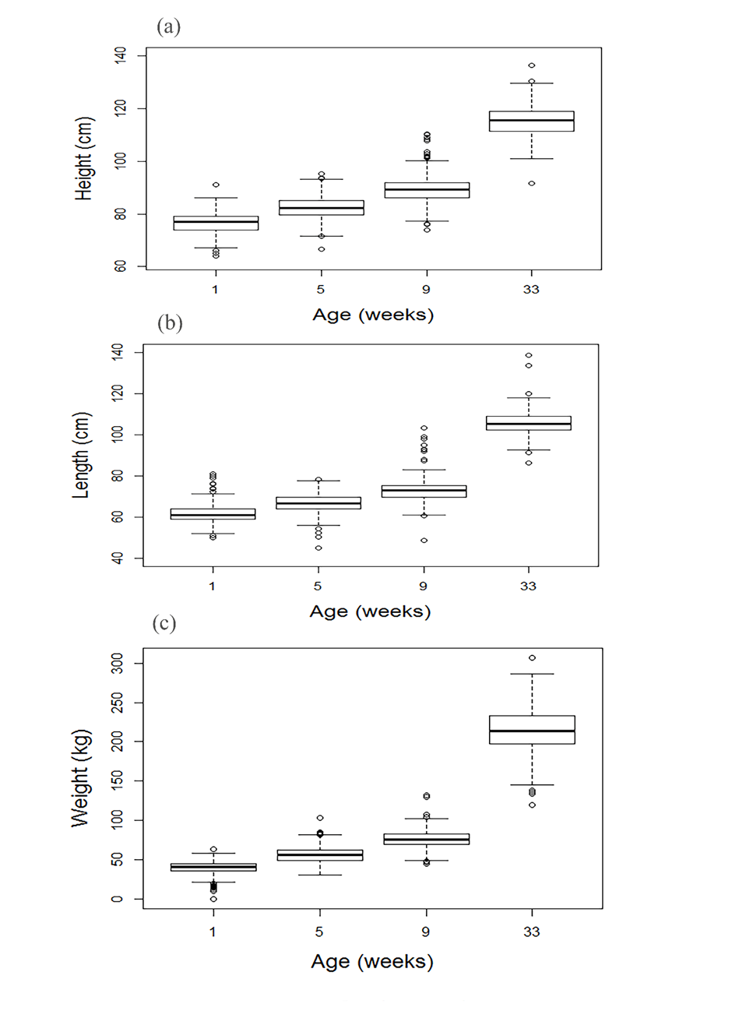 Supplementary Figure S1 Box and whisker plots of (a) height, (b) length and (c) weight of all 492 calves in the study, corrected based on individual growth rates to give the estimated values at each of the four time points.

