Impact of aggressive and sexual behaviours on the welfare of immunocastrated vs. entire heavy female pigs

G. Di Martino¹, A. Scollo², A. Garbo¹, F. Lega¹, A.L. Stefani¹, M. Vascellari¹, A. Natale¹, F. Zuliani¹, C. Zanardello¹, F. Tonon³ and L. Bonfanti¹

¹Istituto Zooprofilattico Sperimentale delle Venezie, viale dell’Università 10, 35020 Legnaro, Padova, Italy

²Swivet Research s.n.c, Via Martiri della Bettola, 67/8, 42123 Reggio Emilia, Italy

³Suivet s.n.c, Via Martiri della Bettola, 67/8, 42123 Reggio Emilia, Italy

Supplementary Table S1. Definition of behaviours used during observations.
Category | Behaviour | Description
State | Inactive | Pigs in lateral or sternal lying, resting or sleeping
 | Positive social | Reciprocal or non-reciprocal sniffing, nosing, licking and moving gently towards/away without an aggressive or flight reaction (Welfare Quality, 2009)
 | Drinking | a pig is sucking or licking the nipple drinker
 | Locomotory | A pig runs, trots, walks or frolics
 | Exploratory | A pig is chewing, sniffing or licking the enrichment material
Event | Aggressive interaction | Rapid reciprocal or non-reciprocal head movement or pushing towards recipient(s); with or without mouth open; with or without contact between aggressor and recipient; with or without bite attempt or direct bite.  (adapted from Thomsen et al., 2012)
 | Ear biting | A pig has in the mouth an ear of a pen mate and bites it, in absence of any sign of aggressive interaction.
 | Tail biting | A pig bites the tail of another pig, in absence of any sign of aggressive interaction.
 | Belly nosing | A pig persistently thrust the nose towards the belly of another pig, nuzzling the teat and flank areas.
 | Sexual mounting | A standing pig lifts its two front legs and puts the two legs or its breast on any part of the body or head of another pig (the recipient or mounted pig) (Hintze et al., 2013).
 | Non-sexual mounting | The mounting pig faces the fence or wall of the pen when mounting. It gets into contact or tries to get into contact with a pig from one of the neighbour pens, drinks or tries to drink at the nipple drinker or licks the wall (Hintze et al., 2013)

Supplementary Table S2. Frequency (mean ± st. dev.) of selected behaviours during fattening in female pigs either vaccinated or not vaccinated against GnRH.
 | Weeks of age
Entire | 18 | 23 | 28 | 33 | 36
Inactive (%) | 72.2±15.1 | 84.4±9.6 | 90.9±9.4 | 83.8±13.4 | 93.2±6.2
Positive social (%) | 6.2+6.2 | 2.0+3.1 | 2.0+3.1 | 2.6+3.6 | 1.4+2.3
Drinking (%) | 1.1+1.7 | 1.4+2.0 | 0.3+0.8 | 1.4+2.7 | 1.1+2.3
Locomotory (%) | 1.6±1.9 | 0.7±0.9 | 0.4±0.7 | 1.4±2.3 | 0.1±0.4
Exploratory (%) | 0.3+0.9 | 0.2+0.4 | 0.1+0.4 | 0.3+0.8 | 0.0
Aggressive interaction | 3.9±5.3 | 1.2±2.8 | 0.2±0.5 | 0.9±1.2 | 0.5±0.8
Ear biting | 2.6±3.1 | 1.0±2.1 | 0.2±0.6 | 1.2±2.3 | 1.2±4.3
Tail biting | 0.2±0.4 | 0.2±0.6 | 0.1±0.2 | 0.5±0.9 | 0.2±0.6
Belly nosing | 0.4±0.9 | 0.2±0.4 | 0.1±0.4 | 0.2±0.5 | 1.0±0.3
Sexual mounting | 0±0 | 0±0 | 0±0 | 0.1±0.2 | 0±0
Non-sexual mounting | 0.7±1.21 | 0.3±0.7 | 0.2±0.5 | 0.4±1.1 | 0.1±0.3
Vaccinated
Inactive (%) | 65.1±16.2 | 85.1±10.2 | 89.2±9.8 | 87.2±12.2 | 91.8±7.5
Positive social (%) | 6.8+6.2 | 2.1+2.6 | 1.1+2.1 | 2.8+4.0 | 0.84+1.4
Drinking (%) | 0.83+1.42 | 0.7+1.2 | 0.7+1.9 | 0.5+1.4 | 0.61.7
Locomotory (%) | 2.4±2.4 | 1.5±1.8 | 1.6±1.8 | 0.5±0.8 | 0.4±1.1
Exploratory (%) | 0.2+0.7 | 0±0 | 0±0 | 0.42+1.17 | 0±0
Aggressive interaction | 6.2±12.3 | 0.8±1.2 | 0.1±0.2 | 0.3±0.9 | 0.2±0.4
Ear biting | 2.4±5.0 | 0.2±0.6 | 0.2±0.7 | 0.4±1.0 | 1.4±2.7
Tail biting | 0.2±0.5 | 0.2±0.8 | 0±0 | 0.1±0.2 | 0.4±1.6
Belly nosing | 0.3±0.7 | 0.4±0.8 | 0.1±0.6 | 0.2±0.6 | 1.0±0.2
Sexual mounting | 0.1±0.4 | 0±0 | 0±0 | 0±0 | 0±0
Non-sexual mounting | 0.5±0.9 | 0.7±1.1 | 0.3±0.8 | 0.5±1.3 | 0.1±0.4

Supplementary Figure S1 Macroscopic morphology of an ovary from a control (C) and a vaccinated (V) female pig.

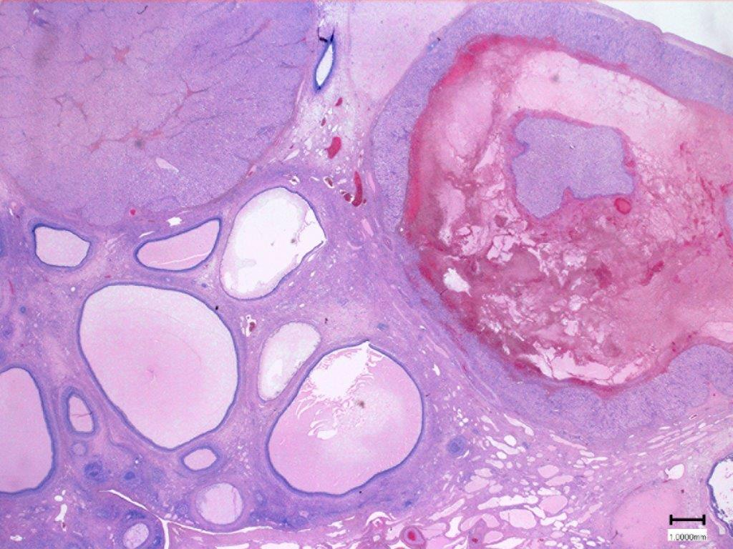
Supplementary Figure S2 Histological section of an ovary of an entire female pig. The bar indicates 1 mm. A corpus luteum and corpus hemorrhagicum are visible on top left and right of the specimen, respectively.
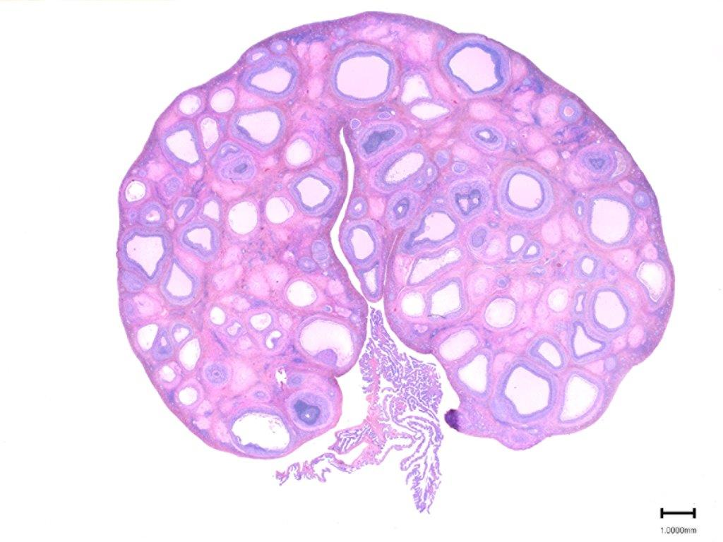
Supplementary Figure S3 Histological section of an ovary of a vaccinate female pig. The bar indicates 1 mm.

