An evaluation of the potential sensitivity of pork production situations aiming at high quality products to the use of entire male pigs as an alternative to surgical castrates

M. Bonneau, M. Čandek-Potokar, M. Śkrlep, M. Font-i-Furnols, M. Aluwé, The Castrum network, L. Fontanesi



Supplementary Figure S1 Model used for the calculation of BT_Inc (Boar taint incidence score) from [Age score] and [Weight score].



Supplementary Figure S2 Model used for the calculation of BT_Per (Boar taint perception score) from [Fat score], [Consumption score] and [Smoke].



Supplementary Figure S3 Model used for the calculation of Manag (Management score) from [Age score], [Weight score] and [Outdoor].

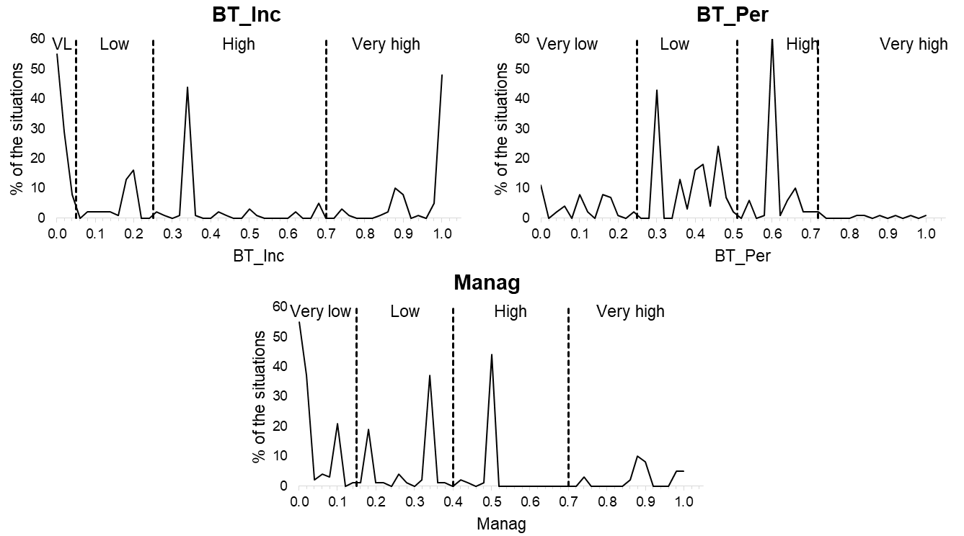

Supplementary Figure S4 Distributions (solid line) of the continuous dimensions of potential sensitivity to entire male pig production (BT_Inc: Boar taint incidence score; BT_Per: Boar taint perception score; Manag: Management score) with indication of the limits (broken lines) used to define the four classes: Very low (VL), Low, High and Very high.

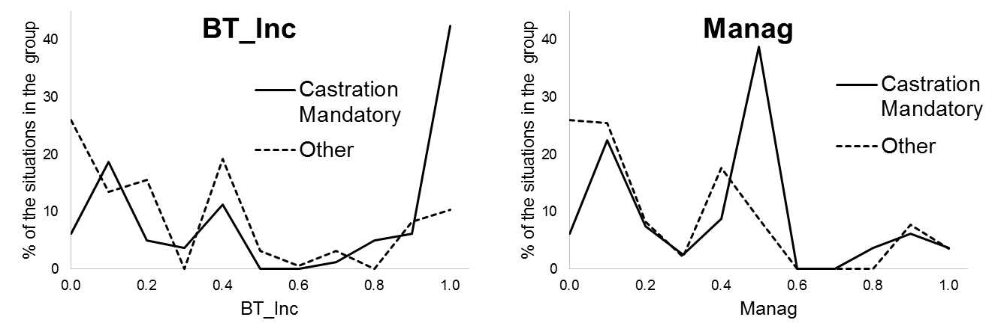

Supplementary Figure S5 Compared distributions of BT_Inc and Manag in situations where castration is mandatory (solid line) and in situations where it is not (broken line). BT_Inc: Boar taint incidence score; Manag: Management score.

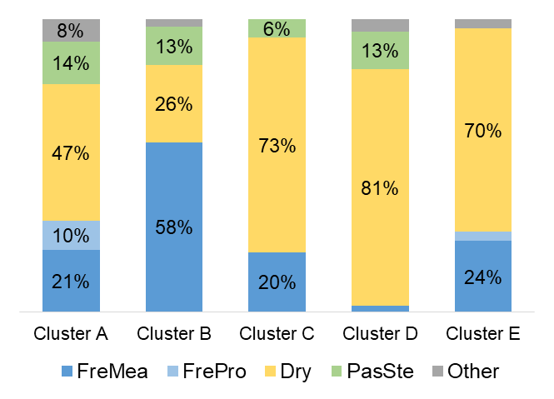

Supplementary Figure S6 Distribution of the categories of products for each of the five clusters of situations determined by Ascending Hierarchical Clustering following Multiple Correspondence Analysis. FreMea: Fresh meat; FrePro: Fresh processed; Dry: Dry cured and dry fermented; PasSte: Pasteurized sterilised. For better legibility, percentages lower than 5% are not shown.

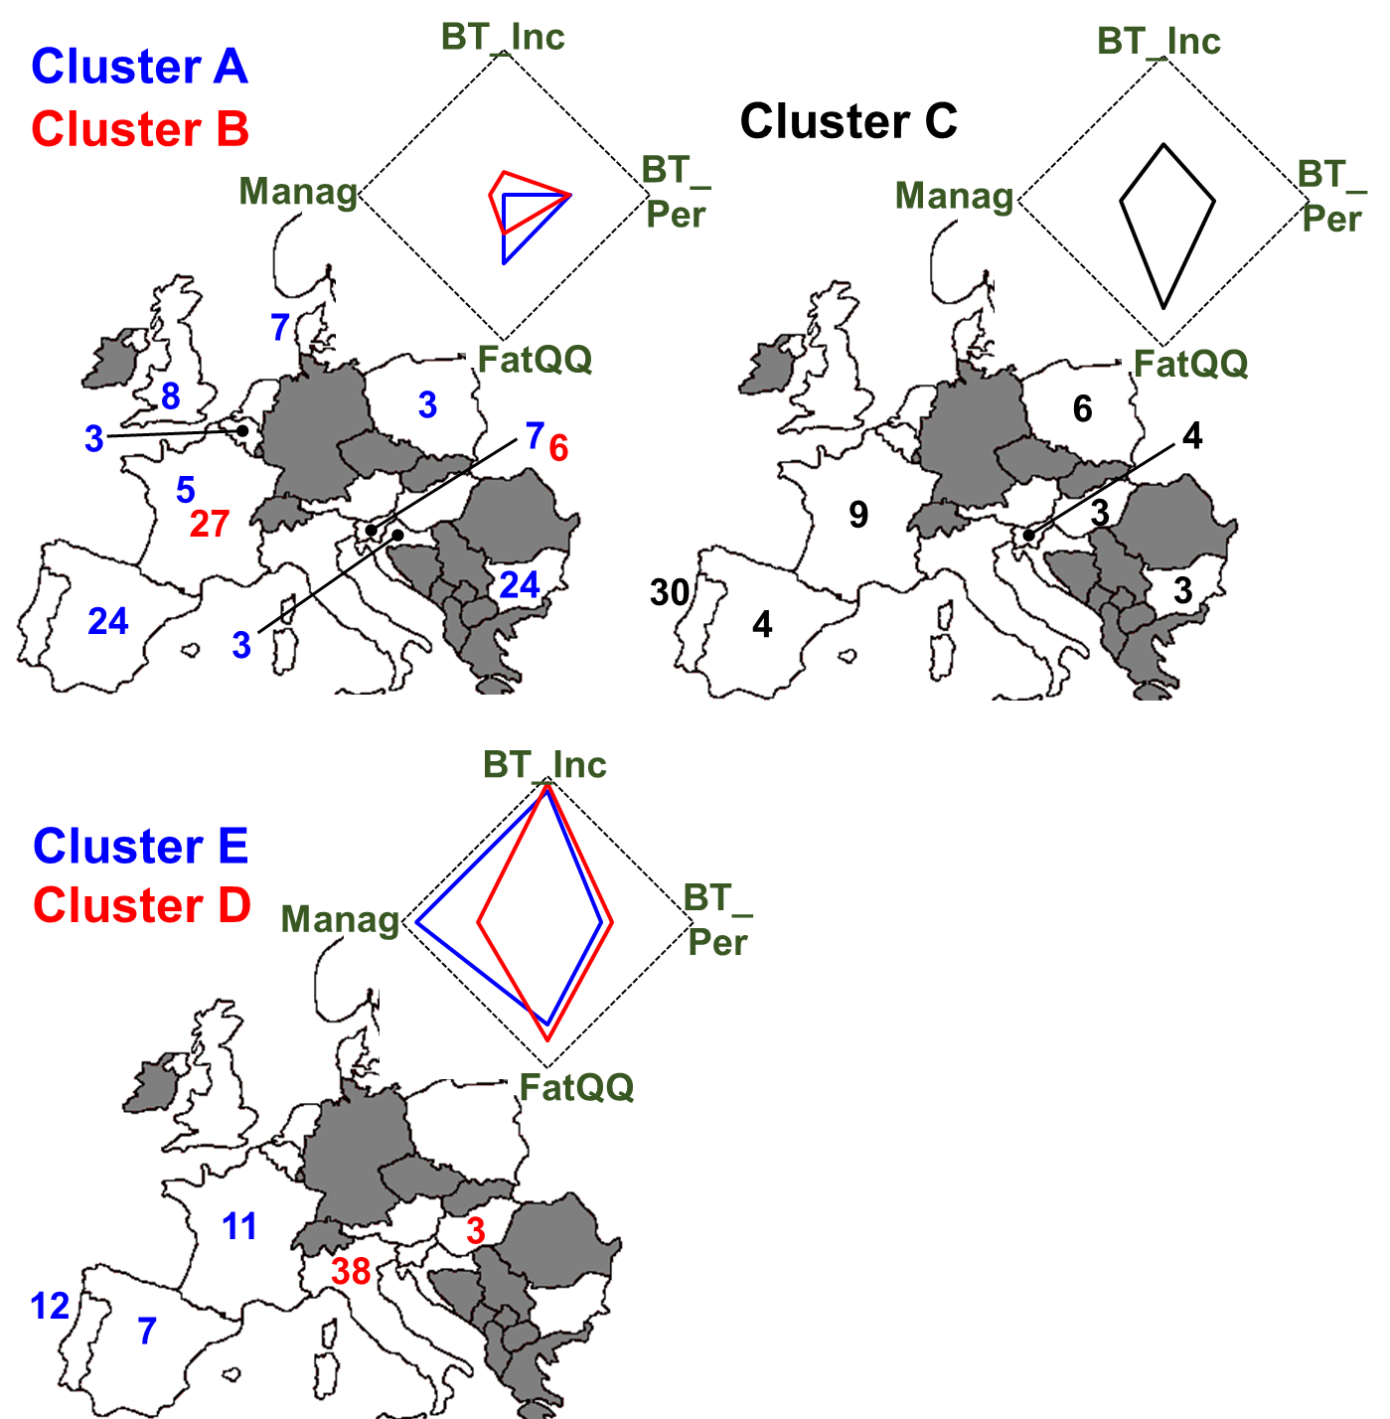

Supplementary Figure S7 Summary of the profiles of the five clusters and main localisation of the situations for each cluster. The five clusters of situations were determined by Ascending Hierarchical Clustering following Multiple Correspondence Analysis. BT_Inc: Boar taint incidence score; BT_Per: Boar taint perception score; FatQQ: Fat quantity and quality; Manag: Management score. For better legibility numbers lower than 3 are not shown (see Table 5 for complete list of numbers per country).

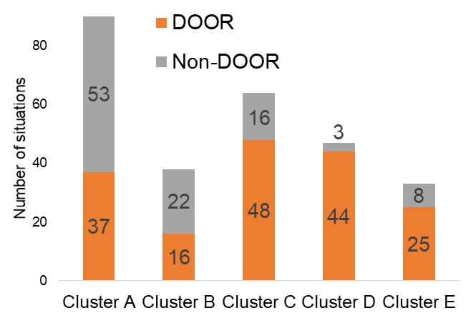

Supplementary Figure S8 Distribution of the DOOR and non-DOOR situations in the five clusters determined by Ascending Hierarchical Clustering following Multiple Correspondence Analysis.

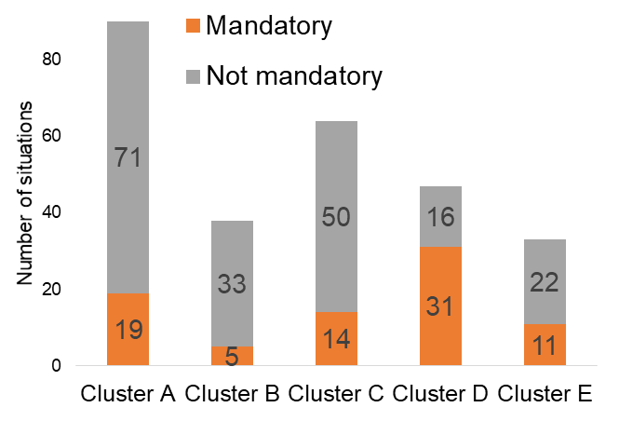

Supplementary Figure S9 Distribution of the situations where castration is mandatory and those where it is not in the five clusters determined by Ascending Hierarchical Clustering following Multiple Correspondence Analysis.

Supplementary Table S1 List of the 272 analysed situations

| **DOOR** | **Country** | **Designation of the situation** |
| --- | --- | --- |
| Yes | Austria | Gailtaler Speck |
| Yes | Austria | Tiroler Speck |
| Yes | Belgium | Jambon d'Ardenne |
| Yes | Belgium | Saucisson d’Ardenne / Collier d’Ardenne / Pipe d’Ardenne |
| Yes | Bulgaria | КАЙСЕРОВАН ВРАТ ТРАКИЯ (Kayserovan Vrat Trakiya) |
| Yes | Bulgaria | Луканка Панагюрска (Lukanka Panagyurska) |
| Yes | Bulgaria | РОЛЕ ТРАПЕЗИЦА (Role Trapezitsa) |
| Yes | Bulgaria | Филе Елена (File Elena) |
| Yes | Croatia | Baranjski kulen |
| Yes | Croatia | Dalmatinski pršut |
| Yes | Croatia | Drniški pršut |
| Yes | Croatia | Istarski pršut / Istrski pršut |
| Yes | Croatia | Krčki pršut |
| Yes | Croatia | Slavonski kulen / Slavonski kulin |
| Yes | France | Boudin blanc de Rethel |
| Yes | France | Coppa de Corse / Coppa de Corse - Coppa di Corsica |
| Yes | France | Jambon d'Auvergne |
| Yes | France | Jambon de Bayonne |
| Yes | France | Jambon de Lacaune |
| Yes | France | Jambon de l'Ardèche |
| Yes | France | Jambon de Vendée |
| Yes | France | Jambon noir de Bigorre |
| Yes | France | Jambon sec de Corse / Jambon sec de Corse - Prisuttu |
| Yes | France | Jambon sec des Ardennes / Noix de Jambon sec des Ardennes |
| Yes | France | Lonzo de Corse / Lonzo de Corse - Lonzu |
| Yes | France | Pâté de Campagne Breton |
| Yes | France | Porc d'Auvergne |
| Yes | France | Porc de Franche-Comté |
| Yes | France | Porc de la Sarthe |
| Yes | France | Porc de Normandie |
| Yes | France | Porc de Vendée |
| Yes | France | Porc du Limousin |
| Yes | France | Porc du Sud-Ouest |
| Yes | France | Porc noir de Bigorre |
| Yes | France | Rillettes de Tours |
| Yes | France | Saucisse de Montbéliard |
| Yes | France | Saucisse de Morteau / Jésus de Morteau |
| Yes | France | Saucisson de Lacaune / Saucisse de Lacaune |
| Yes | France | Saucisson de l'Ardèche |
| Yes | France | Saucisson sec d’Auvergne / Saucisse sèche d’Auvergne |
| Yes | Hungary | Budapesti téliszalámi |
| Yes | Hungary | Csabai kolbász/Csabai vastagkolbász |
| Yes | Hungary | Gyulai kolbász / Gyulai pároskolbász |
| Yes | Hungary | Szegedi szalámi ; Szegedi téliszalámi |
| Yes | Italy | Capocollo di Calabria |
| Yes | Italy | Ciauscolo |
| Yes | Italy | Cinta Senese |
| Yes | Italy | Coppa di Parma |
| Yes | Italy | Coppa Piacentina |
| Yes | Italy | Cotechino Modena |
| Yes | Italy | Crudo di Cuneo |
| Yes | Italy | Culatello di Zibello |
| Yes | Italy | Finocchiona |
| Yes | Italy | Lardo di Colonnata |
| Yes | Italy | Mortadella Bologna |
| Yes | Italy | Mortadella di Prato |
| Yes | Italy | Pancetta di Calabria |
| Yes | Italy | Pancetta Piacentina |
| Yes | Italy | Porchetta di Ariccia |
| Yes | Italy | Prosciutto Amatriciano |
| Yes | Italy | Prosciutto di Carpegna |
| Yes | Italy | Prosciutto di Modena |
| Yes | Italy | Prosciutto di Norcia |
| Yes | Italy | Prosciutto di Parma |
| Yes | Italy | Prosciutto di San Daniele |
| Yes | Italy | Prosciutto di Sauris |
| Yes | Italy | Prosciutto Toscano |
| Yes | Italy | Prosciutto Veneto Berico-Euganeo |
| Yes | Italy | Salama da sugo |
| Yes | Italy | Salame Brianza |
| Yes | Italy | Salame Cremona |
| Yes | Italy | Salame di Varzi |
| Yes | Italy | Salame d'oca di Mortara |
| Yes | Italy | Salame Felino |
| Yes | Italy | Salame Piacentino |
| Yes | Italy | Salame Piemonte |
| Yes | Italy | Salame S. Angelo |
| Yes | Italy | Salamini italiani alla cacciatora |
| Yes | Italy | Salsiccia di Calabria |
| Yes | Italy | Soppressata di Calabria |
| Yes | Italy | Soprèssa Vicentina |
| Yes | Italy | Speck Alto Adige / Südtiroler Markenspeck / Südtiroler Speck |
| Yes | Italy | Valle d’Aosta Lard d’Arnad/Vallée d’Aoste Lard d’Arnad |
| Yes | Italy | Valle d'Aosta Jambon de Bosses |
| Yes | Italy | Zampone Modena |
| Yes | Poland | Kabanosy |
| Yes | Poland | Kabanosy staropolskie |
| Yes | Poland | Kiełbasa biała parzona wielkopolska |
| Yes | Poland | Kiełbasa jałowcowa |
| Yes | Poland | Kiełbasa jałowcowa staropolska |
| Yes | Poland | Kiełbasa lisiecka |
| Yes | Poland | Kiełbasa myśliwska |
| Yes | Poland | Kiełbasa myśliwska staropolska |
| Yes | Poland | Krupnioki śląskie |
| Yes | Portugal | Alheira de Barroso-Montalegre |
| Yes | Portugal | Alheira de Mirandela |
| Yes | Portugal | Alheira de Vinhais |
| Yes | Portugal | Butelo de Vinhais ; Bucho de Vinhais ; Chouriço de Ossos de Vinhais |
| Yes | Portugal | Cacholeira Branca de Portalegre |
| Yes | Portugal | Carne de Bísaro Transmontano ; Carne de Porco Transmontano |
| Yes | Portugal | Carne de Porco Alentejano |
| Yes | Portugal | Chouriça de Carne de Barroso-Montalegre |
| Yes | Portugal | Chouriça de Carne de Melgaço |
| Yes | Portugal | Chouriça de Carne de Vinhais ; Linguiça de Vinhais |
| Yes | Portugal | Chouriça de sangue de Melgaço |
| Yes | Portugal | Chouriça Doce de Vinhais |
| Yes | Portugal | Chouriço Azedo de Vinhais ; Azedo de Vinhais ; Chouriço de Pão de Vinhais |
| Yes | Portugal | Chouriço de Abóbora de Barroso-Montalegre |
| Yes | Portugal | Chouriço de Carne de Estremoz e Borba |
| Yes | Portugal | Chouriço de Portalegre |
| Yes | Portugal | Chouriço grosso de Estremoz e Borba |
| Yes | Portugal | Chouriço Mouro de Portalegre |
| Yes | Portugal | Farinheira de Estremoz e Borba |
| Yes | Portugal | Farinheira de Portalegre |
| Yes | Portugal | Linguiça de Portalegre |
| Yes | Portugal | Linguíça do Baixo Alentejo ; Chouriço de carne do Baixo Alentejo |
| Yes | Portugal | Lombo Branco de Portalegre |
| Yes | Portugal | Lombo Enguitado de Portalegre |
| Yes | Portugal | Morcela de Assar de Portalegre |
| Yes | Portugal | Morcela de Cozer de Portalegre |
| Yes | Portugal | Morcela de Estremoz e Borba |
| Yes | Portugal | Paia de Estremoz e Borba |
| Yes | Portugal | Paia de Lombo de Estremoz e Borba |
| Yes | Portugal | Paia de Toucinho de Estremoz e Borba |
| Yes | Portugal | Painho de Portalegre |
| Yes | Portugal | Paio de Beja |
| Yes | Portugal | Presunto de Barrancos /Paleta de Barrancos |
| Yes | Portugal | Presunto de Barroso |
| Yes | Portugal | Presunto de Campo Maior e Elvas ; Paleta de Campo Maior e Elvas |
| Yes | Portugal | Presunto de Melgaço |
| Yes | Portugal | Presunto de Santana da Serra ; Paleta de Santana da Serra |
| Yes | Portugal | Presunto de Vinhais / Presunto Bísaro de Vinhais |
| Yes | Portugal | Presunto do Alentejo ; Paleta do Alentejo |
| Yes | Portugal | Salpicão de Barroso-Montalegre |
| Yes | Portugal | Salpicão de Melgaço |
| Yes | Portugal | Salpicão de Vinhais |
| Yes | Portugal | Sangueira de Barroso-Montalegre |
| Yes | Slovenia | Istrski pršut |
| Yes | Slovenia | Kranjska klobasa |
| Yes | Slovenia | Kraška panceta |
| Yes | Slovenia | Kraški pršut |
| Yes | Slovenia | Kraški zašink |
| Yes | Slovenia | Prekmurska Šunka |
| Yes | Slovenia | Prleška tünka |
| Yes | Slovenia | Šebreljski  želodec |
| Yes | Slovenia | Zgornjesavinjski želodec |
| Yes | Spain | Botillo del Bierzo |
| Yes | Spain | Chorizo de Cantimpalos |
| Yes | Spain | Chorizo Riojano |
| Yes | Spain | Chosco de Tineo |
| Yes | Spain | Dehesa de Extremadura |
| Yes | Spain | Guijuelo |
| Yes | Spain | Jabugo |
| Yes | Spain | Jamón de Serón |
| Yes | Spain | Jamón de Teruel / Paleta de Teruel |
| Yes | Spain | Jamón de Trevélez |
| Yes | Spain | Jamón Serrano |
| Yes | Spain | Lacón Gallego |
| Yes | Spain | Los Pedroches |
| Yes | Spain | Morcilla de Burgos |
| Yes | Spain | Salchichón de Vic ; Llonganissa de Vic |
| Yes | Spain | Sobrasada de Mallorca |
| Yes | Sweden | Falukorv |
| Yes | UK | Carmarthen Ham |
| Yes | UK | Melton Mowbray Pork Pie |
| Yes | UK | Newmarket Sausage |
| Yes | UK | Traditional Cumberland Sausage |
| Yes | UK | Traditionally Farmed Gloucestershire Old Spots Pork |
| Yes | UK | Traditionally Reared Pedigree Welsh Pork |
| No | Belgium | Le Porc plein air / Het buiten gekweekte varken |
| No | Belgium | Organic wallonie |
| No | Belgium | Pâté Gaumais |
| No | Belgium | Porc fermier de Wallonie |
| No | Bulgaria | Бански старец (Banski starets) |
| No | Bulgaria | Бут по Еленски (But po Elenski) |
| No | Bulgaria | Карловски Бабек (Karlovski Babek) |
| No | Bulgaria | Кебапче (kebepche) |
| No | Bulgaria | Кърначе (karnache) |
| No | Bulgaria | Кюфте (kyufte) |
| No | Bulgaria | луканка Смядовска (lukanka Smyadovska) |
| No | Bulgaria | луканка Трапезица (lukanka Trapezitsa) |
| No | Bulgaria | луканка Троянска (likanka Troyanska) |
| No | Bulgaria | луканка Чумерна (lukanka Chumerna) |
| No | Bulgaria | месо от Източнобалканска свиня (meso ot Iztochnobalkanska svinya) |
| No | Bulgaria | наденица Стара Планина (nadenica Stara Planina) |
| No | Bulgaria | салам Амбарица (salam Ambaritsa) |
| No | Bulgaria | салам Дебоя (salam Deboya) |
| No | Bulgaria | салам Диавена (salam Diavena) |
| No | Bulgaria | салам Медвен (salam Medven) |
| No | Bulgaria | сланина от Източнобалканска свиня (slanina ot Iztochnobalkanska svinya) |
| No | Bulgaria | солена сланина (solena slanina) |
| No | Bulgaria | Странджански дядо (Strandzhanski dyado) |
| No | Bulgaria | субпродукти от Източнобалканска свиня (subproducti ot Iztochnobalkanska svinya) |
| No | Bulgaria | суджук Плевенски (sudzhuk Plevenski) |
| No | Bulgaria | суджук Чипровски (sudzhuk Chiprovski) |
| No | Bulgaria | суджук Шопски (sudzhuk Shopski) |
| No | Bulgaria | филе свинско двойно Арабанаси (file svinsko dvoino Arbanasi) |
| No | Croatia | Meat of Crna Slavonska pig |
| No | Croatia | Međimursko meso z' tiblice |
| No | Denmark | Antibiotic free production |
| No | Denmark | Antonius |
| No | Denmark | Bornholmergrisen (pig from Bornholm, a Danish island) |
| No | Denmark | Den goé gris |
| No | Denmark | Friland (Free range pigs) |
| No | Denmark | Grambogaard |
| No | Denmark | Organic pork |
| No | France | Abattoir des Crêts |
| No | France | Basque |
| No | France | Bayeux |
| No | France | Blanc de l'Ouest |
| No | France | Cocholin |
| No | France | Cochon du druide |
| No | France | Cochon paysan |
| No | France | Cul noir du Limousin |
| No | France | ERCA BIO |
| No | France | Fattening pigs to higher weight for home consumption/processing |
| No | France | Francochon |
| No | France | Jambon du Kintoa |
| No | France | Jean Rozé sélection |
| No | France | Kintoa |
| No | France | Nustrale |
| No | France | Organic pig production in France |
| No | France | Porc au grain du Sud-Ouest |
| No | France | Porc Bio Atlantique |
| No | France | Porc d'Argoat |
| No | France | Porc Délice |
| No | France | Porc Fermier d'Argoat |
| No | France | Porc Franc |
| No | France | Porc Maggiore |
| No | France | Tradival |
| No | France | UNEBIO |
| No | France | Vallégrain tradition |
| No | Hungary | Excellent Pork Quality (KMS) |
| No | Hungary | Fattening heavy pigs for own consumption/processing |
| No | Hungary | Rearing of Mangalica |
| No | Netherlands | Organic system |
| No | Netherlands | Outdoor housing system |
| No | Norway | Santa Kristina |
| No | Slovenia | Agricultural policy measure Welfare |
| No | Slovenia | Dobrote naših kmetij (En. Delicacies of our farms) |
| No | Slovenia | Dobrote slovenskih kmetij (En. Delecacies of Slovenian farms) |
| No | Slovenia | Fattening heavy pigs for direct sale of products to consumers |
| No | Slovenia | Fattening heavy pigs for known buyer (demanding higher weight) |
| No | Slovenia | Fattening heavy pigs for own consumption/processing |
| No | Slovenia | Izbrana kakovost (Selected quality) |
| No | Slovenia | Mesnine krškopoljskega praši (Meat and products of Krskopolje pig) |
| No | Slovenia | Organic/ecological farming |
| No | Spain | Androlla |
| No | Spain | Androlla Maragata |
| No | Spain | Bacon |
| No | Spain | Baiona curada |
| No | Spain | Bisbe, bull |
| No | Spain | Bolas |
| No | Spain | Borono |
| No | Spain | Butifarra |
| No | Spain | Cabeza de jabalí |
| No | Spain | Chistorra |
| No | Spain | Chorizo de Pamplona |
| No | Spain | Farinato |
| No | Spain | Fuet |
| No | Spain | Hamburguer |
| No | Spain | Lomo de ibérico |
| No | Spain | Longaniza |
| No | Spain | Magreta |
| No | Spain | Morcilla |
| No | Spain | Mortadela |
| No | Spain | Patatera |
| No | Spain | Salami |
| No | Spain | Salchicha |
| No | UK | Assured Food Standards Red Tractor Scheme |
| No | UK | Males castrated in Hobby farms |

Supplementary Table S2 Characteristics of the 272 analysed situations. To preserve anonymity, the listing order is different from Supplementary Table S1. DOOR: DOOR situation; Cast Mand: Castration Mandatory; BT_Incid: Boar taint incidence score; Weight: Weight score; Age: Age score; Manag: Management score; Outdoor: outdoor production; BT_Per: Boar taint perception score. Consum: Consumption score; Home Cook: Cooked at home; Cons Warm: Consumed warm; Fat Score: Score for fat content of the associated product; Smoke: The associated product is smoked; FatQQ: Fat quantity and quality.

| **DOOR** | **Cast Mand** | **BT_ Incid** | **Wei ght** | **Age** | **Ma nag** | **Out door** | **BT_ Per** | **Con sum** | **Home Cook** | **Cons Warm** | **Fat Score** | **Smo ke** | **Fat QQ** |
| --- | --- | --- | --- | --- | --- | --- | --- | --- | --- | --- | --- | --- | --- |
| Yes | Yes | 1.00 | 1.00 | 1 | 0.50 | No | 0.44 | 0 | no | No | 0.35 | No | Yes |
| Yes | Yes | 1.00 | 1.00 | 1 | 0.50 | No | 0.29 | 0 | No | No | 0.10 | No | Yes |
| Yes | No | 0.89 | 0.84 | 1 | 0.89 | Yes | 0.71 | 0 | No | No | 0.80 | No | No |
| Yes | Yes | 1.00 | 1.00 | 1 | 0.50 | No | 0.82 | 1 | yes | Yes | 0.50 | No | Yes |
| Yes | No | 0.00 | 0.00 | 0 | 0.00 | No | 0.35 | 1 | Yes | Yes | 0.20 | Yes | No |
| Yes | Yes | 1.00 | 1.00 | 1 | 0.50 | No | 0.29 | 0 | No | No | 0.10 | No | Yes |
| Yes | No | 0.01 | 0.01 | 0 | 0.00 | No | 0.19 | 0 | No | No | 0.43 | Yes | Yes |
| No | Yes | 0.01 | 0.02 | 0 | 0.01 | No | 0.44 | 0 | No | No | 0.35 | No | Yes |
| Yes | No | 0.88 | 0.82 | 1 | 0.88 | Yes | 0.38 | 1 | Yes | Yes | 0.25 | Yes | Yes |
| Yes | No | 0.00 | 0.00 | 0 | 0.00 | No | 0.65 | 1 | Yes | Yes | 0.20 | No | No |
| No | No | 0.50 | 0.25 | 1 | 0.50 | Yes | 0.29 | 1 | Yes | Yes | 0.10 | Yes | No |
| No | No | 0.00 | 0.00 | 0 | 0.00 | No | 0.61 | 1 | Yes | Yes | 0.14 | No | No |
| Yes | No | 0.11 | 0.16 | 0 | 0.05 | No | 0.29 | 0 | No | No | 0.10 | No | Yes |
| No | No | 0.18 | 0.02 | 0.5 | 0.09 | No | 0.59 | 1 | yes | Yes | 0.10 | No | No |
| Yes | No | 0.93 | 0.90 | 1 | 0.47 | No | 0.09 | 0 | No | No | 0.25 | Yes | Yes |
| Yes | Yes | 0.03 | 0.05 | 0 | 0.02 | No | 0.03 | 0 | No | No | 0.15 | Yes | Yes |
| No | No | 0.01 | 0.01 | 0 | 0.00 | No | 0.59 | 1 | Yes | Yes | 0.10 | No | No |
| Yes | Yes | 1.00 | 1.00 | 1 | 0.50 | No | 0.45 | 0 | no | No | 0.37 | No | Yes |
| Yes | No | 0.00 | 0.00 | 0 | 0.00 | No | 0.37 | 1 | Yes | Yes | 0.23 | Yes | No |
| No | No | 0.01 | 0.01 | 0 | 0.00 | No | 0.29 | 1 | Yes | Yes | 0.10 | Yes | No |
| Yes | No | 0.34 | 0.01 | 1 | 0.34 | Yes | 0.09 | 0 | No | No | 0.25 | Yes | Yes |
| Yes | Yes | 0.73 | 0.60 | 1 | 0.73 | Yes | 0.00 | 0 | no | No | 0.10 | Yes | Yes |
| Yes | No | 0.03 | 0.04 | 0 | 0.01 | No | 0.71 | 1 | Yes | Yes | 0.30 | No | No |
| Yes | No | 0.01 | 0.01 | 0 | 0.00 | No | 0.49 | 0 | No | No | 0.43 | No | No |
| No | No | 0.00 | 0.00 | 0 | 0.00 | No | 0.45 | 0 | No | No | 0.37 | No | Yes |
| Yes | No | 0.34 | 0.01 | 1 | 0.34 | Yes | 0.09 | 0 | No | No | 0.25 | Yes | Yes |
| Yes | No | 0.41 | 0.12 | 1 | 0.41 | Yes | 0.38 | 1 | Yes | Yes | 0.25 | Yes | Yes |
| No | No | 0.89 | 0.84 | 1 | 0.89 | Yes | 0.59 | 1 | yes | Yes | 0.10 | No | No |
| Yes | Yes | 0.33 | 0.00 | 1 | 0.33 | Yes | 0.38 | 1 | Yes | Yes | 0.25 | Yes | Yes |
| Yes | No | 1.00 | 1.00 | 1 | 0.50 | No | 0.45 | 0 | no | No | 0.37 | No | Yes |
| Yes | No | 0.34 | 0.01 | 1 | 0.34 | Yes | 0.06 | 0 | No | No | 0.20 | Yes | Yes |
| No | No | 0.00 | 0.00 | 0 | 0.00 | No | 0.59 | 1 | Yes | Yes | 0.10 | No | No |
| Yes | No | 0.34 | 0.01 | 1 | 0.34 | Yes | 0.38 | 1 | Yes | Yes | 0.25 | Yes | Yes |
| No | No | 0.00 | 0.00 | 0 | 0.00 | No | 1.00 | 1 | Yes | Yes | 0.80 | No | No |
| No | No | 0.00 | 0.00 | 0 | 0.00 | No | 0.65 | 1 | Yes | Yes | 0.20 | No | No |
| Yes | No | 0.34 | 0.01 | 1 | 0.34 | Yes | 0.53 | 0 | No | No | 0.50 | No | Yes |
| Yes | No | 0.67 | 1.00 | 0 | 0.33 | No | 0.35 | 0 | No | No | 0.20 | No | Yes |
| Yes | No | 0.44 | 0.16 | 1 | 0.44 | Yes | 0.29 | 0.67 | Yes | No | 0.25 | Yes | Yes |
| Yes | Yes | 0.00 | 0.00 | 0 | 0.00 | No | 0.47 | 0 | No | No | 0.40 | No | Yes |
| No | No | 0.17 | 0.25 | 0 | 0.08 | No | 0.59 | 0 | No | No | 0.60 | No | No |
| Yes | Yes | 1.00 | 1.00 | 1 | 0.50 | No | 0.41 | 0 | no | No | 0.30 | No | Yes |
| Yes | Yes | 1.00 | 1.00 | 1 | 0.50 | No | 0.29 | 0 | No | No | 0.10 | No | Yes |
| Yes | Yes | 1.00 | 1.00 | 1 | 0.50 | No | 0.38 | 0 | No | No | 0.25 | No | Yes |
| Yes | Yes | 1.00 | 1.00 | 1 | 1.00 | Yes | 0.18 | 0 | No | No | 0.40 | Yes | Yes |
| Yes | No | 0.88 | 0.82 | 1 | 0.88 | Yes | 0.29 | 0.67 | Yes | No | 0.25 | Yes | Yes |
| Yes | No | 1.00 | 1.00 | 1 | 0.50 | No | 0.35 | 0 | no | No | 0.20 | No | Yes |
| Yes | No | 0.97 | 0.96 | 1 | 0.97 | Yes | 0.29 | 0 | No | No | 0.10 | No | Yes |
| Yes | No | 0.88 | 0.82 | 1 | 0.88 | Yes | 0.38 | 1 | Yes | Yes | 0.25 | Yes | No |
| No | No | 0.00 | 0.00 | 0 | 0.00 | No | 0.36 | 0 | No | No | 0.22 | No | No |
| No | No | 0.67 | 1.00 | 0 | 0.33 | No | 0.47 | 0 | No | No | 0.40 | No | Yes |
| Yes | No | 0.34 | 0.01 | 1 | 0.34 | Yes | 0.38 | 1 | Yes | Yes | 0.25 | Yes | Yes |
| Yes | No | 0.01 | 0.01 | 0 | 0.00 | No | 0.00 | 0 | No | No | 0.10 | Yes | Yes |
| Yes | Yes | 0.33 | 0.00 | 1 | 0.33 | Yes | 0.38 | 1 | Yes | Yes | 0.25 | Yes | Yes |
| No | Yes | 0.01 | 0.02 | 0 | 0.01 | No | 0.45 | 0 | No | No | 0.37 | No | Yes |
| Yes | Yes | 1.00 | 1.00 | 1 | 0.50 | No | 0.29 | 0 | No | No | 0.10 | No | Yes |
| No | No | 0.17 | 0.01 | 0.5 | 0.17 | Yes | 0.59 | 1 | yes | Yes | 0.10 | No | No |
| Yes | No | 1.00 | 1.00 | 1 | 0.50 | No | 0.63 | 0.33 | no | Yes | 0.50 | No | Yes |
| No | No | 0.00 | 0.00 | 0 | 0.00 | No | 0.64 | 0 | No | No | 0.68 | No | Yes |
| Yes | No | 0.00 | 0.00 | 0 | 0.00 | No | 0.44 | 0 | No | No | 0.35 | No | Yes |
| Yes | Yes | 0.33 | 0.00 | 1 | 0.33 | Yes | 0.09 | 0 | No | No | 0.25 | Yes | Yes |
| No | Yes | 0.00 | 0.00 | 0 | 0.00 | No | 0.48 | 0 | No | No | 0.42 | No | Yes |
| Yes | No | 0.13 | 0.20 | 0 | 0.07 | No | 0.00 | 0 | no | No | 0.10 | Yes | Yes |
| Yes | Yes | 0.03 | 0.04 | 0 | 0.01 | No | 0.41 | 1 | yes | Yes | 0.30 | Yes | No |
| Yes | No | 0.34 | 0.01 | 1 | 0.34 | Yes | 0.06 | 0 | No | No | 0.20 | Yes | Yes |
| No | No | 0.00 | 0.00 | 0 | 0.00 | No | 0.64 | 1 | Yes | Yes | 0.18 | No | No |
| No | No | 0.50 | 0.25 | 1 | 0.25 | No | 0.29 | 1 | Yes | Yes | 0.10 | Yes | No |
| Yes | No | 0.17 | 0.01 | 0.5 | 0.09 | No | 0.59 | 1 | yes | Yes | 0.10 | No | No |
| Yes | Yes | 0.07 | 0.10 | 0 | 0.03 | No | 0.00 | 0 | no | No | 0.10 | Yes | Yes |
| Yes | No | 0.33 | 0.00 | 1 | 0.33 | Yes | 0.38 | 1 | Yes | Yes | 0.25 | Yes | Yes |
| Yes | No | 0.34 | 0.01 | 1 | 0.34 | Yes | 0.53 | 0 | No | No | 0.50 | No | Yes |
| Yes | Yes | 1.00 | 1.00 | 1 | 0.50 | No | 0.81 | 1 | yes | Yes | 0.47 | No | Yes |
| No | No | 0.50 | 0.75 | 0 | 0.25 | No | 0.29 | 1 | Yes | Yes | 0.10 | Yes | No |
| Yes | No | 1.00 | 1.00 | 1 | 0.50 | No | 0.40 | 0 | no | No | 0.28 | No | No |
| Yes | No | 0.00 | 0.00 | 0 | 0.00 | No | 0.45 | 0 | No | No | 0.37 | No | Yes |
| Yes | Yes | 0.19 | 0.04 | 0.5 | 0.10 | No | 0.47 | 0 | no | No | 0.40 | No | No |
| Yes | No | 0.00 | 0.00 | 0 | 0.00 | No | 0.41 | 0 | No | No | 0.30 | No | Yes |
| No | Yes | 0.01 | 0.02 | 0 | 0.01 | No | 0.44 | 0 | No | No | 0.35 | No | Yes |
| No | No | 0.17 | 0.25 | 0 | 0.08 | No | 0.29 | 1 | Yes | Yes | 0.10 | Yes | No |
| No | No | 0.01 | 0.02 | 0 | 0.01 | No | 0.45 | 0 | No | No | 0.37 | No | Yes |
| Yes | Yes | 1.00 | 1.00 | 1 | 0.50 | No | 0.41 | 0 | No | No | 0.30 | No | Yes |
| Yes | No | 0.34 | 0.01 | 1 | 0.34 | Yes | 0.41 | 1 | Yes | Yes | 0.30 | Yes | Yes |
| Yes | No | 0.62 | 0.93 | 0 | 0.31 | No | 0.18 | 0 | No | No | 0.40 | Yes | Yes |
| Yes | No | 0.34 | 0.01 | 1 | 0.34 | Yes | 0.41 | 1 | Yes | Yes | 0.30 | Yes | Yes |
| Yes | Yes | 0.33 | 0.50 | 0 | 0.17 | No | 0.03 | 0 | No | No | 0.15 | Yes | Yes |
| Yes | No | 0.88 | 0.82 | 1 | 0.88 | Yes | 0.38 | 1 | Yes | Yes | 0.25 | Yes | Yes |
| Yes | Yes | 0.01 | 0.02 | 0 | 0.01 | No | 0.29 | 0 | No | No | 0.10 | No | Yes |
| Yes | No | 0.34 | 0.01 | 1 | 0.34 | Yes | 0.41 | 1 | Yes | Yes | 0.30 | Yes | Yes |
| Yes | Yes | 0.86 | 0.79 | 1 | 0.86 | Yes | 0.59 | 1 | Yes | Yes | 0.10 | No | No |
| No | No | 0.18 | 0.02 | 0.5 | 0.09 | No | 0.59 | 1 | yes | Yes | 0.10 | No | No |
| No | No | 0.00 | 0.00 | 0 | 0.00 | No | 0.59 | 1 | Yes | Yes | 0.10 | No | No |
| Yes | No | 0.00 | 0.00 | 0 | 0.00 | No | 0.44 | 0 | No | No | 0.35 | No | Yes |
| No | No | 0.33 | 0.00 | 1 | 0.33 | Yes | 0.59 | 1 | Yes | Yes | 0.10 | No | No |
| Yes | No | 0.03 | 0.04 | 0 | 0.01 | No | 0.41 | 0 | no | No | 0.30 | No | No |
| Yes | No | 0.08 | 0.12 | 0 | 0.04 | No | 0.10 | 0 | No | No | 0.27 | Yes | Yes |
| No | No | 0.00 | 0.00 | 0 | 0.00 | No | 0.65 | 0 | No | No | 0.70 | No | No |
| Yes | No | 0.97 | 0.96 | 1 | 0.97 | Yes | 0.29 | 0 | No | No | 0.10 | No | Yes |
| No | Yes | 0.89 | 0.84 | 1 | 0.89 | Yes | 0.29 | 0 | no | No | 0.10 | No | Yes |
| Yes | Yes | 1.00 | 1.00 | 1 | 0.50 | No | 0.18 | 0 | No | No | 0.40 | Yes | Yes |
| Yes | No | 1.00 | 1.00 | 1 | 0.50 | No | 0.62 | 1 | yes | Yes | 0.16 | No | No |
| Yes | Yes | 0.67 | 0.50 | 1 | 0.33 | No | 0.15 | 0 | No | No | 0.35 | Yes | Yes |
| Yes | No | 0.88 | 0.82 | 1 | 0.88 | Yes | 0.34 | 1 | Yes | Yes | 0.18 | Yes | Yes |
| Yes | No | 0.33 | 0.00 | 1 | 0.33 | Yes | 0.68 | 1 | Yes | Yes | 0.25 | No | No |
| Yes | Yes | 0.33 | 0.25 | 0.5 | 0.17 | No | 0.59 | 1 | yes | Yes | 0.10 | No | No |
| Yes | No | 1.00 | 1.00 | 1 | 1.00 | Yes | 0.29 | 0 | No | No | 0.10 | No | Yes |
| No | No | 0.33 | 0.25 | 0.5 | 0.17 | No | 0.59 | 1 | yes | Yes | 0.10 | No | No |
| Yes | No | 0.01 | 0.01 | 0 | 0.00 | No | 0.00 | 0 | No | No | 0.10 | Yes | Yes |
| Yes | No | 0.01 | 0.02 | 0 | 0.01 | No | 0.29 | 0 | No | No | 0.10 | No | Yes |
| No | No | 0.00 | 0.00 | 0 | 0.00 | No | 0.59 | 1 | Yes | Yes | 0.10 | No | No |
| No | Yes | 0.01 | 0.02 | 0 | 0.01 | No | 0.45 | 0 | No | No | 0.37 | No | Yes |
| No | No | 0.00 | 0.00 | 0 | 0.00 | No | 0.35 | 1 | Yes | Yes | 0.20 | Yes | No |
| Yes | No | 0.83 | 1.00 | 0.5 | 0.42 | No | 0.12 | 0 | No | No | 0.30 | Yes | Yes |
| No | No | 0.01 | 0.01 | 0 | 0.00 | No | 0.59 | 1 | Yes | Yes | 0.10 | No | No |
| Yes | No | 0.03 | 0.05 | 0 | 0.02 | No | 0.29 | 0 | No | No | 0.10 | No | Yes |
| No | Yes | 0.17 | 0.25 | 0 | 0.17 | Yes | 0.29 | 1 | Yes | Yes | 0.10 | Yes | No |
| Yes | No | 1.00 | 1.00 | 1 | 0.50 | No | 0.41 | 0 | no | No | 0.30 | No | Yes |
| No | Yes | 0.33 | 0.25 | 0.5 | 0.33 | Yes | 0.59 | 1 | Yes | Yes | 0.10 | No | No |
| Yes | No | 0.00 | 0.00 | 0 | 0.00 | No | 0.06 | 0 | No | No | 0.20 | Yes | Yes |
| Yes | No | 1.00 | 1.00 | 1 | 1.00 | Yes | 0.59 | 1 | yes | Yes | 0.10 | No | No |
| No | No | 0.00 | 0.00 | 0 | 0.00 | No | 0.62 | 1 | Yes | Yes | 0.16 | No | No |
| No | No | 0.00 | 0.00 | 0 | 0.00 | No | 0.59 | 1 | Yes | Yes | 0.10 | No | No |
| Yes | No | 0.33 | 0.50 | 0 | 0.17 | No | 0.15 | 0 | No | No | 0.35 | Yes | Yes |
| No | No | 1.00 | 1.00 | 1 | 0.50 | No | 0.59 | 1 | Yes | Yes | 0.10 | No | No |
| Yes | No | 0.33 | 0.00 | 1 | 0.33 | Yes | 0.09 | 0 | No | No | 0.25 | Yes | Yes |
| Yes | No | 0.00 | 0.00 | 0 | 0.00 | No | 0.69 | 1 | Yes | Yes | 0.28 | No | No |
| Yes | No | 0.03 | 0.05 | 0 | 0.02 | No | 0.41 | 1 | Yes | Yes | 0.29 | Yes | No |
| Yes | No | 0.18 | 0.02 | 0.5 | 0.09 | No | 0.59 | 1 | yes | Yes | 0.10 | No | No |
| No | No | 0.00 | 0.00 | 0 | 0.00 | No | 0.35 | 0 | No | No | 0.20 | No | No |
| No | No | 0.18 | 0.02 | 0.5 | 0.09 | No | 0.59 | 1 | yes | Yes | 0.10 | No | No |
| No | No | 0.18 | 0.02 | 0.5 | 0.09 | No | 0.59 | 1 | yes | Yes | 0.10 | No | No |
| Yes | Yes | 0.01 | 0.01 | 0 | 0.00 | No | 0.36 | 1 | yes | Yes | 0.22 | Yes | No |
| Yes | Yes | 1.00 | 1.00 | 1 | 0.50 | No | 0.44 | 0 | No | No | 0.34 | No | Yes |
| No | No | 0.01 | 0.02 | 0 | 0.01 | Yes | 0.59 | 1 | Yes | Yes | 0.10 | No | No |
| Yes | Yes | 0.33 | 0.00 | 1 | 0.33 | Yes | 0.18 | 0 | No | No | 0.40 | Yes | Yes |
| Yes | No | 0.00 | 0.00 | 0 | 0.00 | No | 0.53 | 0.33 | no | Yes | 0.33 | No | No |
| Yes | No | 0.88 | 0.82 | 1 | 0.88 | Yes | 0.38 | 1 | Yes | Yes | 0.25 | Yes | Yes |
| Yes | Yes | 0.17 | 0.00 | 0.5 | 0.08 | No | 0.29 | 0 | No | No | 0.10 | No | Yes |
| Yes | Yes | 1.00 | 1.00 | 1 | 0.50 | No | 0.29 | 0 | No | No | 0.10 | No | Yes |
| Yes | No | 0.34 | 0.01 | 1 | 0.34 | Yes | 0.09 | 0 | No | No | 0.25 | Yes | Yes |
| No | Yes | 0.01 | 0.02 | 0 | 0.01 | No | 0.45 | 0 | No | No | 0.37 | No | Yes |
| No | No | 0.01 | 0.02 | 0 | 0.01 | Yes | 0.59 | 1 | Yes | Yes | 0.10 | No | No |
| No | Yes | 0.89 | 0.84 | 1 | 0.89 | Yes | 0.59 | 1 | Yes | Yes | 0.10 | No | No |
| No | No | 0.00 | 0.00 | 0 | 0.00 | No | 0.59 | 1 | Yes | Yes | 0.10 | No | No |
| No | Yes | 0.89 | 0.84 | 1 | 0.89 | Yes | 0.59 | 1 | Yes | Yes | 0.10 | No | No |
| Yes | No | 0.31 | 0.46 | 0 | 0.15 | No | 0.00 | 0 | no | No | 0.10 | Yes | Yes |
| Yes | Yes | 1.00 | 1.00 | 1 | 0.50 | No | 0.29 | 0 | No | No | 0.10 | No | Yes |
| No | No | 0.17 | 0.01 | 0.5 | 0.17 | Yes | 0.59 | 1 | yes | Yes | 0.10 | No | No |
| Yes | No | 0.01 | 0.01 | 0 | 0.00 | No | 0.29 | 0 | No | No | 0.10 | No | Yes |
| No | No | 0.18 | 0.02 | 0.5 | 0.09 | No | 0.59 | 1 | yes | Yes | 0.10 | No | No |
| Yes | No | 0.00 | 0.00 | 0 | 0.00 | No | 0.29 | 0 | No | No | 0.10 | No | Yes |
| No | No | 0.19 | 0.03 | 0.5 | 0.09 | No | 0.59 | 1 | yes | Yes | 0.10 | No | No |
| Yes | No | 1.00 | 1.00 | 1 | 0.50 | No | 0.38 | 0 | No | No | 0.25 | No | No |
| No | No | 0.00 | 0.00 | 0 | 0.00 | No | 0.65 | 0 | No | No | 0.70 | No | No |
| Yes | Yes | 1.00 | 1.00 | 1 | 0.50 | No | 0.87 | 0.33 | No | Yes | 0.91 | No | No |
| Yes | No | 0.88 | 0.82 | 1 | 0.88 | Yes | 0.41 | 1 | Yes | Yes | 0.30 | Yes | Yes |
| No | No | 0.00 | 0.00 | 0 | 0.00 | No | 0.65 | 0 | No | No | 0.70 | No | Yes |
| Yes | Yes | 0.75 | 0.63 | 1 | 0.38 | No | 0.47 | 0 | No | No | 0.40 | No | Yes |
| Yes | No | 0.16 | 0.24 | 0 | 0.08 | No | 0.29 | 0 | no | No | 0.10 | No | Yes |
| Yes | No | 0.34 | 0.01 | 1 | 0.34 | Yes | 0.41 | 1 | Yes | Yes | 0.30 | Yes | Yes |
| Yes | No | 0.00 | 0.00 | 0 | 0.00 | No | 0.65 | 1 | Yes | Yes | 0.20 | No | No |
| Yes | Yes | 1.00 | 1.00 | 1 | 0.50 | No | 0.29 | 0 | No | No | 0.10 | No | Yes |
| No | No | 0.00 | 0.00 | 0 | 0.00 | No | 0.59 | 1 | Yes | Yes | 0.10 | No | No |
| No | No | 0.00 | 0.00 | 0 | 0.00 | No | 0.65 | 0 | No | No | 0.70 | No | Yes |
| Yes | No | 0.34 | 0.01 | 1 | 0.34 | Yes | 0.24 | 0 | No | No | 0.50 | Yes | Yes |
| No | No | 0.00 | 0.00 | 0 | 0.00 | No | 0.45 | 0 | No | No | 0.37 | No | Yes |
| Yes | No | 0.00 | 0.00 | 0 | 0.00 | No | 0.00 | 0 | No | No | 0.10 | Yes | Yes |
| Yes | No | 1.00 | 1.00 | 1 | 0.50 | No | 0.64 | 1 | yes | Yes | 0.18 | No | No |
| No | No | 0.01 | 0.02 | 0 | 0.01 | No | 0.59 | 1 | Yes | Yes | 0.10 | No | No |
| No | No | 0.00 | 0.00 | 0 | 0.00 | No | 0.59 | 1 | Yes | Yes | 0.10 | No | No |
| Yes | No | 0.00 | 0.00 | 0 | 0.00 | No | 0.65 | 1 | Yes | Yes | 0.20 | No | No |
| Yes | Yes | 1.00 | 1.00 | 1 | 0.50 | No | 0.41 | 0 | no | No | 0.29 | No | Yes |
| Yes | No | 0.01 | 0.01 | 0 | 0.00 | No | 0.38 | 0 | No | No | 0.25 | No | No |
| Yes | No | 0.34 | 0.01 | 1 | 0.34 | Yes | 0.41 | 1 | Yes | Yes | 0.30 | Yes | Yes |
| Yes | Yes | 1.00 | 1.00 | 1 | 0.50 | No | 0.35 | 0 | No | No | 0.20 | No | Yes |
| Yes | Yes | 1.00 | 1.00 | 1 | 0.50 | No | 0.29 | 0 | no | No | 0.10 | No | Yes |
| Yes | No | 0.03 | 0.05 | 0 | 0.02 | No | 0.46 | 0 | No | No | 0.38 | No | Yes |
| Yes | Yes | 0.97 | 0.96 | 1 | 0.97 | Yes | 0.29 | 0 | No | No | 0.10 | No | Yes |
| Yes | No | 0.00 | 0.00 | 0 | 0.00 | No | 0.44 | 0 | No | No | 0.35 | No | Yes |
| Yes | No | 0.03 | 0.05 | 0 | 0.02 | No | 0.06 | 0 | No | No | 0.20 | Yes | Yes |
| No | No | 0.41 | 0.12 | 1 | 0.21 | No | 0.59 | 1 | yes | Yes | 0.10 | No | No |
| No | Yes | 0.01 | 0.02 | 0 | 0.01 | No | 0.45 | 0 | No | No | 0.37 | No | Yes |
| No | Yes | 0.00 | 0.00 | 0 | 0.00 | No | 0.45 | 0 | No | No | 0.37 | No | Yes |
| No | No | 0.00 | 0.00 | 0 | 0.00 | No | 0.35 | 1 | Yes | Yes | 0.20 | Yes | No |
| No | Yes | 0.01 | 0.02 | 0 | 0.01 | No | 0.45 | 0 | No | No | 0.37 | No | Yes |
| No | No | 0.00 | 0.00 | 0 | 0.00 | No | 0.65 | 0 | No | No | 0.70 | No | Yes |
| No | No | 0.00 | 0.00 | 0 | 0.00 | No | 0.47 | 0.33 | No | Yes | 0.24 | No | No |
| Yes | Yes | 0.26 | 0.14 | 0.5 | 0.26 | Yes | 0.59 | 1 | yes | Yes | 0.10 | No | No |
| No | No | 0.18 | 0.02 | 0.5 | 0.09 | No | 0.59 | 1 | yes | Yes | 0.10 | No | No |
| No | Yes | 0.26 | 0.14 | 0.5 | 0.13 | No | 0.59 | 1 | Yes | Yes | 0.10 | No | No |
| Yes | Yes | 1.00 | 1.00 | 1 | 0.50 | No | 0.29 | 0 | No | No | 0.10 | No | Yes |
| No | No | 0.67 | 1.00 | 0 | 0.33 | No | 0.29 | 0 | No | No | 0.10 | No | Yes |
| No | No | 0.97 | 0.96 | 1 | 0.97 | Yes | 0.29 | 0 | No | No | 0.10 | No | Yes |
| Yes | No | 0.34 | 0.01 | 1 | 0.34 | Yes | 0.38 | 1 | Yes | Yes | 0.25 | Yes | Yes |
| Yes | No | 0.33 | 0.50 | 0 | 0.17 | No | 0.15 | 0 | No | No | 0.35 | Yes | Yes |
| No | No | 0.17 | 0.01 | 0.5 | 0.17 | Yes | 0.59 | 1 | yes | Yes | 0.10 | No | No |
| No | No | 0.89 | 0.84 | 1 | 0.89 | Yes | 0.59 | 1 | yes | Yes | 0.10 | No | No |
| No | No | 0.17 | 0.25 | 0 | 0.08 | No | 0.29 | 1 | Yes | Yes | 0.10 | Yes | No |
| Yes | Yes | 1.00 | 1.00 | 1 | 0.50 | No | 0.42 | 0 | no | No | 0.32 | No | Yes |
| No | No | 0.18 | 0.02 | 0.5 | 0.09 | No | 0.59 | 1 | yes | Yes | 0.10 | No | No |
| Yes | Yes | 0.73 | 0.60 | 1 | 0.73 | Yes | 0.00 | 0 | no | No | 0.10 | Yes | Yes |
| Yes | No | 1.00 | 1.00 | 1 | 0.50 | No | 0.42 | 0 | No | No | 0.31 | No | Yes |
| Yes | No | 0.97 | 0.96 | 1 | 0.97 | Yes | 0.29 | 0 | No | No | 0.10 | No | Yes |
| No | No | 0.17 | 0.00 | 0.5 | 0.17 | Yes | 0.59 | 1 | Yes | Yes | 0.10 | No | No |
| No | No | 0.35 | 0.02 | 1 | 0.35 | Yes | 0.59 | 1 | yes | Yes | 0.10 | No | No |
| Yes | No | 0.11 | 0.16 | 0 | 0.05 | No | 0.00 | 0 | No | No | 0.10 | Yes | Yes |
| Yes | No | 0.13 | 0.20 | 0 | 0.07 | No | 0.41 | 0 | no | No | 0.30 | No | Yes |
| Yes | No | 0.10 | 0.15 | 0 | 0.05 | No | 0.12 | 0 | No | No | 0.30 | Yes | Yes |
| No | No | 0.01 | 0.01 | 0 | 0.00 | No | 0.59 | 1 | Yes | Yes | 0.10 | No | No |
| No | No | 0.33 | 0.00 | 1 | 0.33 | Yes | 0.59 | 1 | Yes | Yes | 0.10 | No | No |
| No | Yes | 0.01 | 0.02 | 0 | 0.01 | No | 0.45 | 0 | No | No | 0.37 | No | Yes |
| Yes | Yes | 1.00 | 1.00 | 1 | 0.50 | No | 0.47 | 0 | No | No | 0.40 | No | Yes |
| Yes | Yes | 1.00 | 1.00 | 1 | 0.50 | No | 0.42 | 0 | No | No | 0.31 | No | Yes |
| Yes | Yes | 0.73 | 0.60 | 1 | 0.73 | Yes | 0.00 | 0 | no | No | 0.10 | Yes | Yes |
| No | No | 0.00 | 0.00 | 0 | 0.00 | No | 0.59 | 1 | Yes | Yes | 0.10 | No | No |
| No | No | 0.01 | 0.01 | 0 | 0.00 | No | 0.29 | 1 | Yes | Yes | 0.10 | Yes | No |
| No | No | 0.89 | 0.84 | 1 | 0.89 | Yes | 0.59 | 1 | yes | Yes | 0.10 | No | No |
| Yes | No | 0.00 | 0.00 | 0 | 0.00 | No | 0.59 | 1 | Yes | Yes | 0.10 | No | No |
| Yes | No | 0.33 | 0.50 | 0 | 0.17 | No | 0.15 | 0 | No | No | 0.35 | Yes | Yes |
| Yes | No | 0.34 | 0.01 | 1 | 0.34 | Yes | 0.53 | 0 | No | No | 0.50 | No | Yes |
| Yes | Yes | 1.00 | 1.00 | 1 | 0.50 | No | 0.43 | 0 | No | No | 0.33 | No | Yes |
| No | No | 0.67 | 1.00 | 0 | 0.33 | No | 0.59 | 1 | Yes | Yes | 0.10 | No | No |
| No | No | 0.00 | 0.00 | 0 | 0.00 | No | 0.59 | 1 | Yes | Yes | 0.10 | No | No |
| No | No | 0.01 | 0.02 | 0 | 0.01 | No | 0.45 | 0 | No | No | 0.37 | No | Yes |
| No | No | 0.18 | 0.02 | 0.5 | 0.09 | No | 0.59 | 1 | yes | Yes | 0.10 | No | No |
| Yes | Yes | 0.18 | 0.02 | 0.5 | 0.09 | No | 0.59 | 1 | yes | Yes | 0.10 | No | No |
| Yes | No | 0.33 | 0.50 | 0 | 0.17 | No | 0.15 | 0 | No | No | 0.35 | Yes | Yes |
| No | No | 0.00 | 0.00 | 0 | 0.00 | No | 0.94 | 1 | Yes | Yes | 0.70 | No | No |
| Yes | No | 0.88 | 0.82 | 1 | 0.88 | Yes | 0.34 | 1 | Yes | Yes | 0.18 | Yes | Yes |
| Yes | Yes | 0.33 | 0.50 | 0 | 0.17 | No | 0.29 | 0 | No | No | 0.10 | No | Yes |
| Yes | No | 0.34 | 0.01 | 1 | 0.34 | Yes | 0.24 | 0 | No | No | 0.50 | Yes | Yes |
| No | No | 0.19 | 0.03 | 0.5 | 0.09 | No | 0.59 | 1 | yes | Yes | 0.10 | No | No |
| No | No | 0.00 | 0.00 | 0 | 0.00 | No | 0.57 | 0 | No | No | 0.57 | No | Yes |
| Yes | Yes | 0.86 | 0.79 | 1 | 0.86 | Yes | 0.29 | 0 | no | No | 0.10 | No | Yes |
| Yes | Yes | 1.00 | 1.00 | 1 | 0.50 | No | 0.47 | 0 | No | No | 0.40 | No | Yes |
| Yes | No | 0.18 | 0.02 | 0.5 | 0.09 | No | 0.59 | 1 | yes | Yes | 0.10 | No | No |
| No | Yes | 0.27 | 0.16 | 0.5 | 0.27 | Yes | 0.59 | 1 | yes | Yes | 0.10 | No | No |
| Yes | No | 0.62 | 0.93 | 0 | 0.31 | No | 0.18 | 0 | No | No | 0.40 | Yes | Yes |
| No | No | 0.33 | 0.00 | 1 | 0.33 | Yes | 0.59 | 1 | Yes | Yes | 0.10 | No | No |
| Yes | No | 1.00 | 1.00 | 1 | 0.50 | No | 0.91 | 0.33 | no | Yes | 0.99 | No | No |
| Yes | Yes | 1.00 | 1.00 | 1 | 0.50 | No | 0.69 | 1 | yes | Yes | 0.28 | No | Yes |
| No | No | 0.00 | 0.00 | 0 | 0.00 | No | 0.39 | 0.33 | No | Yes | 0.10 | No | No |
| Yes | No | 0.34 | 0.01 | 1 | 0.34 | Yes | 0.53 | 1 | Yes | Yes | 0.50 | Yes | Yes |
| Yes | No | 0.33 | 0.50 | 0 | 0.17 | No | 0.35 | 0 | no | No | 0.20 | No | Yes |
| No | No | 0.17 | 0.01 | 0.5 | 0.17 | Yes | 0.59 | 1 | yes | Yes | 0.10 | No | No |
| Yes | Yes | 0.33 | 0.00 | 1 | 0.17 | No | 0.29 | 0 | No | No | 0.10 | No | Yes |
| No | Yes | 0.01 | 0.02 | 0 | 0.01 | No | 0.45 | 0 | No | No | 0.37 | No | Yes |
| Yes | No | 0.88 | 0.82 | 1 | 0.88 | Yes | 0.35 | 1 | Yes | Yes | 0.20 | Yes | Yes |
| Yes | Yes | 1.00 | 1.00 | 1 | 0.50 | No | 0.00 | 0 | no | No | 0.10 | Yes | Yes |
| Yes | No | 0.18 | 0.02 | 0.5 | 0.18 | Yes | 0.59 | 1 | yes | Yes | 0.10 | No | No |
| No | No | 0.18 | 0.02 | 0.5 | 0.09 | No | 0.59 | 1 | yes | Yes | 0.10 | No | No |
| Yes | No | 1.00 | 1.00 | 1 | 0.50 | No | 0.29 | 0 | No | No | 0.10 | No | Yes |
| Yes | No | 0.33 | 0.50 | 0 | 0.17 | No | 0.15 | 0 | No | No | 0.35 | Yes | Yes |
| No | No | 0.89 | 0.84 | 1 | 0.89 | Yes | 0.59 | 1 | yes | Yes | 0.10 | No | No |
| Yes | No | 0.88 | 0.82 | 1 | 0.88 | Yes | 0.34 | 1 | Yes | Yes | 0.18 | Yes | Yes |
| No | No | 0.51 | 0.27 | 1 | 0.26 | No | 0.43 | 0.67 | Yes | No | 0.50 | Yes | No |
| Yes | Yes | 0.01 | 0.02 | 0 | 0.01 | No | 0.29 | 0 | No | No | 0.10 | No | Yes |
| Yes | No | 0.34 | 0.01 | 1 | 0.34 | Yes | 0.09 | 0 | No | No | 0.25 | Yes | Yes |
| Yes | Yes | 0.00 | 0.00 | 0 | 0.00 | Yes | 0.68 | 1 | Yes | Yes | 0.25 | No | No |
| Yes | No | 0.09 | 0.13 | 0 | 0.04 | No | 0.29 | 1 | yes | Yes | 0.10 | Yes | Yes |
| No | No | 0.17 | 0.01 | 0.5 | 0.17 | Yes | 0.59 | 1 | yes | Yes | 0.10 | No | No |
| Yes | Yes | 1.00 | 1.00 | 1 | 0.50 | No | 0.41 | 0 | no | No | 0.30 | No | Yes |
| Yes | No | 0.33 | 0.50 | 0 | 0.17 | No | 0.15 | 0 | No | No | 0.35 | Yes | Yes |
| No | No | 0.00 | 0.00 | 0 | 0.00 | No | 0.35 | 0 | No | No | 0.20 | No | No |
| No | No | 0.00 | 0.00 | 0 | 0.00 | No | 0.15 | 0 | No | No | 0.35 | Yes | Yes |
| Yes | Yes | 1.00 | 1.00 | 1 | 0.50 | No | 0.18 | 0 | No | No | 0.40 | Yes | Yes |
| Yes | Yes | 1.00 | 1.00 | 1 | 0.50 | No | 0.29 | 0 | no | No | 0.10 | No | Yes |
| No | No | 0.00 | 0.00 | 0 | 0.00 | No | 0.64 | 1 | Yes | Yes | 0.19 | No | No |
| No | Yes | 0.00 | 0.00 | 0 | 0.00 | No | 0.45 | 0 | No | No | 0.37 | No | Yes |
| Yes | No | 0.34 | 0.01 | 1 | 0.34 | Yes | 0.53 | 1 | Yes | Yes | 0.50 | Yes | Yes |
| Yes | Yes | 1.00 | 1.00 | 1 | 1.00 | Yes | 0.18 | 0 | No | No | 0.40 | Yes | Yes |
| Yes | No | 1.00 | 1.00 | 1 | 1.00 | Yes | 0.44 | 0 | no | No | 0.35 | No | Yes |
| Yes | No | 0.00 | 0.00 | 0 | 0.00 | No | 0.59 | 1 | Yes | Yes | 0.10 | No | No |
| No | No | 0.17 | 0.25 | 0 | 0.08 | No | 0.29 | 1 | Yes | Yes | 0.10 | Yes | No |