Longitudinal analyses of correlated response efficiencies of fillet traits in Nile tilapia
E.M. Turra, A. F. A. Fernandes, E. R. de Alvarenga, E. A. Teixeira, G. F. O. Alves, L. G. Manduca, T. W. Murphy, M. A. Silva
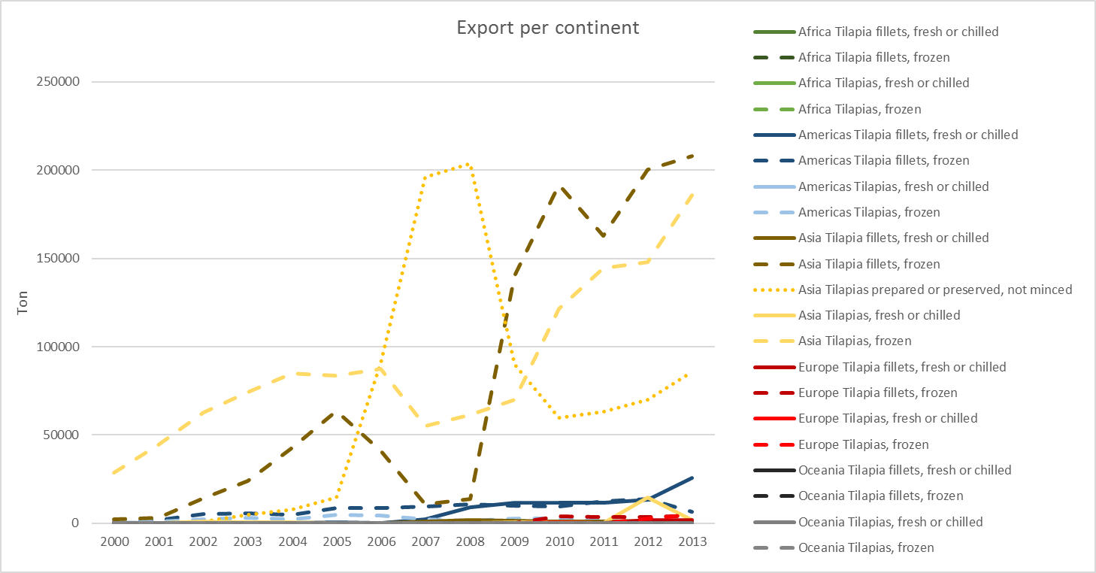
Supplementary Figure S1: Export rate per continent of tilapia products in ton, from 2000 to 2013 (FAO - Fish and Aquaculture Statistics, 2016).

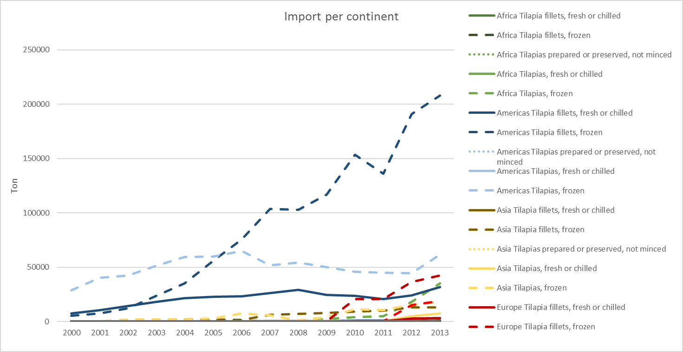
Supplementary Figure S2: Import rate per continent of tilapia products in ton, from 2000 to 2013 (FAO - Fish and Aquaculture Statistics, 2016).

Supplementary Table S1 Covariance components and eigenvalues of the intercept (b₀), linear (b₁) and quadratic (b₂) regression coefficients for the additive genetic effect from the single trait model for fillet yield (FY) assuming homogeneity of residual variance

Additive genetic effect (co)variance
 | b₀ | b₁ | b₂
b₀ | 3.12x10⁻⁴
b₁ | -7.76x10⁻⁵ | 2.79x10⁻⁴
b₂ | -7.16x10⁻⁴ | 1.96x10⁻⁵ | 1,07x10⁻⁴
Eigenvalues | 0.00039 | 0.00022 | 0.00008
% | 56.52 | 31.88 | 11.60

Supplementary Table S2 AIC comparison of random regression models for height (H), width (W) and corrected length (CL) when considering residual homogeneity of variance (HOM), residual homogeneity of variance and inclusion of family effect (HOM + F), residual heterogeneity of variance (HET), or residual heterogeneity of variance and inclusion of family effect (HET + F). AIC and LRT comparison of bivariate random regression models for fillet yield (FY) or fillet weight (FW) with height (H), width (W) and corrected length (CL) when considering a family effect and residual homogeneity of variance (HOM + F), residual heterogeneity of variance with five classes (HET 5 + F) and residual heterogeneity of variance with ten classes (HET 10 + F)

Trait | Model | N | p | Log | AIC | LRT | df* | Critical value (P<0.05)**
H | HOM | 8 758 | 13 | -16 988.93 | 34 003.86
 | HET | 8 758 | 22 | -16 969.72 | 33 977.44
 | HOM + F | 8 758 | 19 | -16 710.06 | 33 464.12
 | HET + F | 8 758 | 28 | -16 689.02 | 33 434.04
W | HOM | 8 758 | 13 | -11 735.96 | 23 497.92
 | HET | 8 758 | 22 | -11 718.13 | 23 474.26
 | HOM + F | 8 758 | 19 | -11 398.16 | 22 840.32
 | HET + F | 8 758 | 28 | -11 381.03 | 22 818.06
CL | HOM | 8 758 | 13 | -21 823.45 | 43 672.90
 | HET | 8 758 | 22 | -21 804.11 | 43 646.22
 | HOM + F | 8 758 | 19 | -21 316.35 | 42 676.70
 | HET + F | 8 758 | 28 | -21 296.76 | 42 649.52
FY x H | HOM + F | 4 084 | 45 | 1 257.29 | -2 424.58
 | HET 5 + F | 4 084 | 57 | 1 274.27 | -2 434.54 | 33.95 | 12 | 21.03
 | HET 10 + F | 4 084 | 72 | 1 283.78 | -2 423.56 | 19.02 | 15 | 25
FY x W | HOM + F | 4 084 | 45 | 3 377.05 | -6 664.10
 | HET 5 + F | 4 084 | 57 | 3 393.99 | -6 673.98 | 33.88 | 12 | 21.03
 | HET 10 + F | 4 084 | 72 | 3 418.88 | -6 693.76 | 49.78 | 15 | 25
FY x CL | HOM + F | 4 084 | 45 | 218.63 | -347.26
 | HET 5 + F | 4 084 | 57 | 240.06 | -366.12 | 42.85 | 12 | 21.03
 | HET 10 + F | 4 084 | 72 | 254.32 | -364.64 | 28.52 | 15 | 25
FW x H | HOM + F | 4 084 | 45 | -11 220.03 | 22 530.06
 | HET 5 + F | 4 084 | 57 | -11 199.78 | 22 513.56 | 40.5 | 12 | 21.03
 | HET 10 + F | 4 084 | 72 | -11 170.44 | 22 484.88 | 58.68 | 15 | 25
FW x W | HOM + F | 4 084 | 45 | -10 113.60 | 20 317.20
 | HET 5 + F | 4 084 | 57 | -10 088.78 | 20 291.56 | 49.64 | 12 | 21.03
 | HET 10 + F | 4 084 | 72 | -10 046.14 | 20 236.28 | 85.28 | 15 | 25

