A. Lepczyński, M. Ożgo, A. Dratwa-Chałupnik, P. Robak, A. Pyć, D. Zaborski, A. Herosimczyk
An update on medium- and low-abundant blood plasma proteome of horse

Supplementary Figure S1
Raw gel representing 1-DE protein profiles of horse blood plasma samples: lines 1-3 - the flow-through fraction of proteins that have been depleted from plasma sample; line 4 - molecular mass marker; line 5-7 – non-depleted plasma; 8-10 plasma samples treated with with the ProteoMiner Protein Enrichment Large-Capacity Kit (Bio-Rad).

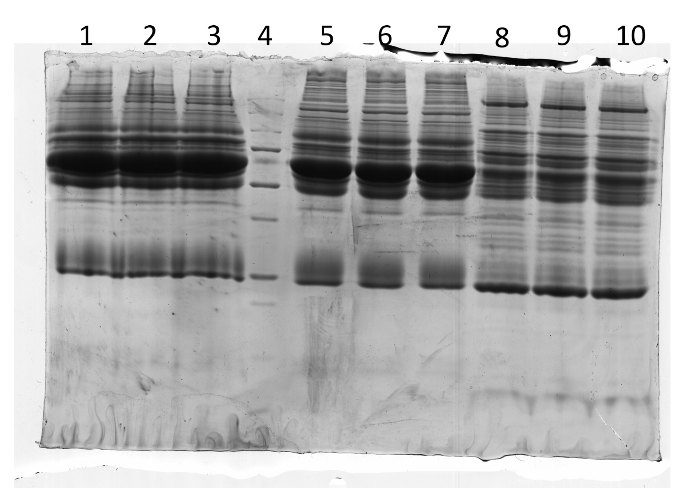

Suplementary Table S1
Summary of the identification of protein bands with the highest depletion ratio using MALDI-ToF mass spectrometry. Protein bands are corresponding to those marked on Figure 1 and signed using gene names. For each identified protein: gene name, accession number are shown as in Uniprot/NCBI database. The Mascot score, the sequence coverage, the number of peptides matched per protein and predicted Mr/pI values are given.
Protein name | Gene name | Accesion number | Mascot score | Sequence coverage | Peprides  mached | Predicted Mr/pI
Serotransferrin | TF | P27425 | 93 | 24 | 13 | 80.27/6.83
Serum albumin | ALB | P35747 | 182 | 18 | 12 | 70.55/5.95
Immunoglobulin gamma 4 heavy chain | IGHC | AAS18415 | 82 | 26 | 8 | 36.21/7.71

Suplementary Figure S2
A raw gel without any image transformation representing 2-D profiles of coomassie-stained horse plasma proteins before and after the depletion of a high abundant proteins. Proteins (280µg) were separated in 4–7 pH gradient for the first dimension followed by 12% SDS-PAGE.
